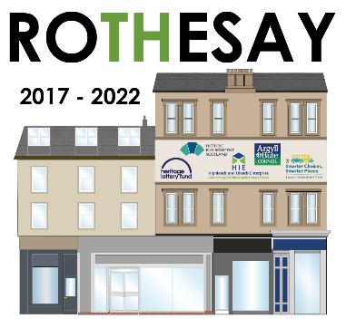

TYPE OF GRANT APPLIED FOR:
Expression of Interest – Rothesay Townscape Heritage
Please type or complete in black ink, paper copies can be supplied on request
If you would like any advice or assistance in completing this form, please contact Project Officer: Colin Fulcher Tel: 01700 501373 Email colin.fulcher@argyll-bute.gov.uk
Small Repair Grant ☐ Shopfront Repair ☐ Window Repair/Replacement ☐

ADDRESS OF PROPERTY APPLIED FOR:
Address: Click here to enter text.

Postcode: Click here to enter text.

APPLICANT DETAILS:
Name of Applicant: Click here to enter text.

Address: Click here to enter text.

Postcode: Click here to enter text.

CONTACT DETAILS:
Telephone Number: Click here to enter text. Mobile: Click here to enter text.

Email Address: Click here to enter text.

STATUS OF APPLICANT: (Owner Occupier, Tenant, Business, Charity)
Owner Occupier: ☐ Tenant ☐ Business ☐ Charity ☐

PROPERTY OWNER DETAILS: (if different to applicant)
Name of Applicant: Click here to enter text.

Address: Click here to enter text.

Postcode: Click here to enter text.

Telephone Number: Click here to enter text. Mobile: Click here to enter text.

Email Address: Click here to enter text.
PROPERTY CLASS:
Residential: ☐ Commercial ☐ Tenanted ☐ Other (detail below) ☐

Other: Click here to enter text.

SHORT DESCRIPTION OF PROPOSED PROJECT
(Please include detail on what works you are requesting to have funded)

Click here to enter text.

If you have a Professional Advisor, please provide contact details:
Name of Applicant: Click here to enter text.

Address: Click here to enter text.

Postcode: Click here to enter text.

Telephone Number: Click here to enter text. Mobile: Click here to enter text.

Email Address: Click here to enter text.

SIGNED: Date:

Please return completed form to:
Colin Fulcher – Project Officer
Rothesay TH, Eaglesham House, Mount Pleasant Road, Rothesay, Isle of Bute, PA20 9HQ
or by email to: colin.fulcher@argyll-bute.gov.uk

