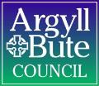

Member Zone: Member Update Briefing 3 (October 2022)

- INTRODUCTION
Since the launch of Member Zone in May 2021, a total of 571 requests have been logged by 34 different members. 441 (77%) of those were for Roads and Infrastructure Services with 130 for other Services. As the development of Member Zone continues, the following new features / updates will be made live on Friday 7th October:
- New member feedback form for resolved enquiries (point 2 below)
- New Constituent Details field added to all Member Zone forms (point 3 below)
- New Community Council field added to all Member Zone forms (point 4 below)
- New dedicated form for Planning / Building Standards enquiries (point 5 below)
- Tips on viewing your caseload on the home screen (point 6 below)
The purpose of this briefing is to advise Members of these new features that will be made live on Friday 7th October and to outline a number of other developments in progress and these are outlined at the end of this briefing (point 8 below). Training videos showing how these features can be accessed will be added to the section on the Member Zone menu.
- NEW: Member Feedback Form for Resolved Enquiries
To help track performance of speed and quality of response to member enquiries and to inform improvements, a new Member feedback form has been created. When Members close an enquiry, they will now receive an email inviting them to complete a short survey:
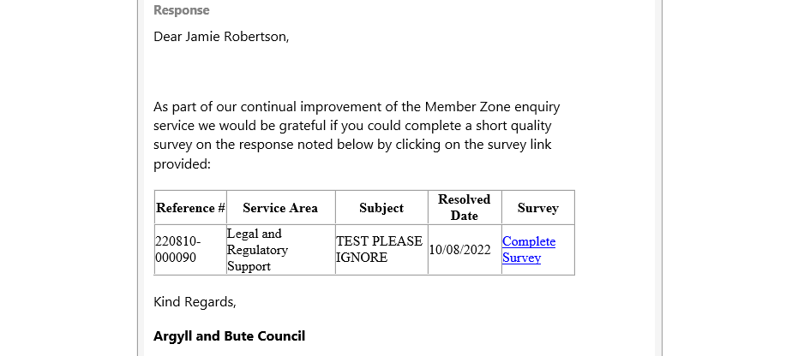
The survey invite email contains basic information about the enquiry and a link to complete the survey. Clicking on the link will open the survey for Members to complete:

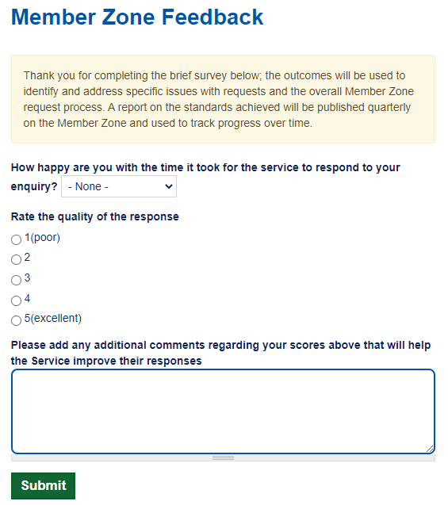
The completed surveys will be used to track performance and identify areas for improvement. It will allow speed and quality of responses to be reported on to members and DMT/SMT over time.
NOTE: the survey invite email will only be sent to Members that have marked enquiries as resolved. Once a Member is satisfied with the final response / outcome for an enquiry they must mark the enquiry as resolved within Member Zone:
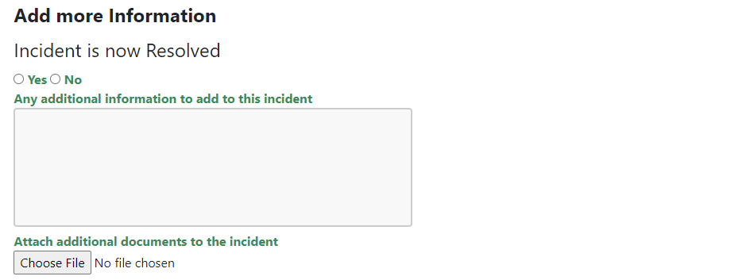

- NEW: Constituent Details Field Added to All Member Zone Forms
A new Constituent Details field has been added to all Member Zone forms. This has been requested by a number of Members to help them track and manage enquiries. This field is optional so when logging an enquiry, if there is no added value in completing this field please ignore and leave blank.
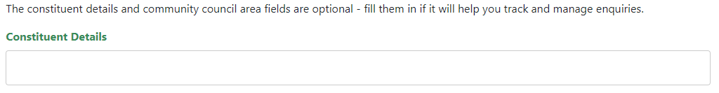
- NEW: Community Council Field Added to All Member Zone Forms
A new Community Council field has been added to all Member Zone forms. This has been requested by a number of Members to help them track and sort enquiries related to specific Community Councils. This field is optional so when logging an enquiry, if there is no added value in completing this field please ignore and leave blank.
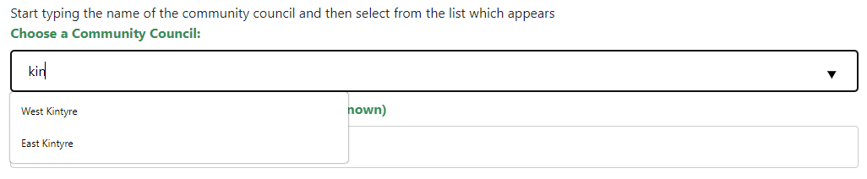
When using the Community Council field, Members can either scroll through the list of all community councils or can type in the box the name of the community council, which will auto filter the list of available options as you type. In the example above ‘kin’ has been entered and the list of available community councils with ‘kin’ in their name has been narrowed down to only show West Kintyre and East Kintyre.

- NEW: Planning / Building Standards Enquiry Form
A new dedicated form for Planning / Building Standards enquiries has been added to Member Zone. From the homepage, select New Enquiry and the Enquiry Type page is displayed:
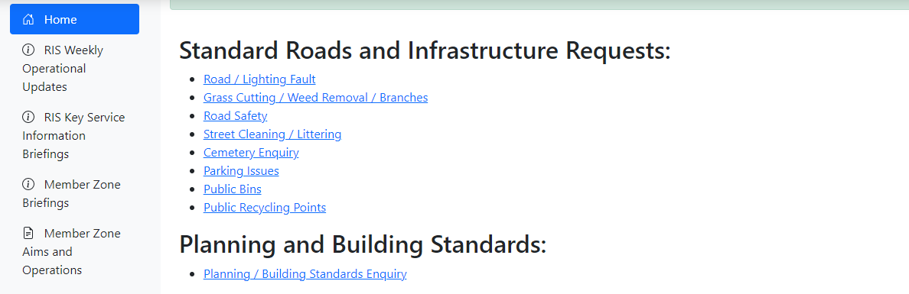
There is a new section for Planning and Building Standards. From here select the Planning / Building Standards Enquiry which will display the new form:
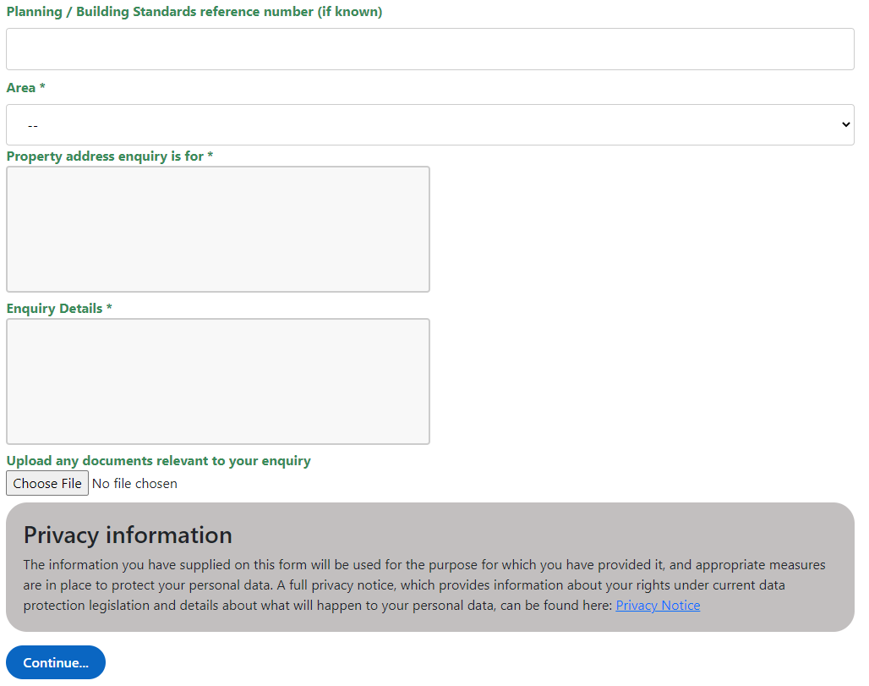
The form includes some additional fields relevant to Planning / Building Standards enquiries and will help Members to log what the enquiry is about and help officers in dealing with the enquiry; particularly if there is an associated reference number.

- TOP TIPS: Viewing Caseload on Home Screen and Reference Number
  - Viewing Caseload
On the Member Zone home screen, all enquiries are listed in a table:
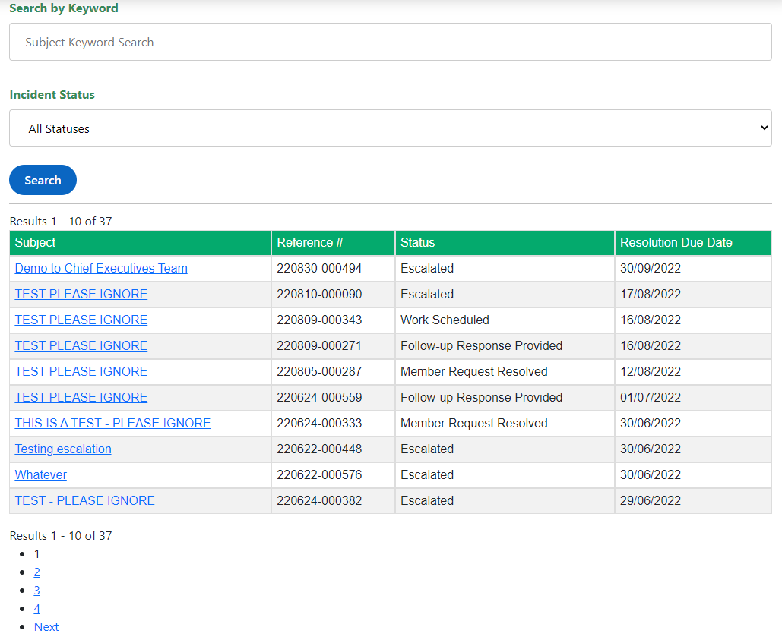
When viewing all enquiries, Members can:
- Use the Search by Keyword to search on the subject of an enquiry and click Search button
- Use the Incident Status to filter on incidents with a specific status (e.g. only show Follow-up Response Pending) and click Search button
*Combinations of subject keyword and status can be used

- Click on a column header to sort enquiries in order for that column. By default they will sort in ascending order (AZ for text, oldestnewest for dates). If you want to reverse the order, click on the column header again and they will be sorted in descending error.
  - Reference Number
Once logged in to Member Zone, the table displaying all incidents will automatically be sorted based on the enquiry reference number. The reference number for enquiries contains the date the enquiry was made and is in the following format:
YYMMDD-000000
YY: the year that enquiry was logged (e.g. 2022 the first two digits will be 22)
MM: the month that enquiry was logged (e.g. October will be 09)
DD: the day of the month that enquiry was logged
000000: unique reference number for enquiry
Sorting by Reference # column can be very useful if a Member wishes to view their enquiries in order of when they were created.

- Member Zone – Member Sounding Board
The first meeting of the Member Sounding Board took place on Tuesday 20th September. Five members attended and a list of priority enhancements for a future release were agreed:
- Fortnightly scheduled reports to be produced showing members a list of their current open cases (in excel so it can be sorted by members as they wish)
- Creation of stationery within system to allow members to produce letters etc. Some standard response templates for email and downloadable letters
- Look at self-colour option for members to navigate/sort their cases better, including option to archive closed cases, which can still be viewed under a different tab
- Organisation chart to be improved – area listing which categories sit under each service to help members identify ownership of case being raised
- Add a link to the GIS/maps into Member Zone for members to look up ownership of roads etc.
- A standard interpretation and rationale for the “Resolved” status will be proposed for consideration by the next SB.
The next meeting is in December and membership of the Board is open to any member by letting Helen MacLeod in Member Services know of your wish to join.

- Future Developments
In line with planned developments and in addition to the enhancements identified by the Member Sounding Board, the next developments will be:
  - Improved Reporting / Extracting Information from Member Zone
It is clear from the sounding board that Members require better reporting capabilities; both for viewing enquiries within Member Zone and for exporting information out of Member Zone.
  - Share Enquiries with other Members in Same Ward
The option to share enquiries with other Members within the same ward was rarely used in the previous application for Member enquiries, however, it is clear from individual feedback from Members and from the sounding board that this functionality should be available in Member Zone.
  - Two Factor Authentication
To provide additional security when members log into Member Zone. This provides security for both the council network and for customer information held within Member Zone.

  - Additional Information Resources
Roads and Infrastructure Services has begun adding topic specific Service Information Briefings to Member Zone in addition to their Weekly area specific Operational Update briefings and these can be accessed here:
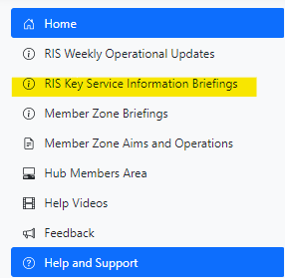
The briefings contain useful background information on how important services are delivered, the constraints and legalities around service delivery and local policy decisions. These will be added to over time.
Members are welcome to suggest any topics they would like additional information on using the Feedback facility on Member Zone.

----------------------------------------------------

If you require any further information or need any clarifications on the content of this Briefing, please do not hesitate to contact Member Services (memberservicesteam@argyll-bute.gov.uk, 01546 60 4305) or Jamie Robertson (01586 55 5202, jamie.robertson@argyll-bute.gov.uk).

Bob Miller Helen MacLeod
Customer Engagement Manager Member Services Officer
October 2022 October 2022

