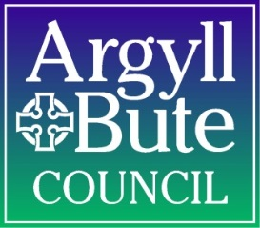

Reporting of Accidents/Incidents
and Violence and Anti-Social Behaviour Returns

Witness/1st responder completes Accident/Incident Report Form (PER/S/100C). Ensure form is signed by Head Teacher/Depute Head Teacher/Principal Teacher.
(see attached sample)

Witness/First Aider informs Head Teacher if accident/incident is severe.
Head Teacher takes decision to inform parents/carer. This should be recorded on the PER/S/100C form.

Complete Violence and Anti-Social Behaviour Incident Report Form (Appendix 2(a)). E-mail to suzanne.harper @argyll-bute.gov.uk Add relevant information to Violence and Anti-Social Behaviour Summary Form. E-mail Summary Form, at the end of each term, to: suzanne.harper @argyll-bute.gov.uk

Add relevant information to Bullying Incident Recording Form. E-mail completed form, at the end of Dec and June, to: suzanne.harper@argyll-bute.gov.uk

Within 24 hours, completed PER/S/100C form MUST BE
e-mailed to: karen.miller@argyll-bute.gov.uk

Within 24 hours, completed PER/S/100C form MUST BE
e-mailed to: karen.miller@argyll-bute.gov.uk

Within 24 hours, completed PER/S/100C form MUST BE
e-mailed to: karen.miller@argyll-bute.gov.uk

If reportable under RIDDOR, responsible person must report online via www.hse.gov.uk/riddor and contact H & S section. Responsible person to take further action, if required, to prevent repeat incident.

Staff Related
Pupil Related
Yes
No
Is this accident/incident, violence and/or aggression related?

