Tick  One  Box | For Information Only | For Decision |  | For Discussion
 |  | X
ARGYLL AND BUTE COUNCIL |  |  | SMT
CUSTOMER SERVICES |  |  | 28th January 2019
DIGITAL TRANSFORMATION 2019 and Beyond

- 0 INTRODUCTION

  - In October 2018 SMT received the report entitled “Digital Transformation – New Opportunities” (See Appendix 2). That report took a technology centric view of new digital enablers that could be deployed by the council, over and above those originally covered by the “Bob’s 11” transformation project. SMT noted the report at that point as there were two additional pieces of work in train that would shape how the council should approach digital transformation going forward:
- The Digital Maturity Assessment completed independently by the Scottish Local Government Digital Office Team (See Appendix 3)
- The Digital Transformation Workshops held at COSO on 9th October 2018 that gave managers the opportunity to feed into our digital development plans (See Appendix 4).
  - The feedback from the Digital Maturity Assessment and managers at COSO shows that a digital culture and skills are not as well embedded as was supposed and that this is an essential prerequisite for digital success. The council cannot take a technology only based approach to digital transformation, but a holistic organisational approach is needed that covers people, systems and processes if a truly transformational digital first culture is to be embedded. This paper winnows the output from the research completed over the past four months to propose a holistic Digital Transformation Programme that will take the rest of 2019/20 to implement and which will put in place ongoing practices that will last long beyond that.
  - Appendix 1 summarises that programme and it is important to note that this is in addition to the considerable volume of small and large scale digital innovations already being developed. The organisation’s capacity and capability for digital related change must be factored in; along with ensuring business as usual standards are maintained.

- 0 RECOMMENDATIONS
It is recommended that:
2.1 SMT approves the proposed approach to ensuring we have a digitally skilled workforce, including a digital skills audit, basic digital skills training and the embedding of digital champions across the organisation to provide practical support (para 3.4).
2.2 SMT considers this report and approves the Digital Transformation Programme detailed at Appendix 1.

2.3 SMT advises its preferred approach to ensuring delivery of any approved programme, given potential impending organisational changes.

- 0 DETAIL

Actions Arising from the Digital Maturity Assessment

3.1 During the Autumn of 2018 the Scottish Local Government Digital Office undertook a Digital Maturity Exercise using an established benchmarking framework for digital leadership that has been used in other councils. Thirty eight third tier and above managers were interviewed or surveyed and the detailed report is at Appendix 3. However in summary the analysis found we are similar to a number of other councils in our rating. Additionally there is a clear appetite for digital transformation and a number of significant digital advances; particularly around our customer facing digital services.
3.2 We were scored as being on the second step of the 5 point scale of digital maturity:
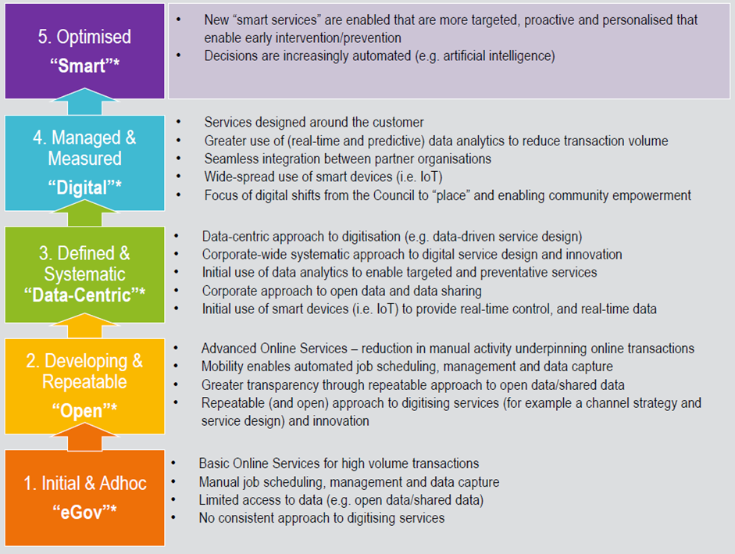

Broadly our capacity for digital transformation is being inhibited by lack of digital skills across the organisation (50% of managers felt their staff did not have the digital skills to do their jobs). Also digital transformation is still seen as largely something ICT does rather than being a fully embedded digital culture within employees in services, “There is a lack of ownership (and this is very common amongst councils) in the business areas for taking forward opportunities, there is a view that it should be IT led as opposed to business led which would be entirely the wrong model.”
3.3 The report stated that to fully realise our capacity for transformation and build on the clear appetite we have for it, we should be:
“Equipping staff with digital, data and technology skills to continually reimagine service delivery will be key to delivering future services to offer the best possible outcomes for residents. The ultimate goal is to equip the business areas with the transformational capabilities to continually review current business models and service delivery processes in light of technological developments and citizen’s expectations. Other councils are starting to create networks to support the development of essential digital skills across the workforce. …These networks are also being used to support change and cultural shifts.”
3.4 The SLGDO set out 9 recommendations in Appendix 3 and these have been reviewed and revised into the six recommendations below; split into Digital Skills and Digital Leadership.
Digital Skills recommendations
- Undertake an organisation wide digital skills audit to determine the actual levels of essential digital skills (there is an established model for this endorsed by Digital Scotland), and to identify employees who require additional training and support.
- Implement an Essential Digital Skills training programme for those employees requiring it. The Talent Management Team are applying for the maximum £15k grant from the Flexible Workforce Development fund for this and seeking input from the West College Scotland regarding delivery.
- Review our essential digital skills offering available to all new recruits and ensure this is offered to those who an Essential Skills Checklist identify as requiring it.
- To develop a network of council wide Digital Champions who can provide support and advice to those with less advanced skills. This model has had great success in Dundee Council and there is training available for Champions that can be offered.

In addition there needs to give more opportunity with those having greater digital skills to be able to collaborate and learn from colleagues and external exemplars (known as Open innovation), but this is covered in more detail later.

Digital Leadership
3.5 In terms of digital leadership the report noted a need to focus on long term transformation activity from short term efficiency and build separate new business models enabled by technology. The clear message being technology is the enabler but the Service has to redesign its service delivery models. It also highlighted a need to continue to improve and implement digital change to meet the high expectation of customers, improving confidence levels in the Council’s ability to keep up with the times. Appendix 1 details proposals in that regard; many of which were highlighted by managers in this exercise.
3.6 Another key factor in ensuring a Digital Transformation culture is the need to continually re-affirm its importance and there were a number of recommendations in this respect:
- Continuously celebrate and publicise successes, both small and large, on all platforms so the culture becomes one of stimulating continual digital improvement. This could for example be a monthly video of latest improvements on the Hub.
- Invest in structured digital awareness sessions with all staff using successful examples to showcase benefits and follow up with idea storming sessions to identify innovations.

Actions Arising from the COSO Digital Transformation Workshops

3.7 COSO meeting of 9th November 2018 had four digital transformation focused workshops based on themes influenced by the Scottish Government sponsored report ‘Dialling Scotland in for Digital Success’:
- Empowering Change; about vision and leadership
- Tackling Digital Exclusion; aimed at ensuring all can benefit from digital
- Moving Beyond Channel Shift; to identify further digital opportunities
- Redefining and Liberating Data; How can we use our considerable data resources to increase efficiency and benefit customers?
A full digest of the outcomes is at Appendix 4.

3.8 Empowering Change: In this workshop there was broad agreement with many of the Digital Maturity Assessment recommendations around the need for a digital skills audit, skills framework with associated training and having Digital Champions. There was also a desire however to have an overhaul of our current Digital First Policy “Vision”, which was thought to be too narrow and focused on technology and customers and not enough on employees and internal facing digital support systems. The other perceived gap was felt to be the lack of opportunity for digital collaboration, idea sharing and case studies.
3.9 The key recommendations arising from COSO for inclusion on the Digital Transformation Programme are therefore:
- Review, update and relaunch the current Digital First Policy to reflect the wider scope of Digital Transformation.
- Establish a specific Digital Transformation Hub on the Intranet to be the home for our internal Digital Community of Practice. It will also have collaboration room capabilities to allow cross team working on formal and informal innovations (The Skunk Works Approach).
3.10 Digital Exclusion: This workshop looked at digital exclusion and identified that upskilling our own workforce with better digital skills would have a ripple effect to the community as they would be able to pass on these skills to family and friends. There was also a belief that there are many people who are digitally aware but just choose not to participate in that way for whatever reason. So we do need to respect that choice and continue to offer analogue channels. Making our digital services as simple and intuitive to use as possible was seen as a vital contribution in this area, but also use analogue media to publicise and promote them and their benefits and more effectively reach our excluded audience.
  - Moving Beyond Channel Shift: This workshop identified a number of possible additional use cases for the new technologies advocated in the New Opportunities Report at Appendix 2 and by the SLGDO Maturity Assessment opportunities annex. The actions for this workshop are therefore picked up in the Appendix 1 Technology recommendations.
  - Redefining Data There was also strong support for recruiting a skilled data scientist to look at Big Data and Open Data but it was recognised that this would need a business case to be developed, which at the moment was difficult to justify. The recommendations from this workshop are picked up in the next section of the report.

Actions Arising from Digital Transformation – New Opportunities Report

  - This report (Appendix 2) related a number of new and emerging technologies that the council should pursue in coming years that hold the promise of efficiencies or improvements in service delivery. The proposed actions to progress this technological element of transformation are set out below.

Internet of Things
  - Internet of Things (IoT) consists of sensors embedded in devices that can send back information to a user over a network, typically using the internet, mobile phone network or wireless signal. Recommended actions are:
- Work with SWAN and IoT Scotland to establish an internet of things n across our area.
- Develop an IOT Strategy. IoT has wide application and therefore should not be pursued in a haphazard way. Having a clear strategy and subject matter expert lead is vital.
- Complete at least 1 IOT Pathfinder Deployment in 2019/20. Common areas for exploitation are Environmental Monitoring, Device Function, Capacity Management and Motion Sensing telecare.
Artificial Intelligence
  - Artificial Intelligence can include physical robotics, however the report focused on data robots or bots. These fall into three categories ‘probots’, which process data and are also commonly known as Robotic Process Automation (RPA); ‘knowbots’ to gather and store data; and ‘chatbots’, which act as virtual agents to respond to customer queries in real time. Recommended actions are:
- Research, procure and implement a voice automated (Alexa type) chatbot capability to complement the online Virtual Assistant AI capability being introduced in the CSC.
- Utilise the council’s NDL software to implement at least one additional Robotic Process Automation service in 2019.
- Implement a ‘knowbot’ to provide automated outreach for bin related issues direct to customers and CSC agents.
Drones
3.16 Drone technology has already been used to a very limited extent by some teams and their commonest forms of use are in survey and inspection work and in providing aerial video reporting. Recommended actions are:
- Research and utilise a framework contract for access to Drone Services for any Service to use (and Community Planning Partners). At present ad hoc arrangements are being made to obtain services.
- Develop a Drone Usage Policy and best practice guide. This is a rapidly evolving technology with new laws and capabilities, hence council officers need firm guidelines regarding usage.
Big Data & Open Data
  - Use of data to enhance efficiency is essential as the data usage and computing power is growing exponentially. The report explored both ‘Big Data’ (large data sets used to predict behaviours or identify patterns that can be used beneficially e.g. to help target resources), and “Open Data (data generated by the council or its partners that can be published openly and used by others; usually to feed into Big Data type analysis). This was also considered by a COSO workshop and our recommendations are:
- Give further consideration to recruiting a skilled data scientist to define a data management strategy and to review use cases, for example in tourism, amenities, health and social care and improved data management.
- Do research development of a secure personalised info-dashboard that individual customers could securely access to see information held in various back office systems, thus increasing transparency, reducing fears about data sharing and getting customers to help ensure their data is up to date.
Residual Tasks
  - In addition to these new technologies this report outlined a number of residual tasks from the original 2016 Digital Transformation paper that it is proposed should be implemented, including:
- Implement a fully integrated online licensing and grants forms with a Grants A-Z to complement the one that exists for licensing. This was hoped to be done on a national level but did not gain sufficient support.
- Deliver an enterprise review of and strategy for mobile working to maximise usage. The council has many workers who gather or receive information on external visits to customers and then rekey or return to base. Mobile working opportunities have never been systematically investigated and exploited.
- Research and implement a mobile working solution for H&SCP employees based on the Carefirst and NDL Mx software platform. Such an integration has been successful in Newcastle City Council and its potential is being explored by ICT and the H&SCP.
- Following lessons from the Carefirst Mobile solution, develop agile proposals for replicating this for Amenity Services using Oracle CRM. At present a complex integration with Oracle CRM and WDM’s ELM Module is proposed for this, however an NDL based integration could deliver the benefits faster.

Other Actions
3.19 In addition to these recommendations there are other nationally related technology developments that should be included in the 2019 Digital Transformation Plan, including:
- Capitalise on the National Stakeholder Identity Programme and the planned new Scottish Digital Identity to ensure it intercepts seamlessly with our current MyAccount online authentication service. Also to ensure services migrate seamlessly from MyAccount to the Scottish Digital Identity where appropriate and that new Scottish Digital Identity enrolement and services are introduced locally when that service is launched.
- Further develop the Council’s local MyAccount offering to increase uptake and thus further increase channel shift. Specifically in 2019/20 to introduce personalised information regarding local planning and licensing applications.

- CONCLUSION

  - The original Bob’s 11 Digital Transformation report took a very customer focused view of transformation, as it was driven by the need for immediate digital efficiencies. The research done recently strongly advocates a more widely based and longer term culture change based approach to Transformation. Here the digital skills of our own workforce are the key enabler to success, allowing a more systemic digital capability to be the soil on which our Services’ collaborative digital business models will flourish.
  - We need to seize the opportunities that emerging technologies are providing now. This report contains a Digital Programme Action Plan at Appendix 1 that covers the holistic digital approach and technology innovations needed.

- IMPLICATIONS

5.1 Policy | Advocates update of Council’s Digital First Policy
5.2 Financial | Will underpin an efficient digital culture with individual deliverables providing short and long term cashable savings to be defined.
5.3 Legal | None
5.4 HR | Technology changes may impact on jobs
5.5 Equalities | None at this stage
5.6 Risk | None
5.7 Customer Service | All digital developments are aimed at delivering better services for customers.

Judy Orr
Head of Customer and Support Services
17th January 2019

For further information contact: Judy Orr or Bob Miller
Policy Lead: Rory Colville

APPENDIX 1: The 2019/20 Digital Programme
Technology Based Digital Developments

REF | OUTCOME
T1 NS | Review, update and relaunch the current Digital First Policy to reflect the wider scope of Digital Transformation
T2 NS | Mobile: Deliver an enterprise review of and strategy for mobile working (Not Agile Working)
T3 S | Mobile: Research and implement a mobile working solution for H&SCP employees based on the Carefirst and NDL Mx software platform
T4 S | Mobile: Following lessons from the Carefirst Mobile solution, develop agile proposals for replicating this for Amenity Services using Oracle CRM
T5 NS | IoT: Work with SWAN and IoT Scotland to establish an internet of things network across our area.
T6 NS | IoT: Develop an IOT Strategy.
T7 S | IoT: Complete at least 1 IOT Pathfinder Deployment in 2019/20 (Environmental Monitoring, Device Function, Capacity Management: Motion Sensing telecare).
T8 S | AI: Research, procure and implement a voice automated (Alexa type) chatbot capability to complement the online Virtual Assistant AI capability being introduced.
T9 S | AI: Utilise the council’s NDL software to implement at least one additional Robotic Process Automation service in 2019.
T10 CS | AI: Implement a ‘knowbot’ to provide automated outreach bin related issues direct to customers and CSC agents.
T11 NS | Drones: Research and utilise a framework contract for access to Drone Services for any Service to use (and Community Planning Partners).
T12 NS | Drones: Develop a Drone Usage Policy and best practice guide.
T13 S | Data: Give further consideration to recruiting a skilled data scientist to define a data management strategy and to review use cases, for example in tourism, amenities, health and social care and improved data management.
T14 CS | Data: Do research development of a secure personalised info-dashboard that individual customers could securely access to see information held in various back office systems,
T15 NS | Pressure, Promote and Participate with Scottish Local Government Digital Office to deliver meaningfully on common cutting edge technologies so that all councils are not doing duplicating effort e.g. re IoT and AI etc.
T16 S | Fully integrated online licensing and grants forms with a Grants A-Z to complement the one that exists for licensing.
T17 CS | Develop a life and business event hub on the website providing structured online resources with links to partner resources.
T18 CS | Capitalise on the National Stakeholder Identity Programme and the planned new Scottish Digital Identity to ensure it intercepts seamlessly with our current MyAccount online authentication service.
T19 S | Further develop the Council’s local MyAccount offering to increase uptake and thus further increase channel shift. Specifically in 2019/20 to introduce personalised information regarding local planning and licensing applications.
People and Culture Based Digital Transformation
REF | OUTCOME
P1 NS | Undertake an organisation wide digital skills audit to determine the actual levels of essential digital skills (there is an established model for this endorsed by Digital Scotland), and to identify employees who require additional training and support.
P2 NS | Implement an Essential Digital Skills training programme for those employees requiring it, using funding from Flexible Workforce Development fund and seeking input from the West College Scotland regarding delivery.
P3 NS | Review our essential digital skills offering available to all new recruits and ensure this is offered to those who an Essential Skills Checklist identify as requiring it.
P3 NS | Develop a council wide network of trained Digital Champions who can provide support and advice to those with less advanced skills.
P4 S | Invest in structured digital awareness sessions with all staff using successful examples to showcase benefits and follow up with idea storming sessions to identify innovations.
P5 NS | Continuously celebrate and publicise successes, both small and large, on all platforms so the culture becomes one of stimulating continual digital improvement. This could for example be a monthly video of latest improvements on the Hub.
P6 S | Establish a specific Digital Transformation Hub on the Intranet to be the home for our internal Digital Community of Practice. It will also have collaboration room capabilities to allow cross team working on formal and informal innovations.

Appendix 2: Digital Transformation – New Opportunities
Tick  One  Box | For Information Only | For Decision |  | For Discussion
 |  |  |  | X
ARGYLL AND BUTE COUNCIL |  |  | Policy Leads
CUSTOMER SERVICES |  |  | 14 November 2018
DIGITAL TRANSFORMATION - NEW OPPORTUNITIES

- INTRODUCTION

1.1 The July 2018 Transformation Board asked for consideration of new options for further digital transformation beyond those in the “Bob’s 11” transformation ideas which are all on track to be implemented by the end of this financial year. This paper outlines a number of options for future exploration. It should be recognised that because of the pioneering digital work done over many years by the council, most of the big ticket items (Unified Comms, Omnichannel Contact Centre and CRM, SOCITM 4 star website etc), that bring significant cashable savings have already been implemented. The new opportunities identified here are leading edge and business cases for these are las yet undeveloped.

  - This paper shows a direction of travel that the council should undertake as the next stage of its digital evolution. However there is a Digital Maturity Assessment underway with the help of the Scottish Digital Office and workshops at COSO on 9th November that will also allow wider management input to inform next steps.

2. RECOMMENDATIONS

2.1 It is recommended that SMT considers this report and notes the proposals for the next stage of digital evolution and that these will be further developed following input from the Digital Maturity Assessment and COSO Workshop outcomes.

3. DETAIL

  - A report was tabled to the Transformation Board in July 2018 which detailed all the implementable outcomes of the 11 digital transformation options commissioned in 2017 (known informally as Bob’s 11). A summary of the Bob’s 11 deliverables which are already being implemented is attached at Appendix 1 for reference. In consequence and to continue the momentum for digital led transformation, the Board asked for a range of further digital options to be presented to it.

  - It is also important to be aware of the significant technology based initiatives already under way in the Education Service out with the Bob’s 11. Skype for Business has been operational in 3 secondaries and their satellite primaries for some time, and may be expanded further subject to bandwidth constraints, and a Chromebook pilot has recently completed in Cardross Primary and is being evaluated along with G Suite. Google Classroom is part of this and offers along with other tools the possibility of a Virtual School which is to be trialled through GLOW. SEEMIS next generation systems are under development along with the MyAccount Parent Portal. We are looking at mobile apps for pupils to manage and share portfolios of work. We already make significant use of Messenger for communicating with parents and use s-Sgoil’s free arrangement for use of VScene to provide Gaelic teaching over video conferencing.

  - Whilst the need for significant cashable savings to contribute to a balanced budget in a continually challenging financial climate is well understood, the realistic prospect for significant savings from further digital transformation is assessed as slim due to:
- The mature nature of our existing digital services. The council has been radically improving its digital services for over a decade and has already implemented many cutting edge automated, integrated self-service systems.
- Evolution rather than transformation is more realistic and is being actively pursued. The final stage of transformation is defined by digital guru Brian Solis as: “Digital transformation becomes a way of business as Executives recognise that change is constant. A new ecosystem is established to identify and act on technology and market trends”. In other words Transformation becomes a journey and not and end.
- The variety and scope of council services and their digital systems. Savings from Digital transformation are greatest in large, limited product areas such as online retail or financial services.
- The council has already subscribed fully to national initiatives including TellMeScotland, the national Planning Portal and MyJobScotland.
- Relative lack of further national outputs - The Scottish Local Government Digital Office has yet to produce any outputs that have delivered radical change or savings opportunities beyond assistance with GDPR compliance and a methodology for digital maturity assessment.
The Digital consultants GOSS have produced an annual report on digital transformation in 200 organisations in the public sector since 2015 and their recently published report recognises that instead of a revolutionary approach to digital transformation “organisations have been forced to scale back their ambitions in favour of a much more evolutionary approach instead”.

  - This does not mean that opportunities for significant digital progression are not there. The scope for things digital is ever widening and the diagram below shows the key areas of interest. However the challenge is identify and act on the trends to apply that innovation to real world council activities.
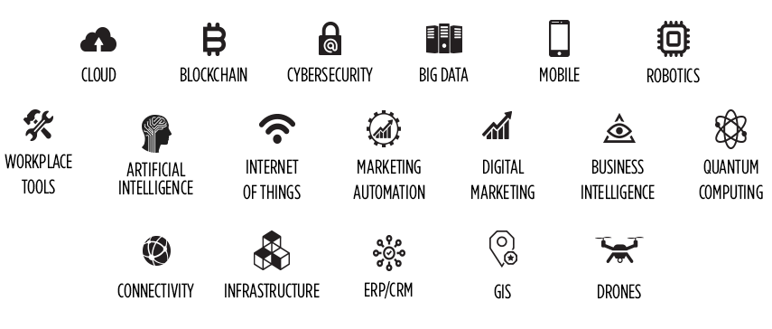
Of the digital enablers above the Bob’s11 options focused on cloud, mobile, workplace tools, digital marketing and marketing automation, ERP/CRM and GIS. Cybersecurity (along with PSN and Cyber essentials plus and PCI-DSS accreditation), connectivity and infrastructure resilience have been the ongoing focus of the ICT Service.

  - Working within our limited capacity and capability for change there remain a number of items from the original Transformation Report (based on the NESTA Digital Councils 2025 vision), that were not progressed, but which should still be considered for implementation. These are:
- Further rationalising face to face service provision by offering co-located cross organisation customer service or digital only assistive services enabled by Skype type technology and Artificial Intelligence. This is covered in more detail in a separate standalone report.
- An interoperable unified communication system (Skype), shared between all community planning organisations, and between council and H&SCP. This is still on the H&SCP agenda but funding and existing H&SCP commercial arrangements are impediments from any progress in the short term.
- An enterprise review of and strategy for mobile working. At present we have a piecemeal Service based approach e.g. ELMS for Roads and Amenities. In social care it is hoped the new Eclipse system will revolutionise mobile working connected capability, but it is not due until 2020/21 and there is no funding for any upgrade from CareFirst. NDL could potentially provide a cheaper, tactical solution. This review could be undertaken by ICT.
- Fully integrated online licensing and grants forms with a new Grants A-Z to complement the one that exists for licensing. At present nearly all grants and licensing forms submitted by customers require rekeying. Linking this to national authentication could also remove levels of manual identity checking. ICT are working with Governance and Law to identify a solution to the lack of an integrated licensing self-service portal as it is now clear that the national project will not deliver this.
- Life and business event based structured online resources this could improve digital usage and engagement by grouping together facilities which reflect real life scenarios / events in customer lives. This would sit alongside the traditional view offered on the website and would include signposting to non-digital support for key life events and business events. Recognising that the council works in partnership with many other public and voluntary services, a key element will be to link to these resources to provide a virtual one stop shop for customer and business events. This could be progressed by the Web Team as an additional action to the Web Strategy action plan.
All of the above have the potential to deliver savings through a combination of employee or employee cost related savings and productivity efficiencies.
To Boldly Go…….
  - Looking at the remaining enabling technologies for digital transformation noted at para 3.4 above that have not already been investigated, some are nearer to having deployable solutions that can be applied to council services in Argyll and Bute than others. Others are more distant propositions.

Promising Candidates | Far Horizons
Internet of Things | Block Chain
Artificial Intelligence | Quantum Computing
Robotics
Drone Technology
Big Data/Business Analytics

Internet of Things (IoT)

3.7 IoT in simple terms consists of sensors embedded in devices that can send back information to a user over a network, typically using the internet, mobile phone network or wireless signal. Locally we already use IoT in telecare using 3 types of sensors – movement detectors, door sensors and activity sensors attached to kettles and shower heads. The data is collected by a single plug and go hub which feeds the data back to the supplier servers over the mobile network using a 4G SIM card. IoT is also used in monitoring of roads for winter maintenance and in environmental building monitoring (temperature and humidity).
3.8 The use cases for IoT are considerable and can produce savings by moving from the use of expert or expensive resources from a planned basis to an only when needed or just in time basis. The ability for sensors to produce alerts also helps manage risk and increase opportunities for preventative action. Common applications are:

- Environmental Monitoring: Air quality, water quality, shellfish, algae bloom, flooding
- Device function: Streetlamp failure, Payment machine failure, bridge condition, camera function
- Capacity management: Road traffic flows, parking availability, bin fullness/weight, crowd density, marine berthing
- Motion Sensing: To turn things off and on, to check on wellbeing, to enforce payment, particularly in unmanned facilities.

3.9 The Scottish Government has recognised the importance of IoT by establishing IoT Scotland, a joint venture with Boston Networks seeking to establish 500 IoT wireless network gateways for use by public and private sector across Scotland. This is a £6m project. The Council’s ICT Team has already engaged with Boston Networks to potentially host gateways in our larger towns as they overcome the limitations of having limited 4G coverage in our area.

3.10 In parallel Capita are running a pilot with SWAN to create 50 LoRa IoT network gateways across Scotland with coverage of up to 6 miles using Innovation funding and existing SWAN connections and are looking for potential use cases. Highland Council have piloted this to automate Legionella Sampling. This would be offered as a Shared Service (at no additional cost) with SWAN members paying only subscription costs for connecting sensors to the service or adding additional gateways beyond the initial rollout to support future project coverage demands.

3.11 Scottish Procurement are developing a Dynamic Purchasing System (DPS) to ensure suppliers of sensors, analytics and dashboards have a route to market.

3.12 Once a cheap and effective IoT network is created, then the opportunity exists to invest in a wide range of IOT sensors that could fundamentally change many regularly scheduled manual activities. This work needs to be carefully co-ordinated across the council geographically so economies of scale and best practice learning is shared.

Artificial Intelligence (AI)

3.13 The council has already invested in early forms of AI through its use of algorithm based voice automated services and online Smart Assistant service and imminent Virtual Assistant. These however rely on pre-programmed databases and rules and the next generation of AI is a significant advance as it involves machine learning, where systems learn from interactions and mistakes to grow and improve capability.

3.14 Chat bots and other forms of AI automated assistants (including some that have a physical holographic presence) have been trialled in local government. However the costs of setting up the initial council specific dataset and the underlying software has been prohibitive to all but the largest councils. This is an area that needs the Scottish Digital Office to step up to the mark.
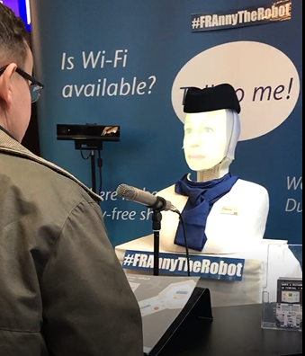

3.15 However Kirklees Council is pioneering an Alexa based voice recognition service coupled to AI for council specific scenarios. This approach will potentially reduce the number of expensive mediated contacts both internally (HR AI Chatbots) and externally e.g. Pre-Planning AI chatbots.
AI is also being heavily trialled in the NHS as an expert diagnosis aid for doctors and to improve success rates for identification of disease from patient samples. AI is deployable in any scenario where there is IFTTT (If this, then that,) logic and decision making, such as benefit claims. It can both help improve the quality of decision making to reduce rework, but can also replace the human in the decision making to save costs.

3.16 There is no national lead in this area for local councils, but a number of vendors (Netcall, Genysys, Firmstep), are developing local authority centric AI chatbot solutions so they should become affordable to smaller councils in the near future. Consideration should be given to wider use cases across the council.

Robotics

3.17 Robotics has two forms:
- Data automation (also known as Robotic Process Automation – RPA), where a form of AI allows a computer to undertake routine and repetitive tasks such as the keying of data from one system to another where pre-conditions are met. The council has used NDL middleware to do this at annual billing time in benefits to apply rent increases. This could be extended to other areas.

- Physical robots doing the work previously completed by humans. In local government this has been commonest in Amenity Services where driver only bin lorries use forms of mechanical arms to empty bins and in Roads where jet patchers replace road gangs to fix potholes. Both of these use robotic elements, but still require to be “flown” by a skilled operative.

3.18 The council has not yet fully leveraged the capabilities of its investment in NDL for RPA. Engie is one company which has invested heavily in using RPA in the areas of facilities management and revenues and benefits. They find it very useful for handling spikes in demand, and particularly for high volume repetitive work, particularly batch processes. Analysis should be done however to identify other use cases for RPA across the council that will return on the development investment. RPA is an on demand virtual workforce that is waiting for jobs to do.

3.19 Physical robots are more problematic as their cost rises exponentially with the complexity of the task they are required to complete. For example a robot hoover could be bought quite cheaply that could be programmed to clean Kintyre House in Campbeltown as it is on one level and has a simple layout. Finding a robot hoover on the market that could cope with the levels and layout of Kilmory would require NASA expertise.

3.20 Domestic care robots are being intensively developed as suppliers see ageing populations as a lucrative future market. Early versions are robotic companions that are in effect telecare bundled in a morphic form that can be human or animal (companion electronic cats loaded with IoT sensors and cameras). These are not yet cost or trust effective enough for widespread adoption by public authorities (driverless bin lorries will be some way off!). Similarly robotic traffic wardens have been used in Africa and Taipei but the costs are still outweighing benefits. RPA is therefore still the most realistic form of usable robotics for Argyll and Bute Council.

Drone Technology

3.21 Drones are a subset form of robotics and are an aerial platform on which to mount various types of cameras and sensors. Despite falling sharply in price they have been slow to be adopted. In November 2017 Police Scotland tendered for 2 drones to be used by a new unit to help with missing person searches and crowd control at a cost of £125k. In 2016 Moray council said it would use drones to do pre-planning application photo surveys to obviate the need for planning committee members to visit sites. Edinburgh and Scottish Borders have also used drone technology in building surveys and engineering project before/after and progress photography. They both used a specialist provider each time which made it very affordable with no capital outlay or training required (users need a pilot’s licence). Aberdeen City council’s digital strategy includes looking to use drones for building safety inspections and planning compliance including the uses of infrared and x-ray cameras.

3.22 The key constraints are the relative infrequency of use versus the cost and expertise needed to deploy and maintain the technology. Hence other councils often buy in the service whenever they need it at a cost of c. £550 per session rather than have a capital investment. Another limiting factor in Argyll and Bute is the weather, especially as it is damage to buildings, bridges, roads etc. that is the most likely use case and that usually happens in the winter when poor weather and darkness renders drones useless. It may be worth investigating a shared cost shared use arrangement with Community Planning Partners.

Big Data & Data Analytics

3.23 Big Data is the term used to describe the huge volumes of readily available data that is increasingly complex in variety and comes at individuals and organisations with ever increasing velocity. That data is however a resource that can be analysed to generate better strategies and informed decision making. IoT will lead to another quantum increase in the three Vs of data (volume, variety, velocity) and its benefits will be curtailed without an investment in data analytical capability and capacity.

3.24 Councils have always done data analytics in many forms, be it to identify potential benefit fraud by cross checking what customers are telling different teams in the council or using it forecast demand for new service or ICT network, or even to predict how much salt to pre-buy for a winter ahead.

3.25 “Smart Cities” like Glasgow have started to use data analytics and IoT outputs to identify air quality, fly tipping and graffiti blackspots, traffic flow problems and other urban centric issues that happily Argyll and Bute is largely free of. They have employed data scientists to both analyse the data but also to make data available in support of the Scottish Government’s Open Data standard. Typically the use of data analytics is around:
- Obtaining a 360 degree view of customers from different data sources; very important in social care and the safeguarding of children
- Using the above to provide tailored personalised service and services
- Predictive data to optimise delivery and distribution
- Prevention of everything from fraud to mechanical breakdowns of bin lorries.

3.26 Argyll and Bute Council has from time to time bought in specialist data analytical services from for example Experian for specific use cases, but has not been able to justify the recruitment of a dedicated data scientist. Widespread deployment of IoT may require that to change but at the moment one off instances (for example to target anti-poverty resources) are perhaps best still done on a case by case basis by specialist supplers. One area that the council could progress Big Data is to set up an open Data hub, to publish our own uncontroversial data sets for open analysis and use by others; in effect getting free data analytics. This has been done by the 7 cities in the Scottish Cities Alliance, albeit with central funding.

Progressing Our Digital Evolution

3.27 The developments at 3.5 a-e are either already being progressed or have clear pathways recommended for progression noted against them. The next generation digital developments at 3.6 - 3.11 require further investigation and identification of specific use cases to take them forward. The council is also undertaking a Digital maturity Assessment with the help of the Scottish Digital office and has made Digital the topic of the workshop element at the next COSO meeting on 9 November. The aim should be to identify a clear digital vision and strategy with specific proofs of concept across the council having identified leads. These proof of concepts would then be examplars which then form the seed corn basis from which lessons have been learned and additional use cases and eventually full business cases are developed. There should be no expectation of financial savings from these as yet until they are worked up.

- CONCLUSION

  - The ‘Bob’s 11’ Digital Transformation program was just the starting point of a digital evolution process that is now constant as digital technology progresses. This paper identifies that there is still value to be gained from a number of ideas that have yet to be implemented. It also identifies emerging technologies that will be the catalyst for the next wave of efficiency promoting technology implementations. The best way to ensure progression within each of these enablers is to identify specific Service based leads and use cases to take through to proof of concept stage. These proof of concepts can become exemplars to stimulate wider digital innovation.

- IMPLICATIONS

5.1 Policy | Builds on the Council’s Digital First Policy
5.2 Financial | Yet to be defined, but no significant savings anticipated
5.3 Legal | None
5.4 HR | Technology changes may impact on jobs
5.5 Equalities | None at this stage
5.6 Risk | None
5.7 Customer Service | All digital developments are aimed at delivering better services for customers.

Judy Orr
Head of Customer and Support Services
5th November 2018

For further information contact: Judy Orr or Bob Miller
Policy Lead: Rory Colville

APPENDIX 3: Digital Maturity Assessment Report, October 2018

Argyll and Bute Digital Maturity Assessment (Leadership)

Main report

Findings from the digital maturity assessment of Argyll and Bute Council (October 2018)

CONTENTS PAGE
Summary and recommendations 3-6
Methodology 7
The assessment areas
Digital Strategy 7
Capacity for Transformation 8
Digital skills and culture 9-10
Research and innovation 11
Annex 1 Opportunities 12-13

SUMMARY AND RECOMMENDATIONS
There is a clear appetite for transformation across services but it is very difficult with current resource levels to be able to progress opportunities (Annex 1). The key barriers to transformation include lack of dedicated resources and time.
The council has prioritised work to ensure the effective delivery of customer services. This valuable work has been recognised as best practice. However there is now a recognition that the council needs to focus on how staff work internally to encourage collaboration across service areas, improve automation and facilitate mobile working. Equipping staff with digital, data and technology skills to continually reimagine service delivery will be key to delivering future services to offer the best possible outcomes for residents.
With a difficult financial climate, the Council needs to understand where changing business delivery models will result in both better outcomes and substantial savings.
Argyll and Bute is very similar to other councils in where they are in their digital transformation journey. The council has clearly developed good practice in customer service and has set clear aspirations for technological foundations.
Other councils are developing dedicated transformational capability using a variety of models e.g. virtual teams or centralised models. The ultimate goal is to equip the business areas with the transformational capabilities to continually review current business models and service delivery processes in light of technological developments and citizen’s expectations. It is clear from the responses to the interviews and the survey that there is real appetite to look at new ways of working and offer more opportunities for service delivery and many of these will yield savings but there is a lack of time and resource to support this.
There is a lack of ownership (and this is very common amongst councils) in the business areas for taking forward opportunities, there is a view that it should be IT led as opposed to business led which would be entirely the wrong model.
Other councils are starting to create networks to support the development of essential digital skills across the workforce. These networks are also being used to support change and cultural shifts away from fixed specialism and presenteeism to anytime anywhere and flexible role development.

KEY QUOTES

“Our remote location and geographic challenges make digital a key to future service delivery.”

“Employer for life not job for life- staff will need to continually learn, be flexible and able to do different roles in their lifetime.”

“It’s a no brainer, the more we can do digitally, the better.”

“We expect people to do change as part of the day job. This is becoming impossible.”

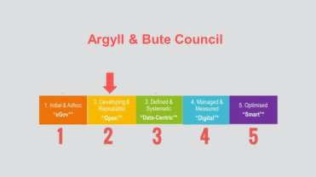

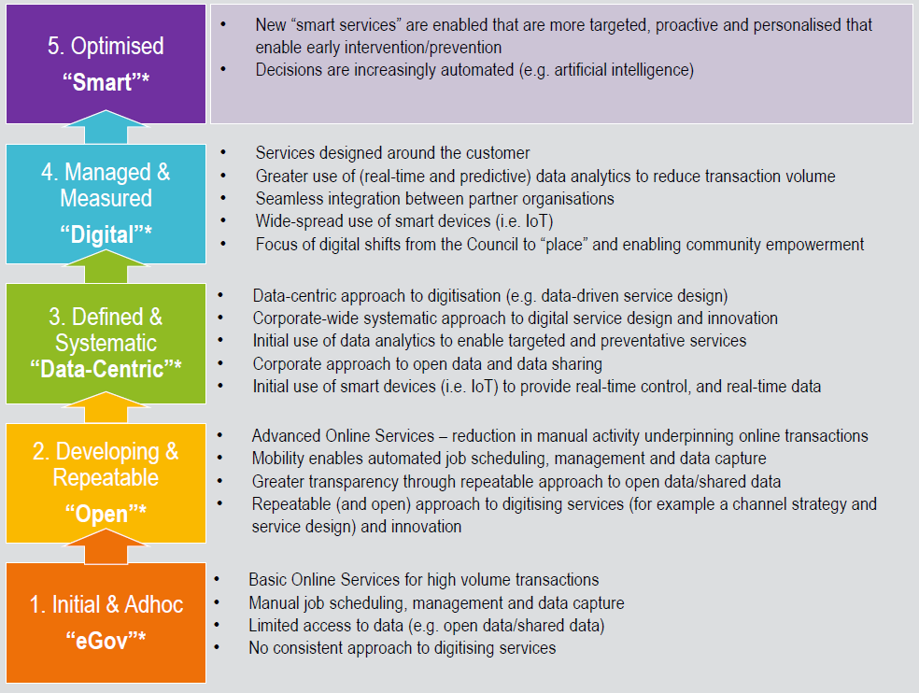
DIGITAL MATURITY SCORE

Recommendations are presented below but these are very much a first draft and it would be more useful to discuss these in a leadership workshop setting to agree the next steps. There is also a section below the recommendations which provides a signpost to relevant underway work in other councils.

Recommendations

Clear transformation capability and governance
- Review process of transformation and effectiveness of boards to develop consistent capability, priorities, realise opportunities (Annex 1) and enable new business models enabled by technology.

Transformation plans longer term outcome focused and are not quick efficiency savings
- Transformation activity should have a long term focus and be separated out from short term efficiency savings.

Investment in underlying technology
- Investment in the basics such as integration of systems, automation of back office, mobile working for all front line staff, development of internal processes and rationalisation of estate will be critical in moving forward and providing data driven intelligence for staff and better customer experience.

Ownership of digital transformation
- The ICT and Digital Strategy has a strong focus on developing foundations with a robust set of principles to enable technology to work. However there is need for more focus on cultural change to deliver new business models, technology is the enabler but the business area has to redesign the service. Ownership for digital transformation should sit within the business areas with close liaison with IT to enable new ways of working. It would be useful to offer a digital leadership programme (inc elected members) which supported leaders to think differently about how they could deliver services and would address the comment “we don’t know what we don’t know.”

Workplace fit for the future
- Evaluate how the office environment can support new ways of working and create cultural shift to anytime/ anywhere working e.g. Helensburgh open plan

Flexible approaches to new ways of working
- Consider empowerment of staff to try out new ways of working in safe space providing freedom to experiment/ fail and innovate. Reduce levels of approval required to set up new projects.

Collaboration across services areas (bring to life one of your 4 C’s)
- Examine how staff can work across services working on joint outcomes around exploring new ways to deliver services with a citizen focus. There will also be real value in sharing lessons learnt in good practice across the council.

Digital skills
- Ensure there is an up to date skills gap analysis of all skills including digital, data and technology skills is essential for future planning. Understanding the current and future requirements and creating a core competency of essential digital skills for all staff will be an important aspect of workforce planning.

Digital culture
- There is a very committed workforce and strong people culture within Argyll and Bute. It is important to plan for the impact of digital on the workforce and the need to support staff to embrace continual learning/ role changes and encourage creativity away from fixed specialisms (and there is real acceptance of this from the top around an employer for life as opposed to a job for life). A review of current offerings and approach to self-learning should be undertaken. It would be helpful to review the programmes offered to staff to support the cultural shift required to move to new ways of service delivery. Many councils are creating digital champions or buddies to support staff with digital skills and help reassure staff through periods of change.

GOOD PRACTICE- LOOK AT OTHERS IN THESE AREAS
Digital Leadership
Aberdeen City Council coaching and mentoring leaders and bringing in art of possible to test thinking (part of digital leadership programme)

Office rationalisation and employee empowerment
West Dunbartonshire Council office rationalisation and move to workplace of the future – video and written case studies

Innovation and agile
City of Edinburgh Council work on innovation, creating Edinburgh living lab. Agile used in Fife Council, Angus Council, Renfrewshire Council and Orkney Islands Council. Agile webinar will be held 4 December.

Redesigning services- building transformation capability
Dundee City Council using Service Design to collaborate across services on joint outcomes.
Skills gap analysis
East Dunbartonshire Council carried out full workforce analysis of all skills including digital and have identified clear succession plan and revamped their workforce plan to be fit for the future. Video and written templates

Digital Champions or Transformers
Dundee City Council has created a digital champion network and North Lanarkshire has just used the essential digital skills survey with its full 16,000 workforce and is creating a network of digital transformers, webinar will follow soon.

Digital skills
Perth and Kinross Council has a digital toolkit which the IT team lend to staff but they also provide skilling sessions as part of that hire of equipment to discuss their needs and support them in areas such as videos, storytelling, webinars, meetings and so on.

Elected members
COSLA, IS and the Digital Office are developing a programme with elected members around digital leadership.

FULL RESULTS

METHODOLOGY
During September/ October 2018 a series of thirteen 1 to 1 interviews were held with senior leadership across all services to determine current baseline for digital transformation journey and to identify opportunities and appetite for change. Jenny Sime from North Ayrshire Council (peer interviewer) kindly carried out the face to face interviews. Thereafter an online survey was sent around middle managers and there were 25 responses. The Digital Office combined the information collected from both methods into this report which provides an overview, recommendations, signposting and an annex with the detail of the opportunities that were discussed.

CONFIDENCE LEVELS
Confidence levels of senior managers (in the online survey) around understanding around how digital is transforming services and citizens expectations averages around 56% although actual confidence levels varies hugely from 3% up to 100%
Most of the senior leadership interviewees stated confidence levels between medium and high.

SECTION 1: DIGITAL STRATEGY

Overall high appetite for change and real recognition of importance of digital
It is well recognised that it is very difficult financially to invest in service areas, innovation and transformation – budgets cuts have reduced ability to focus on anything other than core statutory service provision.
There are many strategies and plans (Customer Service/ Development Plan, Digital and ICT Strategy, Bobs 11 and there are some robust principles included in these. There is also a need to measure how you are meeting the principles set out in the Digital and ICT Strategy.
It is less clear in these documents to understand how the Council is building transformation/ service design capability (e.g. using specialist to help us design services v reskill staff to do this). The strategy for changing business models and redesigning services across the whole council is less apparent. Many other councils are developing transformation plans which refer to other strategies but provide clear direction, investment and governance around whole scale change.

Digital Strategy Summary
  - Clear vision and principles
  - Strong foundation aspirations
  - Need investment based on creating better outcomes and savings
  - Need more focus in the strategy on cultural change and how you will deliver new business models- technology is the enabler but the service has to redesign its service delivery models

SECTION 2: CAPACITY FOR DIGITAL TRANSFORMATION
Other councils are developing dedicated transformational capability using a variety of models e.g. virtual teams or centralised models. The ultimate goal is to equip the business areas with the transformational capabilities to continually review their current business models and service delivery processes in light of technological developments and rising citizens expectations. It is clear from the responses to the interviews and the survey that there is real appetite to look at new ways of working and offer more opportunities for service delivery and many of these will yield savings but there is a lack of time and resource to support this.

Capacity for Digital Transformation Summary
  - Appetite for transformation
  - Experience in customer service area
  - Build transformation capability in business areas so they can constantly redesign the way they work and service delivery
  - Review focus of transformation and governance
  - Work collaboratively across service areas to change the way people work
From interviews and survey results, there is valued work by IT customer service liaison officers and a real focus on customer services which is very important. However there is a need to redesign back office so it is efficient as possible and feeds through to front office so end to end experiences are as rich as possible. However real recognition that services are responsible for improvement but not necessarily clear consistent methods used for transformation (more improvement rather than transformation
Some quotes about who does service redesign and change capacity:
“All of us but with too many fires to fight to give it a proper look ahead”.
“All service staff have a part to play and are encouraged to participate, though it is largely management led. With so many other work streams being priorities, the push for digital transformation is critical, but not always a priority when delivering front line services.”
“Depends on what the level of change is. Change that happens, happens above the day job.
This is not necessarily about skills. Would be more effective to have resources devoted to this”.

“Issue for us going wider, if everyone is doing different things, how do we know we are not duplicating. For example with citizen contacts and engagement.”

“Digital tends to be the shorthand for the customer facing element of ICT, whereas there is a big ICT iceberg under pinning digital, be it connectivity, security, authentication etc.
Technology is vital as an enable, but like all tool unless there is leadership saying where and how it can be applied and a culture that values its application and development, then it is not going to have maximum impact.”
“Things can be done differently e.g remote contact and online service.” “Waiting on a pipeline of transformation ideas with benefits.”

SECTION 3: DIGITAL SKILLS AND CULTURE
Most councils are at the start of understanding the impact of digital and what is will mean to the future workforce. In addition, we are only now starting to ensure that all staff including front line operational staff have basic or essential digital skills as we roll out mobile technology and the way people work is changing. Digital skills are key life skills enabling people to realise financial benefits and access vital services. While councils have been working on ensuring citizens have digital skills there remains work to do with the full workforce although the support and lessons learnt are already there. There is a cultural shift required for local government to enable staff to work anytime/ anywhere. The mobile technology offers the opportunity to remove the need for various approval layers and creates a different service delivery model. However the business areas need to review how people work and what approach would work best for the customer.
The council will need to develop specialist digital, data and technology roles and skills. As automation enables staff to work in different ways or different roles, the softer skills such as creativity, coaching, mentoring, collaborating, testing and experimenting will become much more important.

Digital Skills and Culture Summary
  - Strong people culture
  - People work well together
  - Open and honest workforce
  - Consider cultural shift required for working and learning in different ways, encouraging innovation, empowerment, collaboration and mentoring.
  - Measure full workforce skills (essential up to specialist) and use champions to mentor others.
  - Develop support for staff to help them continually learn and become more flexible in their roles.
QUOTES
Excellent vision- “employer for life not guaranteed job for life”
“We have staff values. The right to be respected. Work in an environment that is safe. Voice heard. This is embedded. There is a leadership programme A&B Manager. Senior Leaders Leadership. Education have leadership programmes nationally also.”
“Ok resource customer facing side, not invested as much in internal customers. This is having a bigger impact due to reduction in resources. For example paper forms between teams.”
“Training for staff,. I have recently been informed that I need to arrange my own training for this - yet others across council when I speak to them in COSO are interested. There is a danger that we upskill separately and create different levels of digital skills.”
“Our service has gone from having staff who were afraid to switch on a computer to confidently using email and catering management software. Their skills have changed, and this is only the beginning of what will be in the future.”
“Digital is not regarded as a competency but as a skill, there is not yet an agreed base minimum and so in certain areas work that should be digitally driven is still paper driven and the benefits of digital are lost.”
“Current assessment of current skills of workforce is not something we have. Or what more we can get out of our team. We know what we need people to have or get training in.”

Technology is in place and works well to enable Skype. Flexible working from home or other locations is mentioned as permitted but seen in some cases (not all) as for emergency/ bad weather rather than routine or first option. Therefore there is still real potential for staff to work in different ways (remove flexi system to fully flexible working) across services. In the interviews they discussed how about 3 to 4 years ago there was a focus on the utilisation of office spaces and workstyles (fixed, flexible, mobile) with designated roles against this.
However this was some time ago and it would be beneficial to revisit and look at the policies around flexi time, special leave to enable a real cultural shift and shift away from fixed spaces to anytime anywhere (See West Dunbartonshire case study on this- has created savings in absence, travel, printing, better work life balance and savings in cost of flexi and all the unnecessary admin adjustments and better leadership approach).
The HQ workplace environment is very traditional and service specific so difficult to embrace open plan collaborative spaces with choice of ways to work with management acting as role models for different ways of working. However there are some roles which do make very good use of Skype and could lead the way for others.
“Not many home workers – this is a cultural thing – managers are not comfortable with this as a preferred method. Still a high level of presenteeism.”

“Still some elements of presenteeism –flexi system. Willingness to allow more flexibility, not everyone is as comfortable with it.”

Skills you will develop
Analytical skills, Mobile technology expertise, Multi platform expertise to service mobile, internet platforms, Increase focus on network, internet security and most of all Creative Thinking
Specialist skills in analysis and development of processes and the development/refinement of back office systems will be required for the team who will deliver digital change.
Staff will not necessarily be processing everything coming through on forms, often their role will be to carry out compliance checks for the integrated process that we can automate.

Different writing skills; different production of info skills

SECTION 4: RESEARCH AND INNOVATION

Research and Innovation Summary
  - Lots of great opportunities provided by staff so clearly an innovation culture would work well
  - Need to devote time to supporting and nurturing innovative ideas & giving staff freedom to experiment
  - Consider how to use open innovation to engage with academia and innovation centres

ANNEX 1 OPPORTUNITIES
Q Are there any digital solutions you would like to explore which could assist you with transforming the way you deliver your services e.g. aid more mobile working, better data or even a more user friendly services? What are they?

Digital Learning

Digital Classrooms, Google Classrooms, Twitter for CPD
Curriculum availability – hard to have subject teachers in each area. Looking ESgoil in Western Isles. where we have not been able to get teacher. Digital Classroom Wish we had quality time to devote to such transformation
Digital Platform for Teachers for CPD – really expensive to get someone from Tiree for training. Wider range of training activity on a digital platform. Training packages that can be accessed digitally. Classroom assistants to Teachers. Webinars, variety of content
Absolutely keen to learn more and learn more about how I can support elected members in increased use of digital in their work - this will be challenging but it has lots of potential.

BYOD
BYOD for cleaning and catering staff

Tourism
Digital portal for selling Argyll – our website is service oriented but would like an economic regen portal.

Automation
IoT, Robotic Process Automation, AI.
Automation of back office – linking to customer journey (website etc.) Proactive information that can cut reactive responses.
Improvements in back office so staff can be doing the right things.
Would like integration of IT solutions. NHS and Council software to integrations. Different logs in for each. Lack of internal customer centric processes. This needs to catch up.
User friendly services for internal customer. Some of these could be simple changes. Prepopulated forms.
Integrations and interfaces between systems (case management & DMS)
Connected systems to complete a process from start to finish, use of shared workspaces Chatbots, mobile app for citizens, mobile app for staff, Alexa skills and other platforms, sensor information in various environments - water quality, telecare, bins, grit bins.

Apps
Mobile Platforms (apps)

Storage
Better data storage capability, quicker applications Looking at ways to store information
Internet of Things Better use ofInternet of things
Use of Drones - visiting sites dangerous buildings, processing planning applications, digital surveys of islands
Looking at IOT solutions for legionella – these need to be funded.
IOT - different use cases. Proof of concepts.

3D
3D plans

Skype
Skype for all public authorities (SEPA, SNH) Expanding use of Skype - mobile working

Data
Business intelligence software (MS PowerBI), mobile connectivity, data warehousing, fewer but integrated systems to improve reliability and reduce admin burden, key set of principles
= one version of the truth, no side systems, no paper, self-service access to information anywhere, anytime
Open data
Data management better management/sharing/disposal of data,

Telecare
Telecare – HSCP take the lead in that area. We are not linked up. Moving everyone to Carefirst. Funding is not clear.

Mobile
Mobile Working is a big issue for property.
Property Officers – things like condition surveys to complete on tablets. Mobile working solutions.
Assist with roads inspections and provide a better service to our communities

Elected members
Elected member are paperless but we have not had much engagement strategically.

Smart working
A proper smart working strategy.

Website
An improved web site and digital comms team incorporating graphic designers etc.

Access and engagement
Better access to council officers who are not on e-mail system. Improved connectivity so that all areas are digitally accessible
Time and Attendance, An employee portal on the web

Learning and collaboration
Webinar set up and provision (so we can provide training through this) Collaboration platforms.

APPENDIX 4: COSO Digital Transformation Workshops Outcomes

COSO Digital Transformation Workshops Outcomes
November 2018
  - The COSO meeting of 9th November 2018 had four digital transformation focused workshops based on themes influenced by the Scottish Government sponsored report ‘Dialling Scotland in for Digital Success’. That report is a high level roadmap to how local authorities can contribute to the plan outlined in the Scottish Government’s Realising Scotland’s full potential in a digital world – A Digital Strategy for Scotland. Along with the technology centric paper to SMT entitled ‘Digital Transformation – New Opportunities’ and an independent review of the council’s Digital Maturity by the Scottish Local Government Digital Office this threefold set of research will shape our medium to long term digital future.
  - The four workshop themes were:
- Empowering Change; about vision and leadership
- Tackling Digital Exclusion; aimed at ensuring all can benefit from digital
- Moving Beyond Channel Shift; to identify further digital opportunities
- Redefining and Liberating Data; How can we use our considerable data resources to increase efficiency and benefit customers?
Despite only having an hour some important feedback and ideas emerged and these are detailed below.

EMPOWERING CHANGE
  - This workshop adopted a new online interactive tool called Menti to make digital proposals based on benchmarking with national and local government practices regarding digital leadership. The group then used Menti to vote on these and to give freeform feedback. The first proposal was around our current Digital Vision for Digital First, which has been in place since 2014. When asked to use one word to describe this vision the word matrix was not wholly positive:
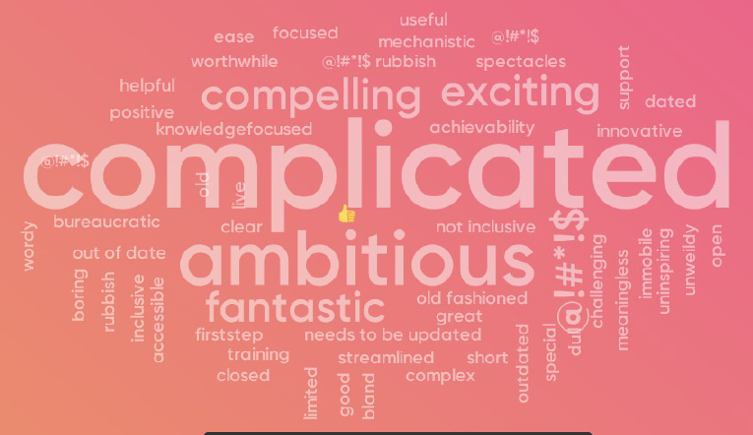
When asked what was missing or deficient with the current vision the main criticisms were:
- It focused too much on customers facing systems and neglected staff and internal systems
- It focused on technology and not enough on skills; both customer and staff
- It had little on tackling digital exclusion
- It had little on the importance of data as an asset/resource
- It did not mention connectivity which is the key enabler of digital
- It had no targets or responsibilities
In short the vision was not comprehensive enough and needed a thorough review
  - The second proposal was about Employee digital skills and how we ensure our people develop the skills needed to transform the way we work. The 14 participants were given a number of options for boosting digital skills that have been used in other councils and were asked to rate them, with clear results:
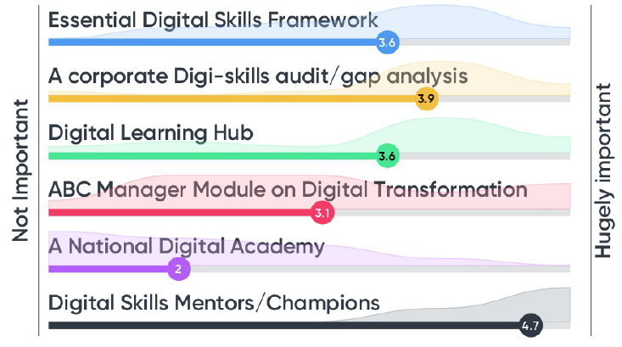
They were also asked for additional ideas and these included:
- Short videos on the Hub showing successful case studies and good practices
- Provide reassurance to staff that by adopting digital and upskilling they are not at risk of losing their jobs, but rather ensuring long term security
- Focusing efforts first on front line employees to identify their needs and develop approaches that fitted in with their capabilities and capacity for learning
- Encourage staff to work together so the more digitally able helped and supported the less skilled, over and above formal courses etc.
  - As a light hearted but illuminating way to determine the digital dexterity of the COSO attendees, all were asked to complete a “Digital Bingo” sheet with 30 questions relating to common and advanced everyday digital tasks. The completed sheets were collated after the event and showed that of the 35 respondents six were ‘digital dinosaurs’ who scored 10 or less, four were ‘Digital Gurus’ who scored over 25 and so 25 were in the broad digital mainstream at various levels. This shows that even amongst senior managers who are required to lead digital change, there is scope for digital upskilling.
  - The final proposal in this workshop was in relation to creating a successful digital taskforce, because digital transformation is not done by ICT Teams. The attendees were asked how we can organisationally inspire wider digital buy-in and innovation and again they were given a number of options to assess:
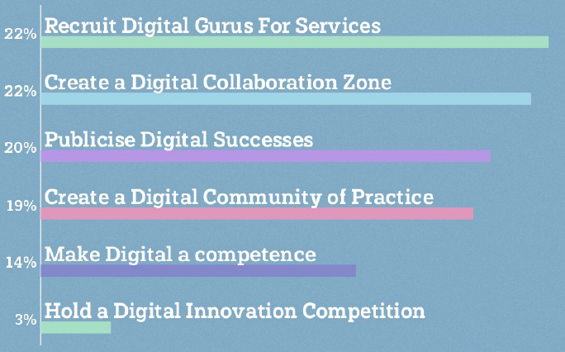
Hence four of the ideas gained almost equal support, however other ideas included:
- Invest in structured digital awareness sessions with all staff using successful examples to showcase benefits and then have idea storming sessions (digital guru led) to identify innovations.
- Make digital collaboration easier by setting up collaboration rooms akin to skunk works “a small and loosely structured group of people who research and develop a project for the sake of innovation in technology”.
- Constantly celebrating and publicising successes both small and large so the culture becomes one of continual digital advances. Perhaps through a digital successes blog.
So this workshop group has given a number of strong leads as to wider elements of digital vision, digital skills and digital engagement that they believe should be included in any new Digital Transformation strategy and programme.
TACKLING DIGITAL EXCLUSION & INCREASING INCLUSION
  - This workshop group recognised that poor rural connectivity, both in mobile network and superfast broadband coverage was still a powerful determinant of digital exclusion in certain areas. Although the levers for change here lie largely at a national level the council does have a supportive and clarion role in promoting progress, which should be reflected in any digital strategy. We also need to ensure we are well placed to capitalise on the completion of the R100 programme for 100% superfast broadband by 2021.
  - There was recognition too that Digital Exclusion generally reflects societally excluded groups; particularly the poor and less well educated. A number of ideas gained traction for addressing this; including:
- Improving digital inclusion must start at home by ensuring our own staff have basic digital skills. This has the added benefit of them then being able to teach their own families and friends so they become digital champions by default.
- Extend the concept of digital champions to the community and act as a central brokerage, putting people who want/need better digital skills/knowledge in touch with capable volunteers and professionals who are willing to help. (would need checks). This could be done in partnership with our community planning and third sector partners.
- Use analogue publicity media to promote our own digital services and the benefits of using them (including incentives where needed), and how to go about improving digital skills/knowledge.
- Continue to develop our own digital services so they are as simple and intuitive to use as possible for all levels of ability
Ultimately though there was also a belief that there are many people who are digitally aware but just choose not to participate in that way for whatever reason. So we do need to respect that choice and continue to offer non digital channels; although finance may eventually rule that out.
MOVING BEYOND CHANNEL SHIFT
  - This group used as their basis for discussion the Digital Transformation - New Opportunities paper recently issued to SMT. Given the limited time three areas of interest were targeted and attendees asked for more detailed ideas and case studies both at home and abroad, with a view to identifying those that could be considered for a business case for pilot and/or attract external funding.
- Drone Technology.
- Internet of Things
- Robotics- both data and physical.
Drone Technology
  - The group saw merit in Procurement Services procuring a corporate drone call down contract to facilitate easier access for Services to drone services that would reduce health and safety risks and create efficiency savings.
  - A number of existing and potential drone applications were identified that could use such a contract including:
- Estates is increasing commercial sale/lease council of properties and drone video is useful to showcase location outlook for potential developers/buyers.
- Drone videos are useful to present complex large scale planning applications to members which would normally require a site visit and take a high level of co-ordination and length of time to organise. Planning decisions could be made much quicker with drone footage.
- Infrastructure design has used drone services to develop a specialist 3d Cloud point data file to support road design on Kerrera and are keen to build on this experience.
- There is much interest in using drones therefore for heat mapping (e.g. landfill site surveys), 3D survey, GIS/spatial projects. Coastal protection under and above water and surveying all of these type of structures – retaining walls, seawalls, bridges, landslips, coastal pollution e.g. extent of blooms and slicks.

Internet of Things Technology
  - Given that the national networks through which data from IoT sensors can be transmitted is rapidly evolving and the procurement frameworks through which IoT services can be obtained, there was agreement that a number of opportunities for pilots could be considered including:
- Adding sensors to commercial and domestic bins to identify where commercial companies paying NDR are avoiding contracting for commercial waste services; sensors to indicate where public or commercial bins actually need emptied to avoid unnecessary pickups or to increase pickups and reduce customer complaints; and weight sensors on commercial bins to change the pricing and service model and encourage more recycling.
- On and off street parking sensors to indicate available parking spaces especially in Oban town centre, linked to an App.
- Streetlight monitoring particularly in island locations with no electrician which can identify the type of fault and reduce need for site inspection/ automatically email power supplier.
- Infrastructure design are also keen to explore sensors to monitor water levels for flood monitoring purposes on known risk sites, and to monitor cracking or structural movement e.g. bridges.
- Health and Safety showed particular interest in Legionella monitoring and better use of remote monitoring sensors and controls on building M&E equipment to reduce officer time and cost of external contractors.
- Telehealth is a growth area, driven also by the analogue to digital changeover and HSCP are keeping a keen eye on developments such as the FitHomes initiative in Highland Council.
It should be noted that progress is being made by ICT regarding our connection to an IOT network via either SWAN or the IOT Scotland/Boston Networks offerings.
Robotics Technology
4.5 The group did not identify and immediate opportunities for mechanical robotic developments but felt that the biggest gains would come from data robots whose use is in
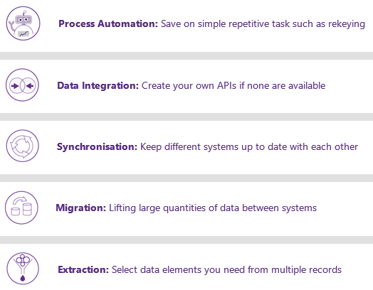

Specific use cases identified were:
- Use of data robotics to support better integration with the corporate ‘machine’ particularly HR and payroll;
- field workforce mobile apps integration to back office e.g. social care and RAS;
- to process council tax direct debits
- to process Attachment of Benefit Orders and Water Direct deductions
- Use NDL MX to automatically rekey in data collected by mobile workers such as those in Roads and Amenities and H&SCP so it is uploaded seamlessly.

REDEFINING AND LIBERATING DATA
  - This workshop considered both “Big Data” (large data sets used to predict behaviours or identify patterns that can be used beneficially e.g. to help target resources), and “Open Data (data generated by the council or its partners that can be published openly and used by others; usually to feed into Big Data type analysis).

BIG DATA
  - There is no expertise in the council to exploit Big Data, despite the fact we have many of the tools. For example features within Excel such as Power Query and Power Pivot are used to report against big data sources of trillions of rows and business intelligence tools like Microsoft’s Azure cloud platform includes tools which can use machine learning techniques to analyse data and will ask “have you noticed?” questions about trends/patterns it sees in the data. Hence there is little capability to exploit potential use cases such as:
- Applying UPRN property references to Carefirst and allowing very granular heat maps of deprivation and health issues etc. to be developed so social care resources can be efficiently targeted and additional datasets from other sources overlaid. The addition of NHS CHI customer reference numbers to Carefirst records also opens up many possibilities for comparative analysis of health and social care data.
- Use data from IoT and geospatial trackers to be analysed e.g. seasonal route planning for mobile workers and amenities vehicles using data from existing in cab devices.

OPEN DATA
  - The council publishes a large amount of performance and mapping and planning related data via its website and has an open data portal of sorts, although virtually nobody knows about it and there is no systematic approach to the identification and publication of depersonalised data sets. Along with Big Data there was a strong feeling in the group that the recruitment of a skilled data scientist was needed both to define a strategy and prove that the post could in effect be self funding, by highlighting use cases in for example tourism, amenities, health and social care and improved data management.
  - Open Data is wholly about depersonalised data sets, but the group also felt there was an opportunity for us to be more open with personal data (small data), providing it was in a secure and personalised way. The council holds information about individual customers in a number of different places and very little of it is made readily available to them. The concept is for us to develop a personalised info-dashboard that individuals could securely access to see information held in:
- CRM
- Civica Revs and Bens
- SEEMIS
- Carefirst/Eclipse
- Licensing
This is based on the Unique Citizen Reference Number that should/could be applied across these systems. There is a strong argument that customers will be less fearful about sharing data and using digital if we are more transparent with them and above all they can help us curate that data by pointing out inaccuracy and changes.

CONCLUSION
  - Each of the workshop groups have come up with interesting and valid improvement ideas that will now be fed into the wider Digital Transformation Strategy and action planning.

Bob Miller
January 2019

