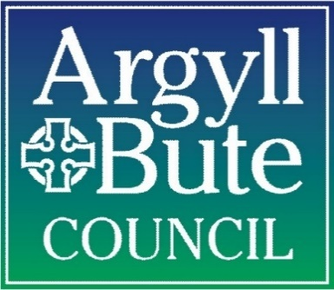
Dunoon Shopfront Improvement Scheme

GRANT APPLICATION FORM

This is a grant application form to seek funding from the Dunoon Shopfront Improvement Scheme. This form should be fully completed in conjunction with application guidance notes.
Business/Shop Address
(for which grant aid is being sought)

Postcode
Name of Applicant
(Individual, Group or Organisation)
Address of Applicant
(If Different From Project Address)

Postcode
Contact Telephone Number

Contact Email
Type of Applicant
(Individual, Partnership, Limited Company)
Applicants Interest In Building
(Owner, Tenant etc.)
Name & Address of Property Owner (If not the Applicant)

Where the Applicant is not the owner written consent from the owner must be submitted by the applicant.
Postcode
Grant Payee
(Normally this will be the Applicant)
Brief Description of Proposed Works
Current Use of Property

Proposed Use of Property
(if being changed)

Details Of Formal Consents
(If Applicable)

Listed Building Consent:
Planning Permission:
Advertisement Consent:
Building Warrant:

No. of Employees At The Property
Specification & Drawings Enclosed (If required)
Timescales for work
Summary of Competitive Tenders for the works
(A minimum of 3 quotes must be submitted for all works over £500. 2 quotes for works under £500)
Total Grant Eligible Costs
Is VAT Reclaimable?
Grant is only paid on VAT if VAT is not reclaimable by the applicant
VAT Registration No. (If Applicable)
I understand that making this application does not entitle me to grant aid as a right and that I will receive no financial assistance for work carried out prior to the approval of the grant.

I confirm that costs associated with the services provided by a professional agent in preparation of information associated with the grant application are eligible for inclusion but where a grant application is unsuccessful then these costs will NOT be reimbursed.

I declare that ALL INFORMATION given on this application form is truthful, accurate and that information has not been deliberately withheld.

I have the power to accept any grant offer made subject to conditions and the power to repay all or part of the grant in the event of the conditions not being met.

Print Name:

Signature:

Date:

Data Protection/Freedom of Information Statement

Your privacy is important to us. We will treat the information we collect from this form in accordance with the Data Protection Act 1998. We intend to use the information for the following purposes:
• To allow us to contact you if we have any questions about the information you provided
• To assist the Council in considering your proposals for grant funding
• To keep you updated on the Dunoon Shopfront Improvement Scheme
Argyll and Bute Council is under an obligation to properly manage public funds. Accordingly information provided on this form may be used to prevent and detect fraud, and may be shared for the same purpose with public bodies or other organisations which handle public funds.

Argyll and Bute Council is subject to the provisions of the Freedom of Information (Scotland) Act 2002 and may be obliged to provide anonymised copies of information under any request for freedom of information.

