Argyll and Bute Improvement Framework

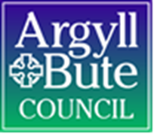

July 2018
Version 1.3

Contact: Jane Fowler
Head of Improvement and HR

Version control
Version | Date | Amended
1.1 | 1 December 2017 | Changes in light of feedback; narrative reinforcing linkage to PIF; changes to topic guides etc
1.2 | 1 June 2018 | Replaced references to BOPIs with Impact Measures; changed report format
1.3 | 24 July 2018 | Incorporates changes requested by SMT (9 July): relates to stages of process

Contents

1.0 Introduction 4
2.0 Why we have an Argyll and Bute Improvement Framework 4
3.0 The ABIF and the Performance and Improvement Framework (PIF) 4
4.0 How to use this guidance 5
5.0 The ABIF explained 5
6.0 The workshop-based approach 8
7.0 Roles and responsibilities 9
8.0 Further Information 10

1.0 Introduction

1.1 | This guidance document describes the Argyll and Bute Improvement Framework (ABIF). The guidance is designed for anyone who has an interest in, or has a role to play, in the council’s self-evaluation and improvement processes.

2.0 Why we have an Argyll and Bute Improvement Framework

2.1 | The Argyll and Bute Improvement Framework (ABIF) sets out the council’s approach to self-evaluation.
2.2 | Self-evaluation activities help us reflect on where we are now and to look forward to where we want to be in the future. Self-evaluation provides us with a baseline from which we can plan to improve, helps to inform the council’s change and improvement agendas, and plays a role in ensuring that innovation in service delivery is well considered.
2.3 | The Argyll and Bute Improvement Framework sets out a structure that ensures all parts of the council carry out self-evaluation activities, identify areas for improvement, and then make arrangements to ensure that these improvements can be delivered and evidenced.
2.4 | The ABIF helps the council to demonstrate that it has a culture of continuous improvement, and that improvements are delivered in an effective way. The ABIF falls under the umbrella of the council’s Performance and Improvement Framework (PIF).

3.0 The ABIF and the Performance and Improvement Framework (PIF)

3.1 | Self-evaluation is one of the activities identified in the council’s Performance and Improvement Framework (PIF) that helps us to deliver our performance and improvement functions. In turn, the PIF helps the council to deliver its statutory duty 'to make arrangements to secure Best Value (continuous improvement in the performance of functions)', as required by the Local Government in Scotland Act 2003.
3.2 | The ABIF is one of the Monitoring and Review activities of the PIF. Self-evaluation allows us to reflect on how we carry out activities throughout the entire PIF cycle, relating to Looking Ahead, Making it Happen, other aspects of Monitoring and Review, and Implementing Change. In addition, self-evaluation allows us to think more broadly about the difference we made to the people and communities of Argyll and Bute.
3.3 | The outputs of the ABIF become inputs into the Implementing Change section of the PIF, wherein improvements identified through the self-evaluation process are put into effect.

4.0 How to use this guidance

4.1 | This guidance is designed to help you to understand the council’s self-evaluation activities and your roles and responsibilities within them.
4.2 | This guidance has been written for anyone who has an interest in, or has a role to play in, the council’s self-evaluation and improvement processes. People with roles to play include:  - Chief Officers and Senior managers  - Elected Members  - Third Tier Managers  - Fourth Tier Managers  - Members of the HROD Performance and Improvement team
4.3 | The main document of the ABIF has been written to provide you with an overview of how the council’s self-evaluation process works. The document includes the information that you need to understand how the framework works.
4.4 | If you are interested in looking at the Framework in more detail, supplementary information is provided in the appendices:  - Notes for facilitators  - The origins of the ABIF

5.0 The ABIF explained

5.1 | Self-evaluations are made up of two strands of activity that come together to help us identify and deliver improvements across the organisation. The first strand relates to ‘how we do things’ (also known as ‘enablers’). The second strand relates to ‘what we achieve’ (also known as ‘results’). See figure 1.
5.2 | The council’s arrangements for the self-evaluation of its enablers are set out in the ABIF.
5.3 | The council’s arrangements for the monitoring and reviewing its performance results are set out more fully in Appendix 2 of the PIF. The use of Impact Measures (IMs) complements the monitoring of our operational results by helping us to better understand the impact our activities are having.
5.4 | The ABIF guidance focuses on the self-evaluation of teams across the council. (Teams are associated with Third Tier managers, and therefore sit immediately below Services within the organisational hierarchy) and the programme of self-evaluation activities across the council is designed to reflect this. However, the ABIF is flexible, enabling self-evaluation at other levels of the organisational hierarchy to take place as and when required.

Figure 1: The Argyll and Bute Improvement Framework
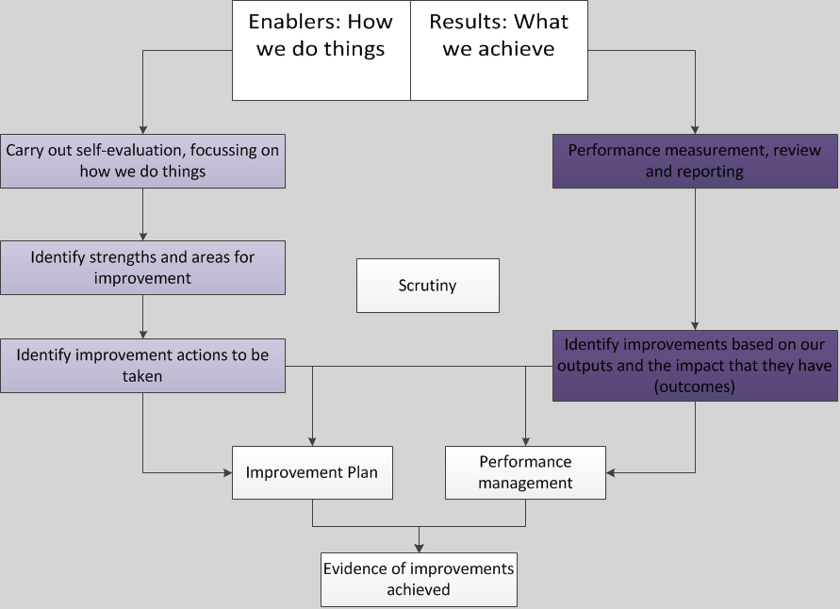

5.2 | Self-evaluation of how we do things (‘enablers’)
5.2.1 | Self-evaluation for teams within the council is carried out using a workshop-based approach, with all eligible teams being evaluated within a three year cycle.
5.2.2 | Workshops are conducted using a flexible approach to facilitation, using topic guides. (See appendix 1.) The workshops enable us to identify areas of strength and areas for improvement at the team level.
5.2.3 | Section 6 of this document looks in more detail at how we carry out self-evaluation of ‘how we do things’.
5.3 | Turning areas for improvement into improvement actions
5.3.1 | Areas for improvement identified in the workshops are translated into improvement actions. In turn, these, along with the improvements identified from evaluation of our results, are added to the Service Improvement Plans.
5.3.2 | Where areas for improvement appear across multiple teams, these will be captured in Service or Corporate Improvement Plans as appropriate.
5.3.3 | Improvement actions should be developed using SMART targets and benefits realisation techniques.
5.4 | Reporting improvement progress, and scrutiny arrangements
5.4.1 | Scrutiny is at the heart of the ABIF. Team level improvement actions will be ‘owned’ by the Third Tier manager, who report on these to SMT.
5.4.2 | Corporate actions are reported to SMT and to the Audit and Scrutiny Committee. The latter prioritises the programme of corporate improvements and monitors progress on their delivery.
5.5 | Self-evaluation of what we achieve (‘results’)
5.5.1 | The council has processes in place for monitoring and reviewing performance results. These arrangements are set out elsewhere, in the Information Guide for the Planning and Performance Reporting Cycles appendix of the PIF.
5.5.2 | In brief, our results (performance) are reported to a range of council committees, with reports being tailored to the remit of the committee to which they are submitted. For more operational matters, monitoring and review of performance is carried out through a range of Departmental and Service-level arrangements. These include quarterly meetings between Executive Directors and the Chief Executive (‘bilateral meetings’) and between Heads of Service and their Executive Directors. Teams have their own arrangements, with performance being reported to the relevant Heads of Service.
5.5.3 | In addition to monitoring our success measures, the use of Impact Measures (IMs) augments the monitoring of our operational results by helping us to better understand the impact our activities are having.
5.5.4 | Issues highlighted at any stage of the performance monitoring and review activities outlined above may be added to improvement plans.

6.0 The workshop-based approach

6.1 | The self-evaluation of what we do is based around a suite of workshops. Also included in the process is a survey of all employees within each team being evaluated. The survey will help us to understand employees’ perceptions of how the team works.
6.2 | HROD will set up and run the survey to help to reassure respondents of their anonymity.
6.3 | HROD will support and facilitate workshops for the first team in a Service (if required). Support to teams within Services will reduce over time as capacity is built within Services to facilitate their own workshops.
6.4 | The self-evaluation process is outlined in Table 1.

Table 1: The self-evaluation process
Stage
1 | Preparatory work | - Carry out survey of team staff; HROD will set up and run the survey. Results to be available at workshops  - Liaise with Third Tier Manager about workshop arrangements and list of participants  - Circulate topics for discussion ahead of workshops to allow participants to consider issues
2 | Half-day workshops, | - Workshops are centred around the themes of:  - Leadership, Strategy and Impact  - Organisational Capability  - Impact on Society  - Facilitation by HROD Performance and Improvement team where required.
3 | Improvement planning session | - Creation of improvement and benefits realisation plans, based on Areas for Improvement identified in Stage 2.  - Session to be owned by Third Tier manager, but facilitation support available from HROD, if requested.
4 | Report to SMT (copying to HROD Performance and Improvement) | - Third Tier manager reports the outcome of the self-evaluation process, including the improvement actions and benefits realisation plan to SMT and to Audit and Scrutiny Committee.
5 | Monitoring, review and scrutiny | - Regular reporting by Third Tier manager on progress and delivery of improvements to SMT and Audit and Scrutiny Committee.
6 | Reporting on progress of the self-evaluation programme and setting of corporate improvements | - HROD to report on progress of self-evaluation programme to Audit and Scrutiny committee  - Elected Members to set agenda and prioritise corporate improvements informed by overview of self-evaluations as programme progresses.

7.0 Roles and responsibilities

7.1 | Members of each of the following groups have roles to play in the self-evaluation of what we do:  - Chief Officers and Senior managers  - Elected Members  - Third Tier Managers  - Fourth Tier Managers  - Members of the HROD Performance and Improvement team  These roles are described in more detail in Table 2.

Table 2: Roles and responsibilities
Who | What
Third Tier Managers | - Own the self-evaluation and improvements identified for their team  - Liaise with HROD Performance and Improvement about arrangements for the self-evaluation process  - Report on the outcomes of self-evaluation to SMT along with the progress made with regarding improvement actions reporting to Audit and Scrutiny Committees
Fourth Tier Managers (and anyone else the Third Tier Manager considers as having relevant experience) | - Take part in the workshops, bringing knowledge, experience and expertise to the self-evaluation process
HROD Performance and Improvement | - Managed team survey.  - Facilitate the workshops and support the self-evaluation process.  - Coordinate the programme of self-evaluation and have an overview of activity across the council, enabling the identification of common themes arising from team-level self-evaluations.  - Report on overall progress of self-evaluation programme.
Chief Officers and Senior Officers | - Champion the self-evaluation process  - Have a monitoring and scrutiny role
Elected Members | - Have scrutiny role in looking at self-evaluation results and monitoring self-evaluation outputs  - Set priorities for corporate improvements.  - Carry out scrutiny with regard to corporate improvements

8.0 Further Information

For further information and support, contact HROD Performance and Information.

