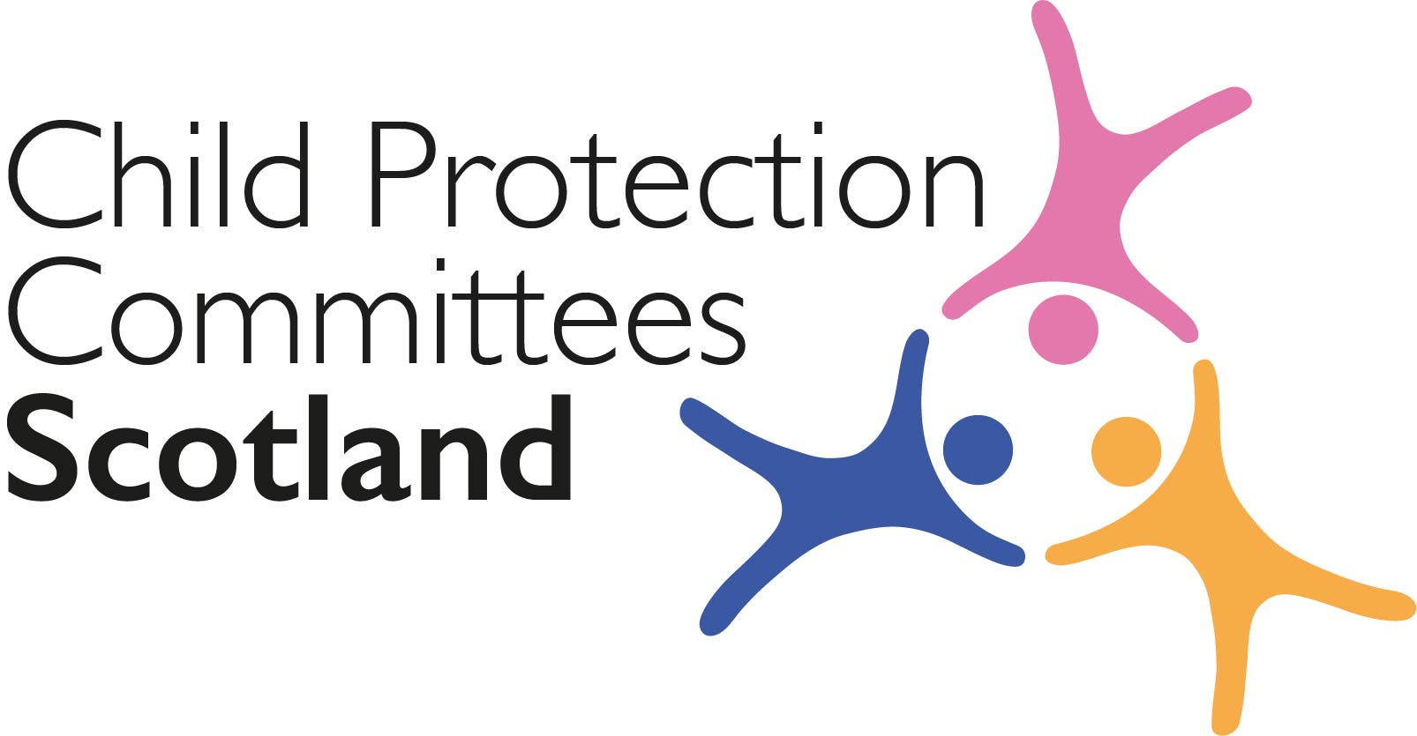
Keeping Connected - The CPCScotland Weekly Bulletin

Issue 58 - Tuesday 25th May 2021

Issued to support Child Protection Committees and partners with up to date information on child protection issues.

Welcome to Issue 58 of Keeping Connected.

This week you will find a range of learning opportunities highlighted in the bulletin. These include podcasts and webinars as well as online masterclasses and large scale events. I know that at a local level CPCs are also adapting to new ways of delivering local training and learning sessions when traditional face to face events are not possible. Feedback from our network highlights that we are getting better at delivering remotely and that in many cases we are achieving increased attendance, especially in remote and rural areas, with reduced costs associated with venues and travel. I think it is fair to say however there are also some challenges both technical and in relation to the experience of participants in learning through a monitor. It will be interesting to see what the balance is between remote learning and face to face events as we emerge from the pandemic and group activities are again permitted.

As always please let us know of any local work your CPC is involved with so that we can highlight it in the bulletin. If your area has published new guidance, research/evaluation findings or resources related to child protection or who is embarking on a new way of working that you can share with others we would love to hear from you. Contact Susan Mitchell at
cpcscotland-liaison@strath.ac.uk

Keep safe and keep in touch.

Alan Small, Chair Child Protection Committees Scotland

ANNOUNCEMENTS

1 ‘Roll up your sleeve’ campaign for 18-29 year olds

From 24th May until 4th June, 18-29 year olds will be able to register for their first dose of the COVID-19 vaccine by going online at nhsinform.scot/under30register (or by calling 0800 030 8013 if they are unable to get online). Those registering will be notified by email or SMS of their appointment. Please help encourage this age group to register for COVID-19 vaccine by spreading the word using the 18-29 Year Old Stakeholder Toolkit which contains key messages, social media and editorial assets specific to this audience.

The Stakeholder Toolkit is available from cpcscotland-liaison@strath.ac.uk or can be downloaded via We Transfer Download COVID-19 vaccine campaign assets via WeTransfer here

2 Scottish Government Ministerial Team

Scottish First Minister Nicola Sturgeon has completed appointments to the new Ministerial team – important changes for the children’s sector include Clare Haughey’s appointment as Minister for Children and Young People and Ben MacPherson’s appointment as Minister for Social Security and Local Government. https://www.gov.scot/news/new-scottish-cabinet/

Guidance, Resources and Information

3 COVID-19 Vaccine Video – Dr Punam Krishan

Scottish Government have worked with GP Dr Punam Krishan to produce a video helping to explain what the vaccine does and doesn’t do. Dr Krishan has shared this on her Instagram channel, and you can view and share the video via YouTube below. Scottish Government are also producing translated versions of this video which should be available shortly
https://www.instagram.com/p/CPI3N6qnGWo/

4 Each and Every Child

The ‘Each and Every Child’ initiative was launched last week supported by Scottish Government, CELCIS, The Promise, Life Changes Trust, Robertson Trust, Social Work Scotland and Esmee Fairbairn. The initiative aims to change how we talk about care experience in Scotland and to help create a fresh, inspiring narrative to shift public attitudes and improve life chances of children, young people and their families. There is a toolkit on the website with before and after examples of types of wording/phrases, helpful metaphors, etc.
https://eachandeverychild.co.uk/

5 Child Safeguarding in England – report summaries
NSPCC Learning has produced briefings summarising the findings from two reports: the Child Safeguarding Practice Review Panel’s annual report for 2020 and the annual review of Local Child Safeguarding Practice Reviews (LCSPRs) and rapid reviews.
https://learning.nspcc.org.uk/research-resources/2021/lcsprs-rapid-reviews-caspar-briefing
https://learning.nspcc.org.uk/research-resources/2021/child-safeguarding-review-panel-2020-report-summary

6 CELCIS coronavirus resource page
The CELCIS information online resource rounds up key information, advice and guidance to help anyone supporting the care and protection of children and young people in Scotland during the coronavirus pandemic: https://www.celcis.org/knowledge-bank/covid-19-homepage/

Training, Learning Events and Resources

7 What does social justice look and feel like for 18-25 year olds in conflict with the law in Scotland? - Launch Event 3rd June
The Children and Young People’s Centre for Justice (CYCJ), the University of Dundee, the University of Strathclyde and the Glasgow School of Art have been working with young adults aged 18-25 and justice professionals across Scotland on a project funded by the Scottish Universities Insight Institute (SUII). Using creative and design-led approaches they held a number of online workshops designed to facilitate engagement, participation and to help find the answer to questions such as ‘What does social justice mean to young adults?’ and ‘What challenges do young adults in conflict with the law face?’ The project findings and online exhibition will be launched on 3 June at 10:00am, with the opportunity to hear from young adults and engage in discussion and dialogue with policymakers, practitioners and academics across Scotland and beyond.
https://www.eventbrite.co.uk/e/a-socially-just-approach-to-justice-tickets-152072062633

8 Learning from the Bright Spots Programme: Webinar 15th June
The Bright Spots Programme is a partnership between Coram Voice and the University of Oxford, funded by the Hadley Trust, which has supported over 50 local authorities in England and Wales to listen to the views of their children in care and care leavers through anonymous surveys about the things that are important to them. On 15 June from 1:00pm, Coram Voice and the University of Oxford’s Rees Centre will host a webinar to mark the launch of the new Bright Spots ‘Practice Bank’, which highlights examples of innovative practice, and the University of Oxford’s evaluation of the Bright Spots programme.
https://www.eventbrite.co.uk/e/how-to-make-life-better-learning-from-the-bright-spots-programme-tickets-154576760251

9 Trauma-informed is not the same as domestic violence-informed (Safe & Together Podcast)

This episode of Partnered with a Survivor tackles one of the most pressing issues in the domestic violence field: how to make mental health and addiction services more domestic violence-informed when it comes to interacting with survivors. While awareness of trauma and its impact continues to increase, it often is decontextualized from the dynamics of coercive control. Mental health and addiction professionals are often ill-prepared by their education and training to integrate coercive control into their assessments. Organizations that are striving to be trauma-informed are not always committing to be domestic violence-informed. Domestic violence survivors are often harmed by these gaps.
Trauma-informed is not the same as domestic violence-informed

10 Upcoming AoCPP events

The events below are organised by the Association of Child Protection professionals (AoCPP). Please note there is a fee for attend the sessions.
- Considering Pathways Toward Harmful Sexualised Behaviour Tuesday 25th May, 10am-1pm with Steve Bore.
https://www.childprotectionprofessionals.org.uk/Event/the-aocpp-masterclasses-in-depth-training-considering-pathways-toward-harmful-sexualised-behaviour
- Policing County Lines - Impact of Covid-19 Tuesday 24th August 10am-1pm: This session will be led by Dr Ben Brewster and Dr Grace Robinson.
https://www.childprotectionprofessionals.org.uk/Event/the-aocpp-masterclasses-policing-county-lines-impact-of-covid-19
- Exploitation 2021 - Tackling the Culture and Challenges of Trafficking, Slavery and County Lines Two day event on 24th-25th June 2021 offering expert keynotes and more than 20 workshops and presentations on all aspects of exploitation.
https://www.childprotectionprofessionals.org.uk/Event/exploitation-2021

11 Child protection for tutors who work with children and young people

NSPCC Learning has launched a new online child protection training course for tutors who work with children and young people. The course is designed to help tutors understand their roles and responsibilities in protecting children and young people from harm, whether they are working with children face-to-face or online. Please note there is a fee for this course.
https://learning.nspcc.org.uk/training/child-protection-tutors

For Children, Families and Communities

12 Continuing Care – young people’s experiences
CELCIS is gathering the views, ideas and opinions of young people under 26 who live in, or who have left, residential, foster, or kinship care, on what ‘Continuing Care’ feels like for them. Young people can share their thoughts in a variety of formats, including in writing as a statement, poem, story, letter, or diary entry; or visually through photographs, art, or videos; or a sound recording such as a voice memo.
https://www.celcis.org/news/news-pages/continuing-care-your-experiences/

13 Children and young people complaint text service

The Care Inspectorate have a complaint text service for children and young people. This text service adds to the other ways young people can raise concerns about the quality of their care. This service allows young people to be more informed about their rights to quality care and support which it is hoped will build trust and improve their experience of care.
https://www.careinspectorate.com/images/documents/coronavirus/Unhappy_about_your_care_poster_A4_SAD_Feb_20.pdf?utm_medium=email&utm_source=govdelivery

Research and Evidence Based Reports

14 Child Mortality and Social Deprivation

This National Child Mortality Database Programme Thematic Report was commissioned by the Healthcare Quality Improvement Partnership (HQIP) on behalf of NHS England. The report includes analysis of the circumstances relating to 3,347 children who died in England between 1 April 2019 and 31 March 2020 and investigates the characteristics of their deaths to identify if socio-economic deprivation is associated with childhood mortality. The analysis of the data found a clear association between the risk of child death and the level of deprivation (for all categories of death except cancer).
https://www.ncmd.info/2021/05/13/dep-report-2021/

15 Recurrent care proceedings

The Nuffield Family Justice Observatory has published a new report on ‘Recurrent care proceedings: five key areas for reflection from the research’, which raises points for reflection for family justice practitioners about the response to mothers and fathers who experience recurrent proceedings: https://www.nuffieldfjo.org.uk/app/nuffield/files-module/local/documents/recurrent_care_proceedings_five_key_areas_for_reflection_from_the_research_spotlight_0521.pdf

News and Opinion

16 In the Media

- The National has published a letter by Dr Sarah Nelson OBE, Research specialist on childhood sexual abuse, in response to Professor Andrew Bilson’s interpretation of the latest Scottish child protection statistics – Professor Bilson questioned the justification for an increase in child protection investigations because the majority did not lead to children being placed on the child protection register, while Dr Nelson cautions that this could be an argument for more, and more thorough, multi-disciplinary investigations. https://www.thenational.scot/news/19305917.interpretation-ignores-dangers-misreading-child-protection-statistics/

- The Scotsman has reported on issues with child contact decisions faced by victims of domestic abuse in family courts in Scotland. https://www.scotsman.com/news/people/experts-and-campaigners-warn-plight-of-domestic-abuse-victims-and-their-children-ignored-in-scottish-courts-3238452

- Research by Loughborough University on behalf of the End Child Poverty coalition shows that child poverty has risen in every Scottish local authority over the past six years, and the coalition is calling on the UK Government to recognise the scale of the problem and its impact on children’s lives.
https://www.heraldscotland.com/news/19312211.every-scots-local-authority-area-child-poverty-rises-last-six-years-one-area-topping-list/

- The BBC has reported on concerns over social media platform Facebook’s plans to introduce end-to-end encryption on its Messenger and Instagram Direct apps, which experts say will make it much harder to combat online child abuse: https://www.bbc.co.uk/news/business-57050689

- The Scottish Child Abuse Inquiry (SCAI) has heard that boarding school pupils at Morrison’s Academy in Perthshire were let down by decades of ‘systemic failures’ and faced pupil-on-pupil sexual abuse as well as physical beatings and emotional torments
https://www.tes.com/news/Scottish-Child-Abuse-Inquiry-boarding-pupils-failed-decades-systemic-failure

Please let us know what you think about the bulletin and provide information for inclusion in future editions. Contact Alan Small or Susan Mitchell at cpcscotland-liaison@strath.ac.uk.

Please note that the information included in this bulletin is provided in good faith. Inclusion does not indicate CPCScotland endorsement of the content of the linked documents or websites.

