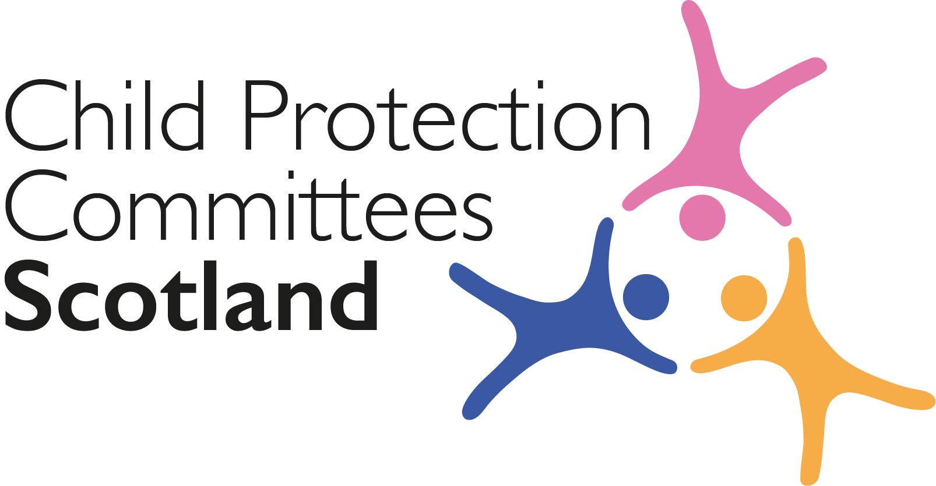
Keeping Connected - The CPCScotland Weekly Bulletin
Issue 48 - Tuesday 16th March 2021

Issued to support Child Protection Committee’s and partners with up to date information on child protection issues.

Welcome to Issue 48 of Keeping Connected.

As we approach our first CPCScotland meeting of 2021 and as more children start to return to school I hope this year will see us gradually and safely return to a more normal work and personal life. For now CPCScotland continues to meet virtually, more regularly but for shorter meetings, which I know has advantages for many. I look forward to seeing many of you on screen on Wednesday and who knows we may even be able to see each other in person before the end of the year.

I hope you find some useful information in this week’s Keeping Connected and as always if you have anything from your area that you would be willing to share with colleagues please let us know at cpcscotland-liaison@strath.ac.uk

Keep safe and keep in touch.

Alan Small, Chair Child Protection Committees Scotland

ANNOUNCEMENTS

1 CPCScotland Online Safety Campaign - Reminder

On 20th March CPCScotland will launch an online safety social media campaign as part of a co-ordinated response alongside the Scottish Government CSEthesigns campaign, which launched on 3rd March, and the Police Scotland ‘Get Help or Get Caught’ campaign. The CPCScotland campaign will run for 10 days and will be directed specifically at parents and carers. An embargoed campaign briefing will be issued to CPCScotland members by close of play on 18th March.

2 Learning Review Community of Practice (Knowledge Hub) Learning Event - ‘Undertaking SCRs – Islands examples’ - Reminder

Our next Learning Event will take place on 23rd March at 10.00am. Tam Baillie, Chair of Western Isles CPC, Shetland PPC and Orkney PPC will lead this session where the topic will be ‘Undertaking SCRs – Islands examples’. The presentation will draw on three recent SCRs conducted in two of the island settings. It will cover the main issues highlighted in the SCRs and will illustrate challenges of working in rural and island settings and factors which should be taken into account in conducting SCRs and implementing the findings.
Membership to the Learning Review Knowledge Hub is open to all members of CPCScotland and Child Protection Learning and Development Officers. If you are a member of the KHub you will be able to join on the day by clicking the link in the events page. If you have not yet joined the Learning Review Knowledge Hub and are a CPCScotland member please follow the link in your email invite or contact Susan Mitchell susan.mitchell@strath.ac.uk or Maureen Wylie Maureen.Wylie@careinspectorate.gov.scot

3 Invitation to Take Part in Research on ‘Supporting separated migrant children to thrive during COVID-19’

Researchers based at the University of Stirling, Faculty of Social Sciences invite you to take part in an online survey as part of a research study that seeks to explore your experiences of working with separated migrant children in Scotland during the Covid-19 pandemic and the restriction put in place because of Covid-19. If you would like more information please contact cpcscotland-liaison@strath.ac.uk or you can access the survey at the link below. The survey should not take more than 15-20 minutes to complete.
https://stirling.onlinesurveys.ac.uk/supporting-separated-migrant-children-to-thrive-during-cov-2

Section 1 COVID-19

Guidance, Resources and Information

4 Creating new ways for identifying family support needs during COVID-19
The latest ‘Meeting the Challenge’ example published on the CELCIS website looks at how through the ANEW (Addressing Neglect and Enhancing Wellbeing) work CELCIS’s programme of support to strengthen family and child participation has been adapted by Camperdown Primary School in Dundee during #COVID19.
https://www.celcis.org/knowledge-bank/spotlight/meeting-challenge-2/

5 Parent Club Return to School Campaign

The Parent Club Return to Schools campaign will continue until Wednesday, 24th March. We will also have coverage of key campaign messages via the Bauer Radio Life Matters platforms this week, where parents and experts will be sharing their experiences on the return to schools and nurseries and how they are sticking to the restrictions to help reduce community transmission to help keep schools and nurseries open.
Returning to school and childcare settings | Parent Club

For Children, Families and Communities

6 Young Scot COVID-19 microsite

Young Scot have a range of content on their COVID-19 microsite, including guidance on the new lateral flow tests, the latest news on the restrictions in Scotland for young people and support on going to school during the pandemic. www.young.scot/coronavirus

Research and Evidence Based Reports

7 COVID-19 Recovery Planning – Views from Care Experienced People

Advocacy charity Who Cares? Scotland has published a new COVID-19 recovery planning report, a write-up of its Annual Participation Programme work which includes views from members about how they accessed information about the pandemic, how they felt about living under lockdown rules, how the support they receive changed and the different impacts the pandemic has had on care experienced people’s lives and what can be done to better support them: https://www.whocaresscotland.org/wp-content/uploads/2021/03/Covid-19-Recovery-Planning-Full-Report-Feb-21.pdf

8 The Power of Play
Great Ormond Street Children’s Hospital (GOSH) has published a report looking at the impact of the coronavirus crisis on children’s wellbeing and how lockdowns and restrictions have affected how children play. Findings from a survey of 2,543 parents of children aged between 5 -11 years old, from across the UK include: 30% said that COVID-19 was the topic most explored by their child in play; 66% said they are worried that restrictions on how children play will impact on their child’s future wellbeing; and 61% of parents reported that are bonding with their child more than usual through playing together during the pandemic, this particularly true for fathers, with 55% saying they spend more time playing with their child than before.
https://media.gosh.org/documents/GOSH_Charitys_State_of_Play_report_final.pdf

9 Experiences of low income families before and during the coronavirus pandemic

The Joseph Rowntree Foundation (JRF) has published two reports looking at the experiences of low income families before and after the coronavirus pandemic. The reports find that: families on low incomes who were already facing constraints and instability at the start of 2020 were more vulnerable to the impacts of the pandemic; and the factors most likely to help families get by or improve their lives were: steady work, two wages in the family, reduced need for childcare as children got older, and support from extended family; access to furlough and having supportive employers were also important.
https://www.jrf.org.uk/report/seeking-anchor-unstable-world-experiences-low-income-families-over-time
https://www.jrf.org.uk/report/staying-afloat-crisis-families-low-incomes-pandemic

Section 2 Other Child Protection Topics

Guidance, Resources and Information

10 The Children’s Hearing: What Educational Practitioners should know

The National Improvement Hub has published a resource on The Children’s Hearing System for educational practitioners who support children and families before, at, and after a Children’s hearing. https://education.gov.scot/improvement/learning-resources/the-children-s-hearing-what-educational-practitioners-should-know/

11 CyberScotland Bulletin

The March CyberScotland bulletin is now available online.
https://www.cyberscotland.com/march-2021/

12 Domestic abuse: service for professionals
Women’s Aid has launched a dedicated service for professionals working with survivors of domestic abuse, seeking refuge accommodation and support. Professionals can contact the Women’s Aid direct services team who can search their database of violence against women and girls (VAWG) services across the UK providing up-to-date information on vacancies in refuges and availability of other VAWG services, such as outreach, drop-ins, counselling services and advocacy projects.
https://www.womensaid.org.uk/dedicated-service-for-professionals/

13 Positions of Trust legislation to be extended (England and Wales)

The Ministry of Justice has announced the Positions of Trust law, which currently applies in England and Wales to roles like teachers and social workers, will be extended as part of the Police, Crime, Sentencing and Courts Bill to protect teenagers from abuse by making it illegal for sports coaches and religious leaders from engaging in sexual activity with 16 and 17-year-olds in their care. The Home Office has published a series of factsheets giving details of the measures contained in the Police, Crime, Sentencing and Courts Bill 2021 including a factsheet on the extension of the positions of trust provisions to include those that lead activities in sporting and religious settings.
Police, Crime, Sentencing and Courts Bill 2021: positions of trust factsheet
14 Video-sharing platforms – who needs to notify to Ofcom?
Ofcom has published guidance to help providers self-assess whether they need to notify Ofcom as UK-established video-sharing platforms. Video-sharing platforms (VSPs) are a type of online video service which allow users to upload and share videos with the public.Under the new VSP regulations, there are specific legal criteria which determine whether a service meets the definition of a VSP, and whether it falls within UK jurisdiction. Platforms must self-assess whether they meet these criteria, and those that do will be formally required to notify to Ofcom between 6 April and 6 May 2021.
In the coming weeks, Ofcom will publish a consultation on guidance for the three harms stated in the VSP regulations and examples of practical and proportionate measures that VSPs could take to protect against these harms.
https://www.ofcom.org.uk/tv-radio-and-on-demand/information-for-industry/vsp-regulation/guidance-who-to-notify-to-ofcom

For Children, Families and Communities

15 Money Mules – Don’t be fooled campaign

The March CyberScotland bulletin highlighted the recruitment of ‘Money Mules’ in an article on ‘Fake Jobs’. Criminals post what looks like genuine job adverts, using social networking platforms or approach young people with offers of cash rewards for little work. They promise people will earn money quickly by receiving money into their bank account and then transferring it onto another account. The ‘don’t be fooled’ campaign aims to deter young people from becoming money mules.
https://moneymules.co.uk/partner-pack/

Training, Learning Events and Resources

16 Early Intervention Framework for Children and Young People’s Mental Health and Wellbeing - Launch Webinar
The new Early Intervention Framework for Children and Young People’s Mental Health and Wellbeing, developed by NHS Education for Scotland in partnership with multi-sector stakeholders from across Health and Social Care, education and the Third Sector will be launched at a webinar on 24 March from 1:00 – 2:30pm. This webinar will provide an overview of the background and development of the Early Intervention Framework, and a live demonstration of this digital resource, as well as featuring a panel discussion of how the Early Intervention Framework can support service providers to make fully informed decisions about interventions that are implementable and sustainable for their specific local context.
Early Intervention Framework webinar

Research and Evidence Based Reports

17 Tackling Food Insecurity in Scottish Schools: Case Studies of Strengthening Free School Meal Provision in Scotland

The Scottish Poverty Inequality Research Unit (SPIRU) was commissioned by the Poverty and Inequality Commission to undertake research to further understand the role of free school meals as an anti-poverty action in Scotland and to identify and share good practice and learning around providing free school meals. The findings have now been published.
https://povertyinequality.scot/wp-content/uploads/2021/03/SPIRU-Report-Free-School-Meals.pdf

Section 3 News and Opinion

18 In the media

- MSPs took part in a debate led by the Scottish Liberal Democrats about increasing the school starting age in Scotland to seven in Parliament on 9th March, discussing the benefits of introducing a play-based kindergarten stage similar to that used a number of Nordic countries – the Scottish Greens have already published a plan which would deliver the reform.
https://www.heraldscotland.com/news/19148108.msps-bid-raise-school-starting-age-7/

- The Scottish Child Abuse Inquiry resumes its sixth phase, considering child abuse in boarding schools, this week after it was put on hold due to COVID-19 restrictions, starting with an opening statement from Gordonstoun School in Elgin. https://www.pressandjournal.co.uk/fp/news/moray/2969227/child-abuse-inquiry-to-hear-of-experiences-at-moray-boarding-school/

- To mark the return to school in many parts of the UK this week, The Observer has featured the views of 16 young people on spending the past year at home in lockdown: https://www.theguardian.com/society/2021/mar/07/the-lockdown-generation-16-young-people-on-spending-a-year-at-home

19 Redress for Survivors (Historical Child Abuse in Care) (Scotland) Bill

The Scottish Parliament passed the Redress for Survivors (Historical Child Abuse in Care) (Scotland) Bill on Thursday, 11 March, paving the way for an independent body, Redress Scotland, to be set up to assess applications for the financial redress payments of up to £100,000 – criticism of the new legislation continues to focus on the requirement for survivors to sign a waiver preventing them from taking further legal action against the organisations they suffered abuse within to be eligible to receive the payments. https://www.gov.scot/news/redress-for-survivors/

Please feel free to let us know what you think about the bulletin and provide information for inclusion in future editions. Please contact Alan Small or Susan Mitchell at cpcscotland-liaison@strath.ac.uk. Please note that the information included in this bulletin is provided in good faith. Inclusion does not indicate CPCScotland endorsement of the content of the linked documents or websites.

