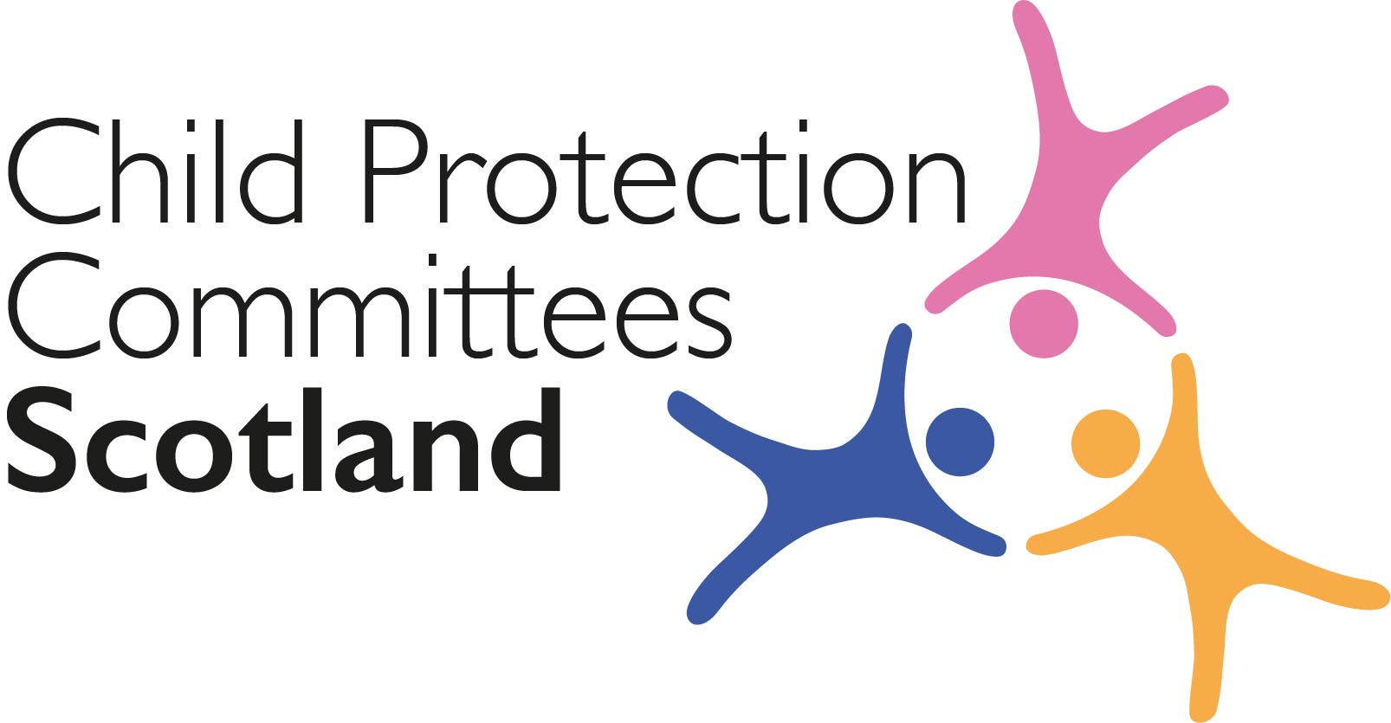
Keeping Connected - The CPCScotland Weekly Bulletin
Issue 44 - Tuesday 16th February 2021

Issued to support Child Protection Committee’s and partners with up to date information on child protection issues.

Welcome to Issue 44 of Keeping Connected.

There are two events featured in this week’s Keeping Connected that I would like to draw to your attention.

Item 18 provides information about the next in our series of Learning Review Community of Practice events which will be led by Niki McNamee and Alison Todd from Angus CPC. There has been a lot of interest in this event and I expect there to be an interesting discussion. Remember if you have not already joined the Community of Practice this is the best way to access the event and any resources shared following the session. Membership is open to all CPCScotland members and members of the National Child Protection Learning and Development group.

Item 19 includes the link to an event being organised by CELCIS colleagues on ‘Using data to improve children’s care and protection’ which will include an input on the National Minimum Dataset. Please sign up using the event-bright link if you would like to attend.
Keep safe and keep in touch.

Alan Small, Chair Child Protection Committees Scotland

Section 1 COVID-19

Guidance, Resources and Information

1 Overview of Practice in Remote Learning – Schools – A focus on meeting learning needs, including those with additional support needs

The Scottish Government has published its most recent report on the national overview of remote learning, based on input from schools, with a focus on meeting the needs of learners including those with additional support needs: https://education.gov.scot/media/rv1iquhw/national-overview-of-practice-in-remote-learning-4-asn.pdf

2 The impact of the coronavirus pandemic on child welfare: d/Deaf and disabled children
NSPCC Learning has published a briefing using insight from NSPCC helpline contacts and Childline counselling sessions to highlight how the pandemic has impacted on d/Deaf and disabled children. Findings include: support services have been harder for young people to access during the pandemic and some have found online services difficult to access; after returning to school, some young people found they were no longer receiving the same support they had received before lockdown; some parents have struggled to cope with caring for a disabled child with reduced support and some children have had to care for a disabled sibling; and some young people reported being unfairly challenged for not wearing a face covering, even when exempt.
https://learning.nspcc.org.uk/research-resources/2021/coronavirus-insight-briefing-deaf-and-disabled-children

3 Advice on mitigations to minimise transmission during phased return to in-person learning

The Scottish Government’s Advisory Sub-Group on Education and Children’s Issues has published an advisory note on the planned phased return to in-person learning in schools and early learning and childcare (ELC) settings, which identifies some key areas where measures to minimise transmission of COVID-19 should be strengthened.
https://www.gov.scot/publications/coronavirus-covid19-advisory-sub-group-on-education-and-childrens-issues---advice-on-mitigations-to-minimise-transmission-of-covid-19-during-phased-return-to-in-person-learning/

4 CyberScotland Bulletin

The February CyberScotland bulletin (previously the Cyber Resilience COVID-19 Bulletin) is now available online.
https://cyberscotlandweek.com/news-database/bulletinfebruary2021

This edition includes information about CyberScotland Week, Scotland’s annual week-long festival of events on cyber awareness, cyber careers, and innovation in cyber security, which takes place from 22nd to 28th February 2021.
https://cyberscotlandweek.com/

5 Scottish Government COVID-19 Campaigns

The following Scottish Government COVID-19 Campaigns are running during February. All are primarily aimed at adults.

- Clear Your Head
- Mind Your Mind
- Test and Protect Self-Isolation Campaign
- FACTS

If you require more information including stakeholder toolkits or links to campaign assets please contact cpcscotland-liaison@strath.ac.uk

For Children, Young People, Families and Communities

6 Survey for Parents and Children

During the first lockdown in 2020, the Child Poverty Action Group conducted surveys and heard from thousands of parents, children and young people in the UK about their experience of learning in lockdown. This research helped shape our recommendations to schools, councils and government about how best to support families. They have now launched new surveys asking families about their experience this year. Please share the surveys with parents, carers, children and young people.
https://cpag.org.uk/news-blogs/news-listings/school-surveys-parents-and-children

Research and Evidence Based Reports

7 ‘Their challenges are our challenges’ - A summary report of the experiences facing nursery workers in the UK in 2020

The Anna Freud National Centre for Children and Families has published a report on the experiences facing nursery workers during 2020. Findings from the report, which surveyed nursery workers between October and December 2020, include: 69% of staff who responded reported working with babies or children affected by trauma or abuse; 75% said they had looked after young children who had displayed unusually aggressive or violent behaviour; 42% noticed signs that children's emotional wellbeing had been affected by the pandemic and lockdown; and 48% said they had worked with children who had experienced the bereavement of either a parent or sibling.
https://www.annafreud.org/media/13013/their-challenges-are-our-challenges-survey-report.pdf

8 Coronavirus and my life – what children say

Children Heard, in collaboration with The Open University Children's Research Centre, undertook a study involving over 500 children from Iceland, Norway, Slovenia and the UK. The ‘Coronavirus and My Life’ project invited children to share their thoughts and feelings in words and art.
https://www.childrenheard.com/coronavirusproject

9 Child protection and social distancing: Improving the capacity of social workers to keep children safe during the COVID-19 pandemic

The University of Birmingham's has published emerging findings from research into improving the capacity of social workers to keep children safe during the Covid-19 pandemic. Findings, drawn from interviews with 48 social workers and 22 family members since April 2020, include: social workers should view digital interactions as different rather than always less valuable; existing research and guidance should be developed to maximise the benefits of digital social work; and social workers and support workers are providing increased material help and support for families.
https://www.birmingham.ac.uk/schools/social-policy/departments/social-work-social-care/research/child-protection-and-social-distancing.aspx

10 Left Out and Locked Down: Rapid research findings on experiences of marginalised and excluded people during COVID-19 in Scotland’

Between July and December 2020 researchers at Glasgow University explored the experiences of four groups already facing isolation prior to the pandemic: people seeking asylum and refugees; survivors of domestic abuse and sexual violence; people under criminal justice control; and people living with disability or long-term health conditions. The Scottish Centre for Crime and Justice Research (SCCJR) is hosting a free online seminar where they will discuss key findings of the research including the nature of vulnerability faced by many in these groups. The seminar will take place on Friday 19th February, 12noon -1pm
https://www.eventbrite.co.uk/e/experiences-of-marginalised-and-excluded-people-during-covid-19-in-scotland-tickets-140994244581
Section 2 Other Child Protection Topics

Guidance, Resources and Information

11 Independent Review of sexual abuse in Scottish Football

The Scottish Football Association has published their final independent report into non-recent sexual abuse in Scottish football. The report, which includes testimony from survivors of abuse, found that there were levels of suspicion of abuse that could have been acted on. The report makes 97 recommendations, including: strategies to combat homophobia, which acted to silence young men who had suffered abuse; implementing a 5-year strategy for the wellbeing and protection of children and young people; and calls for apologies from individual football clubs.
https://www.scottishfa.co.uk/media/7516/independent-review-of-sexual-abuse-in-scottish-football-final-report.pdf

12 Forensic Medical Services (Victims of Sexual Offences) (Scotland) Act 2021 (FMS Act)

The FMS Act received Royal Assent on 20 January 2021. The Act must be commenced by the Scottish Ministers before the statutory duties on health boards contained in the Act have legal effect. To enable this to take place, (amongst other things), a retention period for evidence collected in the course of self-referral forensic medical services must be prescribed under regulations (secondary legislation). Scottish Government have launched a full public consultation to seek views on the appropriate retention period for evidence collected in the course of self-referral forensic medical services (over 16 year olds). The closing date for responses is 30 April 2021.
https://consult.gov.scot/equally-safe/equally-safe-retention-period-of-samples/

13 Community mental health and wellbeing supports and services: framework

The Scottish Government has published a new Community mental health and wellbeing supports and services framework, which sets out a clear broad approach for the support that children and young people should be able to access for their mental health and emotional wellbeing locally: https://www.gov.scot/publications/community-mental-health-wellbeing-supports-services-framework/

14 Serious and organised crime toolkit

The Home Office has published a toolkit to help practitioners target and deliver effective interventions to young people involved in or at risk of becoming involved in serious and organised crime (SOC). The toolkit includes: guidance on planning, implementing and evaluating an intervention; types of interventions and associated outcomes; and information on multi-agency partnerships. Most of the guidance relates to those involved in the supply of illegal drugs and firearms.
https://www.gov.uk/government/publications/help-young-people-avoid-involvement-in-serious-and-organised-crime

15 Sexual abuse online resources
The Marie Collins Foundation and NWG Network have published two guides aimed at reducing online harm for children and young people. The Online Sexual Harm Reduction Guide is aimed at professionals and includes information about: why young people don't always speak out and responding to online harm.
https://www.mariecollinsfoundation.org.uk/assets/news_entry_featured_image/NWG-MCF-Professionals-Leaflet.pdf
The guide aimed at parents, How Can I Help My Child? includes information on: what online harm is; how to respond; and getting help from others.
https://www.mariecollinsfoundation.org.uk/assets/news_entry_featured_image/NWG-MCF-Parents-Leaflet.pdf

For Children, Families and Communities

16 See 15 above for Sexual Abuse online leaflet for Parents and Carers
https://www.mariecollinsfoundation.org.uk/assets/news_entry_featured_image/NWG-MCF-Parents-Leaflet.pdf

17 ‘Expect Respect’ Healthy Relationships Toolkit
Women's Aid have published an update to their Expect Respect Healthy Relationships Toolkit. The toolkit, to be used with children and young people aged 4 to 18, is designed for work in schools and communities around holding conversations on violence and gender-based violence. It includes information on themes such as: assumptions about gender, power and equality; digital footprints; understanding consent online and offline and resolving conflict.
https://www.womensaid.org.uk/what-we-do/education-and-public-awareness/expect-respect/

Training, Learning Events and Resources

18 Learning Review Knowledge Hub Members Event - understanding and meeting the needs of vulnerable young people in transition from child to adult services.

Our next short discussion sessions for Hub members is taking place on 25th February from 10 – 11/11.30am. Angus Child and Adult Protection Committees each published an SCR together at the same time, particularly to highlight the common themes relevant to young people in the transition age group. Angus CPC undertook a Learning Together themed review, to provide further scrutiny and consideration of service provision including mental health assessment, support and intervention and transition planning at key points, including times of crisis. In this session, Niki McNamee and Alison Todd (Lead Officer and Independent Chair of Angus CPC) will provide an overview of the common themes from both SCRs and wider learning from the review. As always there will be time for discussion of the learning and how this may apply across other areas of Scotland.

Membership to the Learning Review Knowledge Hub is open to all members of CPCScotland and Child Protection Learning and Development Officers. If you are a member of the KHub you will be able to join on the day by clicking the link in the events page. If you have not yet joined the Learning Review Knowledge Hub and are a CPCScotland member please follow the link in your email invite or contact Susan Mitchell susan.mitchell@strath.ac.uk or Maureen Wylie Maureen.Wylie@careinspectorate.gov.scot

19 Using data to improve children’s care and protection - Reminder
This free CELCIS online webinar is on Wednesday 24 February at 10.00 am. It will look at how data-informed initiatives are having a direct impact on improving services and outcomes for children and young people in need of care and protection. The CELCIS data team will share insights on the impact of the Permanence and Care Excellence (PACE) programme, the growing importance of Scotland’s child protection minimum dataset, and the role of data in response to COVID-19. Local authority partners will join the discussion to explore the impact changes in support informed by data can have on the lives of children, young people and families.
https://www.eventbrite.co.uk/e/using-data-to-improve-childrens-care-and-protection-tickets-140983287809

20 Supporting children's mental health and wellbeing
This course offered free by The Open University will enable you to understand the influences on mental health in young children from birth to age five.
https://www.open.edu/openlearn/education-development/supporting-childrens-mental-health-and-wellbeing/content-section-overview?active-tab=description-tab

Research and Evidence Based Reports

21 Still not safe – The Public Health Response to Youth Violence

Anne Longfield, Children’s Commissioner for England, has published a new report assessing how existing infrastructure within local authorities is being used effectively or otherwise to deliver a public health approach to preventing gang involvement and youth violence: https://www.childrenscommissioner.gov.uk/report/still-not-safe/

22 'It Takes a Village - how to make all childhoods matter'

London-based baby bank charity Little Village has published a new report to mark its fifth anniversary, which includes new analysis commissioned from the Joseph Rowntree Foundation (JRF). The report outlines the scale, depth and persistence of poverty in families with young children, finding that one-third of children under five live below the poverty line https://littlevillagehq.org/news/little-village-releases-report-it-takes-a-village-how-to-make-all-childhoods-matter/

Section 3 News and Opinion

23 In the Media

- Channel 4 has released the first episode in a series which follows covert police officers' undercover attempts to catch people who pose a threat to children online.
https://www.channel4.com/programmes/undercover-police-hunting-paedophiles
- The Guardian reports that the volume of child abuse material threatens to overwhelm UK police efforts to tackle it. The article shares information on the number of child abuse images and information from the National Crime Agency's child abuse lead, Rob Jones.
https://www.theguardian.com/global-development/2021/feb/09/exclusive-rise-in-child-abuse-images-online-threatens-to-overwhelm-uk-police-officers-warn

24 New Scottish Child Payment

The process for the Scottish Child Payment, which pays eligible families an extra £10 per week per child aged under six, started on 14th February and the first payments will arrive from later this month.
https://www.gov.scot/news/new-scottish-child-payment-starts-today/

Please feel free to let us know what you think about the bulletin and provide information for inclusion in future editions. Please contact Alan Small or Susan Mitchell at cpcscotland-liaison@strath.ac.uk. Please note that the information included in this bulletin is provided in good faith. Inclusion does not indicate CPCScotland endorsement of the content of the linked documents or websites.

