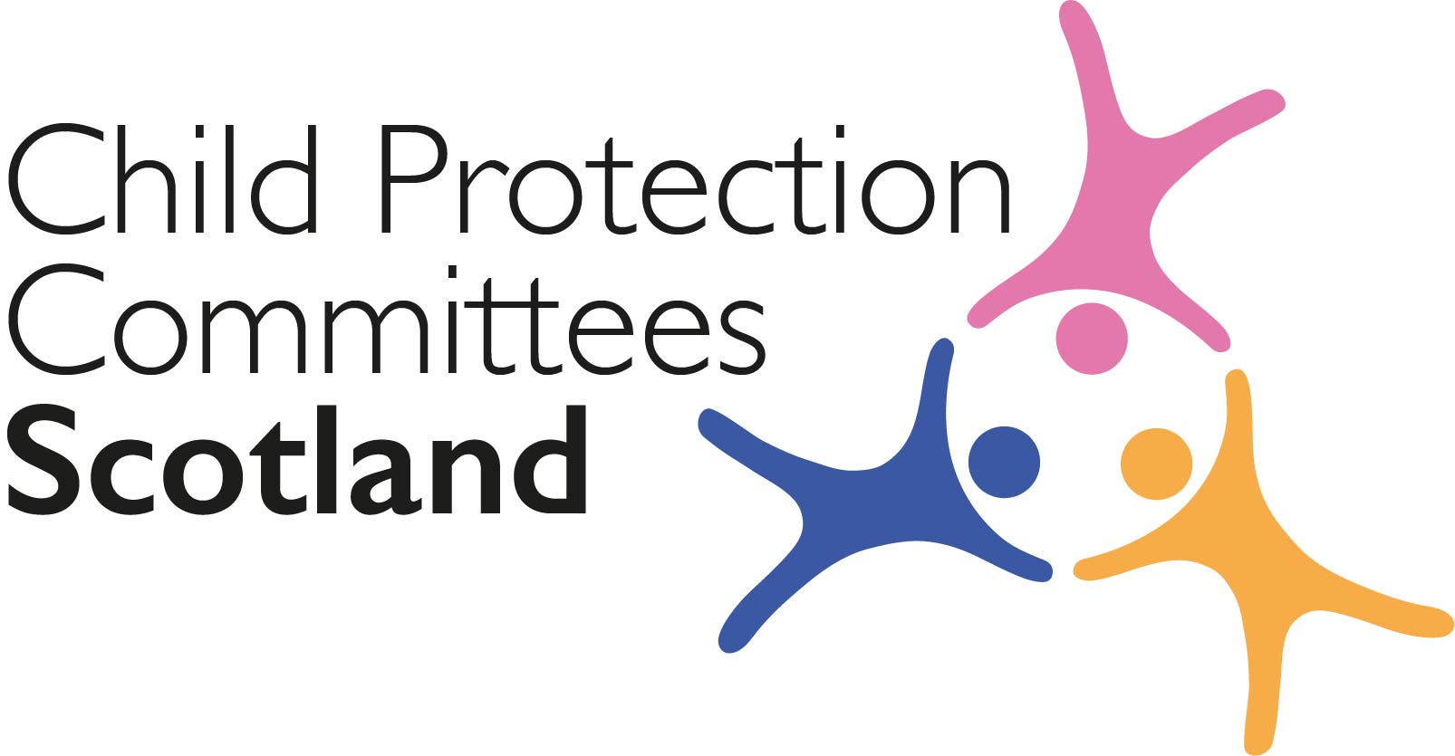
Keeping Connected - The CPCScotland Weekly Bulletin
Issue 36 - Tuesday 1st December 2020

Issued to support Child Protection Committee’s and partners with up to date information on child protection issues.

Welcome to Issue 36 of Keeping Connected.

I hope you and your families are keeping well.

I know many of you will, like me, be busy preparing your response on the National Guidance for Child Protection in Scotland consultation draft. CPCScotland are working on a ‘corporate’ response and draft should be available for members’ comments on by the end of this week. I hope that despite this busy period you will find some time to look at this week’s bulletin and check out some of the links that are relevant to you.

Keep safe and keep in touch.

Alan Small, Chair Child Protection Committees Scotland

Section 1 COVID-19

Guidance, Resources and Information

1 Coronavirus (COVID-19): impact on children, young people and families - evidence summary October 2020

The Scottish Government has published the latest evidence summary on the impact of COVID-19 on the wellbeing of children and young people and families: https://www.gov.scot/publications/report-covid-19-children-young-people-families-october-2020-evidence-summary/

2 Children and COVID-19 Research Library

The UNICEF library contains global scientific research and evidence on children and the coronavirus pandemic, building upon UNCEF Innocenti’s existing COVID-19 rapid research response microsite. The library aims to fill the knowledge gap on the socio-economic impacts of COVID-19 drawing upon publications, blogs, expert webinars and other scientific resources. As the library is still under development, there is an opportunity to offer preliminary feedback to help refine the database content and usability.
https://www.unicef-irc.org/covid-children-library/?utm_source=mailchimp&utm_medium=email&utm_campaign=egmvac

3 Care Inspectorate Covid information pages

The Care Inspectorate have made it easier to information about COVID-19 on their website by adding new menu tabs to the COVID-19 information area. You can find the new tabs on the left hand side of the main COVID-19 page. This includes a frequently asked questions section.
https://www.careinspectorate.com/index.php/coronavirus-professionals?utm_medium=email&utm_source=govdelivery

4 CELCIS coronavirus resource page
The Coronavirus resource page provides a round-up of key information, advice and guidance to help anyone supporting the care and protection of children and young people in Scotland during the coronavirus pandemic: https://www.celcis.org/covid19info/

5 The Care Inspectorate’s role, purpose and learning during the COVID-19 pandemic

The Care Inspectorate have published a report on the Care Inspectorate’s role, purpose and learning during the COVID-19 pandemic. This report was part of the Care Inspectorate’s submission to the Scottish Parliament’s Health and Sport Committee in August. https://www.careinspectorate.com/images/documents/5783/CI%20Role%20Purpose%20Learning%20during%20COVID-19.pdf?utm_medium=email&utm_source=govdelivery
Research and Evidence Based Reports

6 What makes life good? Care Leavers views on their wellbeing
The Coram Voice charity has published the findings of a survey of more than 1,800 care leavers, conducted before the COVID-19 public health emergency, on understanding care leavers wellbeing. The survey found that around 22% of care leavers reported high levels of loneliness, almost double the number of 16-24-year-olds in the general population who feel this way (10%), and for care leavers with a long term health problem or disability this figure rises to 35%: https://coramvoice.org.uk/wp-content/uploads/2020/11/1883-CV-What-Makes-Life-Good-Report-final.pdf

7 Child Welfare and Pandemics

This literature scan undertaken by the Policy Bench, Fraser Mustard Institute of Human Development, University of Toronto, identifies and synthesizes existing literature examining the effects of pandemics and the identification of policy solutions to mitigate their effects on children in the care of Canada’s child welfare system.
https://x2m5b2r8.stackpathcdn.com/wp-content/uploads/2020/03/Child-Welfare-and-Pandemics-Literature-Scan_Optimized.pdf

8 The effects of digital contact on children’s well-being.

This rapid evidence review examines what is known about the implications of digital contact on the well-being of children who have been separated from their birth relatives. This review is part of the Nuffield Family Justice Observatory’s Modernising Contact initiative.
https://www.nuffieldfjo.org.uk/app/nuffield/files-module/local/documents/nfjo_digital_contact_rapid_evidence_review_20200521_final-3-.pdf

9 Children and young people’s mental health during the COVID-19 crisis

The Rees Centre reports on the latest findings from the Co-SPACE study tracking children and young people’s mental health throughout the COVID-19 crisis. The report finds that for participating primary school aged children behavioural, emotional, and restless/attentional difficulties have generally decreased from July, throughout the summer holidays, and as children returned to school in September.
https://cospaceoxford.org/findings/changes-in-children-mental-health-symptoms-from-march-to-october-2020/

Section 2 Other Child Protection Topics

Guidance, Resources and Information

10 Advocacy for Children and Young People – Children’s Hearing System

The Scottish Government has announced the launch of a new national advocacy service to reinforce the rights of children involved in the Children’s Hearing’s System. CELCIS have published a blog post from Minister for Children and Young People Maree Todd explaining why this service is so important.
https://www.gov.scot/news/strengthening-support-for-children-and-young-people/
https://www.celcis.org/knowledge-bank/search-bank/blog/2020/11/national-childrens-hearings-advocacy-service/

11 Safer Internet Day 2021

Ahead of Safer Internet Day next year, taking place on 9 February, the UK Safer Internet Centre has created a range of resources for those working with children and young people. Tailored for age groups 3-7, 7-11, 11-14 and 14-18 years, the educational resources include lesson plans, assemblies, posters, films, and other quick activities to learn about online safety issues. There are also resources for educators and parents and carers.
https://www.saferinternet.org.uk/blog/new-educational-resources-looking-reliability-online-launched-safer-internet-day

12 Connecting Scotland Applications Open
More than 23,000 iPads and Chromebooks are being distributed to digitally excluded low-income families and care leavers as part of the latest phase of the Connecting Scotland programme. As well as a new device, recipients also receive mobile data and help to use the internet confidently and safely for up to two years. Phase 2 (round 2) is now open for applications which can be made by organisations who support eligible groups via the Connecting Scotland website. This round closes on 18 January at 11am.
https://connecting.scot/for-organisations

13 Children and Young Peoples Panel on Europe Report: ‘Young Brexit Voices: It’s Our Future Too’

The Children and Young People’s Panel on Europe is made up of 19 children and young people aged 9-19 from across Scotland. The Panel was set up in 2018 to ensure that children and young people’s views are heard as the UK exits the European Union. The panel have published their report ‘Young Brexit Voices: It’s Our Future Too’. The report will be launched at an online event on Wednesday 9th December from 17:30 – 18:30. Contact Naomi Sutton (naomi@togetherscotland.org.uk) if you wish to attend the launch event.
https://childreninscotland.org.uk/wp-content/uploads/2020/11/PonE_Report_4.10.pdf

Training

14 Creating a culture of collaboration
On Thursday 10 December at 3:00pm YouthLink and the Scottish Attainment Challenge are hosting a webinar considering what approaches and systems help to create the right foundations for effective collaboration.
https://www.youthlinkscotland.org/events/december-2020/creating-a-culture-of-collaboration

15 What Works in Education for Young People with a Social Worker’

This webinar is the third in a series, conducted by What Works for Children’s Social Care in collaboration with the National Association of Virtual School Heads, to support the understanding and use of evidence by Virtual School Heads. This webinar will introduce evidence on what works for young people with a social worker, and the gaps in this area.
https://www.eventbrite.co.uk/e/navsh-wwcsc-what-works-in-education-for-children-with-a-social-worker-tickets-120375810289

16 Technology and mental health
As part of its Online Harms webinar series, the UK Council for Internet Safety (UKCIS) is hosting a free webinar on technology and mental health on Wednesday 9 December at 2:00pm. Speakers include Dr Bernadka Dubicka, Chair of the Faculty of Child and Adolescent Psychiatry at the Royal College of Psychiatrists.
https://www.eventbrite.co.uk/e/online-harms-webinar-series-webinar-1-technology-and-mental-health-tickets-126985698643

Research and Evidence Based Reports

17 The ‘Toxic Trio’ – How good is the evidence base

The National Children's Bureau, the University of Cambridge and the University of Kent have published a systematic review of research looking at the relationship between parental mental illness, drug or alcohol misuse, and domestic violence in combination and child maltreatment. A review of 20 papers and 8 overviews of serious case reviews published between 1998 and 2017 found little understanding of how, or if, the three factors combine to significantly increase the danger to children.
The ‘toxic trio’ (domestic violence, substance misuse and mental ill-health): how good is the evidence base?

18 Understanding Public Attitudes to the Early Years

The ‘5 Big Insights’ from the ‘5 Big Questions on the Under Fives’ survey looking at public attitudes to the early years, conducted by Ipsos MORI on behalf of the Royal Foundation earlier this year have been published, alongside further qualitative and ethnographic research, a national representative survey conducted before the pandemic, and a survey on the impact of COVID-19 on families.
https://mk0royalfoundatcnhl0.kinstacdn.com/wp-content/uploads/2020/11/STRICTLY-EMBARGOED-UNTIL-0001-HRS-FRIDAY-27-NOVEMBER-2020-IPSOS-MORI-ROYAL-FOUNDATION-REPORT.pdf

19 Young people’s mental health

The Centre for Longitudinal Studies at the UCL Social Research Institute has published a report looking at the mental ill-health of young people at age 17 in the UK. Findings from data from more than 10,000 young people who have all been taking part in the Millennium Cohort Study (MCS), a nationally representative study of teenagers born in 2000-02, include: 16% of teenagers report high levels of psychological distress at age 17, 24% of young people report self-harming, and 7% report self-harming with suicidal intent.
https://cls.ucl.ac.uk/wp-content/uploads/2020/11/Mental-ill-health-at-age-17-–-CLS-briefing-paper-–-website.pdf

20 Children’s rights in mental health settings in England

Article 39 has published a report sharing children and young people’s views and experiences of mental health hospitals in England, as told to their advocates. The report finds that children are being kept in hospital for too long, often many miles from home, and in environments not conducive to their needs and rights as children. Issues raised include: children and young people not feeling listened to or involved in the planning of their care and treatment; those wishing to challenge their detention fearing that they might be ‘sectioned’ if they are an informal patient; and inappropriate use of restraint and seclusion or segregation.
https://article39.org.uk/wp-content/uploads/2020/11/A-safe-space_final_Nov20.pdf

21 Personal safety

The Children’s Commissioner for England has published a report looking at children and young people’s views on personal safety in their local area. Recommendations from seven focus groups conducted with 66 children aged 7 to 18 in Sheffield include: planning guidance should be amended to include children’s specific need for access to safe open spaces and play opportunities; local authorities should be required to consult with children when determining their spending on public spaces; and the Government should launch a campaign to make public spaces more child friendly.
https://www.childrenscommissioner.gov.uk/wp-content/uploads/2020/11/cco-mean-streets.pdf

22 Home Education - England

The Association of Directors of Children’s Services (ADCS) in England has published an analysis of their annual elective home education survey to capture the number and characteristics of children and young people who are known to be home educated in England. Estimates, based on data received from 133 local authorities who responded to the 2020 survey, include: 75,668 children and young people were being electively home educated on 1 October 2020, an increase of 38% from October 2019. Feedback from local authorities indicated that health concerns over the coronavirus pandemic was a primary reason for parents and carers choosing to formally home educate their child in 2020.
https://adcs.org.uk/assets/documentation/ADCS_EHE_Survey_2020_FINALweb.pdf

Part 3 News and Opinion

23 In the media

- The Independent has reported on figures from a survey by the County Councils Network (CCN), which represents all county councils and unitary authorities in England, showing that child protection referrals have surged in the months following the first UK lockdown https://www.independent.co.uk/news/uk/home-news/child-protection-referrals-lockdown-abuse-b1746017.html
- The UK Court of Appeal has ruled that the UK Government acted unlawfully in scrapping 65 safeguards for children in care and vulnerable children through temporary COVID-19 legislations – the court said ministers should have consulted England’s Children’s Commissioner and other groups.
https://www.bbc.co.uk/news/education-55057126
- The Daily Record is running a campaign to raise awareness of child poverty, sharing stories from a number of different viewpoints including families, individuals and third sector workers, who call on policymakers to learn more about what life is really like for those facing poverty, as well as featuring an article from First Minister Nicola Sturgeon on what the Scottish Government is doing to protect vulnerable families: https://www.dailyrecord.co.uk/all-about/poverty
- The First Minister Nicola Sturgeon has announced a new £100 grant for low-income families whose children receive free school meals, to help them pay for food and fuel bills during the COVID-19 public health emergency – this will be paid out by the Scottish Government this winter to support those due to have received the weekly £10 Scottish Child Payment, which was delayed due to the pandemic: https://www.bbc.co.uk/news/uk-scotland-55124729
- The Guardian reports that the National Crime Agency (NCA) has warned that a man who admitted 96 counts of child sexual abuse online could have escaped justice if plans to strengthen encryption were in place. The proposed strengthened encryption would mean that offenders using fake identities on Facebook Messenger could escape detection.
https://www.theguardian.com/uk-news/2020/nov/23/facebooks-encryption-plans-could-help-child-abusers-escape-justice-nca-warns

24 Funding for Youth Organisations

The UK Government has announced that £16.5 million of funding from its £750 million package of support for frontline charities will be allocated to youth organisations, including grassroots youth clubs, uniformed youth groups, and national youth and umbrella organisations, to help them mitigate the impact of lost income during the winter period due to the coronavirus pandemic, and ensure services providing vital support can remain open: https://www.gov.uk/government/news/government-announces-165-million-youth-covid-19-support-fund

25 The Mice and the Bakers
In a blog for CELCIS, Nikki Hepburn, an art teacher at Harmeny Education Trust, a residential school providing care and education to children aged 5-14 who have experienced early years trauma, describes how an animation project titled 'The Mice and the Bakers' created an innovative and accessible way for young people to tell their own stories.
https://www.celcis.org/knowledge-bank/search-bank/blog/2020/11/children-get-animated-lockdown/

Please feel free to let us know what you think about the bulletin and provide information for inclusion in future editions. Please contact Alan Small or Susan Mitchell at cpcscotland-liaison@strath.ac.uk. Please note that the information included in this bulletin is provided in good faith. Inclusion does not indicate CPCScotland endorsement of the content of the linked documents or websites.

