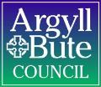

Member Zone: Member Update Briefing 9 (September 2026)

INTRODUCTION
A year has passed since the local elections in May 2023 and the launch of Member Zone shortly afterwards, and in that time:

The Enquiry Autoclosure Function

When a member receives a response to an enquiry made to a Service through MZ, the case incident for that enquiry will be in their caseload with the status Follow Up Response Provided.
Members then have three options as to what to do with that response:
- If they are satisfied with the response and no further action is required of the Service the member should mark the incident as now being resolved:
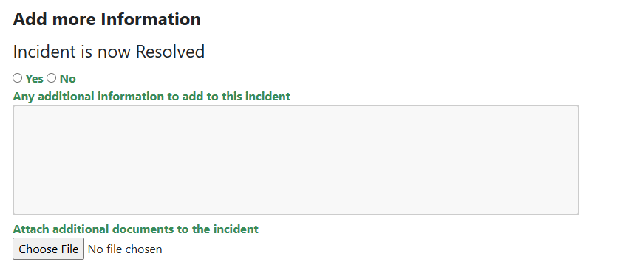
This closes the case and takes it out of the member’s active caseload.
- If they feel further clarification or action is needed from the Service, the member should mark the enquiry as requiring further clarification and add a note to tell the Service why they feel more input is needed
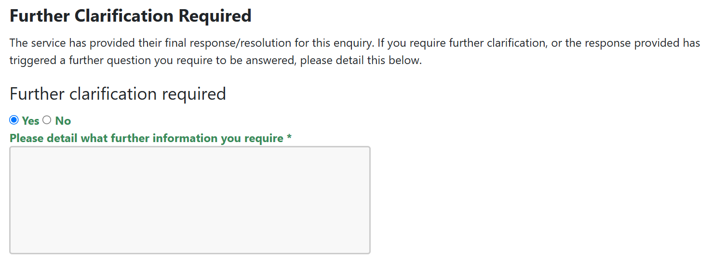
This puts that enquiry back to the Service for more action.
- Sometimes when Services cannot fulfil a request immediately, they tell the member they have scheduled it to be completed at a later date and move the case to a pending queue by changing the status to Work Scheduled. Once completed the Service will change the status to Follow-up Response Provided. The member can then choose to mark the request resolved or updated.
Early in the evolution of MZ it became apparent that members were often not marking their responded to enquiries as resolved or updated and they were left in limbo with the status of Follow Up Response Provided. The MZ Sounding Board asked for an auto closure function to be developed that would send members an email after 8 weeks of an enquiry sitting at status of Follow-up Response Provided and ask them to take action (example below):
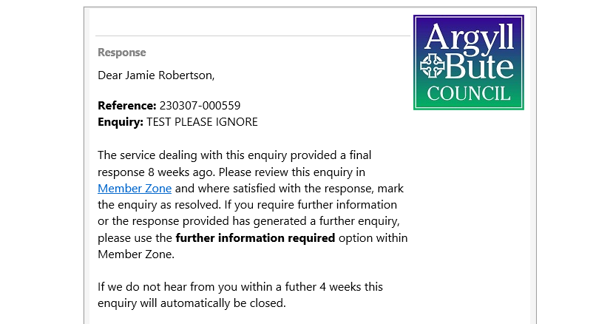
If the enquiry remains open a further 4 weeks the enquiry is automatically marked as Member Request Resolved and a further email issued to advise the member of this.
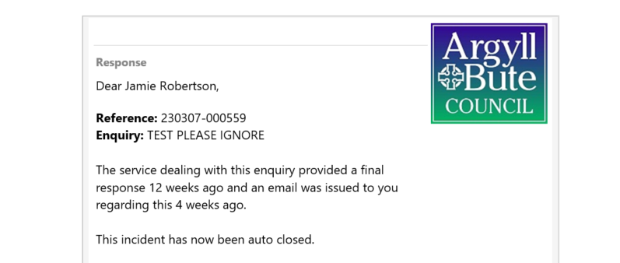

This new functionality aided members by ensuring their caseloads did not get cluttered with fulfilled enquiries, whilst providing plenty of time for them to take action on the case if they wished. An additional safeguard was also built in allowing members to pause auto closure.
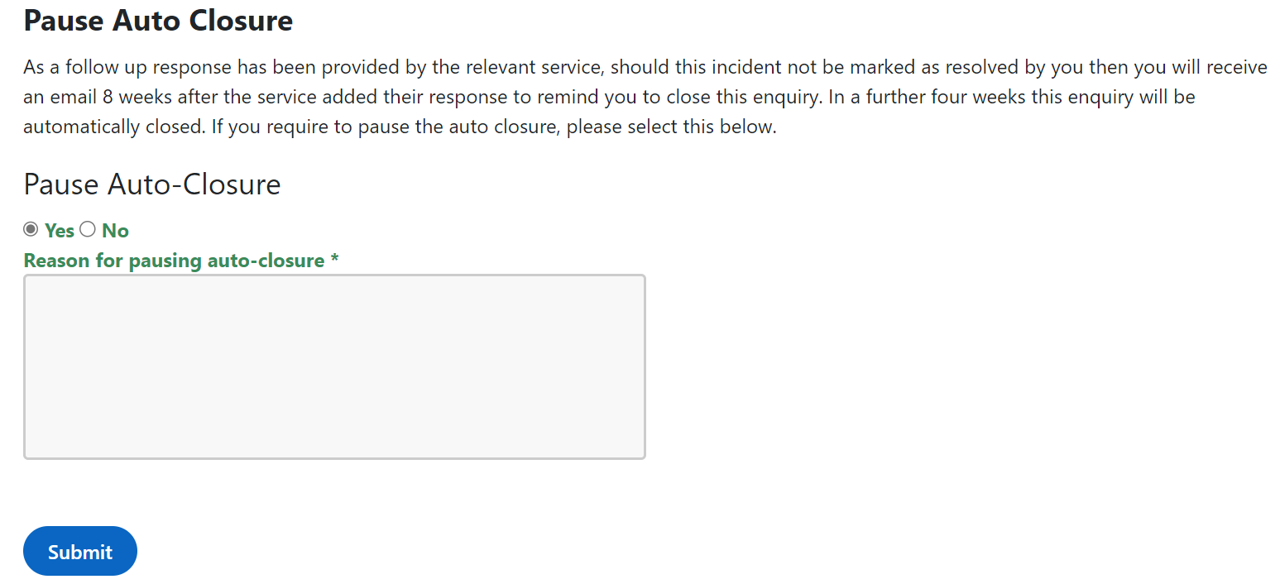
Since its inception in May 2023 the auto closure has worked successfully on 1957 cases/incidents, with only a few instances where a member has requested that a case be re-opened as they missed the reminders. Members have fed back that they value the automated assistance helping them to manage their caseloads.
As of end August 2026, there were still 689 cases with members awaiting them to either mark the case resolved or to update it sitting at Follow Up Response Provided. Most of these relate to cases that predate the auto closure functionality being introduced and members are asked to action these very old fulfilled responses or to contact Member Services and ask them to assist with that task.

Member Zone – Member Sounding Board
The most recent meeting of the Member Sounding Board took place on Wednesday 5th August and minutes of this meeting can be found in Member Zone under the Library grouped menu heading.

----------------------------------------------------

If you require any further information or need any clarifications on the content of this Briefing, please do not hesitate to contact Member Services (memberservicesteam@argyll-bute.gov.uk, 01546 60 4305) or Jamie Robertson (01586 555 202, jamie.robertson@argyll-bute.gov.uk).

Bob Miller
Customer Engagement Manager
September 2026

