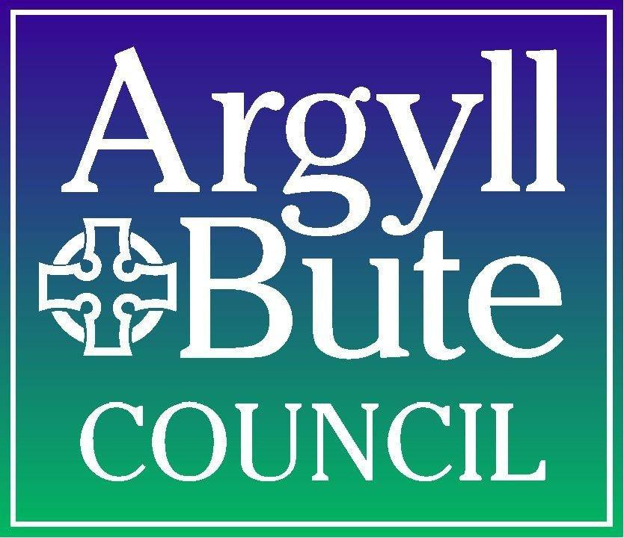
Briefing Note: Introduction of WhatsApp contact channel

Introduction
This briefing note provides an overview of the proposed introduction of WhatsApp as a new customer contact channel for Argyll and Bute Council from August 2026.
The initiative forms part of the Council's Customer Service Strategy Action Plan and supports our ongoing commitment to delivering modern, accessible and customer-focused services. The proposal has been developed in response to customer feedback requesting a wider range of digital communication options and has been enabled by the recent implementation of the Council's new AI-powered Netcall Customer Experience (CX) platform.

2. Background

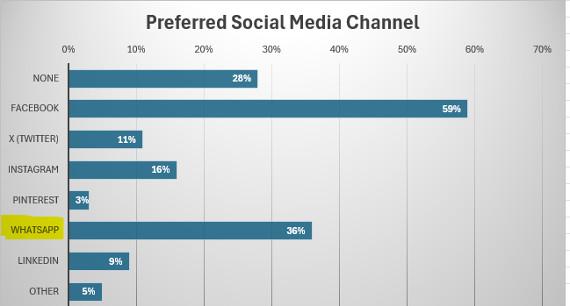
Customer communication has changed significantly in recent years, with messaging services becoming a preferred way for many people to contact organisations. The Ofcom Online Nation Report 2025 identifies WhatsApp as the UK's most widely used messaging platform, with around 44.2 million users and over 36 million adults using it daily.

In the council’s 2024 Customer Contact Preference Survey, Whatsapp was the second most popular social media preference channel (we already offer contact via Facebook):

Until now, the Council has been unable to offer WhatsApp as a customer service channel because previous contact centre technology could not securely route enquiries, support agents or record customer interactions. The implementation of the new AI enabled Customer Experience (CX) platform has removed these barriers, enabling WhatsApp to now be introduced as a secure, fully managed customer contact channel.

Introducing WhatsApp will allow the Council to meet changing customer expectations while maximising the value of its digital investment to move contacts from high to low cost channels . With relatively few local authorities currently offering WhatsApp as a transactional service channel, Argyll and Bute Council will be an early adopter offering this choice in Scotland.

3. Key Considerations
The proposal is to introduce WhatsApp as an additional customer contact channel alongside existing services, including telephone, email, web forms and face-to-face support. The new channel is intended for two-way customer service interactions and not as a news or marketing platform. In effect Whatsapp has supplanted text as a channel and the service will enable customers to submit enquiries and service requests through WhatsApp, with all interactions managed securely within existing Council systems.
Appropriate governance, information security and data protection measures, including completion of a Data Protection Impact Assessment (DPIA), have been completed prior to launch. Contact Centre agents will receive guidance and training to ensure a consistent customer experience. An automated satisfaction survey will be offered after every interaction to allow quality of responses to be monitored.

4. Whatsapp Enquiry Operating Model

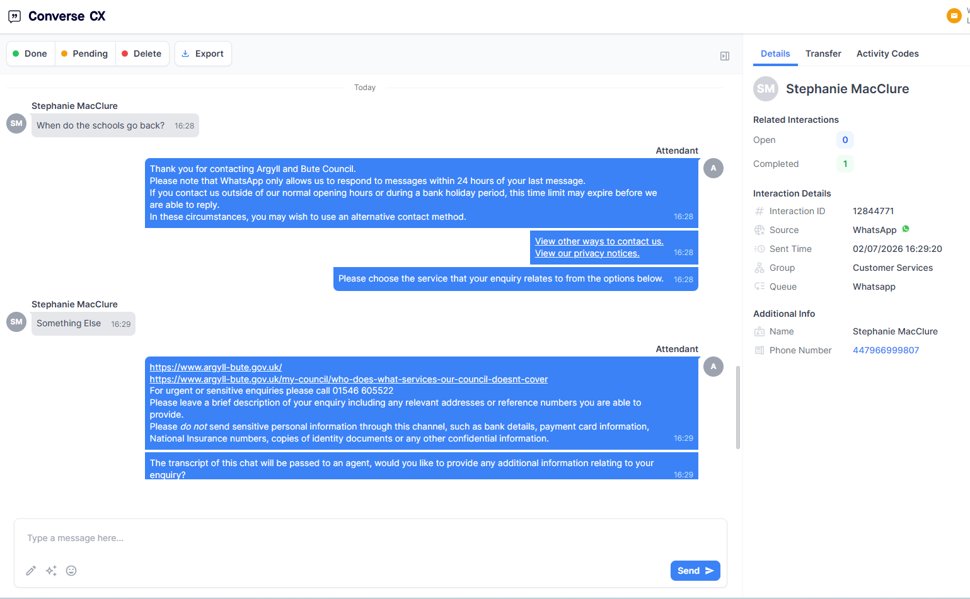
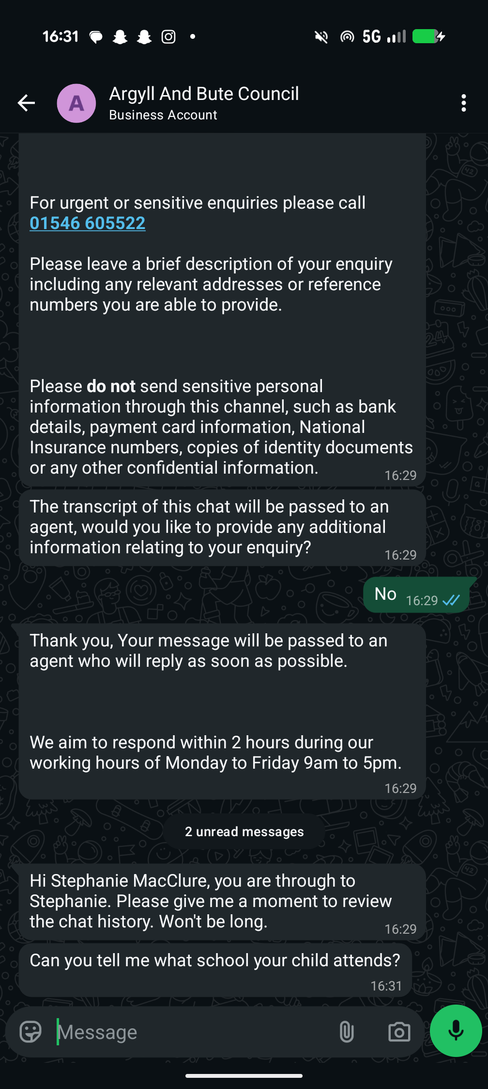
Customer enquiries will be received through the Council's Netcall Customer Experience (CX) platform, where initially the AI-powered Virtual Assistant will respond to common enquiries, directing customers to relevant information and support self-service where appropriate. Where further assistance is required e.g. for complex or personalised enquiries, conversations will be seamlessly transferred to a customer service adviser. All customer interactions will be securely captured and managed through existing customer relationship management processes, including recording on our current Oracle CRM system.

This approach maximises the value of the Council's CX investment while providing customers with a modern and convenient way to contact the Council.

5. Citizen Impact
The experience of other councils that have added Whatsapp to their channel options is that WhatsApp improves customer choice by offering an additional, familiar way for residents, businesses and visitors to access Council services. Customers who prefer messaging will benefit from greater convenience, improved accessibility and faster resolution of simple enquiries through AI-assisted support. It also encourages the younger demographic to interact with the council as they are the preponderant users of this medium.
The proposal also maximises the Council's investment in its digital customer engagement platform and supports wider objectives to improve customer experience, increase digital accessibility and ensure services continue to meet evolving customer needs and expectations in line with Connect for Success principles.

6. Next Steps
The Digital Engagement team is finalising the technical and operational work required to implement the service and have established a corporate WhatsApp Business account, integrated it with the Council's Customer Experience (CX) platform and CRM platforms and completed governance and data protection requirements. Next steps are to deliver staff training and guidance and then undertake a soft launch for live testing in August 2026.
Subject to successful live testing and approval, WhatsApp will be formally publicised and launched as a new customer contact channel in September as part of the Council's ongoing programme of digital service improvements. We aim to respond to all Whatsapp enquiries within 1 working day, but most will be same working day.

7. Contact Information
For further information, please contact:
Jane Fowler, Head of Customer Support Services: jane.fowler@argyll-bute.gov.uk
Stephanie Wright, Digital Systems Developer stephanie.wright@argyll-bute.gov.uk
Bob Miller, Customer Engagement Manager: robert.miller@argyll-bute.gov.uk

