Appendix 6 – Response Form

CONSULTATION RESPONSE FORM
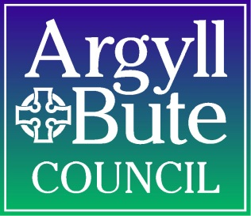

Education Service

Please use this form to let us know what you think about the proposal
You can submit a written representation by downloading this Response Form in Word format, populating it, and emailing the completed form to: schoolsupport@argyll-bute.gov.uk.

Alternatively, you may wish to print out this form, complete it by hand (please use block capital letters), and return the completed form by post to: Education Services, Argyll House, Alexandra Parade, Dunoon, PA23 8AJ.

The closing date for responses to be received by the Council is 5pm on 2nd October 2026.

Proposal

Argyll and Bute Council is seeking the views on the following proposal, namely:

- To relocate the current Tobermory 2-18 Campus School building to a new school building located on the site which is situated to southern edge of Tobermory with the western boundary adjacent to the A848.

If you do not wish your response to be publicly available, you must tick the box below. Otherwise, it will be assumed that you agree to your response being made publicly available.

“I wish my response to be considered as confidential with access restricted to elected members and council officers of Argyll and Bute Council.”

Name
Address
I agree with the proposal (please tick) |  | Yes |  | No |  | Undecided
If you wish to comment on the Proposal please use the space below. Please attach another sheet should you require to do so:
I am responding in my capacity as a (please indicate by ticking the appropriate box)
Parent/ carer of child at  Tobermory ELC/Primary /Secondary |  | Trade Union
Parent/ carer of child at  affected primary school (Dervaig, Lochdonhead, Salen, Ulva Primary School) |  | Elected representative
Pupil |  | Community Council
Tobermory PS / Tobermory HS Parent Council |  | Member of the public/ community
Dervaig, Lochdonhead, Salen, Ulva Parent Council |  | Member of staff
Other |  | Details: _________________________

Handling your response - Please note that:
- We will use the information you provide for the purpose(s) of this consultation, including statistical and analytical purposes;
- We will pass a full copy of your written response to His Majesty’s Inspectorate of Education in Scotland, or a summary of it of agreed with them; and
- We are subject to the provisions of the Freedom of Information (Scotland) Act 2002 and therefore would have to consider any request made under that Act for information relating to written responses/ records of oral representations made to us relating to this consultation.
This consultation, and all other school consultation exercises, can be viewed online on the Council website at:
School consultations and proposals | Argyll and Bute Council
You can also complete and submit this response form online using the above link.

Thank you for taking time to respond.

