Tick  One  Box | For Information Only | For Decision Only |  | For Discussion
Tick  One  Box | X
ARGYLL AND BUTE COUNCIL |  |  | CSSMT
CUSTOMER SUPPORT SERVICES |  |  | June 2025
Member Zone Update Report Covering 2025-26
- 0 INTRODUCTION

  - This report forms part of the ongoing monitoring of the request and information management service provided to elected members by Services via the Member Zone (MZ) system. The report details MZ activity and Member feedback in 2025-26, the work of the MZ Sounding Board and the MZ developments they commissioned. It is significant that the system has had 4628 requests logged since inception in 2022.
  - In summary during 2025/26:
- Members logged 1131 requests through MZ of which 895 were for Roads and Infrastructure Services and 236 for all other Services. At year end 117 of these were in progress and 1014 had been actioned. 99 (8.7% of all requests) triggered the Escalation process, largely for speed of response.
- 34 members used MZ during the year, with the highest number of requests being 252 by a single member. Thirteen members logged under ten requests over the year. Members logged 91% of all requests using digital self-service.
- 97% of members were satisfied with the timeliness of their responses, 98% with the quality of response and 97% satisfied with the final outcome of their enquiry/request out of 133 satisfaction survey responses submitted.
- The MZ Sounding Board met twice last year and a number of enhancements have been made to the MZ platform at their behest. Due to the maturity of the system the Board now meets twice a year.

- 0 RECOMMENDATIONS
2.1 We recommend that CSSMT:
- Note the effective performance of the MZ platform and the teams and Sounding Board supporting it to provide high standards of response to members that used it in 2025/26.
  - DETAIL
Service Request Portal Activity
  - The key element of the Member Zone is the request management system that allows members to make trackable requests for action and information from Services. It also supports both members and Services to manage their caseloads effectively. The table below summarises the key performance metrics of that system in 2025-26:
2025/6 Business Year | RIS Requests | Other Services | Total
Total Requests Made | 895 (79%) | 236 (21%) | 1131
Requests in Action* | 81 | 36 | 117
Requests Actioned by Services | 814 | 200 | 1014
Requests Closed by Members | 574 | 177 | 751
Open with Members in year | 240 | 23 | 263
Escalated Requests in year | 33 | 60 | 99

3.2 Of the 117 requests in action as at end of March 2025:
- 82 are with the Services for response
- 25 have had an initial response and the member has asked for further information
- 10 have been escalated (all non RIS).
Of the 82 requests open with Services for response, 13 (16%) exceed their SLA response time by over one week (3 RIS and 10 Non-RIS).
  - There have been 4628 MZ requests raised by Members since the system went live in May 2022 and there are 719 (16%) requests that are completed by Services, but which still lie with members to formally close. 91% of all requests were raised by members using self service, almost the complete opposite of the old Councillor Casebook.

  - All but two members have used MZ request service at some time during the year, but thirteen used it less than ten times. There are three “Super Users” who have logged 160 or more requests, with the highest number being 252.

Service Request Portal – Member Feedback
  - In order to monitor timeliness, quality and satisfaction with final outcome of Service responses over time from a member perspective, every member is offered a satisfaction survey when they mark a case as closed. In 2025/6 13 members used the feedback function. The tables below show the results of the three survey questions, but overall the feedback has been very positive and the 133 responses is 18% of total closed cases, so a reasonable sample.

128 out of 132 (97%) of respondents said they were moderately to very happy with the speed of response to requests by Services. Comments included:
A very quick response, thanks.
Swift response much appreciated.
This was a query that got stalled in the system but once it has been "unglued" the response was prompt and appropriate - thank you.
It did take a while for the final response to be provided.
Very quick and appropriate response. Thanks.
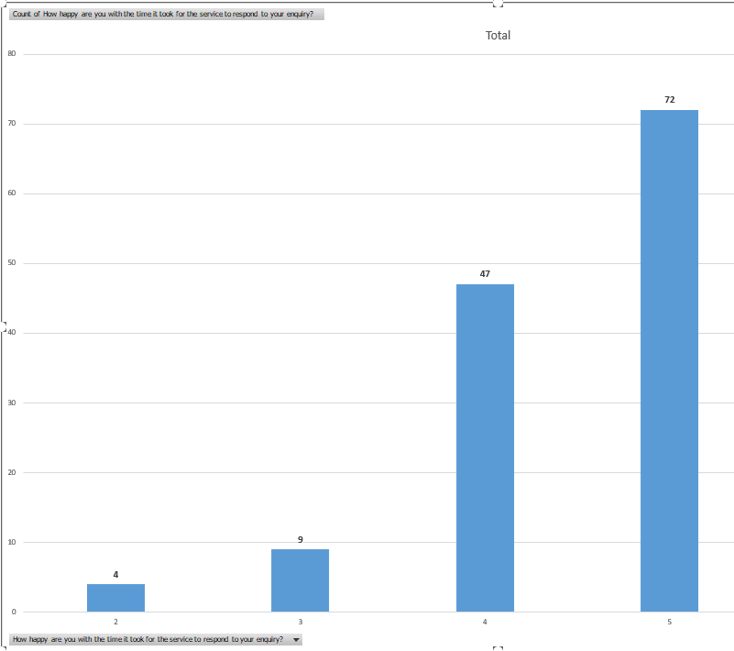

  - 126 out of 129 (97.6%) respondents were satisfied with the quality of response; 119 marking them good or excellent:
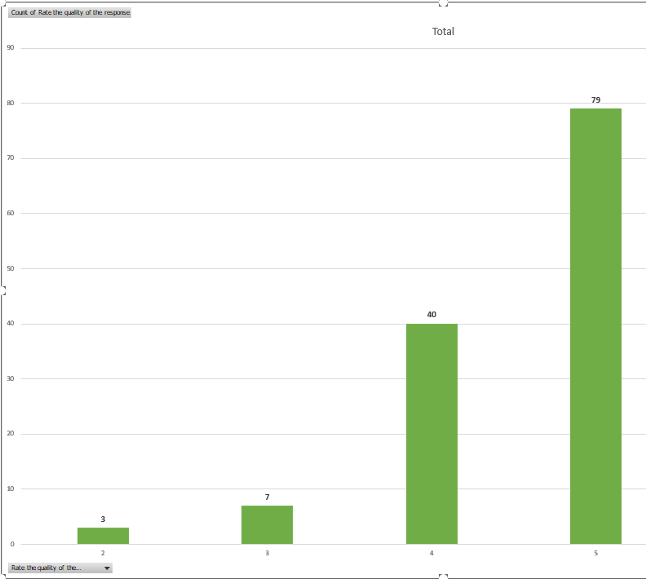
Comments included:
The help and support offered to Carol has been very well received and I know Carol is very grateful, so thanks for the speedy intervention.
The officer allocated this enquiry has been extremely diligent and helpful. This is a difficult case to deal with and work is ongoing.
Great response from the team on Islay, thanks.
Disappointed by the flat rote response. Would have preferred a response that while "no" included an opportunity for further discussion.
  - 127 out of 131 respondents (97%) were satisfied with the final outcome of their enquiry. 121 marking them good or excellent. Comments included:
I first reported the lights not working 7th October 2024 When I escalated the report the engineer was out and fixed the broken lights with a couple of days.
I am being asked to close this enquiry down yet the work has still not been done and really annoying members of the public are still asking why the work has not been done.
Excellent service here and much appreciated.
I Checked and branch has been removed.
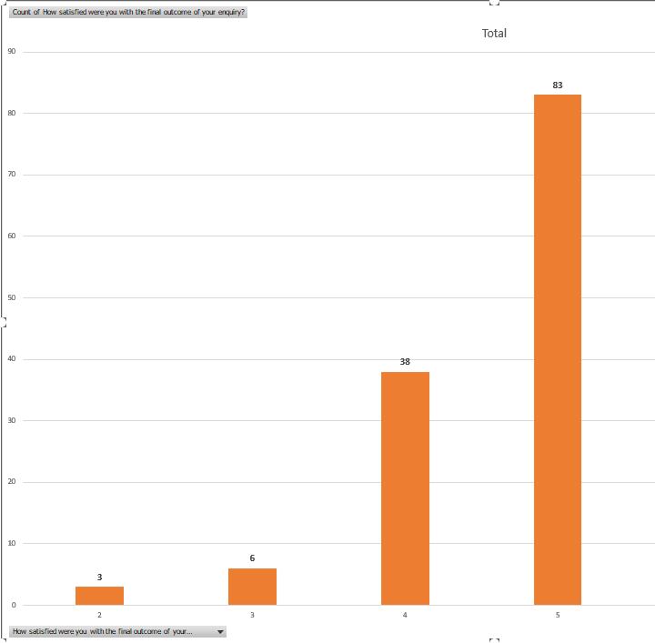

Member Zone Development
  - The Member Zone application and Service is continually developed in response to the needs of Members and Services, led by the Sounding Board. As the system is now very mature that Board has moved to a six monthly meeting cycle and met twice in 2025/26 with all papers and minutes posted on the MZ for all members to access. In 2025/26 the following enhancements were released:
- Functionality to allow members to drop a point on a map, rather than having to identify a specific asset when reporting issues for certain roads and lighting assets
- A new pop-up alert to prevent members logging issues for Trunk Road faults that are not council’s responsibility
- A new emailed alert to Caseload Controllers for those cases with no due date for next action set
- Added new category to escalation criteria for cases where initial response is 10 days past initial response SLA
- Broadened the Director’s DMT monitoring report to include all D&I services, not just RIS
- Ability to add raise cases via a curated email route
- Ability to sort caseload by age of case
- Numerous new informational elements added to the portal and Spatial Hub.

4.0 CONCLUSION
4.1 The Member Zone platform and its procedural operation by members and Services continues is now well embedded and its performance is closely monitored. The low number of case escalations and high feedback satisfaction scores indicate that a good, but not perfect service now operates for that majority of members who choose to use it. RIS has seen very high performance across the year in responding to member enquiries. The system and service continues to evolve under the guidance of the Sounding Board.

5.0 IMPLICATIONS
5.1 Policy | None
5.2 Financial | Self Service and automated elements enhance the efficiency of Member enquiry management
5.3 Legal | None
5.4 HR | None
5.5 Customer Service | Improves constituent enquiry management.
5.6 Risk | Reduces risk of reputational damage and failure demand.
5.7 Climate Change | Is a wholly digital system
5.8 Fairer Duty Scotland | None
5.9 Equalities Protected Characteristics | None
5.10 Consumer Duty | None
5.11 Island Communities | Used by members representing islands.
5.12 Children’s Rights and Wellbeing | None

For further information contact:
Jane Fowler, Head of Customer Support Services
Bob Miller, Customer Engagement Manager

