
All weekly briefings can be accessed here
Roads and Infrastructure
Weekly member briefing
Edition 238: 27th March
2026

Oban, Lorn and the Isles | Helensburgh and Lomond | Mid-Argyll, Kintyre, and the Islands | Bute and Cowal | All areas
Roads updates  scrub cutting along the A816 will complete next week ahead of nesting season.  Next week the team are carrying out some surfacing improvements works for our colleagues at Oban Airport  Clachan Bridge  We are aware of the concerns raised regarding the installation of traffic lights at Clachan Bridge.  The introduction of traffic signals has been identified as the most effective long-term measure to:  - Improve road safety for all users  - Regulate vehicle movements across the bridge  - Reduce vehicle speeds  - Enhance driver awareness where forward visibility is restricted  The traffic lights are vehicle-activated, meaning they will turn Green as a vehicle approaches, unless another vehicle is already on the opposite approach.  This is when the system will provide its intended safety benefits.  Any delays should be minimal and manage traffic in a safer manner.  McCaigs Tower – Sakura Cherry Tree planting  In early 2025 the Lieutenancy of Argyll and Bute was approached by the Sakura Cherry Tree Project – an initiative which seeks to recognise and reaffirm the longstanding friendship between the UK and Japan by donating cherry tree saplings to be planted and enjoyed in community spaces.  The saplings arrived in December 2025 and, in line with planting guidelines, will be planted across Argyll and Bute in the coming weeks.  There are 30 trees in total and the with the assistance from our Amenity team the first six were planted at McCaig’s Tower, Oban on Wednesday 18th March.  With the council currently in pre-election period, the Lord-Lieutenant Mrs Jane MacLeod oversaw planting on this occasion, and it is hoped that local members will be able to join in future planting sessions as these are rolled out | Roads updates  Capital surfacing works on Shore Road, Shandon, have now been completed.  The £100,000 overlay investment significantly improves the condition of the carriageway and enhances safety for road users.  In addition to the surfacing works the team have also been carrying out drainage improvements along Shore road with 70 meters of new pipe installed to address historic flooding issues in the area.  These works are scheduled to complete next week  Luss footway  Funding has been allocated to carry out the required repairs to the collapsed section of footway in Luss.  Work is intended to commence late April / early May | Roads updates  Work has now commenced on the planned overlay works along the B823, covering the section between Stewarton to Drumlemble.  This work is in advance of any future improvement works that will be incorporated into next year’s capital programme aimed at enhancing the road quality and extending the lifespan of the surface  Bruichladdich footway  Work continue on the footway and road improvement works at Bruichladdich.  The new footway will provide a safer access from the distillery to the village hall as well as improving the junction with the Conisby road  Bowmore Square  We are now into the final stage of the improvement works at Bowmore Square.  Works are expected towards the end of next week.  Gartbreck Recycling Centre  Resurfacing improvement works have now been completed at the Gartbreck Recycling Site.  These works form the final stage of the upgrades funded through the Recycling Improvement Fund, secured through the Scottish Government. | Roads updates  The culvert replacement at Ardmarnoch has now been completed.  General revenue works continue across the network repairing defects identified through inspection.  Streetlighting  The team will shortly begin the capital project to replace 70 street‑lighting columns and the associated cabling along Bullwood Road, Innellan.  We anticipate that work will commence in early April and our roads team will be providing assistance with any excavation works required.  Bute  On Bute the team are continuing with preparation works on the Esplanade fountain. Legionella tests have been carried out and we aim to open the fountain ahead of Easter weekend  Ardencraig Road  Following monitoring, recent vegetation clearance works, and a further inspection of the partial road retaining wall collapse on Ardencraig Road (Isle of Bute), it has been observed that the structure has deteriorated further, increasing the potential risk to the public. As a result, a temporary road closure has been requested.  Pedestrian access is still available and no diversion is required. | Capital Programme  Argyll and Bute’s committee have agreed the first £12m of a £24m, two-year roads investment programme announced in February.  This year £6.8m will go toward drainage and road resurfacing across the area, with funding for each administrative area based on its share of the road network.  A further £2m is set aside for major strategic projects that would usually be too costly for the normal annual programme. This includes £1.1m for Islay and Jura, where materials will be shipped by barge to deal with ferry issues, and a longer-lasting cold mix Macadam will be used.  The remaining £3.1m will fund safety improvements such as surface dressing to protect roads from water damage and improve skid resistance, replacing timber vehicle barriers, and upgrading road signs where needed.
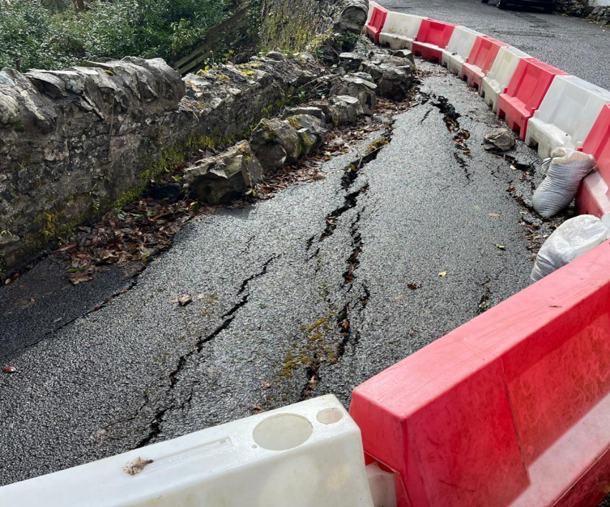
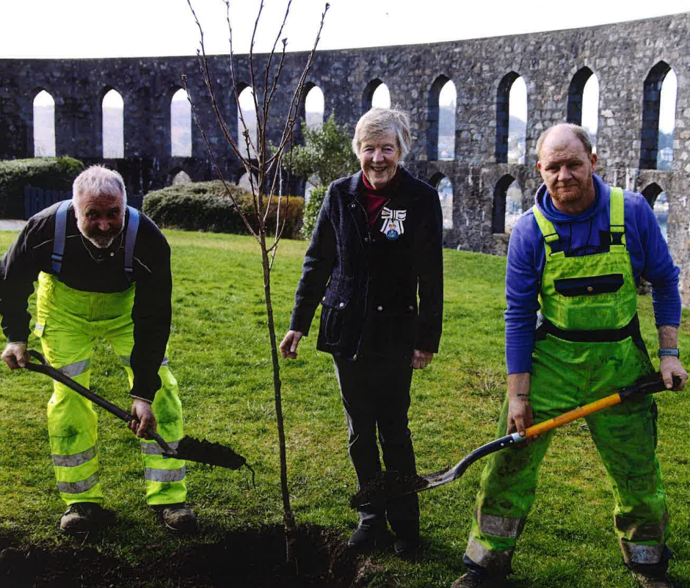
Subsidence on Ardencraig Road
Our Amenity team assisting with the planting the Japanese cherry trees for the Lord Lieutenant of Argyll & Bute at McCaigs tower – picture taken by Kevin McGlynn

