
All weekly briefings can be accessed here
Roads and Infrastructure
Weekly member briefing
Edition 235: 6th March
2026

Oban, Lorn and the Isles | Helensburgh and Lomond | Mid-Argyll, Kintyre, and the Islands | Bute and Cowal
Mull ferries – capital works  CalMac have confirmed that the single vessel timetable serving Mull will remain in place until at least 11 March after the Isle of Arran was redeployed elsewhere on the network. This means the planned transport of materials and plant for Council capital works on Mull cannot take place next week as expected. As a result, works have had to be curtailed and reprogrammed, and it is likely this will lead to some capital carry-forward into 2026/27 given the short notice and difficulty in rebooking sailings.  Mull bin collections  Due to vehicle breakdowns we’ve been running behind with collections on Mull, however the team are out today on a rest day and will be working tomorrow to catch up.  Roads updates  Surfacing works have been ongoing this week on the A816 at Kintraw Hill, with tractor and flail roadside scrub clearance at Kilmore also ongoing. | Cardross Crematorium  There are currently 27 bookings at Cardross Crematorium over the next fortnight.  Roads updates  Surfacing of the two railway bridges as advised last week has been ongoing this week.  The team have also been undertaking clearance and repair works to drainage culverts across the area.  Streetlighting  The last of the new replacement streetlighting columns were installed this week.  Colquhoun square benches  As part of developing plans for the use of the £57,000 CHORD legacy funding as previously reported to the Helensburgh and Lomond Area Committee, we have had a company in last week and this week refurbishing some of the benches within the Square. This is a trial to see how the benches look after refurb, which includes a steam clean and a biocide treatment to prevent fungus. Pictures below show before and after – the benches need to be left now for a couple of weeks to allow the specialist biocide treatment to fully permeate the wood before being sealed/coated.  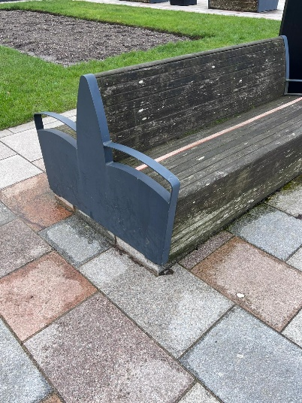  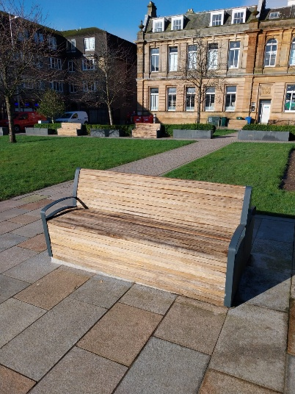 | Roads updates  On Islay the team are continuing with the Bruichladdich footway and block paving at Morrison Court.  Routine works on mainland and ongoing edge strengthening works on the A819 Inveraray to Dalmally road.  Claonaig Bridge strengthening works  These began this week with the contractor setting up their site compound. Works to the bridge itself will begin shortly.  Loch Fyne Oysters – potential new bus stop  There is a site meeting on Wednesday with local businesses, community representatives, landowners, Transport Scotland and our project and public transport teams to further scope out and discuss this project. Funding is in place for a new bus stop and lay by from the bus Infrastructure Improvement Fund. | Roads updates  In Cowal the team have been working on surfacing at the Ardlamont Loop as well as potholing in and around Lochgoilhead, Glen Massan and along the A886.  We have also been undertaking footway works in Tighnabruaich.  On Bute the focus of works this week has been pothole repairs and culvert/drainage works.  Ardencraig Road, Rothesay  We are investigating potential issues with a retaining wall on Ardencraig Road – the vegetation has been cut back and we are going to do some core samples in the next week or so.

