
All weekly briefings can be accessed here
Roads and Infrastructure
Weekly member briefing
Edition 230: 30th January
2026

Oban, Lorn and the Isles | Helensburgh and Lomond | Mid-Argyll, Kintyre, and the Islands | Bute and Cowal | All areas
Roads updates  The Oban and Lorn roads team have bene working on a surfacing job on the U10 Achavaich Road, which will improve the road such that it can form part of a national cycle route. This scheme is expected to complete Monday.  Following that the team will move to surface the Achleven Road which is in the same area. 120tonnes of material will be laid which will improve a roughly 300metre stretch of the road.  On Mull the team are working on replacing damaged drainage channels across the island, as well as scrub cutting.  Luing ferry forum  Our Marine team facilitated a ferry user forum with the Luing community last night, which is part of an ongoing programme of engagement with our ferry users. | Luss road markings  The new road panel markings in Luss have been completed (see image below).  Roads updates  Next week the lining contractor is expected to complete centre and edge lines on the main road through Cardross following a capital surfacing scheme.  This week the team have been undertaking drainage investigation works in Shandon on Shore Road following recent flooding reports/concerns in the area. This investigation work will continue next week.  We also have CCTV equipment surveying the drainage on School Road in Kilcreggan which has suffered from significant flooding issues recently. The purpose of the survey is to see if the existing drainage is operating as it should, however, ultimately the system itself does not appear to be able to cope with the volume of water and may need to be redesigned. | New safety barrier Summerhill Crescent, Campbeltown  We are looking to install a new safety barrier at Summerhill Crescent in Campbeltown. The barrier has been ordered and the contractor is set to start in around four weeks’ time – the job itself is expected to take around a fortnight.  Port Charlotte bus shelter  The shelter was damaged beyond repair, during a storm event last year and the replacement options now require us to consider disability compliance legislation. To meet this requirement and to avoid moving the established bus stop, our proposal is to move a shelter backwards off the pedestrian footpath, into the ground in the lower terrace of the church graveyard. This will involve the removal of a short section of the stone wall, to form a base on the grass area and allow the reinstatement of the boundary wall and erection of a new shelter.  Our burial records have indicated that there are no interments in this part of the graveyard and the presence of the access path (photo attached) to the building at the back of the graveyard, also indicate this is an unused area for interments. We are planning to do a preliminary shallow excavation, to further ascertain any evidence of historic interments, before taking the project forward. | Roads updates  This week the team has been focussing on drainage and ditching works across the network.  A815 debris etc. on road  An issue was reported to us this morning that trucks appear to be driving along the verge along the A815 at the previous landslip site and this is causing mud and debris to scatter across the carriageway. Our contractor is monitoring this situation and clearing any significant build up. | Staff training  This has been a busy week for staff training, with fleet operatives completing air tech exams, a number of colleagues at all supervisory and management levels of the Operations team completing O-Licence awareness training today, and colleagues in our design team continuing with CIPD training provided through the Institute of Civil Engineers.  Weather  The forecast is for a wetter weekend, but there is the prospect of some localised wintery showers. Our daily winter action plan and a host of other helpful resources are available here.

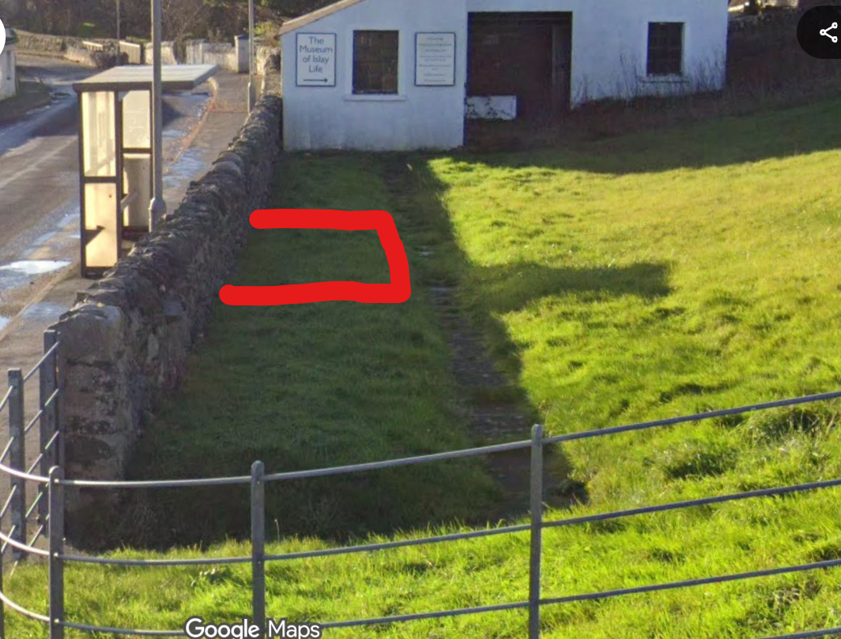
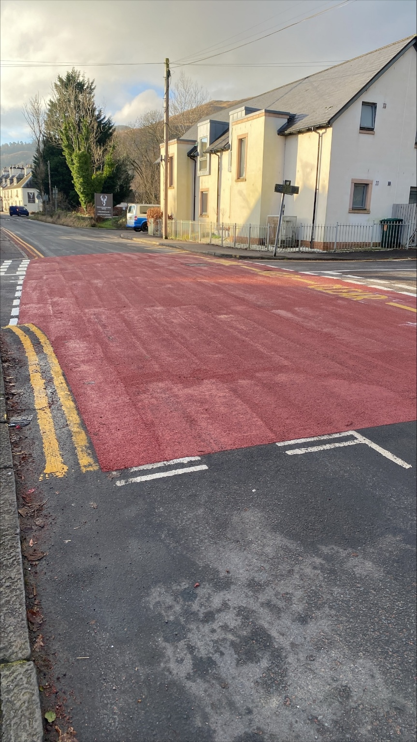
New road panels, Luss

