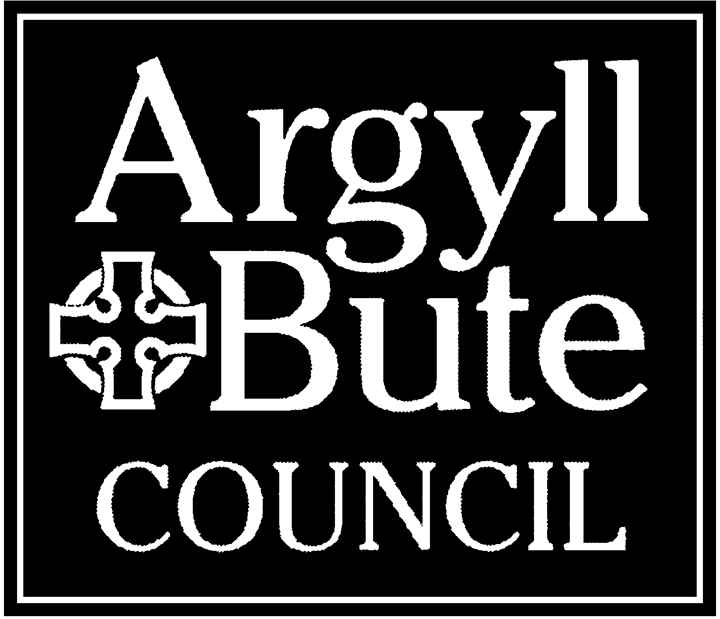
APPLICATION FOR ADDING PROPERTIES TO AN EXISTING LANDLORD REGISTRATION
You can use this form to add properties to an existing registration only.
You can also add these online at www.landlordregsitrationscotland.gov.uk. You can use the online application system to register in several local authorities in one application and this will reduce the total fee that you will have to pay (see the accompanying notes for details on fees).
Please read the accompanying notes carefully before submitting your application. These notes will also tell you how to make payment. Unless stated ALL fields are mandatory.
Important Information
Anyone who gives false information on this form, or fails to give information required by this form, is committing an offence which could lead to prosecution.

Landlord Registration – additional rental properties
Please use this form to provide details of your additional properties. If you have more than one additional properties please use further copies of this form to detail these.

Question 1 – about you
Full Name
Home address

Existing Landlord Registration Number

Question 2 – about your rental properties
Please use this section to enter details of your rental property. If you have more than one rental property please copy this form and use it for each additional property.

Address of rental property
Postcode of rental property
Is this property jointly owned?
(see notes for important information regarding joint owners)

Yes – please provide details below No

Name and address of joint owner :

Is this owner already registered? Yes / No
Joint owner registration number :

Note: ALL owners of the property MUST register and must make their own application/renewal as appropriate – although usually there would be no charge for joint owner applications (unless a late application fee applies) Completing this form DOES NOT make the application on behalf of the joint owner who must also make their own application.
Is this property a house in multiple occupation (HMO)?
(see notes for important information regarding HMOs)

Yes – please provide details below No

HMO Licence number :
HMO Licence expiry date :
Does this property have a Repairing Standards Enforcement Order (RSEO)?

Yes – please provide details below No

RSEO reference number :

Does an agent manage this property on your behalf?

Yes – please provide details below No

Scottish Letting Agent Registration Number :
(New since 2018 - this is NOT the same as a landlord registration number and you may have to contact your agent to get this)
Name and Address of agent :

* remember to add ALL additional properties and joint owners – using additional property sheets as necessary for each property

Question 3 – the public register
Please choose the address you wish to show on the public register for the above property.
This will be the address made available on https://landlordregistrationscotland.gov.uk/

Your Home/Organisation Address
Your agents address (as provided above)

A different address please provide details below (including full postal address with postcode)

Remember you must add all properties that require registration and each of the joint owners for those properties

I declare that I comply with all legal requirements relating to my letting of houses. Full information on requirements for landlords can be found at https://www.mygov.scot/renting-your-property-out/.
If in doubt about legal requirements you should consult a solicitor or professional letting agent.

I declare that the information given in this form is correct to the best of my knowledge.

I enclose a payment of £ - cheques payable to “Argyll and Bute Council” please (each additional property added will have a fee of £19).

A local authority may use information it holds about you to determine whether you are a fit and proper person to act as a landlord, or to act for a landlord. In addition, local authorities to which you apply may share relevant information they hold about you with one another to help those authorities determine whether you are a fit and proper person to act as a landlord, or to act for a landlord. They may also share and seek relevant information with the Police Scotland and, if appropriate, other relevant authorities. Information is shared in terms of the Antisocial Behaviour etc. (Scotland) Act 2004 in terms of s 139.

Signed
Date
Print name

Please send this form once complete along with payment to:

Argyll and Bute Council, Landlord Registration and HMO Licensing, Environmental Health, Kilmory, Lochgilphead PA31 8RT
Email: landlord.registration@argyll-bute.gov.uk
Tel: 01546 604818

