
All weekly briefings can be accessed here
Roads and Infrastructure
Weekly member briefing
Edition 228: 16th January
2026

Oban, Lorn and the Isles | Helensburgh and Lomond | Mid-Argyll, Kintyre, and the Islands | Bute and Cowal | All areas
Roads updates  Next week we will be resurfacing the U10 Degnish road. This work is associated with the ongoing coastal protection works.  Images below show the rock armour that has been installed to create a barrier between the water and road helping to protect against future erosion.  Oban North Pier Pontoons - Breakwater Repairs  Following damage suffered to the breakwater units at Oban from Storm Eowyn and Storm Amy, plans have been developed to temporarily relocate the damaged units within the facility to allow expanded berthing space until new units can be procured and installed.  Contractors are scheduled to begin work in mid-February, with an estimated duration of around 8-10 weeks (weather permitting). Works will include uncoupling the units, relocating and re-tensioning them in their new positions, along with minor surface repairs and replacement of a bridge.  The aim is to partially re-open from April 2026 with access to Breakwater 1 and 2 intended where possible. Final availability will depend on the outcome of the works and further information will be provided as the work progresses. Breakwater 3 is anticipated to remain restricted.  During the works, the facility will be closed to users. Please adhere to any Notice to Mariners in force over the upcoming months.  A full replacement of the units is planned for Winter 2026/27. Further details will follow in due course. | Roads updates  The gully motor is currently operating in the Helensburgh area and is working through the scheduled programme to ensure all gullies are cleaned.  Recent improvements to our asset management system now allow all gullies within the network to be displayed on a mapping system. Gullies that have not yet been cleaned are highlighted in red, helping the team to track progress and help to ensure none are missed.  Barrier works – Rhu  The barrier replacement work along the cyclepath at Rhu is still ongoing and expected to complete next week.  Luss line markings  The lining contractor has commenced work and carried out markings on school road, due to poor weather they had to cease work however they will be returning next week to complete the panels at the Pier Road junction. | Roads updates  Rock armour installation is now commencing at Bruichladdich.  Rock armour works at the south end of Jura are substantially complete. Weather permitting, culvert replacements at these locations will be carried out over the next several weekends.  Rock armour installation on Jura will now progress to the north end at Inverlussa.  Repair works following Storm Eowyn are being finalised on the B8002 at Craignish and the C42 at Achnamara and are expected to be completed over the coming weeks.  Streetlighting  We will have two engineers on Islay next week. They will be assisting with improvement works at Bruichladdich, as well as supporting the contractors working on the dark section at Ballygrant to help restore lighting in that area.  Routine maintenance on drainage and potholes are being carried out across MAKI.  Streetlighting  We will have two engineers on Islay next week. They will be assisting with improvement works at Bruichladdich, as well as supporting the contractors working on the dark section at Ballygrant to help restore lighting in that area. | Roads updates  Following the recent landslip on the A815, the road was closed for a couple of days to allow the hillside to be monitored and to ensure that no further debris or large boulders were at risk of falling.  A diversion route was in place with a weight restriction implemented.  The large boulders that posed the most risk have now been removed, and monitoring of the slope is ongoing.  We have been able to reopen one lane of the road, which is currently operating under traffic management. Specialist contractors remain on site, and a further update will be provided next week.  If weather conditions worsen or there is a risk of further movement on the hillside we need to reclose the road to ensure the safety of the travelling public.  Roads updates – Bute  This week the team have been carrying out a range of general maintenance works, including culvert inspections and ditching works along the A844.  Ditching work involves clearing, reshaping, and maintaining roadside drainage ditches to ensure surface water can flow freely away from the carriageway. This helps prevent flooding, standing water, and damage to the road structure, particularly during periods of heavy rainfall.  In addition, the team have undertaken pothole repairs on Ardmaleish, Eaglesham Terrace, and Dean Hood Place. | TRO requests  We have collated any TRO requests that are in memberzone into a list for each area and will continue to update the lists as new requests are received.  The lists will be passed to the Network and Standards Team prior to any pre-statutory engagement sessions involving Community Councils and Elected Members.  As we are unable to provide individual updates on MemberZone cases at this time, a response will be provided confirming that the request has been added to the relevant list and will be progressed through the Network and Standards Team in due course.  EV chargers  We have secured funding to upgrade nine of our EV chargers to enable contactless payment.  We are currently liaising with the contractor, and works are expected to commence towards the end of February.

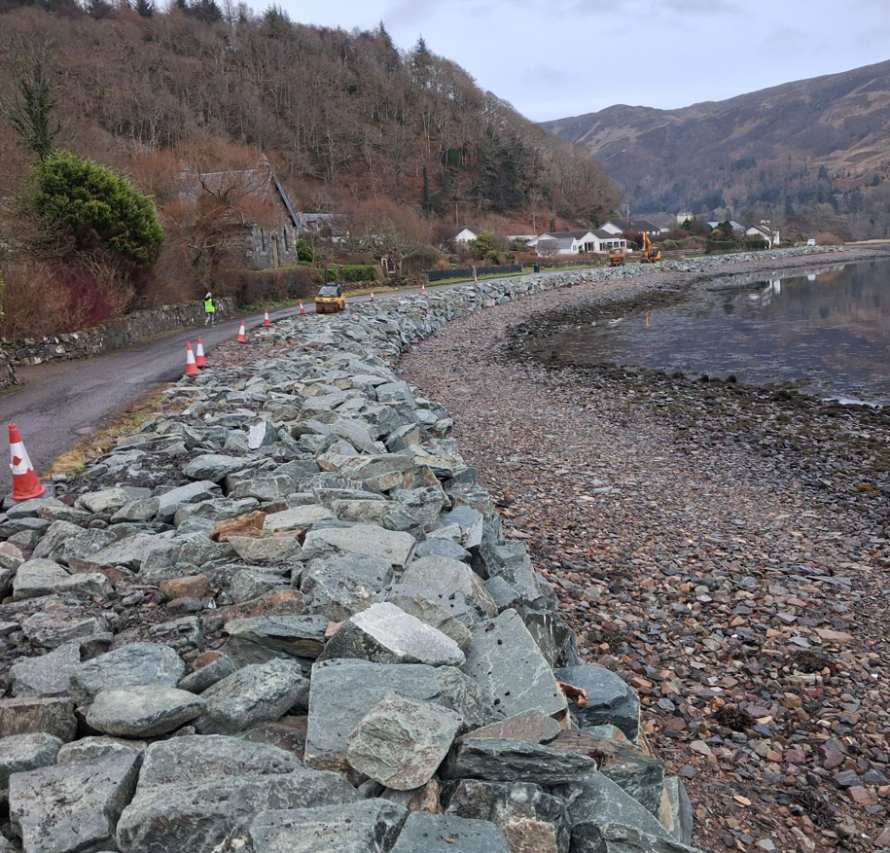
Ongoing coastal protection works at degnish – Rock armour installation

