

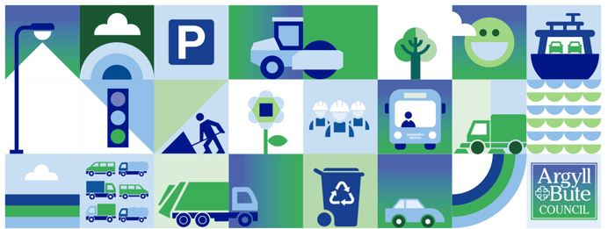
This week’s briefing takes a different format as this is the last working day for many until 5th January, so we’ve included below details on festive working arrangements, what to do in an emergency as well as providing a brief reflection over the last calendar year for the services that Roads and Infrastructure (RIS) deliver for our communities.
Roads and Infrastructure
Weekly member briefing
Edition 226: 19th December
2025 has been another increadibly busy year across the wide and diverse range of services and projects that RIS deliver. In additon to some highlights included in these weekly updates we provide cyclic and planned work across all of our services and these largely happen in the background, unnoticed. We continue to be sucessful in securing external funding, often from very competitive bids, which has enabled many additional projects to be progressed this year and/or plans to be firmed up for future projects and developments.
The team has also responded to some significant storm events this year, most notably Storm Eowyn in January and storm Amy more recently. This involved the normal stand-by crews and staff being supported by a number of others who turned out at weekends and in the evenings to keep the network safe, and open where possible. After the storms, teams have progressed a variety of repair works which have mainly focussed on different types of coastal protection work, from small scale rock armour in some locations to complete new sea walls in others.
Some highlgiths from this year include:
- Successful delivery of our roads reconstruction programme.
- Successful delivery of a number of storm related coastal protection works.
- Progress with playpark improvements across all areas.
- Securing over £1.3million in external funding to support the expansion of our electric vehicle charger network.
- Progress of works at all mainland landfill sites, converting them into waste transfer stations to comply with the landfill ban starting in January. All waste collected in the waste PPP area and in the Lomond area will be going to energy from waste facilities from January.
- Over £400,000 secured from the Transport Scotland road safety fund for new footways, which are progressing across the area.
- Development of our piers and harbour assets with successful completion of the Campbeltown Harbour Wall A project and good progress on the new Iona breakwater.
- £414,000 of bus infrastructure improvement funding secured from Transport Scotland, a report on which was considered at EDI yesterday.
Many of our staff will be working in between Christmas and New Year, while others will be on stand-by to ensure the road network remains open and safe during any periods of poor weather, which could include being out driving gritters on Christmas Day and New Year’s Day if there is cold weather forecast. Council run ferries, refuse and recycling collection services etc only stop for the set public holidays, and our burial service have 2 burials to support between Christmas and New Year.
On the Member Zone resource library you’ll be able to access things like the winter policy and briefing notes on winter. There are also a range of useful resources such as the daily action plan on the Council website here. There you can also access gritting routes, grit bin locations, road cameras and handy FAQs.
For any out of hours emergencies we use a system called RALF, which is used by most roads authorities in the West of Scotland. They operate a call centre in Glasgow which has the contact details of our stand by rota to pass on incidents. You can call RALF on 0800 373 635. More information on the overall arrangements for the Council during this period are available here. On that page you can also find links ot the festive ferry timetables – our ferry crews will be working over the period, but not on Christmas Day or New Years Day.
There are some changes to bin collections over the festive break, and all the details are on the website here.
We will be back with edition 227 on 9th January 2025. We hope that you are continuing to find these weekly updates helpful – we would welcome any feedback or suggestions on the weekly briefing content for 2026.
In the meantime all the very best over the festive period from all the team at RIS.

