
All weekly briefings can be accessed here
Roads and Infrastructure
Weekly member briefing
Edition 225: 12th December
2025

Oban, Lorn and the Isles | Helensburgh and Lomond | Mid-Argyll, Kintyre, and the Islands | Bute and Cowal | All areas
North Pier Car Park – Winter Swimming Event  The North Pier car park is closed today to facilitate the Winter Swimming event. Signage has been put in place, and the public road remains open.  The event area has now been set up (see photo below). There will be around 150 swimmers from 15 countries inc. America, Africa, Thailand, Norway, Austria, Estonia, Sweden, Germany, Finland, Denmark, France and all nations of the UK.  Gribun rockfall  We’ve had a few queries in this week about the timescales on repairs at Grubin on Mull. At this stage it’s too early to say – we are working through various options. A specific report on Gribun is being considered at EDI next week and can be accessed here. | Roads updates  The team have been focussing on the footway improvements on the A814 at Faslane again this week – this scheme will complete next week.  We had arranged contractor assistance for the installation of new railings along the cyclepath at Rhu but were let down by the contractor at the last minute. We are rescheduling this work and will update when a new contractor is found.  A814 Faslane flooding  There have been several incidents of flooding on the A814 at Faslane in recent weeks. All Council culverts/sections of culvert owned by the council are clear and running freely. The issue is with culverts under the road into the Base. We are liaising with the MoD on this and hope that they will have a solution in place shortly.  Luss line markings  The lining contractor is scheduled to go to Luss on 12th January to do the panels at the Pier Road junction. | Roads updates – Kintyre  In Kintyre the team have mainly been undertaking emergency works after Storm Bram. This has included repairs to sea wall breaches on the C19 near to Glenramskil, as well as ditching clearing culverts and tidying up sea debris from affected carriageways on the C18 Keil.  Roads updates - Islay  All rock armour deliveries on Islay are now complete. Due to the bad weather Jura is still ongoing.  Our sub-contractor has already commenced work, and has started putting rock armour in place at Springbank; this will continue into next week.  The team have also started marking out the Bruichladdich footpath and road from the shop to the distillery. This is a new footway funded through the Transport Scotland Road Safety Fund. As part of this scheme we will need to liaise with properties/landowners along the route – this is ongoing.  One of our single-track roads at Ardbeg was affected by Storm Bram. The works required were fairly minor – there was a little bit of erosion to the road edge which we needed to attend and build up. We also carried out drainage and ditching work due to the flooding.  The junction at Frederick Crescent and Mansefield Road flooded again – this was attended to by Scottish Water who rectified the issue.  Roads updates – Mid Argyll  In Mid Argyll the focus of works this week has been on routine maintenance as well as coastal protection storms repairs at Craignish.  Campbeltown New Berth - Wall A  The new berth at Campbeltown welcomed its first visitor – MV Loch Riddon, please see photos  below.  A816 Millbrae (Carnasserie) Landslip – Emergency Works  A significant landslip has occurred below the A816 at Carnasserie, on the bends just past the Ford road end (currently under traffic lights).  The landslip occurred over the weekend of 28–30 November and affects a strategic route.  Specialist contractor Geo-Rope was commissioned to inspect the slope and prepare an options report.  The report concludes that further slope failure is likely and that there is a high risk of a further landslip potentially resulting in closure of the road if works are not undertaken.  As a result, emergency works are required and need to commence as soon as possible to reduce the risk of further failure.  Geo-Rope is currently on site and is the only framework contractor with capacity to undertake the works at such short notice.  Works are expected to commence within the next few days.  The indicative cost of the works is estimated at £1.3m–£2.75m, with the final cost dependent on ground conditions once works begin.  A formal report will be presented to Council in due course setting out how the works will be funded. | Roads updates – Cowal  This week we have been clearing debris on roads following Storm Bram. The gully emptier has been out all week dealing with chocked culvers due to flooding. At Brae Road, Sandbank, we are raising dropped kerbs and reinstating driveways to prevent flooding to the properties, this will continue into next week.  Ditching works on the C9 Blairmore/Ardentinny are now complete, as are drainage works at Midge Lane.  Next week we will be applying a topcoat to the footway at Cowal Place, hot screeding around the cowal area and general housekeeping (potholes/culverts/ditching/offlets).  Pothole repairs on the A815 and in the Lochgoilhead area, along with works on the B8000 are still ongoing.  Roads updates – Bute  Drainage improvements on Eastland Road and Rhubodach Road are now complete.  We have been undertaking culvert works at the Kilmory Circle and the gully motor is out clearing gullys.  Next week we continue on Gully motor and general maintenance works.  Rothesay Harbour – Phase 3 (East Roundhead) – Project Update  Rothesay Harbour has a long history of development and has experienced differential settlement, with Phases 1 and 2 recently completed to address settlement on the main pier deck.  Recent inspections identified concerns at the East Roundhead, which forms part of the harbour entrance.  Dive surveys found significant deterioration to concrete piles, particularly piles 5 and 6, where concrete loss below water level has exposed the reinforcement cage.  Despite this, stainless steel sheet piles installed in the 1990s remain in good condition and continue to provide structural support.  As a precaution:  The roundhead has been restricted to pedestrian loading only,  Berthing activities have been suspended,  With these measures in place, there is no immediate risk to life or assets.  The Council has appointed AECOM to prepare an optioneering report, considering:  Long-term harbour requirements,  Environmental loadings,  Construction methods and materials,  Noise, vibration and social impacts,  Ferry service disruption,  Health and safety.  Six potential options have been identified, ranging from do-minimum to full reconstruction.  The report highlights data gaps, and further investigative work is required before a preferred option can be recommended.  Next steps include:  Gathering additional technical data,  Engagement with CalMac to assess ferry service impacts,  Providing updates to Members once a preferred solution is identified. | EV Charging Network Migration  The council-owned public EV charging networks across Argyll and Bute, the Western Isles, Orkney and Shetland will transition from the ChargePlace Scotland (CPS) platform to Scottish Power’s EV charging network.  This change is required as the ChargePlace Scotland network is being discontinued nationally.  To minimise disruption and avoid a piecemeal approach, the migration will be delivered as a single, coordinated programme during February 2026, with all affected chargers transferring at the same time.  Customers will need to take action by mid-January 2026 to ensure uninterrupted access to public charging facilities both during and after the migration.  The key actions for customers are expected to include:  Registering with or downloading the Scottish Power charging app (or equivalent access method),  Setting up a new customer account, including payment details,  Familiarising themselves with any new tariffs, payment methods, or user interfaces associated with the Scottish Power network.  From 17 December 2025, the Council and partners will issue detailed public information setting out:  What is changing and why,  The benefits of the new charging network,  A clear timetable by location showing when chargers will transfer,  The specific steps customers must take, with clear deadlines.  Communications will be delivered through a wide range of channels, including:  Council, HITRANS and Scottish Power websites,  Social media platforms,  Local and regional media,  to ensure customers have sufficient notice and clear guidance ahead of the changeover.  Further updates will continue to be issued as the migration programme progresses, with a focus on minimising disruption for residents, visitors and businesses reliant on public EV charging.

Winter Swimming Event

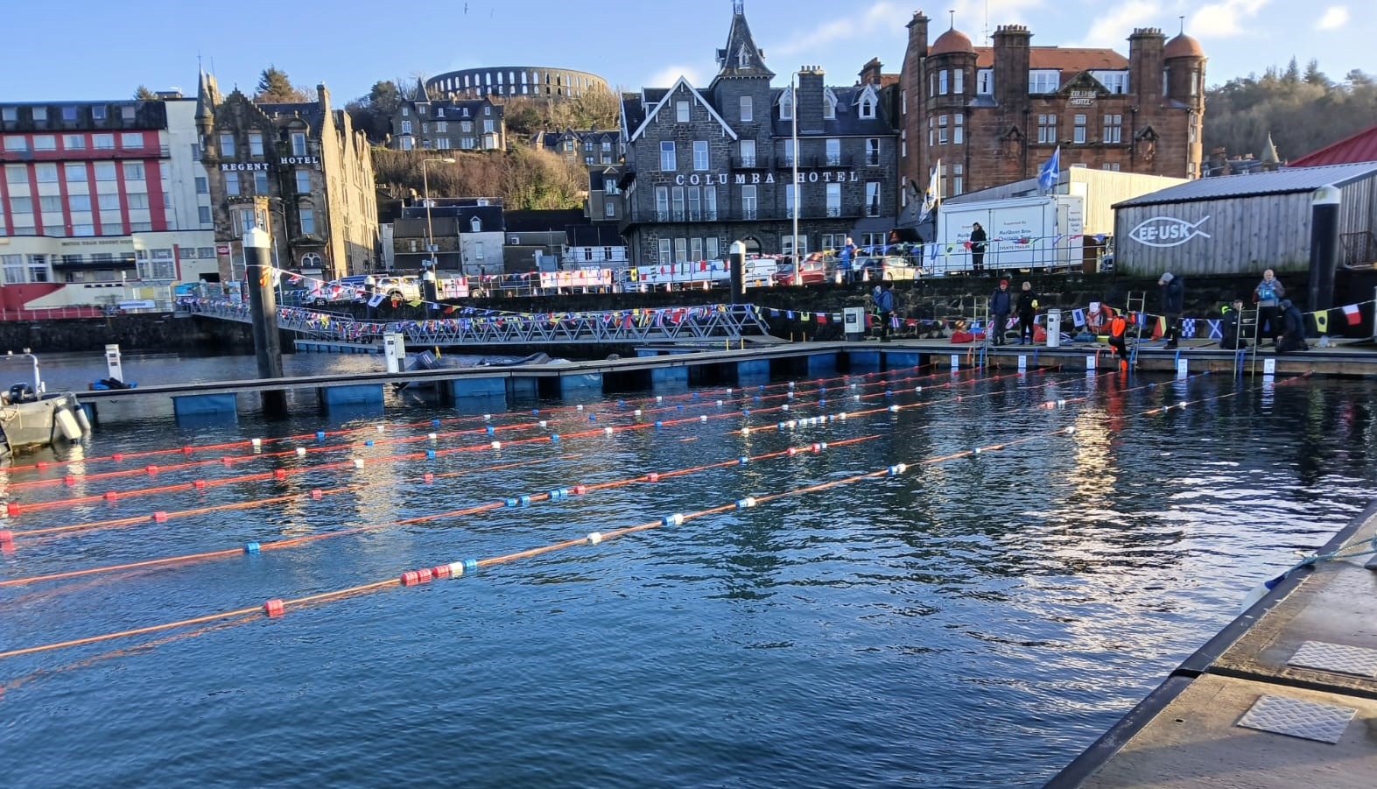

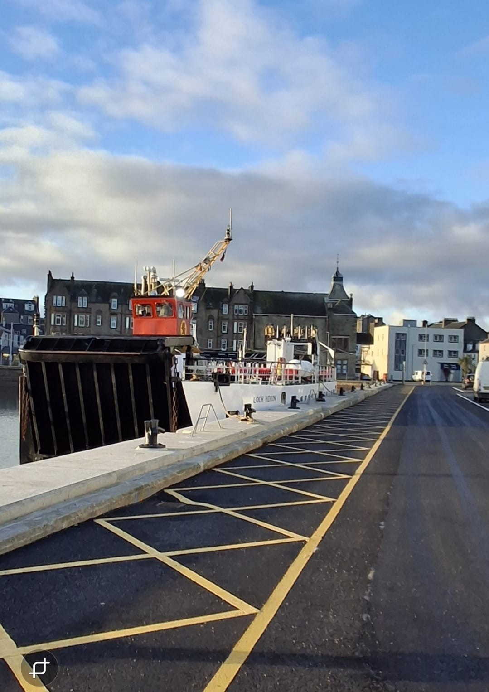
MV Loch Riddon at our new berth on 30th November
