
All weekly briefings can be accessed here
Roads and Infrastructure
Weekly member briefing
Edition 221: 14th November
2025

Oban, Lorn and the Isles | Helensburgh and Lomond | Mid-Argyll, Kintyre, and the Islands | Bute and Cowal | All areas
Roads updates  The capital resurfacing scheme on the B845 completed this week.  General revenue works such as ditching and culvert repairs across the network are ongoing.  Bridges  A works tender is currently out through the structures framework for three bridges:  C029-130 Inverinan Bridge, C029-160 Achachenna Bridge, and the C032-100 Blackmill Reservoir Bridge.  The works are being carried out to fix defective parapets and to improve road safety within the bridge extents, activities to be carried out include:  - Parapet Upgrades/Replacement  - VRS Installation  - Edge Protection  - Bridge Widening by installing additional beams  Tenders are expected to return in December with Contract Award likely to be January 2026 due to the Christmas holidays, this will mean works would be expected to start February 2026. | Roads updates  The team have carrying out general maintenance works across the network with a particular focus being on ditching works along the B833 and the A814.  Lining contractors are scheduled to attend the area next week (weather permitting) to carry out the lining works required following the completion of recent capital schemes.  Barrier contractors have been on sites in Kilcreggan, Clynder and Helensburgh to assess repairs that are required to safety barriers along these routes. | Roads updates  Following damage caused by Storm Eowyn the team have now completed the coastal protection work at Ormsary and will next move to Ardfern.  Similar work also continues at Torrisdale Bay.  Coastal protection projects on Islay and Jura are scheduled to begin within the next week or two.  The coastal protection work involves creating a ditch and lining it with composite geogrid mesh and textile then filling it with rock armour to form a barrier between the coastline and the carriageway, helping to prevent erosion. The image below shows an example of similar work carried out in previous years.  A847 Bruichladdich  Funding has been secured from Transport Scotland to construct a new footway from Bruichladdich Distillery to the Village Hall. As part of this work, the junction will be extended to align with the new footway and improve visibility.  To maintain the existing road width, the carriageway will be widened on the seaward (opposite) side.  Works to be completed before the end of the current financial year.  Claonaig Bridge Strenthening works  The proposed Strengthening Works of the B842-010 Claonaig Bridge have now been delayed and are now due to commence 2nd March 2026. More information can be found on our dedicated webpage.  B842-010 Claonaig Bridge | Argyll and Bute Council | Roads updates – Cowal  The team have continued with scrub cutting on the A815 at Ardno, and have also been carrying out machine off-let works on the A886 at Glendaruel to help alleviate surface water on the carriageway.  In addition, we have replaced a culvert on Newton village to increase the capacity and reduce potential blockages. We have completed routine culvert checks across the network, including the jetting of several culverts in Toward.  Roads updates – Bute  General maintenance works which has included checking the culverts across the network to ensure there are no blockages which may cause flooding  We have carried out some drain investigation works on the A844 at Mountstuart. We are now awaiting the gulley motor to attend to clear the blockage identified.  Rothesay Harbour lift  A technical fault occurred with the lift last week. The contractor has attended and reset the system to prevent any further problems  Ardbeg Seawall  Works are progressing well with Ardbeg seawall and the expected completion date is January 2026 | Armistice Day  Services were successfully across all areas, with no issues reported.  In preparation for Armistice Day, the teams carried out all required works ahead of schedule, ensuring every location was neat, tidy, and respectfully presented.  Their proactive approach and attention to detail contributed to a smooth and well-managed delivery of services throughout
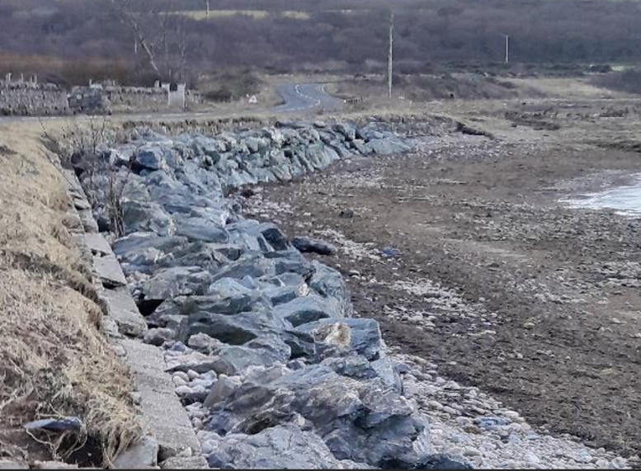

An example of coastal protection work that has been previously completed, using rock armour to create a barrier between the coastline and the carriageway

