
All of this year’s previous weekly briefings can be accessed in order here
Roads and Infrastructure
Weekly member briefing
Edition 209: 22nd August 2025

Oban, Lorn and the Isles | Helensburgh and Lomond | Mid-Argyll, Kintyre and the Islands | Bute and Cowal | All areas
Grubin rockfall  Our contractor has been on site undertaking a drone survey of the affected hillside.  They will now analyse the footage/findings and we expect a report next week.  At present the road remains closed to protect public safety.  Roads updates  Capital improvement works started on Mull this week. The team have completed two schemes in the Bunessan area, and are moving on today to schemes in the Kinloch area. These will continue into next week.  On the mainland this week the focus has been on the second swathe of verge grass cutting.  Oban town centre bring sites  We’ve had some issues with vehicle availability to attend glass bring sites (and commercial customers) this week but have managed now to catch up on overflowing bring sites in Oban town centre.  Recycling Infrastructure Fund (RIF) improvements at Glengorm  The improvement works at Glengorm funded through RIF are making good progress, some photos included below. | Roads updates  Capital surfacing works have progressed this week on Rhu Road Higher and at Woodvale Court.  We try wherever possible to keep disruption to a minimum during works like this, and liaise with key transport providers like local bus companies to make accommodations as far as reasonably practical. | Protection of roadside drainage, Campbeltown  Following reports of local food/catering businesses in Campbeltown depositing oil into the public drainage system we have identified the businesses in question and have visited them and reminded them of their requirements to effectively manage their own waste.  Roads updates  On Islay this week we’ve progressed structural patching on the B8016 – that element of the scheme is now around 75% complete. Surfacing works will commence on Sunday.  As well as the ongoing works on the B8016, we’ll begin culvert improvements work at Springbank on Monday.  On the mainland the focus of work this week has been on surfacing schemes on the Kilberry loop road, in Glenbarr, and at Glenbarr Cottages.  Next week we’ll progress to a drainage, ditching and surfacing scheme at Tangy.  The significant improvements at Electric Cottage on the A819 are continuing – once complete this section of road will be over six metres wide which will provide a huge improvement, as well as the road safety risk of a large drop off being removed.  Campbeltown Music Festival  Ahead of this event we’ve been undertaking additional street cleansing and glass collections, and have plans for same after the event.  Delay set material trial  Following trials with a new cold mix delay set material we are planning to use this for a scheme on Jura starting mid-September. We need to be innovative in trying new surfacing methods on island settings given ferry availability issues meaning we struggle to get enough hot material to the island. The results of recent trials are encouraging. We will provide more details on this when everything is arranged for the Jura scheme. | Roads updates  In Cowal this week the team have been working on surfacing schemes in Tighnabruaich village (Middle Road before moving on to Royal Brae then Shinty Brae) as well as the second swathe of roadside verge cutting.  On Bute the surfacing of the realigned route at Ettrickdale is complete and our lining vehicle has been on the island lining the recent capital sites (see lining vehicle update in the all areas column).  Preparation for local events  This week the team on Bute have been preparing for the Highland Gathering, and the team in Cowal have been preparing for the Cowal Games next weekend. | Lining vehicle  The new lining vehicle is being deployed across various capital sites, and is proving to be a useful addition to our fleet. Providing increased in-house capabilities and making us less reliant on contractor assistance.  Following completion of ling schemes on Bute this week, it will be working in Cowal next week lining capital sites, before heading on to Helensburgh for the same works. After completing the works programme in the East it will move over into the West.  As well as providing commercial opportunities and opportunities to work with neighbouring local authorities, this new vehicle provides the opportunity for staff to receive a recognised SVQ2 level qualification in road lining. To support staff training the vehicle will have some downtime in September when the team goes down to the national training centre in Lincolnshire as part of their ongoing learning.  £400,000 funding secured for bus infrastructure upgrades  We have secured just over £400,000 for bus infrastructure improvements. This is an exciting development – we are in the process of working up potential options for the use of this fund. Given that our annual bus stop improvement budget is just £40,000, we will be able to make significant strides in this area.  For context, a new bus shelter itself costs around £6,000. Of course each site needs groundworks so it’s reasonable to assume at a high level a bus shelter install would cost around £10,000.

Newly surfaced access road to Glengorm
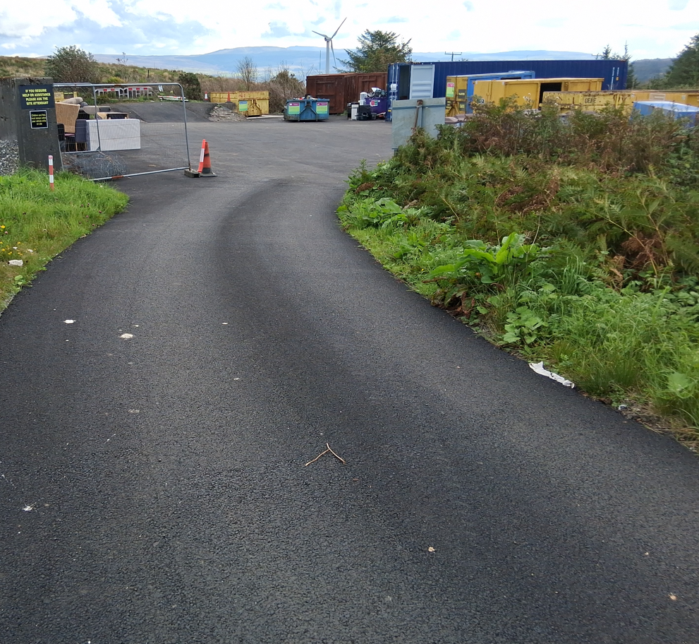

New re-use container
