
All of this year’s previous weekly briefings can be accessed in order here
Roads and Infrastructure
Weekly member briefing
Edition 206: 1st August 2025

Oban, Lorn and the Isles | Helensburgh and Lomond | Mid-Argyll, Kintyre and the Islands | Bute and Cowal | All areas
Roads updates  The Oban roads team are continuing to provide assistance across other areas to complete key capital surfacing schemes in Mid Argyll and on Bute.  The focus of works being delivered in the Lorn area this week are safety defects (pothole) repairs.  Grubin road closure, Mull  We are at the final selection stage of the tender process for a geotechnical specialist to undertake a drone survey of the affected hillside. The contract should be awarded no later than early next week, after which the contractor will have a four week mobilisation period. The road remains closed in the interests of public safety and we would ask people to take heed of the signage which is in place. | Roads updates  The capital surfacing scheme on the A818 Luss Road has successfully completed this week – below is an image of the new, improved surface.  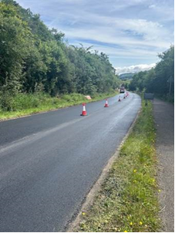  The lining contractor is booked to reinstate the edge and centre lines in the next fortnight, depending on dry weather of course.  Works on Abercrombie Street and Jelico Place have commenced this week and Hardie Hill has been prepared for surfacing – see photo below  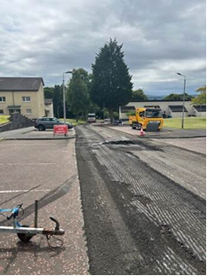  We expect all three sites to be completed by the end of next week.  In terms of day to day maintenance, the roadmaster is working in Lomond this week and next. This week the focus of works has been in and around Fort Road in Kilcreggan.  Disabled bays  A lining contractor will be in on Monday and Tuesday to refresh a number of disabled parking bays throughout the area.  Blackhill household waste recycling centre  The team at Blackhill have made some additions to the site, images below. These are receiving a lot of positive comments from members of the public.  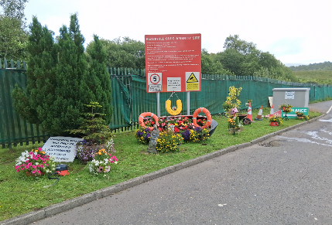  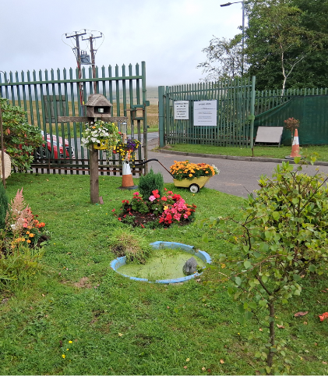    Cardross Crematorium  We’ve recently started taking bookings for chapel use only at Cardross Crematorium. This follows requests from families to use the chapel only before going on to have burials. We feel that if this is a service that people within the community want it is something we should offer, and promote going forward. | Roads updates  Apart from the ongoing works at Electric Cottage the focus of works this week has been on general revenue (safety) works across the area.  In terms of today’s incident on the A82 Tyndrum – Crainlarich, and traffic diverting onto the A819 – we’ve managed to stand down our temporary traffic lights at Electric Cottage to support traffic flow as the carriageway itself is intact – they were only on for safe working space for the embankment excavations. Nevertheless there are reports of traffic tailbacks.  On Monday we will begin the capital scheme at Glebe Street in Campbeltown, following which we’ll move on to surfacing works at the C19 in Southend.  Ground investigation works – Lochgilphead depot  Members might see rotary drilling rigs arriving in Lochgilphead on Monday – these are for ground investigation works at the Monydrain and Bishopton Road depots. | Roads updates  We should be complete at the A8003 road widening scheme outside Tighnabruaich next week.  The team have been undertaking footway works in Dunoon and have also taken the opportunity to install new kerbing at some locations. The surfacing of these areas should complete today.  Towards the end of next week we’ll surface capital schemes at Cowal Place and outside Dunoon Stadium as well as two sections of the Main Road in Sandbank. The planing out of the old surfaces begins on Monday.  On Bute the capital schemes are making good progress. This week the team have progressed schemes at Mill Street, King Street and Stuart Street in Rothesay. | New signage for recycling sites  Below is an image of the new, clear, bright signage, which is part of the wider package of improvements funded through the Recycling Infrastructure Fund  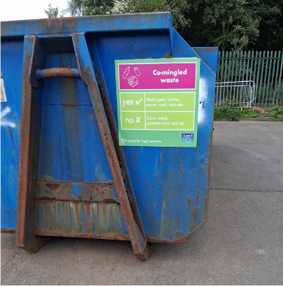  Port Marine Safety Code (PMSC) audits  Next week external audits will begin on our harbours as part of the new PMSC. These are important annual compliance checks.

