
All of this year’s previous weekly briefings can be accessed in order here
Roads and Infrastructure
Weekly member briefing
Edition 202: 4th July 2025

Oban, Lorn and the Isles | Helensburgh and Lomond | Mid-Argyll, Kintyre and the Islands | Bute and Cowal | All areas
Kilninver Bridge  We understand the impact the current weight restriction at Kilninver Bridge is having on the local community and other road users. Together with our contractor, we are doing everything possible to lessen the effects of these emergency repair works and to lift the temporary weight restrictions as soon as possible. The current weight restriction is 18 tonnes, and this will stay in place until 6am on Monday, 7 July, when we expect to lift it and restore access up to the full 44 tonnes.  The overnight closures will be in effect from Wednesday, July 2, until Monday, July 7, between 9pm and 6am. During this time, we will only allow access for emergency services (e.g., police, fire, ambulance). Unfortunately, other vehicles will not be permitted, and we ask road users to make alternative arrangements during these night closures. Our engineers will continue to monitor the bridge's integrity throughout these works, and we will provide an update if the situation changes.  We have received requests to allow pedestrians to cross the bridge at night, unfortunately this is not possible. During the night closure the bridge is an active construction site and therefore to ensure the safety of the public and our construction workers it is not possible to allow pedestrians to cross the bridge.  Cemetery development programme  Calgary Cemetery extension  Planning permission granted on condition Ecological and Archaeological surveys are carried out prior to commencing development. Ecology and Soils surveys complete and reports underway, with Archaeological trench excavations scheduled for w/c 8th July. Land ownership transfer negotiations continue between Estates colleagues and current land owner  Lismore Church Burial ground  In discussions with Lismore Community Council regarding their business plans to purchase and development of existing church building. This involves additional welfare facilities within the existing cemetery - partly within the 1985 extension but on ground not suitable for burials. Works last summer in 1995 extension have treated the ground to release 55-60 multi depth lairs for future sale.  Roads updates  Works are ongoing on Mull where the team are surfacing at the new essential housing development at Rockfield Road in Tobermory.  In Lorn we are continuing with rural grass cutting and safety defects.  The team also repaired a collapsed gully at Soroba Road, Oban this week.  B8035 Gribun – rockfall and road closure  Following a rockfall on the B8035 at Gribun, the road is currently closed while we assess the stability of the rockface.  The diversion is via the A849 Kinloch- Craignure - Salen  Glengorm household waste recycling centre  Surfacing works for the improvements at Glengorm completed this week. Please see photos below. | Roads updates  Grass cutting and scrub cutting continues on B833 this week. We will also be undertaking drainage investigation on B833 to unblock a culvert, traffic management will be in place during this time.  Helensburgh Cemetery  Ongoing - We currently have contractors in Helensburgh Cemetery to repair a large section of damaged wall  Cemetery Development Programme  Arrochar Church  Not a critical site at present but discussions taking place towards potential development of available ground in front of current lairs, towards A814.  Luss, Barbour and Faslane cemeteries  - No presale of lairs in place  - No land available to extend (Faslane 22 years – others 77 years) | Kintyre playparks  All open - Our contractor has advised us that the five playparks will open next week, in time for the school summer holidays.  There is one small issue with the roundabout. We are trying to rectify this in time for next week but if we can’t, the rest of the playpark will open and we’ll barrier off the roundabout until the issue can be fixed.  Royal visit  Our local team assisted around the royal visit by DOING WHAT EXACTLY  Roads updates  Works are underway on the further phase of the improvements on the A819 at Electric Cottage.  The resurfacing of various streets in Campbeltown town centre apart from Glebe Street will complete on Monday.  Cemetery Development Programme  Achnabreac Cemetery  Resources being mobilised late summer / autumn towards excavating remaining area of developed space to remove rock outcrops and maximise multiple depth lair space. Associated works to bring remaining space into operation and improve access and parking facilities, within the boundaries of current ownership.  Kilkerran Cemetery North  Ecology and soils survey completed and reports underway. However, Archaeological trench excavations now postponed until September, due to concerns from current landowner on loss of grazing.  Negotiations continue through Estates colleagues with MoD and main landowner, towards agreements to purchase land for cemetery lairs, access road and parking. formal planning application will be developed to include above survey reports. | Roads updates  This week the widening scheme on the A8003 outside Tighnabruaich has been ongoing. The team have also been out rural grass cutting in the Lochgoilhead area.  The Roadmaster was in Cowal on Monday, and Bute on Tuesday and Wednesday. We also had the new lining vehicle out in Cowal on Tuesday and Wednesday.  Yesterday the team were working on sign poles, culverts and potholing and today general housekeeping.  Next week we will be concentrating on the A8003 widening scheme, and also undertaking rural grass cutting on the A886 at Glendarual.  Bute playparks  The Port Bannatyne and Meadows playpark upgrade works have completed subject to a site safety audit which will be done by our team next week. Audit not happy with finishings, park temporarily closed until contractors rectify work.  Cemetery Development Programme  Cowal Cemetery – Sandbank  Torlochan extension  Ecological and Archaeological surveys are being carried out prior to commencing development and producing a finalised design for planning approval. Ecology and Soils surveys complete and reports underway, with Archaeological trench excavations scheduled for early July. Land owned by A&BC  Kingarth Cemetery extension  Ecology and soils survey completed and reports underway. However, Archaeological trench excavations now postponed until September, due to concerns from current landowner / tenant on loss of grazing / silage crop yield.  Historic Environment Scotland and Archaeologist have advised that the area of the original Kingath Parish Church removed ~1960’s is likely to have buried foundations and historical unmarked interments and is therefore unavailable to re-develop for new lairs, as an interim stop-gap.  Dunoon Cemetery vandalism  Unfortunately Dunoon Cemetery suffered some vandalism this week (see photos below). We have reported this matter to the police. | New signage for household waste recycling centres  New container signage has arrived in Lochgilphead for checking before being taken on to our various HWRCs.  The new signage is for on-site containers and are clear and easy to read. This should make our HWRCs easier to navigate for the public  PCN payment issue  Due to a glitch in our parking payment system it appears that around a week’s worth of PCN payments have not been properly recorded. This is something we are working through with our supplier – we want to rectify this quickly and to ensure the system doesn’t trigger automatic follow up, thinking that people haven’t paid.

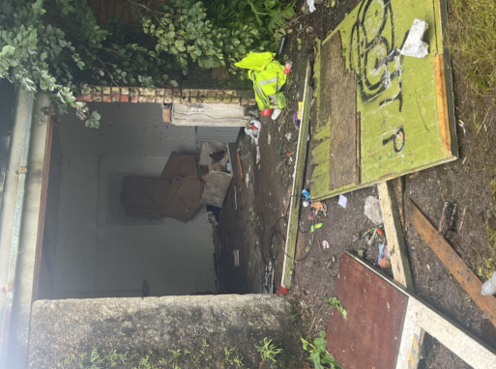 |  | 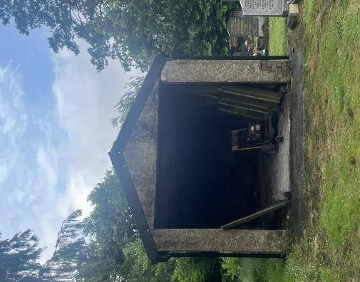

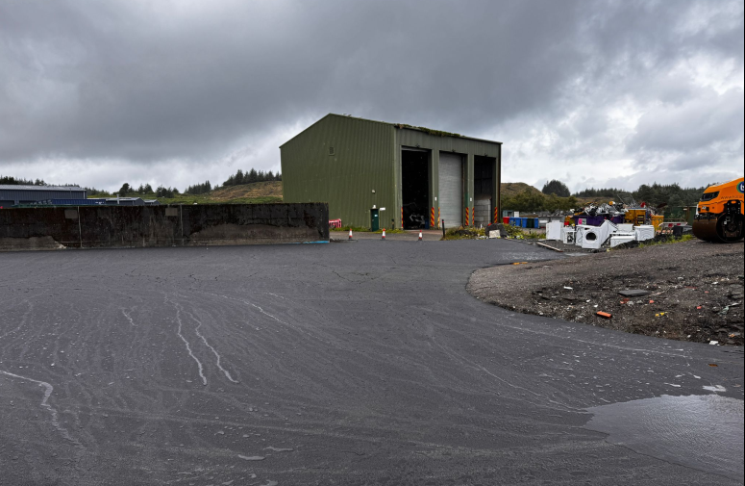 | 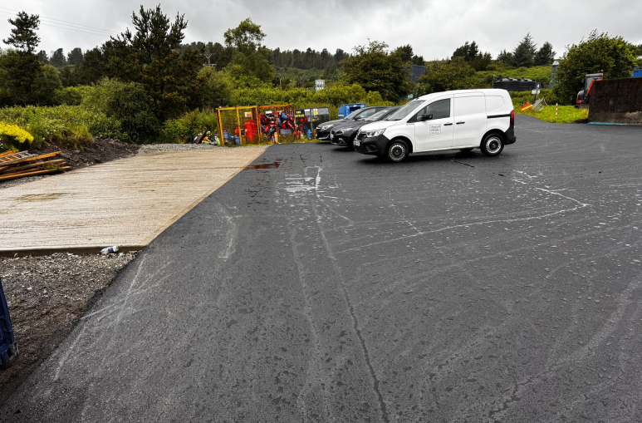
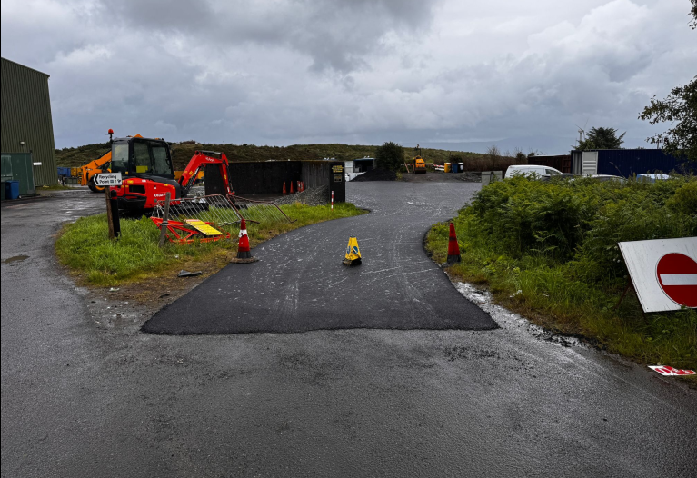 | 