
Roads and Infrastructure
Weekly member briefing
Edition 199: 13th June 2025

Oban, Lorn and the Isles | Helensburgh and Lomond | Mid-Argyll, Kintyre and the Islands | Bute and Cowal | All areas
Roads updates  The ongoing capital works on the Isle of Tiree are progressing well and remain on schedule for completion by next week.  In addition to the works in Tiree, we are planning to complete further capital surfacing schemes in the Lorn area. These include inlay resurfacing on:  - U14 Benvoullin Road  - U18 Rockfield Road  Both schemes are designed to significantly improve the quality and durability of the road surface.  Grass cutting  Rural grass cutting has been underway in the Lorn area.  Next week the team will be moving over to commence grass cutting on Mull. | Roads updates  This week and next, our teams are primarily focused on scheduled cyclic grass cutting across key routes in the area.  This week we have completed grass cutting along the A814 (Helensburgh–Cardross) and the A818.  Crews have now moved on to the A817, B872, and B833, where work is currently in progress.  These efforts are part of our ongoing commitment to maintaining roadside verges and ensuring visibility and safety for road users.  Lining contractors  The lining contractors have been in attendance carrying out the marking of any outstanding disabled bays.  Arrochar Electrical Vehicle Charger  The EV charger at Glen Loin carpark in Arrochar has now been installed.  We're currently waiting on Scottish Power to fit the meter, after which it should be up and running.  Ducting and associated infrastructure have also been put in place to allow for potential future expansion at this location. | Roads updates  Surfacing work has commenced within the Daill Na Mara housing scheme in Port Ellen. This work is being carried out as part of a contractor agreement as we have not adopted this network at present.  Work has also commenced on the Capital surfacing scheme on the UC25 Emeraval link road.  Both schemes will continue into next week.  Next week we are also carrying surfacing works on West Bank road in Ardrishaig.  Pre surface dressing work will also commence in Crinan above Scottish Canals carpark.  Bowmore Public Toilet  Unfortunately we have had to close our disabled toilet at Bowmore due to vandalism, which has caused safety issues. We hope to re-open as soon as possible once repairs are complete.  Traffic and Development Officer  The closing date for this post has now passed and interviews will take place on 25th June.  Gartbreck  Push walls have now been installed at Gartbreck Recycling Centre to help keep waste segregated and the site cleaner and more organised. See photos below. | Roads updates  Capital surfacing works have begun on the A8003 in Tighnabruaich as part of a £63,000 inlay scheme aimed at enhancing the durability and lifespan of the road surface.  We have also been carrying out some general footway repairs in Dunoon town centre.  The jet patcher has also been carrying out some repairs to safety defects identified through inspection.  Bogleha recycling centre  Please be aware that there may be some minor disruption at the Bogleha on Thursday 19th June to allow for the delivery of cabins.  We will make every effort to keep any disruption to a minimum, and will provide further updates on our website closer to the time.  On Bute, we've been marking out all our surface dressing sites in preparation for work scheduled to begin later this month, subject to contractor availability. | Flower beds  Planting efforts are actively underway across all areas, with teams working diligently to ensure flower beds are beautifully arranged and maintained in time for the upcoming season.

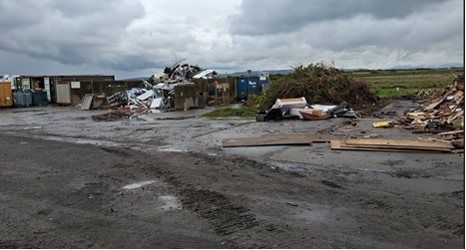
BEFORE

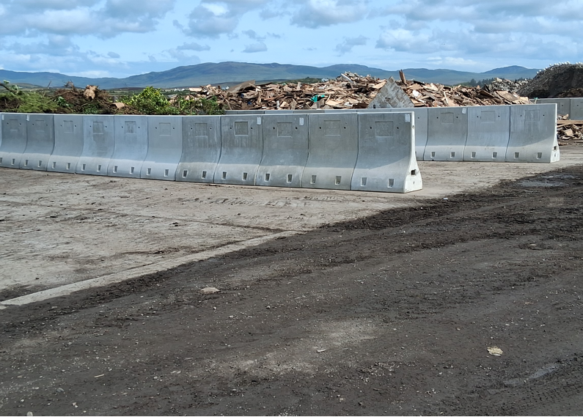

AFTER

