
Roads and Infrastructure
Weekly member briefing
Edition 198: 6th June 2025

Oban, Lorn and the Isles | Helensburgh and Lomond | Mid-Argyll, Kintyre and the Islands | Bute and Cowal | All areas
Roads updates  This week, the main focus is on completing the capital overlay work on Tiree.  The three projects scheduled for completion are:  • U61 Milton Road  • U69 Croft View  • U32 Moss Road  These improvements represent a total investment of approximately £150,000 to enhance the road surfaces.  This work is expected to be completed within the next week.  Iona breakwater  The contractor continues with the landward aspect of the works, including the toilets. However, we are currently addressing a specific environmental issue with the seagrass, that has delayed Transport Scotland’s Marine Directorate from granting authorisation to proceed with the breakwater structure itself.  Fionnphort berthing facility  The Fionnphort overnight berthing facility is scheduled to follow the completion of the Iona breakwater works, with an estimated construction period of approximately 18 months.  An Environmental Impact Assessment (EIA), including a socio-economic assessment, is underway.  Given the issues identified with seagrass on the Iona side, we anticipate similar challenges at Fionnphort.  Consequently, we are making every effort to resolve the core issue with Transport Scotland and the Marine Directorate to avoid delays, and ensure a smooth progression of the project. | Roads updates  The resurfacing works on East Princes Street were successfully completed this week, improving both the safety and overall quality of the road surface.  Although the surfacing itself is now finished, the road markings have not yet been reinstated. A contractor is scheduled to return at a later date to complete the lining works.  This week we engaged a contractor to carry out essential scrub cutting at various locations across the network.  This work was necessary to improve sightlines for drivers, and to clear vegetation around traffic signs.  Next week, our focus will shift towards grass cutting along our priority 1 routes, specifically the A814, A817, and B833. | Roads updates  The team have been completing capital surfacing works in Cairnbaan this week.  This £80,000 investment aims to improve the road surface between the A816 junction and the canal swing bridge.  Line-marking will follow at a later date, in coordination with other necessary works in the area.  Islay  On Islay the Jetpatcher is currently working through safety defects and pre surface dressing works.  On Monday we will commence surfacing work in Port Ellen.  Towards the end of the week we will also be commencing a Capital surfacing scheme on the UC25 Emeraval link road.  This is a £60,000 investment to overlay the surface and improve its longevity.  Streetlighting, Campbeltown  The traffic lights in Campbeltown have now been replaced and are operational again.  We also have contractor assistance for excavation work required to repair a number of dark lamps.  Campbeltown TRO  The Traffic and Development Officer vacancy closed yesterday, and we are now in the process of reviewing the applications received.  We are hopeful that we will be able to identify and secure a suitable appointment. We will then be in a stronger position to prioritise this matter effectively and take the necessary steps to ensure progress is made. | Roads updates  Work on the safety improvements at Strachur has now been completed.  The improvements include extending the 40mph speed limit zone on the A815 south towards Dunoon by 100 yards. As a result, the crossing point now sits 160 yards inside the 40mph zone, compared to only 60 yards previously.  Additionally, the kerbline has been extended to narrow the crossing point, enhancing safety for pedestrians.  All required road markings have also been completed along with the installation of new railings to replace the damaged ones.  Balliemore Bridge  The deck beams for the B836 Balliemore Bridge were successfully lifted into place this week.  The next phase will involve the installation of the approach walls and the casting of an in-situ concrete slab above the beams, which will provide additional structural support and form the final bridge deck.  Rothesay Lifts  Installation and control improvements are being agreed with specialist engineers, which will aim to have both passenger lifts in service and operationally reliable.  Timeline for this will be confirmed when the on-site survey by the new contractors has been completed, this is expected to be over the next couple of weeks, however not confirmed as yet.  Kilchattan Bay sea wall  We have awarded a repair contract to Ross MacArthur Contractors to carry out essential repairs to the coastal wall damage.  We are currently coordinating with the contractor to confirm a start date for the works, and we will provide further updates as soon as the schedule is finalised. | Bus shelter cleaning contractor  We recently issued the tender for the Bus Shelter Cleaning Contract for Argyll and Bute, and are currently reviewing the bids received.

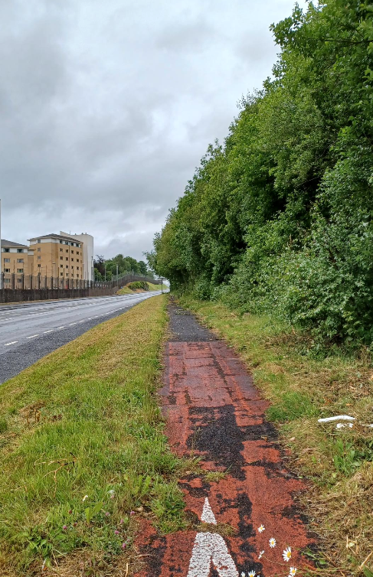
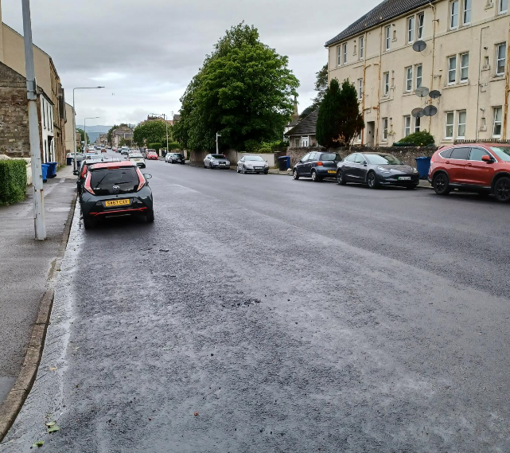
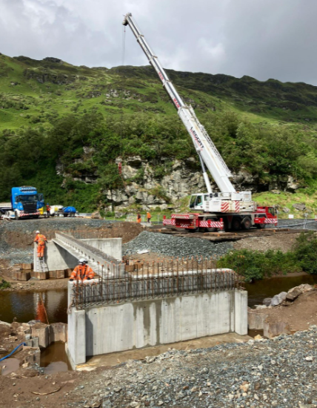
Balliemore Bridge deck being lifted in
Recent resurfacing work on East Princes Street
Recent shrub cutting on the A814

