
Roads and Infrastructure
Weekly member briefing
Edition 196: 23rd May 2025

Oban, Lorn and the Isles | Helensburgh and Lomond | Mid-Argyll, Kintyre and the Islands | Bute and Cowal | All areas
Roads updates  The capital schemes at Balvicar (£60,000 overlay) and on the U18 Loch Nell (£30,000 inlay) have completed this week.  The scheme at the A819 Claddich should complete today. This is a £65,000 scheme of regulate and overlay which will improve over 3,000 sq m of carriageway, and is the fourth phase of improvements at this location in recent years.  Next week’s works include three days of surfacing on the B845 at Otter Creek – traffic management will be in place for that job for the safety of the workforce and travelling public.  SS Waverley  The SS Waverley was at Oban North Pier this week as part of celebrations for its 50th anniversary (see photo below). | Roads updates  The capital scheme on East Princes Street is well underway and is on track to be completed by the end of next week.  This is a £130,000 inlay scheme, which will see over 5,000 sq m of carriageway improved.  The roadmaster has been out again this week in and around Helensburgh repairing safety defects.  302 bus service  The 302 bus service jointly funded by the Council and SPT has been retendered for another three year period. This runs from Helensburgh to Succoth then on to Carrick Castle, with the latter part of the journey being the part the Council funds. The successful bidder was the incumbent supplier Garelochhead Coaches. The new contract will come into effect this summer. | Traffic lights, Campbeltown  Following issues with the pedestrian crossing on Main Street, these lights will be completely replaced starting Sunday 1st June.  Roads updates  Capital works started on Tuesday at the Barnluagan junction and will complete today. This is an overlay scheme which is seeing a £90,000 investment in over 2,000 sq m of carriageway.  The team will be working in Kintyre next week to commence patching at and around the Stewarton junction. This is expected to take three days and traffic management will be in place for the safety of the workforce and road users.  On Islay we’ve completed improvements in Bowmore at the round church, the square and along past Kilarrow.  We’ve also started ditching works at the High and Low roads and will be attending to safety defects in Coull today. | Castle Gardens, Dunoon  To finalise the improvements to Castle Gardens we’ve ordered some new benches and picnic benches. One of the picnic benches is specifically designed to provide wheelchair access.  They are all made of a composite plastic material which has a wood-effect. These wear better and reduce any ongoing maintenance costs. The benches are actually made from recycled plastic bottles!  Youth football tournament  There was a youth football tournament in Dunoon last weekend attended by teams from all across Argyll. Our team received very positive feedback on the condition of and facilities at Dunoon Stadium. A couple of particular quotes have been included below:  The pitch for our festival on Saturday was outstanding, we've had numerous messages from visiting teams commenting on it.  The feedback from the visiting teams was also that they now look forward to coming to Dunoon for league games because of the facility.  Roads updates  The team have been progressing capital works on the A815 at Dunoon road end this week – planing out the old surface on Monday and Tuesday and surfacing Wednesday, Thursday and today.  We’re also undertaking an overlay scheme further down the A815 at St Catherines this week. This is a £45,000 scheme which will see nearly 1200 sq m of carriageway improved.  302 bus service  The 302 bus service jointly funded by the Council and SPT has been retendered for another three year period. This runs from Helensburgh to Succoth then on to Carrick Castle., with the latter part of the journey being the part the Council funds. The successful bidder was the incumbent supplier Garelochhead Coaches. The new contract will come into effect this summer.  Bus services  A contract management meeting was held yesterday with West Coast Motors. Given some recent issues with certain low-use backshift services needing to be stood down by WCM due to driver availability, we felt it would be helpful to arrange a session with Dunoon and Cowal members, colleagues form public transport and West Coast Motors to discuss the issues and the positive efforts WCM are making. This will be arranged shortly.  Dunoon Harbourmaster  Paul Lambert, Harbourmaster, retires today after 34 years’ service  We wish Paul all the best for a happy and healthy retirement. | Lining vehicle  Our lining vehicle is now here and is being stored at our roads depot at Victoria Road, Dunoon.  Three members of the team were being trained on its operation earlier this week, with more training planned for June. It is hoped that we can deploy the new vehicle and start to use it across the network shortly.  We’ve included some photos below.

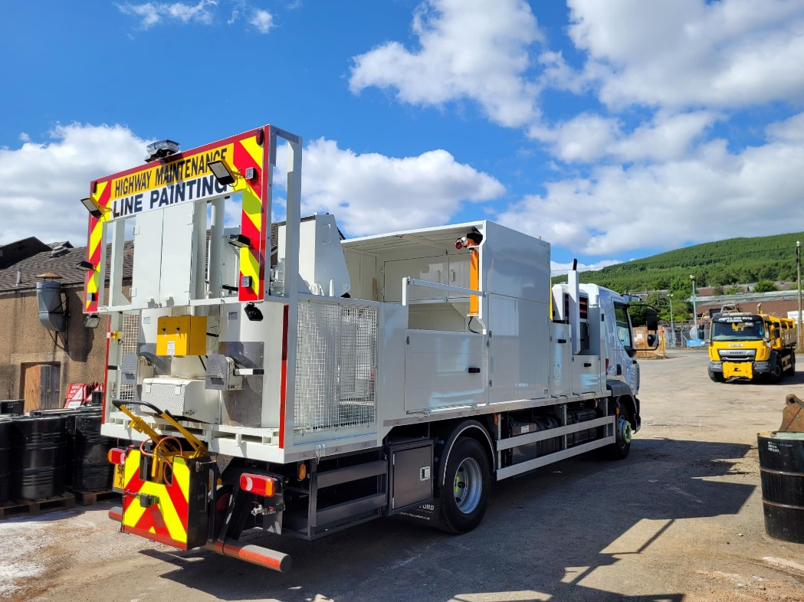
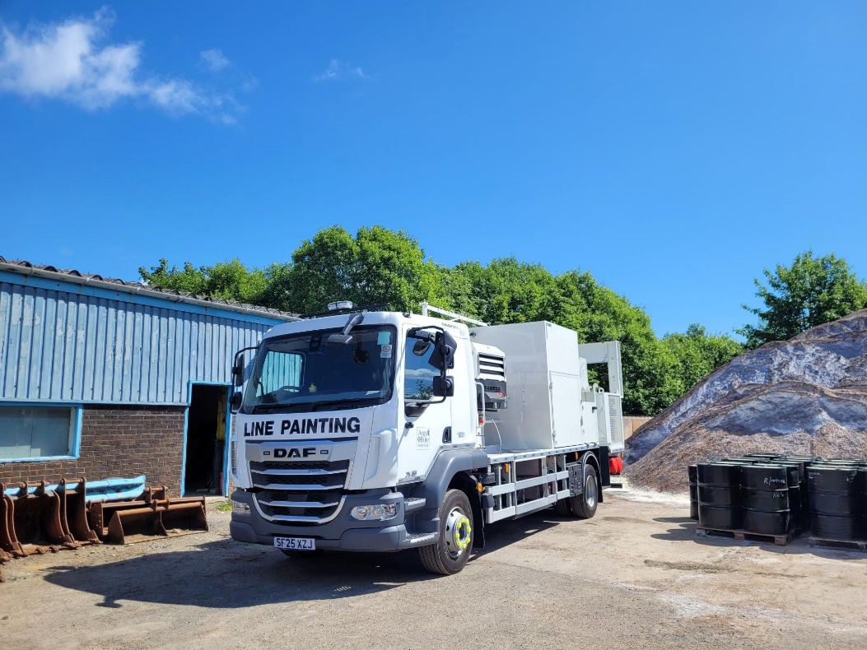
New lining vehicle
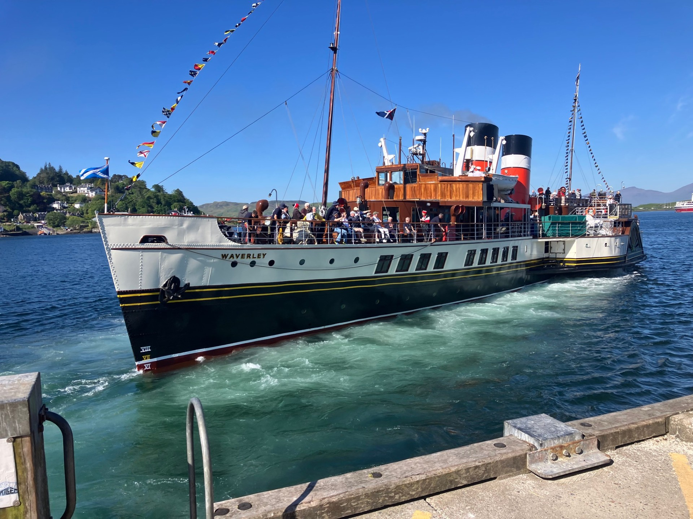
The Waverley visiting Oban this week

