
Roads and Infrastructure
Weekly member briefing
Edition 192: 25th April 2025

Oban, Lorn and the Isles | Helensburgh and Lomond | Mid-Argyll, Kintyre and the Islands | Bute and Cowal | All areas
Roads updates  The final phase of the improvement works at Blaran on the A816 has now completed with the exception of the required lining works, which will be arranged.  Capital surfacing work to commence on Mull in the Dervaig / Calgary area and is expected to take around 3 weeks.  Capital surfacing work also scheduled to commence next week on Luing. Delays will be inevitable however works will generally be early in the day due to tidal issues with the ferry.  We will be looking to start around 0830 each morning but finished around lunchtime all going well. A copy of the schedule has been emailed to the community council as requested.  Work continues with the footway improvements in Combie Street in Oban. | Roads updates  The team in Lomond have been focussing on the Rosneath cycle way scheme as well as safety defect works across the area.  Gulley cleaning will continue this week and next until the hire vehicle is returned.  Streetlighting  Ongoing lighting issues with the lights being locked on at Howie Park have now been resolved. | Roads updates  Works are still planned for Barn Park, Foulis Road, Riochan and Upper Riochan in Inveraray week commencing 5th May.  The same week, we are also undertaking pre-surface dressing on the A816 south of the Ardfern junction, and at Drimvore Road off the A816 near Dunadd.  A816 rockfall  The road is still open under traffic management (one lane). However we hope to have both lanes back open around the end of next week.  Rockbreaking should be finished today and we will be working on the last of the clearance next week.  Islay Skip Lorry  Unfortunately our skip lorry has broken down, which means we are unable to accept any skip hires, collections of hired skips or uplift of commercial skips. This also effects our recycling centre skips at Bowmore, Port Ellen, Bruichladdich and Jura skip sites, we would ask that members of the public refrain from using these sites for the time being, until we have the lorry back on the road or a replacement in place. This could take up to 2 weeks, however we will update the website with any changes. | Roads updates  The team have been carrying out some revenue maintenance works which include ditching along the A844 New Farm and pothole / safety defect patching.  Ditching prevents water from pooling on or under the road, which can weaken the structure and lead to potholes / erosion.  Dead whale, Ettrick Bay  The whale at Ettrick Bay on Bute has now been removed and the shore cleaned.  In Cowal we have been carrying out some pre surface dressing patching on the B836 Glen Lean and U22 West Glendaruel road.  We have also been carrying out footway and drainage improvements at Castle Gardens, Dunoon.  Cothouse Bridge  Next week we are material testing the half-joints of Cothouse Bridge prior to preparation for the repair works that will be tendered later this year. A specialist contractor with a pontoon system and boat will be under the bridge for the full week, no traffic management will be required. | Lining vehicle  We have taken delivery of our lining vehicle. It is currently being registered into our fleet of vehicles.  The supplier will be providing the 1st lot of training to our crew mid May.  The lining vehicle will allow lining work to be completed following the completion of capital surfacing jobs, required disabled bays, junction markings etc and reduce the amount of time we need to wait on contractors attending.  It will be used across all areas and will be scheduled in order of priority works  Grass Cutting  Summer grass cutting schedules have begun in all areas  Bus travel survey  We are currently undertaking a review of how people use buses in Argyll and Bute, with a view to getting the best public transport service possible, within the budgets available.  The survey is online and everyone with an interest in local transport is invited to take part before 5pm on Weds 30th April. It will take no more than five minutes to complete.

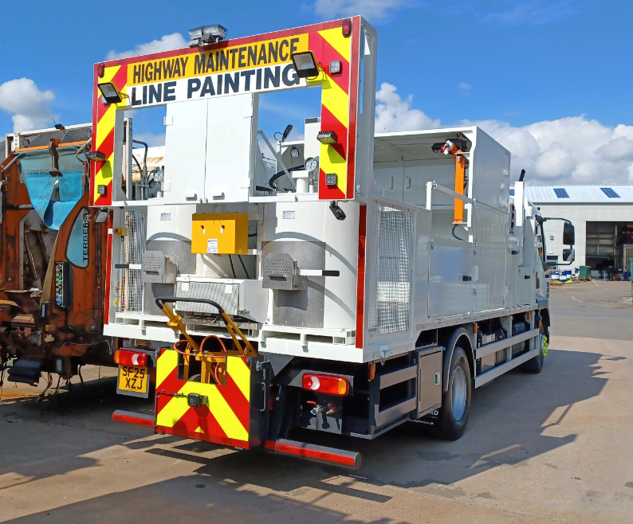
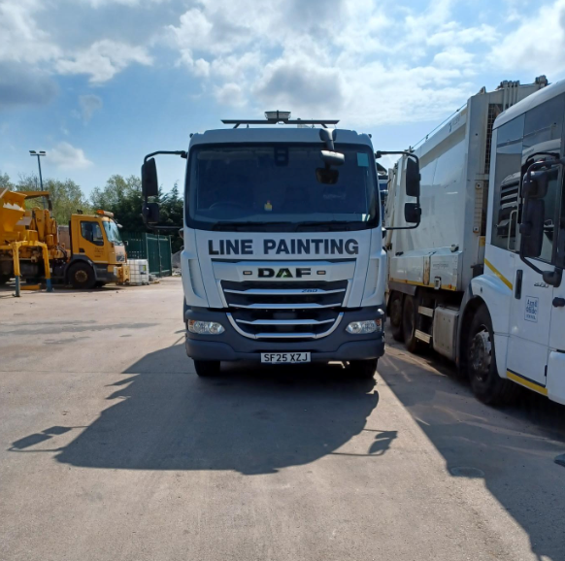
New lining vehicle

