ARGYLL AND BUTE COUNCIL CUSTOMER ENGAGEMENT TEAM
Briefing Note on 2024/25 Channel Shift Activity

EXECUTIVE SUMMARY

Argyll & Bute Council’s Channel Shift program continues to modernize public service delivery by moving customers from traditional methods, like face-to-face or telephone, to more efficient and convenient digital self-service options. In 2024/25, the Council recorded 497,141 web-based and 41,397 voice-automated transactions, generating a total estimated savings of £2.07 million compared to if there had been no digital alternatives.

Below is a table that documents the steady increase in channel shift transactions made by external customers and potential cashable savings over the last five years:

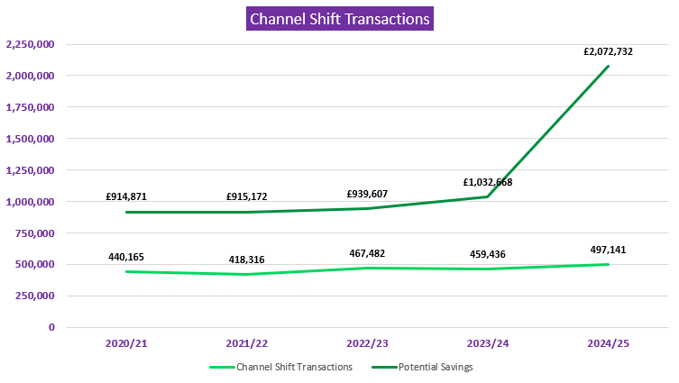

A new locally calculated cost model replaced national averages to better reflect actual service delivery expenses. It found that while a face-to-face enquiry costs £14.34, a web self-service transaction costs just £0.31. This cost gap underpins the Council’s strategic focus on digital channels to maximise efficiency.

The biggest growth came from Online Payments, which increased by 36%, and proactive Keep in the Loop & Eloqua Mailings, which rose by 42%. Netcall Voiceforms saw a 106% rise. In total, self-service platforms collected £9.1 million in payments for the Council, while the automated switchboard handled 33,150 calls, easing staff workloads.

The Digital Engagement Team (DET) supported this shift by building and launching new user-friendly systems across multiple Services and systems. These included centralised referrals for Educational Psychology, streamlined event applications, a new feedback dashboard, and digitised grant and school registration processes; all aimed at improving clarity and speed of service for customers.

Innovative new technologies such as Humley Studio AI, Zipporah Registration system, and Liberty Spark service design studio helped automate responses, simplify registration, and visualise workflow processes. These tools boosted efficiency across services including HR, waste collection, and statutory registrations.

Despite the rising use of digital channels, growing demand means some savings are reinvested to meet increasing service pressures rather than released as cash. Nonetheless, the channel shift approach remains a strong success, helping the Council enhance service delivery, reduce costs, and better meet the needs of citizens and communities. It is a fundamental part of the Connect for Success principle to deploy beneficial technology.

2. INTRODUCTION
Overview
Argyll and Bute Council continue to lead in digital transformation through its ongoing Channel Shift initiative led by the Customer Engagement Team. By using local customer service budget data instead of SOCITM national averages, the Council now provides a more accurate reflection of service delivery costs.
Local Cost Comparison of Customer Interactions
• Web-Based Self-Service: £0.31 per enquiry
• Telephone: £4.26 per enquiry
• Face-to-Face: £14.34 per enquiry
These figures have supported better decisions around resource use and service accessibility.
2024/25 Highlights
• Web Transactions: 497,141
• Voice-Automated Interactions: 41,397
• Estimated Savings compared to if digital approaches had not been used: £2 million+
Service Growth Areas
• Online Payments: +36% (approx. 20,000 more transactions)
• Voiceform Usage: More than doubled
• Pro-active Outreach Mailings: +42%
Innovations and Digital Tools Deployed in 2024/25
Digitised educational referrals, streamlined event applications, automated feedback systems, and AI-powered customer support.

Channel Shift Performance: 2020–2025
Year | Transactions | Potential Savings
2020/21 | 440,165 | £914,871
2021/22 | 418,316 | £915,172
2022/23 | 467,482 | £939,607
2023/24 | 459,436 | £1,032,668
2024/25 | 497,141 | £2,072,732

Key Trends & Insights: 2024/25
• Digital Transaction Volume: +8% from 2023/24
• Transaction Value: +102%, driven by the new local cost model
• Top Feature – Online Bin Day Lookup: Used 92,126 times
Voiceforms
Top voiceforms (Bin Day Lookup & Missed Bins) increased by 106%, with 704 additional submissions.
Outreach Mailings
Subscriptions up by 13,331 (+42%), driven by tools like Oracle Eloqua and enhanced service disruption notifications. 33,041 Keep in the Loop mailings issued.
Online Payments
Increased from 55,785 to 75,751 (+36%), reflecting demand for faster digital options and together with voice automated payments collecting £9.1m.
MyAccount & OpenPortal Logins
Increased from 25,433 to 31,719 (+25%), driven by digital council tax bills and service convenience. 10,982 customers now have online council tax and benefits portal accounts and over 7,00 are signed up for paperless billing.
Other Transactions
ePlanning Comments: +20% (867 → 1,044)
Drupal Web Forms: +13% (13,267 → 14,944)
Additional services showing growth: eBuilding Standards, Stopford Online Bookings, ePlanning Comments.
Voice-Automated Telephony Savings
£16,407 in savings compared to a ½ FTE LGE6 agent (£30,707), contributing to a revised total savings of £2,089,139 for 2024/25.

3. Total Savings
Compared to if these transactions had to be completed or assisted by council employees:
- Estimated savings of £2,089,139 for 2024/25.
- Unquantified additional amount of savings in automated back office processing.

4. DETAIL
Statistics
Argyll & Bute Council now uses locally calculated costs—based on their actual customer service budget—instead of SOCITIM national averages to measure the benefits of channel shift. This gives a more accurate view of what different types of customer interactions really cost.
The average cost per enquiry by channel is:
• Face-to-face: £14.34
• Telephone: £4.26
• Email: £8.38
• Web self-service: £0.31
Each digital self-service transaction is given a weighted value based on how likely it would have used a more expensive, staff-assisted channel if self-service wasn’t available. This helps the council better assess savings from moving services online and make smarter decisions about customer access and cost management. The total volume of self-service digital transactions for 2024/25 is 497,141 web and 41,397 voice automated, as detailed in the table below:

Transaction Type | Q1 Stats | Q2 Stats | Q3 Stats | Q4 Stats | 2024/25 YTD Total
Online Payments | 17579 | 18200 | 21153 | 18819 | 75751
Oracle / Create Webforms | 5604 | 7019 | 5756 | 7667 | 26046
Netcall Voiceforms | 183 | 638 | 317 | 231 | 1369
Drupal Web Forms | 3860 | 2538 | 3122 | 5424 | 14944
Document Downloads | 45926 | 48000 | 47000 | 47000 | 187926
ePlanning Applications | 360 | 313 | 328 | 289 | 1290
ePlanning Comments on Applications | 197 | 172 | 264 | 411 | 1044
eBuilding Standards | 427 | 349 | 417 | 542 | 1735
My Job Scotland Applications | 539 | 499 | 1906 | 2220 | 5164
My Account & Openportal Logins | 9762 | 5740 | 5645 | 10572 | 31719
Stopford Online Bookings | 59 | 68 | 49 | 28 | 204
Social Media | 2523 | 2496 | 2308 | 2912 | 10239
Smart Assistant | 237 | 118 | 91 | 124 | 570
Outreach & Eloqua Mailings | 8007 | 8205 | 13136 | 15892 | 45240
Satelite Websites | 185 | 382 | 311 | 414 | 1292
Alexa | N/A | 139 | 194 | 149 | 482
Bin Day Look Up (web) | N/A | 26310 | 32398 | 33418 | 92126
Total  (£Channel Shift savings) | 95,448  (£280,157) | *121,186  *(£521,333) | *134,395  *(£612,476) | *146,112  *(£658,766) | 497,141  (£2,072,732)
Plus Telephone Self Service  *New adjusted constants from Q2 2024/25 | Payments = 2620  (£797,436)  Switchboard= 9500  Disruption = 6 | Payments = 2343  (£535,803)  Switchboard= 9335  Disruption = 5 | Payments = 2070  (£428,383)  Switchboard= 7718  Disruption = 14 | Payments = 1182  (£441,543)  Switchboard= 6597  Disruption = 7 | Payments 8215  (£2,203,165 collected)  Directory 33,150  Disruptions 32

The value of the savings attributable to digital transactions (excluding voice automated switchboard), was £2,072,732 with the full breakdown as follows:
Significant improvements were seen in several high-impact digital services between 2023–24 and 2024–25. The most notable gain was in Online Payments, which increased by 36%, with nearly 20,000 more transactions, reflecting growing public trust in and reliance on digital payment systems. Netcall Voiceforms usage more than doubled, rising by 106%, while Outreach & Eloqua Mailings grew by 42%, indicating enhanced engagement through automated communication and outreach channels.
In addition to these major gains, there were steady improvements in self-service platforms. My Account, ePlanning Comments, and Drupal Web Forms all saw modest but positive growth, suggesting continued progress in enabling residents to access and interact with services independently and efficiently.
It is important to note that as overall customer contact via all channels continues to increase, some of the potential savings are actually being taken as efficiency to cope with higher demand with reduced resources and cannot be released as cashable savings.
The transactions and savings noted above are largely for web channel shift but also includes some savings arising from voice automated self-service and delivered:
- 8,215 payments (which collected £2,203,165 from customers)
- 39,054 calls responded to by the 24/7 service switchboard.
This saves the equivalent of two CSC agents at LGE6 (£30,707), thus saving £62k alone. When added to the savings from other channel shift, this makes a total revised channel shift figure of £2,089,139 for 2024/25. The self-service payments (web and voice), element of these transactions also collected £9.1m in customer payments for the council.
The split of channel shift transactions between Services is mainly shared among five services with 99% of the channel shift activity and related savings.
This report includes two charts showing how people contact the council and which services are most in demand.

The first chart looks at the channels used by customers to interact with the council’s Customer Engagement Team across 2024/25. While traditional mediated by human methods are still common, there's a progressive shift toward digital options like Web downloads, webforms and email, which are quicker and more cost-effective and now make up 77% of the total:
The second chart shows the number of requests by service, with the highest demand in Roads and Amenity Services, Social Work, Registration, and Council Tax. Together, this data helps identify where to improve services and encourage more use of digital channels:
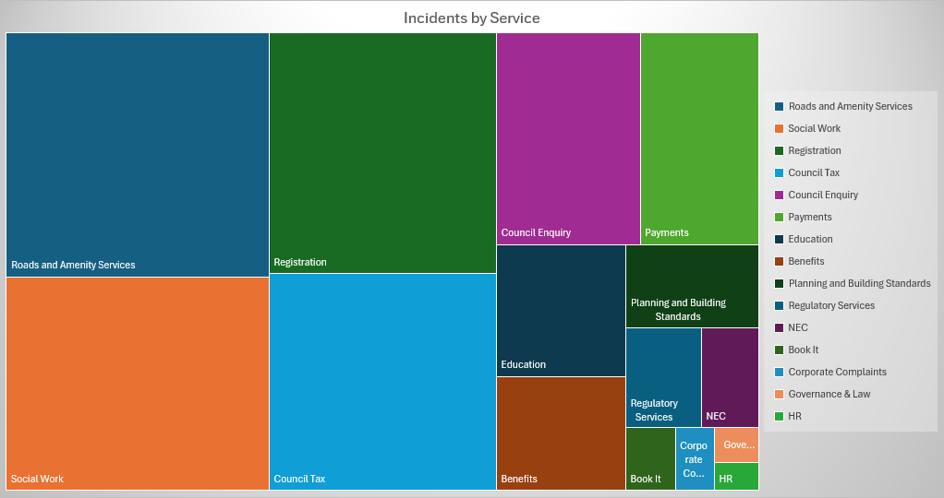
Digital Enhancements and Innovation 2024/25
The Digital Engagement Team (DET) have been involved in a number of initiatives over the last year as follows:

Educational Psychology Referrals (Create)
The Educational Psychology Team is replacing a confusing, area-by-area referral process, currently split between social services, the NHS, and schools, with a single, centralised system. At the moment, referrals are tracked using spreadsheets and shared in many different ways, making things messy and inefficient. Cases often involve questionnaires and referrals to other services, like speech and language, which are managed by the Educational Psychology Team (Epsyc). Epsyc then collects the feedback and decides on next steps. By using an online form and a staff portal through a system called Create, the team will manage all referrals in one place, making the process clearer, faster, and more consistent. The aim is for Epsyc to become the single point of contact for all enquiries.

New Events Applications Development (Oracle)
The council’s old event application form was long and hard to complete in one go, which frustrated many customers. To make things easier, a new online form was created that lets people save their progress and come back later. Once someone submits the new form for an event in Argyll and Bute, it starts a process where the event is reviewed, messages are sent, and feedback is requested. Tasks for assisting the back office event team are automatically created when the form is submitted, and additional tasks and documents can be added as needed. A decision is then made about what to do next. If no further action is needed, a 7-day countdown begins. If no feedback is received, a second 14-day timer starts, and after that, the decision is treated as approved. Different teams work together to make sure everything is handled properly.

Feedback Rating and Improvement Insights (Create)
This development provides a clear, user-friendly feedback system across our key customer service digital platforms, along with a modern dashboard for monitoring and evaluating responses. It includes a set of simple, accessible online forms to collect customer satisfaction data from the corporate website, internal Hub site, Create application platform, and Oracle CRM. Using well-established iconography, the forms make it easy for customers to share as much or as little feedback as they like, quickly capturing both satisfaction and sentiment. The dashboard presents this data in a clear, actionable format, making it easy to spot trends, extract data for use in other systems, and share insights with relevant council services. Overall, this is a major improvement on our previous feedback form and is already proving popular with customers as reflected in much bigger response volumes.

Free School Meals / Clothing Grants (Create & Oracle)
The Clothing Grants and Free School Meals service helps eligible families by providing support based on their income, benefits, and other criteria. Applications are submitted through a digital form that uses Optical Character Recognition (OCR) to read supporting documents. The system checks this information against pre-set rules from Argyll & Bute Council and the Scottish Government to decide if the applicant qualifies. It then gives staff a recommendation based on the evidence. Because the process is quite complex, it's being introduced in stages—Stage 1 uses a Netcall Create form, which sends data to the existing Oracle CRM system, allowing staff to review and process applications as usual.

Humley Studio Conversational AI
Humley is a conversational AI platform being used to improve customer service and reduce costs, while also exploring areas such as data protection, security, and HR use of AI. There are currently three live projects: a Visitor Levy FAQ chatbot for the public, a transactional Rubbish and Recycling chatbot that can log missed bins directly into Oracle, and an HR iTrent chatbot for customer queries on MyCouncilWorks. The platform also includes a new ingestion feature that automatically updates FAQ`s from web page information, as well as ad-hoc email reporting capabilities. Next steps are a voicebot for phone callers and a Teams bot.

Zipporah (Commercial System)
Zipporah is an online system used by Argyll and Bute Council to manage birth, death, and marriage registrations, ceremony bookings, and certificate applications. It allows customers to book appointments, submit required information and documents, and make payments online through a secure portal. Registration staff can also use it to manage bookings, allocate staff, and track payments. All data is securely stored for up to three years, after which personal details are removed, leaving only statistical information. The system helps improve efficiency, ensures accurate data collection, and supports legal reporting requirements.

Supporting Communities Fund (Create)
The Supporting Communities Fund is Argyll and Bute Council’s grant scheme to help local charities, community groups, and social enterprises deliver non-profit projects that benefit their communities. Applications are only accepted through a simplified online form, supported by a back-office system that helps manage and process submissions efficiently. Grants of up to £1,500 are available for projects in areas like sports, arts, education, and social welfare, as long as the group’s annual income is under £150,000. Projects must take place in Argyll and Bute between September 2025 and March 2027, and funding can cover the full cost of eligible items like equipment and supplies (but not capital projects). Groups must meet set criteria and complete an end-of-project report if successful.

Education Placing Requests (Create & Oracle)
Parents in Argyll & Bute can use a new online form to register their child for primary school, choose between school or homeschooling, request extra Early Learning and Childcare (ELC), apply for school transport, or request a place at a different school. This flows in to a semi automated application management system. Children usually start Primary 1 in August if they turn five between March and the end of February and can also ask for early entry if your child turns five after that. Most children attend their local school and move on to its linked secondary school, but you can ask for a different one through a placing request. These are best made before the new school year. Free transport is provided if your child lives far enough from their catchment school, but not for those attending through a placing request. In some cases, paid transport may be available. You can appeal if a placing request is refused, but early entry decisions can’t be appealed. Parents can also ask for Gaelic Medium Education if needed.

Liberty Spark
Spark is a simple, visual collaboration tool that helps organisations map out how their processes work so everyone can understand them, spot problems, and make improvements. It uses clear diagrams to show step-by-step workflows, making it easier for teams to collaborate, find inefficiencies, and improve how things get done, leading to better services, lower costs, and smoother operations. The team has been using Spark to support a range of projects, including short-term let licensing, communities fund applications, and primary school registration processes, among others.

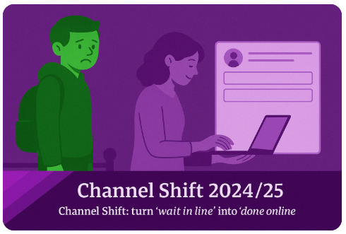
497,141
Channel Shift
Transactions
£9.1 m
Web and voice
Automated payments collected.
40,990
Online Forms
Submitted

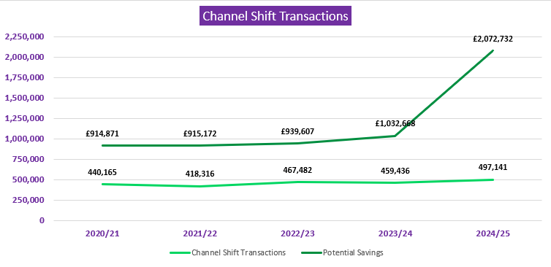
14,176
Keep in the Loop subscribers

19,690 MyAccount & 10,982 CT portal users
39,054
CSC Calls Automatically Directed

5. CONCLUSIONS
Strategic Value of Digital Investment
The shift toward digital self-service channels has yielded substantial financial benefits, with Estimated savings of over £2 million in 2024/25. This validates the strategic importance of continued investment in digital transformation, ensuring that council services remains sustainable and cost-effective amid growing public demand and limited resources.

Enhanced Customer Engagement and Service Efficiency
The growth in convenient digital transactions, particularly in areas like online payments, voiceforms, and outreach communications demonstrates increased public confidence in online services. These tools not only improve user experience but also free up staff capacity for more complex or sensitive cases, enhancing overall service efficiency.

Importance of Data-Driven Decision Making
By using local cost data instead of national averages, Argyll & Bute Council has refined its understanding of channel shift impacts. This and improved automated feedback insight tools tailored approach enables more accurate performance evaluation and smarter resource allocation e.g. to prioritise digital projects. This strengthes operational planning and budget management.

Continuous Improvement and Future Opportunities
The successful implementation of initiatives like AI-driven services, streamlined grant and registration processes showcases a commitment to ongoing innovation. As some services remain underutilized digitally, there is clear potential to boost awareness and adoption through targeted outreach and education, further maximising value from digital initiatives.

4. IMPLICATIONS

Policy | Aligns with Connect for Success principles, particularly use of effective technology.
Financial | Channel shift savings are an enabler for Services to help meet operational efficiency targets
HR | Efficiencies facilitate employee reductions without impacting service delivery and frees up employees to focus on complex and higher graded work.
Equalities (All) | Digital provides equality of access to services irrespective of geography and 24/7 access. Non Digital channels are also still provided. Hi Standards of accessibility are also built into online content.
Legal | Digital solution comply with relevant online and data protection laws.
Risk | Failure to continue to maximize channel shift savings opportunities may impact on the council’s ability to meet savings targets and customer service expectations
Climate Change | Digital transactions and processing reduces paper and postal processes, thus reducing carbon footprint.
Customer Service | The year-on-year increase in digital transactions shows that the council is using modern, on demand and convenient digital services to meet customer’s changing channel needs and digital expectations

Alistair Caw
April 2025

