
Roads and Infrastructure
Weekly member briefing
Edition 189: 21st Mar 2025

Oban, Lorn and the Isles | Helensburgh and Lomond | Mid-Argyll, Kintyre and the Islands | Bute and Cowal | All areas
Craignure ferry terminal  Yesterday’s Harbour Board meeting agreed funding of £3 million over the next two years to progress the next phase of work to replace Craignure Ferry Terminal, improving connectivity to the island.  This will help bring the project to its construction stage by funding the completion of business cases, Environmental Impact Assessments, planning, licensing, design and tendering.  This stage will also produce more accurate construction estimates, which are currently projected at £96 million for the project, based on inflationary increases to the original 2020 estimates.  Replacing the existing terminal infrastructure would:  - Increase berth capacity which will meet the requirements of the full range of design vessels  - Provide year-round berthing in challenging weather and overnight, which will reduce cancellations and improve the winter timetable  - Make the terminal operations more resilient  - Increase the vehicle marshalling area capacity  - Provide a modern terminal building with facilities that meet the needs of customers and staff  - Provide access for RNLI lifeboat and so facilitate medical emergencies  Roads  The team have been working at the start of this week in the Appin area on ditch maintenance and repairing damaged culverts, and on the same tasks in and around Kilmore in the latter part of the week.  There has also been routine maintenance in the Benderloch area and we’re continuing with footway improvements in Soroba. | Rosneath cycle way  Work continues on the Rosneath cycle way, with a funding deadline of 31st March approaching.  Below are photos of the base of the completely new cycleway section through what was an area of grassland.  Cardross Crematorium  SEPA will be in at Cardross Crematorium next week undertaking emissions testing of the cremator. The crematorium will stay open and available as normal on what is a busy week, with 22 services booked.  Sign replacements, Luss  The team have also been out this week installing new signage in Luss  New bin lorry  We have taken delivery of a new bin lorry which is currently in Dunoon having final checks before going into service in Helensburgh. This will replace an older, unreliable bin lorry and should improve the reliability of the service.  Waste transfer station  Yesterday the Environment, Development and Infrastructure Committee took the decision not to proceed with a new Waste Transfer Station in Helensburgh.  This makes a saving of £3 million which will be used to address cost pressures within the waste service.  A review of the project indicated that it was not value for money and not the best solution to provide Biodegradable Municipal Waste (BMW) ban compliant waste disposal arrangements for Helensburgh and Lomond.  You can access the full report here. | Campbeltown active travel scheme  This scheme is making slower progress than we would like – in Kintyre due to a flu bug we currently have several members of the team off ill.  This has an effect on what other works we have been able to do this week so our main focus has been on high category safety defects only across the network.  Gartbreck landfill cell works  We currently have a contractor in at Gartbreck undertaking drainage works to one of the landfill cell caps. This is the type of ongoing work and maintenance needed for landfill cells. | Castle Gardens improvements  The Castle Gardens improvement scheme is ongoing and making good progress  Roads  The team not working on the Castle Gardens job have been focussing on safety defects repairs in the West Cowal area.  Strachur road safety improvements  We will shortly be beginning the installation of new safety features on the A815 in Strachur. These include:  - A build out to narrow the carriageway at the primary school  - Advance warning signs  - Extending the 40mph limit 100m to the south  - Installing countdown markers  - Installing rumble strips  Rumble strips in particular are good improvements – these have been shown to reduce traffic speeds by between 15% and 30%  Ardentinny road safety improvements  We are currently progressing road safety improvements in Ardentinny which include new lining, signage etc. This will be completed next week. | Route optimisation  The installation of the in-cab technology for the route optimisation project is nearly complete.  As a result we are off-hiring the additional bin lorries we had in to support service delivery during the installations. We had these extra lorries in because each in-cab install takes around three to four hours.  Roads capital programme  Yesterday Environment, Development and Infrastructure Committee agreed at today’s meeting (20 March) to endorse a £10m programme of work to improve Argyll and Bute’s roads and support recovery work resulting from Storm Eowyn.  Last month’s budget included an £8m uplift to the roads reconstruction programme. Members of the committee agreed that £2m will be allocated to support repairing roads and coastal assets damaged by Storm Eowyn.  Allocations for the 2025-2026 roads reconstruction programme are:  - MAKI - £2.48M  - OLI - £2.8M  - B&C - £1.6M  - H&L - £1.12M  The overall budget is divided on the basis of the area of the road network. For example, there is a greater road surface area in Oban, Lorn and the Isles than in Helensburgh and Lomond.  We will send each area’s individual programme to local members. The full report and programme is available at Item 11 here.

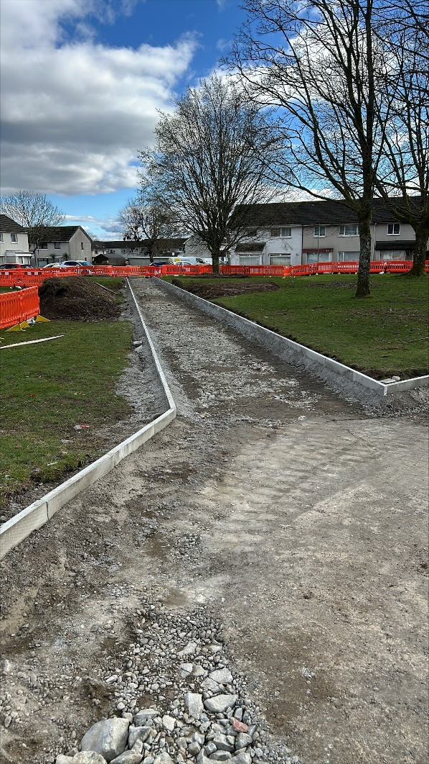
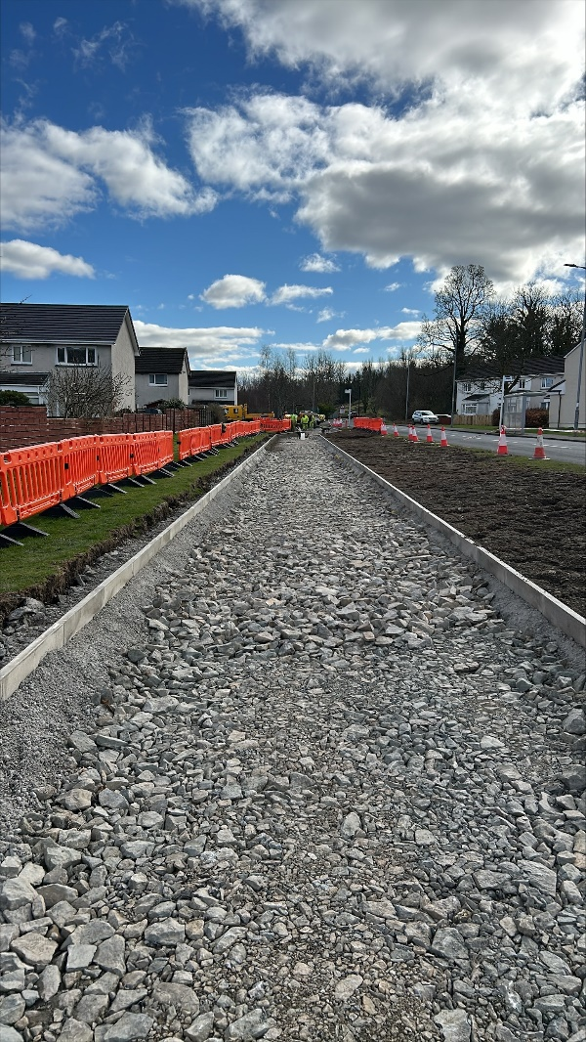
Rosneath cycleway

