
Roads and Infrastructure
Weekly member briefing
Edition 183: 7th Feb 2025

HEADLINE – the main focus of work over the past couple of weeks has of course been the response to, and ongoing recovery from, Storm Eowyn. As a result this briefing is in a slightly different format to the normal one, with a heavy focus on storm activities, then the usual table is at the bottom with a few more normal course of business highlights.

In terms of winter with a cold forecast overnight we deployed on all priority one and two routes and are going to go out today to catch the lower priorities routes ahead of the cold weekend.

Storm Eowyn

Reporting issues

Our teams have been out since the storm across the network, and we are compiling good intelligence on the scale of issues. This is being co-ordinated centrally and we have a record of issues which extends to over 220. Many of these were dealt with in the initial weekend, while some can be dealt with in the next couple of months, with others being longer term problems.

Please be assured that, as well as proactive and ongoing inspections of the network, we are also acting on reports from the public and elected members. We have a good level of awareness of any issues and anything which hasn’t been catalogued yet is unlikely to be major.

We’ll provide regular updates through our weekly briefings as things progress.

First weekend response

Although there was a huge amount of work done across the network in the immediate response to the storm, this was in the main clear-up works which didn’t cause any long term damage to the network.

Cemetery damage

There has been some damage to cemetery walls which will be picked up. Potentially more problematic and something members may receive contact form constituents about is damage to headstones. Headstones are the responsibility of families, not the Council. We are in the process of contacting families about damage, and we will support them as far as possible by recommending memorial masons and so on, but unfortunately any costs would be for them to bear. Below is an image of damage at the High Street Cemetery in Rothesay on the left and Helensburgh Cemetery on the right.

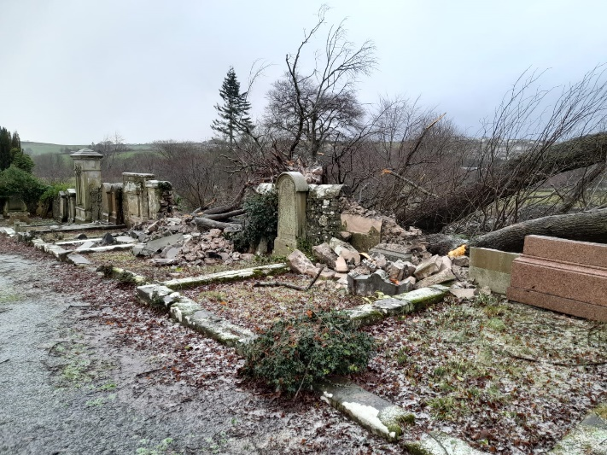

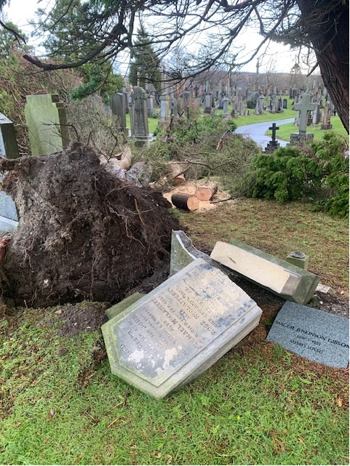

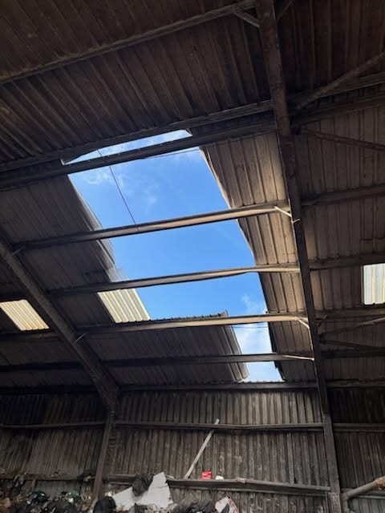
Examples of damage

To one extent or another we experienced issues across all asset groups due to the storm, from damage to the roof of the recycling shed on Tiree (see photo opposite) to bus shelters being destroyed on Islay, to seawalls being damaged in Dunoon and roads nearly washing away in Southend.

The longer term issues seem to be more in the marine and coastal protection asset groups, and our teams are working through these, continuing to assess damage and compile estimates, and prioritise work programmes which take a balanced view on level of risk versus people affected, versus cost, versus time of works.

We’ve included some of the more significant issues in a list below.

Location | Details
Dunoon Harbour | Rock armour damage, electrical works, block paving, brick facing, shelter damage, pumpshed damage.
Tayinloan Pier | Deck boards, handrails and shelter.
Oban North Pier | Pontoon access platform, new bridge, ladder damage, concrete unit, tensioning cables.
B8024 Ormsary | Significant undermining and erosion noted on roads and verges on multiple location. Damaged or blocked culverts noted along the section of the roads. Revetments to be provided to reduce further damage.
B8002 Adfern Coastline | Undermining of roads in several locations, Damaged verges/walls, Damaged/blocked culverts and outlets all over the line and Debris have been settled over the lane/lay-by in some places. A BT pole is very unstable and undermined as it is near an outlet.
B842 Torrisdale Bay | Wall undermined and washout behind, risk to undermining road, BT pole at risk.
B842 Grogport wall | Small existing wall - Erosion either side of wall under verge.
C18 Keills / Southend | Washout of gabion baskets, beach lowed, no protection to road, washed out and undermined road and foundation.  Section appears to have been repaired before with mass concrete exposed and sunk due to undermining. Further temporary repairs won’t provide value for money.  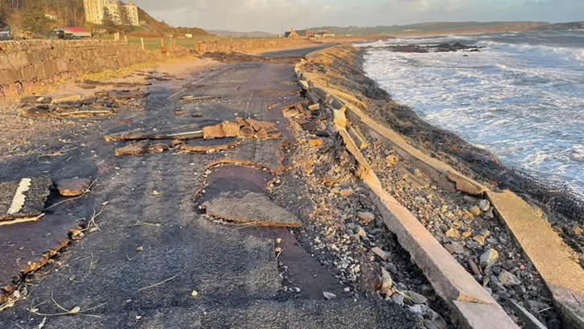
Degnish, Kilmelford | Severe damages to the existing revetment, walls and the road. Immediate action needed. The overall span of coastline which needs attention is 315m.  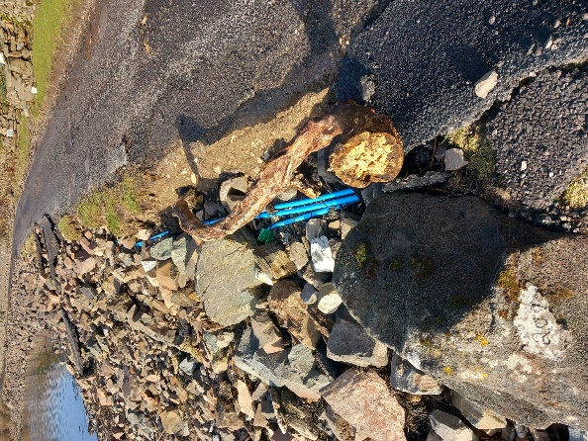  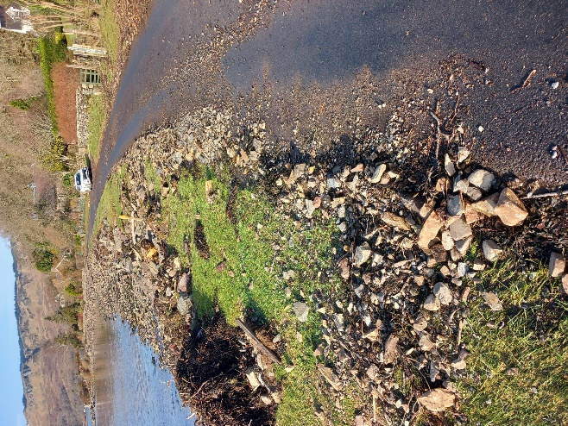
Dunoon - Alexandra Parade Coastal Wall | TBC – At least coastal wall, cope, pedestrian barrier and footpath damage. Emergency repairs including removal of damaged section and reinstatement of cope, railing and footpath proposed.
A814 Glen Douglas | Landslip. Clearance of obstruction and slope stabilisation with mesh netting proposed.  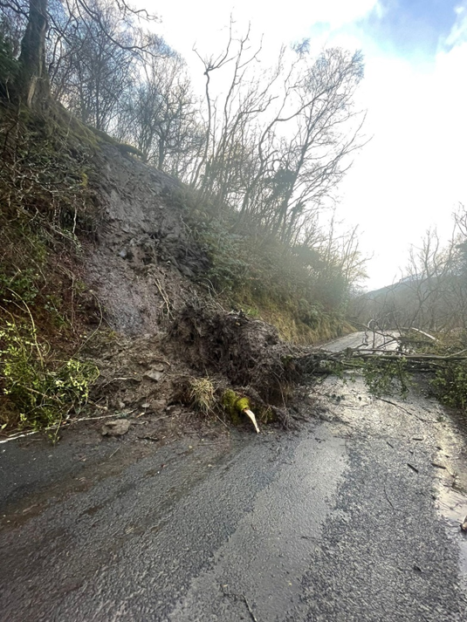
B842 Ugadale | Rock armour moved, verge collapsed, potential for road undermining.
U029 Ellary | Collapsed seawall noted in multiple location, which leaves the site in highly unsafe condition. Missing cope, partially collapsed walls, displacement of stones, undermining and vegetation growth noted on several locations. The collapsed wall and road sections to be reinstated, preferred concrete repairs.
Bus stop Main Street, Port Charlotte | Full replacement including making the site DDA compliant.

Oban, Lorn and the Isles | Helensburgh and Lomond | Mid-Argyll, Kintyre and the Islands | Bute and Cowal | All areas
Roads  We have been working this week on the repair of the footpath at the back of Torrosay Court which was damaged during freefall in the recent storm. We’ll take the opportunity when there to future proof the works somewhat, by removing additional trees that might cause problems in the future.  The Port Appin footway improvement scheme is nearly finished, with just a bit of site tidy up and a fence to go in.  On Mull last week we did a private scheme for TSL which generates income for the Council. This was an access road to the Ben More Estate.  We’ve also completed the last parts of capital works in the Dervaig area – we managed to lay 600tonnes of material which is good going in January! | Rosneath active travel scheme  The £265,000 cycle way scheme in Rosneath will get underway next week. This is a job being delivered by our in-house teams on behalf of colleagues in Economic Development.  Roads  The capital footway scheme outside Cardross should finish next week, providing a welcome improvement to that important walking route.  CHORD silver bins  We are aiming to begin the removal of these bins next week as per the agreement at the most recent Lomond Area committee. | Islay streetlighting  We have a particular issue with streetlighting in the Port Ellen area, which requires excavation works as the problems seem to be related to power supply. We’ve engaged a local contractor who has been on site to assess the required works and we’re waiting on them feeding back to us with a price and timescale. This is taking longer than we would have liked because of the availability of resources both in terms of our own teams and our external contractors. We’ll update as soon as there is a confirmed timeline.  Our street lighting electrician will be over on Islay next week to do a sweep of the island. One issue we found with the storm was that it knocked out a lot of timeclocks on individual columns – resetting these is fairly straightforward so any issues with lights being on at odd times should be addressed next week.  Quarry Green active travel scheme  Following the storm clear up this job will restart on Monday. | Montague Street closure  This road will re-open this afternoon. The building owner has reduced the chimney stack to a safe height and while there is still debris on the roof, there is no longer any public safety issue. There will be a scaffold needed for ongoing works and this will go through the normal permitting process.  Cowal roads  The team have been working on the Castle Gardens drainage scheme this week in addition to storm clear up. | Municipal bus operation  Following agreement to explore the above at the most recent EDI meeting, the team have been liaising with the consultant. In particular we have been providing data and information on the subtleties of our network and service. A draft questionnaire is being prepared which will be published shortly.

