
Roads and Infrastructure
Weekly member briefing
Edition 181: 10th Jan 2025
HEADLINE – the main focus of the work of our teams in the past week has been winter maintenance, keeping the network safe and open and keeping Argyll and Bute moving. There are a host of excellent resources online including the daily winter action plan. These can be accessed on the winter section of the website here.

The lowest recorded road surface temperature this morning was -7.4 in Oban.

Oban, Lorn and the Isles | Helensburgh and Lomond | Mid-Argyll, Kintyre and the Islands | Bute and Cowal | All areas
Coll winter maintenance  On Coll we use a trailer spreader for winter maintenance – this is attached to the back of an existing vehicle.  We had started the process of ordering a new machine in May 2024 but unfortunately there has been a delay in placing the order which seems to be down to an administrative error in the purchasing process.  We have contacted the supplier this week and the order has now been placed. Unfortunately the machine will not be with us for 4-6weeks.  We can only apologise for this and assure people living on Coll, that we will do our best to ensure a level of gritting with the equipment we have until the new trailer arrives.  Planned road improvements  If the weather conditions allow we are planning to resurface the U22 Achavaich Road next week.  Pennygown Cemetery  A driver lost control of their vehicle and ran off the road into Pennygown Cemetery over the holiday period (see photo below).  The Police have been unable to trace the vehicle yet, albeit they are working with CalMac for assistance should a damaged vehicle leave the island.  Two headstones were damaged and we are in contact with those families and have requested a price from memorial masons for repairs.  If the driver can be traced we will revert any costs to them through the insurance process.  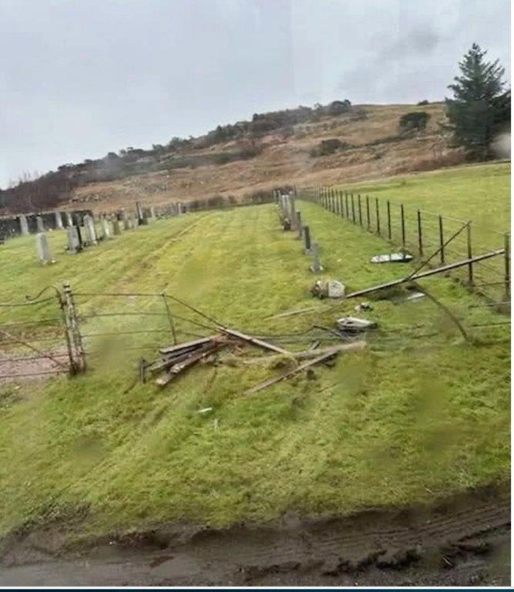 | C70 Glen Fruin  The C70 Glen Fruin road was closed last week. You can see the exact location in the map segment below.  After the planned winter treatment on the morning of Saturday 4th January our operatives and a local contractor worked on the road. Much of the treatment was carried out by hand to enable them to progress with the vehicle.  This was an outstanding effort from our crews to get this route reopened in difficult conditions.  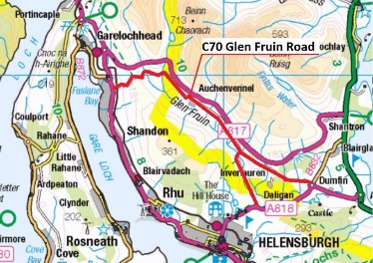  Tigh Dearg Road  During heavy rainfall over the festive period a significant amount of water overtopped the field above Argyll Road and came down Tigh Dearg Road.  As the works are not yet complete, and the new drainage channel on Argyll Road is not yet installed, there was no additional capacity to take this flow.  This meant there was some washout of material, but this was quickly dealt with by our contractor.  Drainage works, kerbing and boundary wall repairs are now underway again following the Christmas shutdown.  To enable the drainage works on Argyll Road to go ahead safely, there will be a road closure which will take effect at 0600 hours on 20/01/2025 until 1800 hours on 26/01/2025. This will be at the junction of Tigh Dearg Road with Argyll Road.  Road maintenance  The team are focussing on winter gritting and pothole repairs in and around Helensburgh town. | Saddell Mill and Torrisdale bridges  Following damage to both of these bridges in December, the Saddell Mill bridge was successfully reopened to vehicles up to 26tonnes the week before Christmas following a full closure.  The Torrisdale bridge was a more complicated repair but was able to stay open for light vehicles (3 tonne limit) throughout.  Following concrete testing and a site inspection earlier this week both bridges were able to fully reopen to all traffic.  Our thanks to the local community for their patience during these works, and well done to our teams and local contractors involved for effecting repairs so quickly.  Public convenience cash theft  Unfortunately there has been a further theft of cash bags from our public conveniences – this time from Lochgilphead (again) and Ardrishaig for the first time.  We had put additional locking bars and padlocks in place but unfortunately these haven’t deterred the thieves. We will report this to the Police again in the hope of catching the perpetrators.  We don’t expect that there was a lot of money stolen given the time of year, but nevertheless it is a cause for concern, even in a practical sense because we need to order new cash bags now from the supplier and these cost £70 each. They are specially designed to fit into the payment system and lock in place.  Road maintenance  As well as delivering the winter service, our teams are carrying out pothole repairs on the Tayvallich and Kilberry roads, as well as ditching works.  Campbeltown active travel scheme  Depending on an improvement in the weather the team are looking to restart this scheme next week. | Road maintenance  The main focus of work in Bute and Cowal this week has been on winter maintenance.  In addition we’ve had teams out on roads in and around Dunoon, Lochgoilhead and Carrick Castle attending to potholes, effecting temporary repairs until the weather conditions are such that permanent repairs can be made.  We have had a few queries recently about the use of cold mix in pothole repairs during the winter months.  During periods of cold weather it can often be the case that a temporary fix is the only viable option using a cold-mix solution until hot material can be used to permanently fix the issue.  While we aim for a ‘’right first time’’ permanent repair wherever possible this has to be balanced with what is feasible given the prevailing conditions and the overall risk to the travelling public | Possible extension of reuse containers  Following on from the previous update about this in the 13th December edition, we have now scheduled a meeting with colleagues at Dumfries and Galloway Council and a local reuse charity who jointly operate a site in Stranraer. Waste and project management colleagues will be visiting the site at the end of this month to see how it operates and to take any learning from that into our proposal to extend reuse containers on our sites and work with community groups in this important area.  Changing the priority of roads for winter maintenance  We’ve had a few questions over the festive period about making certain roads higher priority routes for winter treatment.  The routes are determined in order of priority, with resources focussed on the roads which carry the greatest volume of traffic.  Routes are agreed annually at Committee as part of the winter maintenance policy.  Any reclassification of routes would ultimately be a policy decision.  Currently we pre-treat around 54% of our road network (over 750miles – the equivalent of driving from Lochgilphead to Paris).  Any increase to the pre-treatment routes would mean we would need additional resources to deliver a revised programme.  Burials and cremations  As is normal in January, given the festive holidays, this service area will be busy this month. We already have 23 burials booked in for the next fortnight as well as 20 cremations from today until next weekend. Losing loved ones over the holidays can be particularly hard and our teams will be doing all they can to support families.

