

This week’s briefing is a little different from normal because the main focus of our work has been winter related – keeping the road network safe and open has been the main area of work this week.
Roads and Infrastructure
Weekly member briefing
Edition 176: 22nd Nov 2024

Protecting driver and working hours is a key component of winter maintenance – we have certain legal requirements about HGV driving hours that we must comply with to keep our staff and road users safe. The way this works in practice is that in prolonged winter weather we often need to send drivers home during the day to protect their hours for winter gritting in the evenings and early mornings.

We’ve had to do that several times this week which has had a knock on effect to other programmed work which means the extent of what has been delivered this week in terms of roads maintenance, grounds etc. is substantially less than normal. That is because we prioritise the winter service and keeping the network open. Furthermore, many of the construction related activities cannot be carried out in sub-zero temperatures which help to free up staff for winter activities.

There are a number of really helpful and informative resources on the Council website where you can find out more about the winter maintenance service.

One particularly good resource is the interactive gritting map which lets you see which routes have which level of priority (you can click onto a road for more information). The map can be accessed here and we’ve included below a screengrab:

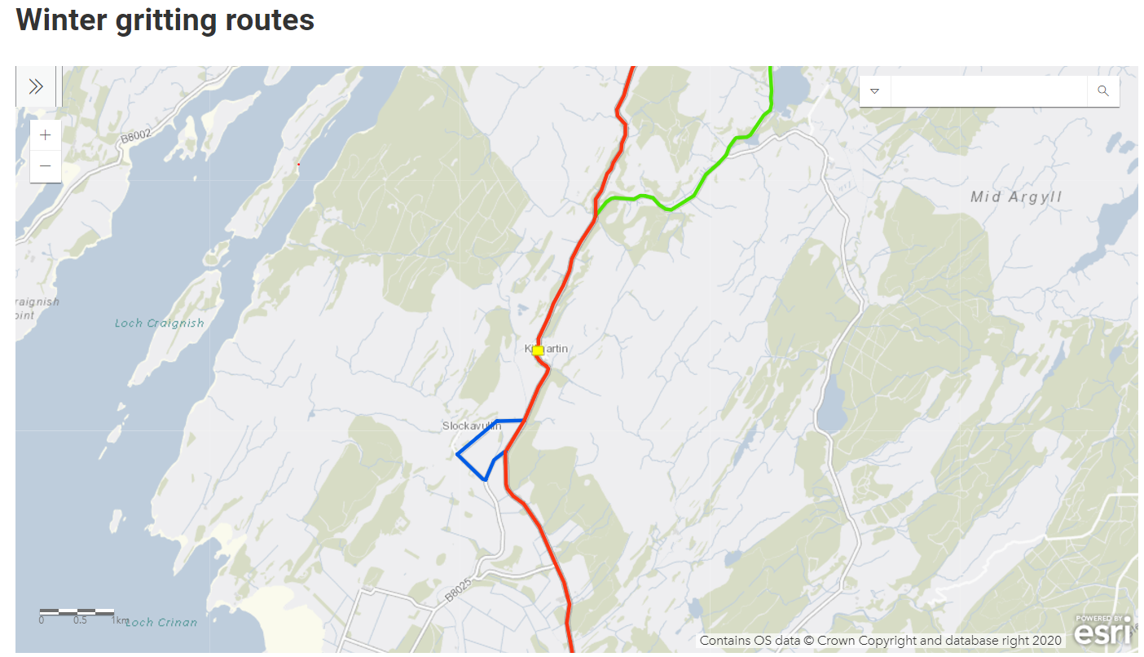

Another helpful resource is the daily action plan which is posted on the website by the stand by winter manager for that day, which can be accessed here. We’ve included a couple of screengrabs below of the type of information on the daily plan. Basically this will let you see what action is planned where on a given day. Full and up to date details can be found in the link above.

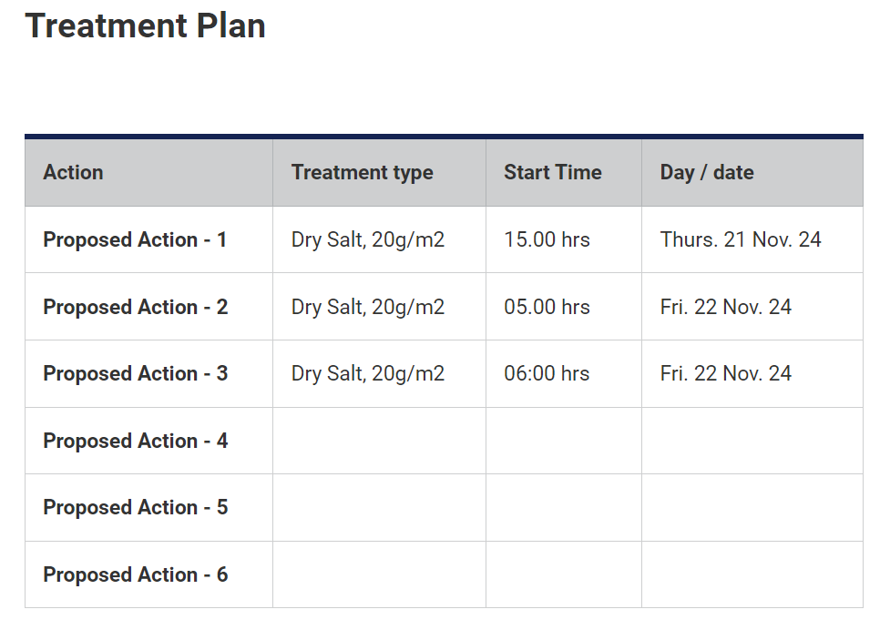
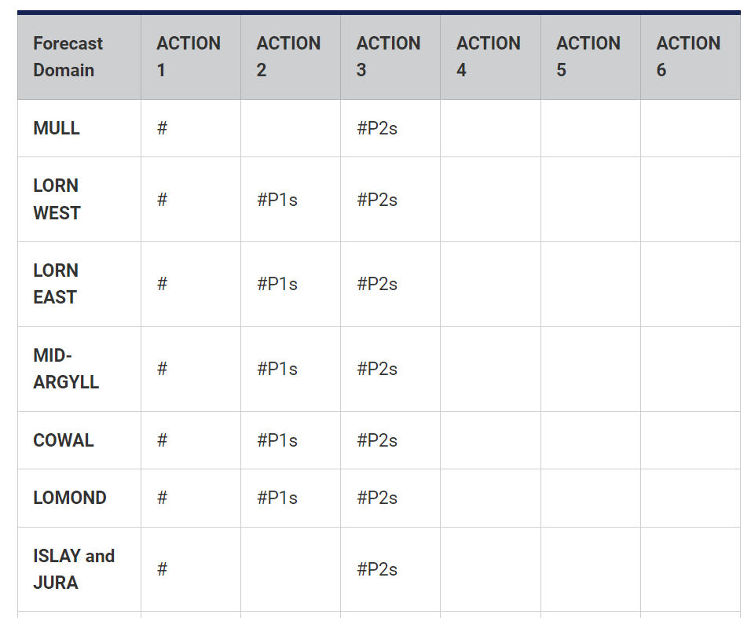
The process of deciding what actions to take where is supported by detailed weather reports we get from our weather stations across the network. Below is a screenshot of the weather summary for this morning:

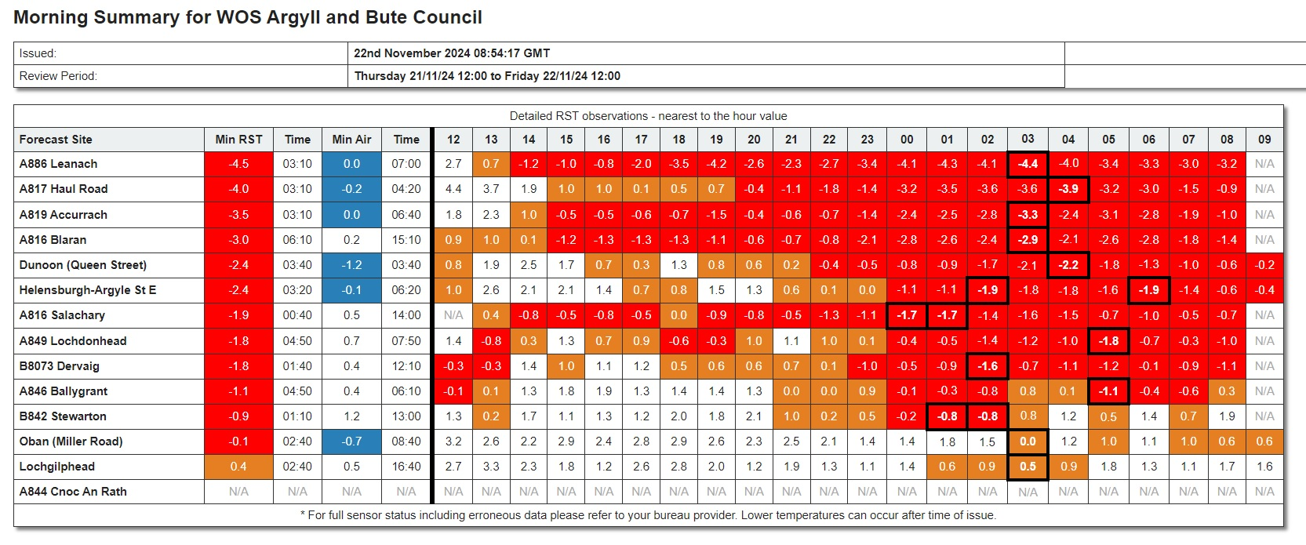

Below are some FAQs and answers which are designed to allow you to copy and paste them into any correspondence you have with constituents.

What is the aim of the Council’s winter maintenance plan?

To maintain access to the Council’s strategic road network, or to put it another way – to keep Argyll and Bute moving.

What is the law in terms of winter maintenance?

The Council has a statutory obligation to take such steps as it considers necessary to prevent snow and ice endangering the safe passage of pedestrians and vehicles over public roads (Section 34 of the Roads Scotland Act 1984)

How many gritters do we have?

32 main frontline vehicles (mix of Council owned; hired and local contractor); 4 spare vehicles; 7 extra vehicles which can be deployed if required.
We also have a network of local contractors who can be mobilised in severe or extended periods of winter weather.



What roads do we grit?

Roads are treated on a priority basis, with busier routes treated first, as detailed in section 4 of the Winter Service Policy.

Priority 1
Strategic high speed, main traffic routes
Lomond - A814 Dumbarton- Garelochhead, A818 Arden (A82) - Helensburgh
Cowal A815 Cairndow – Dunoon Ferry
Lorn / Mid-Argyll - A816 Oban - Lochgilphead, A819 Dalmally – Inveraray
 | 04:00 – 08:00hrs | 08:00 – 16:00 hrs | 16:00 – 22:00 hrs | 22:00 – 04:00 hrs
Mon -Sat | Pre-treat as required + reactive | Pre-treat as required + reactive | Pre-treat as required + reactive | Reactive as reported conditions dictate
Sun & PH | Pre-treat as required + reactive | Pre-treat as required + reactive | Pre-treat as required + reactive | Reactive as reported conditions dictate

Priority 2
Other “A” and “B” classified roads
Except where treatment is categorized under Priority 3 bus routes, or less.
A814 Garelochhead –Arrochar, A815 Dunoon-Toward,
A817 Haul Road & B833 Rosneath Peninsula, A880 to Ardentinny,
A885 Sandbank, A886 Strachur– Colintraive, A8003 Tighnabruich,
A844 / A845 & A886 on Bute, A846 / A847 on Islay, A846 on Jura,
A848 / A849, A884 & B8073 Tobermory – Dervaig, on Mull,
B828 / B839 to Lochgoilhead , B842 Southend –Carradale,
B843 to Machrihanish, B844 / B8003 to Easdale & Cuan,
B8024 Kilberry Loop , B841 / B8025 Achnamara & Tayvallich.
Plus
Principal Accident and Emergency routes or roads to hospitals and routes to Police stations, Fire stations and Ambulance depot accesses Other selected streets in main urban areas e.g. steep hills, etc where route efficiency permits.
 | 06:00 – 08:00hrs | 08:00 – 16:00 hrs | 16:00 – 22:00 hrs | 22:00 – 0600 hrs
Mon -Sat | Pre-treat as required + reactive | Pre-treat in advance  (if possible) + reactive | Reactive as reported conditions dictate | Reactive - only in extreme conditions
Sun & PH | Pre-treat as required + reactive | Pre-treat in advance  (if possible) + reactive | Reactive as reported conditions dictate | Reactive - only in extreme conditions

Priority 3
Any section of public road, out with P1 & P2 above, subject to :-
Main Public Service bus routes as timetables require that can be met
within operational time bands. Should it be impractical to cover a service then the
operator must be notified
or
Main School Bus routes prior to or during term days only.
New designation |  | 06:00 – 08:00hr | 08:00 – 16:00 hrs |  | 16:00 – 22:00 hrs | 22:00 – 0600 hrs
Priority 3  Service Route | Mon-Fri | Pre-treat as required  + reactive | Pre-treat in advance (if possible) + reactive |  | No treatment unless stable conditions forecast a.m. | No Treatment
Priority 3  Service Route | W/E | Pre treat in advance of journey, if possible, but no guarantee.  Timetabled days only.
Priority 3  School Route  (12 or more occupied seats) | Mon- Fri | Pre-treat as required  + reactive | Pre-treat in advance  + reactive | No treatment unless stable conditions forecast a.m. (Not Friday p.m.) |  | No Treatment
Priority 3  School Route  (12 or more occupied seats) | No treatments out-with School Term days  (apart from Sunday evenings in advance, if stable conditions forecast Monday a.m.)

Priority 4
All other public roads,
Only as actual conditions dictate and resources are deemed to be effective.
 | 06:00 – 08:00hr | 08:00 – 16:00 hrs | 16:00 – 22:00 hrs | 22:00 – 0600 hrs
Mon - Fri | No treatment | Reactive (may include pre-treat) | Reactive – only in extreme conditions | No treatment
W/E & PH | No treatment | Reactive – only in extreme conditions | No treatment | No treatment

Can you add roads to your treatment routes?
Unfortunately we are unable to add roads to our treatment routes, out with the terms of the Policy on priority treatments. The routes are determined in order of priority, based on the current Policy agreed at Committee and we stick to this strict programme. However the route coverage under these priorities has been re-assessed over the past 2 years and additional sections have been added where necessary. If we were to add a lesser priority road to a route, it would divert resources away from busier roads.

Do you grit the approaches to schools?

Yes – We incorporate treatments up to at least one school vehicle entrance in Priority 2 routes.

Do you grit school car parks?

Normally school car parks would be gritted by that school’s facilities management (janitorial) staff.

How do you decide when to grit?

The Winter Manager and Duty Managers analyse the forecast data, often liaising with the forecast provider, and use this information to produce the Daily Action Plan. This means that by early afternoon each day we have a plan in place to make sure the roads are treated appropriately for the forecast weather conditions for the following 24 hours. The weather conditions are then monitored and any changes to the plan are made as required.

What’s the most gritted road in Argyll and Bute?

For the past five winters this has been the A819 Inveraray to Dalmally road.

How many miles of road do you grit?

Over 760 miles, which is roughly the equivalent of driving from Lochgilphead to Paris are treated when we carry out a full pre-treatment. Often we will not treat all routes, only those where ice or snow is forecast are treated.

Do you grit pavements/footways?

If it is particularly icy, and if we have the resources to allow us to, we aim to grit footways, with busy town centres prioritised, but generally only after we’ve gritted the roads and operatives are available for other tasks.

As always, there will be grit provided in grit bins across the area so people can help their own communities by treating roads and footways in their neighbourhood during periods of severe weather. Please look out for vulnerable neighbours when conditions underfoot are poor. The grit is provided for use on public roads and streets, not for private roads and driveways. Most builders’ merchants, a number of supermarkets and hardware stores sell grit and salt.

Can I have a grit bin in my street?

Grit bins and heaps are placed at strategic locations throughout the area to allow communities to help themselves, and are refilled when possible. It is highly unlikely that we will be able to add to the existing network of grit bins, but we may be able to place grit heaps in isolated locations which become problematic this year.

How do I get a grit bin refilled?

You can request a grit bin refill online at:
https://argyllandbute.custhelp.com/app/LAP_Forms/LAP_Winter_Maintenance

You can also call the Council to request a grit bin refill on 01546 605514.

Grit bins will be refilled when possible, but with limited resources our top priority is gritting the roads.

Normally grit bins are refilled as part of a cyclic programme when possible, rather than according to specific requests.



As a result of the focus on winter this week there are very few highlights to report so the normal table of information is quite short:

Oban, Lorn and the Isles | Helensburgh and Lomond | Mid-Argyll, Kintyre and the Islands | Bute and Cowal
School transport  There was a problem collecting pupils because of ice on the Dalavich road this morning, but this was quickly resolved.  Craignure electrical load demands  We have been doing some work this week with our consultants on the Craignure Outline Business Case to confirm potential future electrical load demands for the project. This will include the capacity for additional EV charging, both slow charging for foot passengers who intend to leave their cars at Craignure, and rapid charging for those looking for a quick boost before going onto the ferry. | Blairvadach flooding  Work is scheduled to commence on 2nd December to repair the damaged culvert.  We will be upgrading to a new, more efficient piping system which will redirect rainfall and help prevent future flooding in the area. | Inveraray sea wall  There has been research carried out which suggests the sea wall is in third party ownership – Argyll Estates.  We are progressing discussions with them regarding the issues with the sea wall and will hopefully have an update soon.  Cairnbaan traffic management  Temporary traffic management in place on the Cairnbaan corner in connection with required works by BT.  BT have not yet provided a timescale for work but we have regular engagement with them and will pick this up with them.  Islay salt stocks  We have had concerns raised with us this week about salt stocks on the island. The annual average tonnage used on Islay is 600 tonnes and we currently have 300 tonnes in stock with a delivery of 750tonnes, request for which was placed on 5th September, but has been delayed for various reasons, expected into Campbeltown then onwards to Islay tomorrow. | Road improvements  We have been clearing offlets on the A886 Rhubodach road this week as well as drainage and ditching works to reduce run off.  Despite the winter maintenance focus we have managed to continue with the road widening scheme at the A8003 Tighnabruaich road.  School transport  Carrick Castle service bus decided not to travel this morning due to concerns over the road condition. The pupils usually collected by this bus were taken to school by their parents.  Ultimately these decisions are for professional drivers to take to protect the safety of everyone.  Service will resume this afternoon.

