
APPLICATION FOR PERMISSION TO PLACE A BUILDERS SKIPON THE PUBLIC ROAD
Roads (Scotland) Act 1984 Section 85

Applicants Name
Address

Post Code
Tel No |  | Fax No
Mobile No
E-Mail

Out of Hours Contact Name |  |  | Out of Hours/ Emergency Contact No
Address or location of Skip please provide a sketch if necessary

Description of Works

No. of Skips at Location |  | Start Date |  | End Date
Name of Skip Provider

Address
Tel No |  | Out of Hours Contact No.
IMPORTANT: NO WORK SHOULD COMMENCE UNTIL YOU RECEIVE OFFICIAL PERMISSION FROM ARGYLL AND BUTE COUNCIL
I hereby apply for permission to occupy part of the adopted road as detailed above. I confirm that I have read and understood the Guidance notes and Conditions for granting of Permission relevant to this application and agree to be bound by these should this application be successful.
Applicants Signature

Date
PLACEMENT OF SKIPS ON ANY PART OF THE ADOPTED ROAD OR FOOTWAY

NOTES FOR GUIDANCE AND CONDITIONS FOR GRANTING OF PERMISSION

Permission to place a skip on any part of the adopted road, including the footway, is granted by the issue of a permit by the Argyll and Bute Council as the Roads Authority under Section 85 of the Roads (Scotland) Act1984.
Placement of a skip on any part of the adopted road or footway without permission constitutes an offence and the Council will take enforcement action in such cases. Applicants and skip hire companies should be aware that under the Transport (Scotland) Act 2005, section 34, The Roads Authority have the power to issue a fixed penalty notice of £120 to the Skip Hire Company for not obtaining, or complying with the conditions of, a permit.

The granting of permission under Section 85 of the Act only relates to occupation of the road for the purpose of placing a skip and applicants will need to ensure that they obtain all other necessary permits and permissions e.g. planning consent, building warrant. Specifically this permission will not carry with it the right to close any public road or footway or deposit building materials on any part of the adopted road. Separate permission must be sought for these activities.

The granting of other relevant permits/consents should not be taken as an indication that occupation of the road with a skip will be permitted.

The owner of the equipment placed on the public road or footway under this permission must be covered by Public Liability Insurance for a minimum of £5 million which should be available for inspection. Such insurance must indemnify Argyll and Bute Council as Roads Authority from and against all actions arising out of or in any way attributable to the presence of the equipment covered by this permission.

Where approval is given for the siting of more than one skip they shall be positioned as closely as possible to each other but not so as to obstruct access to any premises unless the consent of the occupier(s) of those premises has been obtained.
Each skip or group of skips shall, while on the carriageway / footway / verge, be marked, guarded and lit in accordance with Chapter 8 of the Traffic Signs Manual and to the satisfaction of the Roads Authority.

Where pedestrians have to be diverted onto the carriageway, pedestrian barriers shall be erected in accordance with Chapter 8 of the Traffic Signs Manual.

At night, lamps complying with The Traffic Signs Regulations and General Directions,
shall be attached to or placed against each corner of the skip, or at the end corners of a row of skips where the distance between adjacent skips does not exceed 2m, and shall also be placed between each traffic cone.

The skip shall be marked in accordance with the Builder’s Skip (Markings) (Scotland)
Regulations 1986 and shall have the owner’s name and telephone number clearly and indelibly displayed.

Skips shall comply with the appropriate Motor Vehicles Construction and Use Regulations when carried on a vehicle.

Each skip shall not exceed 5m in length by 2m in width.

Material shall be placed in the skip in such a manner as to avoid creating a danger to road users and pedestrians.

No skip, when standing on the carriageway / footway / verge, shall contain any inflammable, explosive, noxious or dangerous material or any material which is likely to putrefy or which otherwise is, or is likely to become, a nuisance to users of the road or pedestrians.

Each skip shall be removed for emptying as soon as is practicable and in any case not later than 2 working days after it has been filled.

No skip to which this consent relates shall remain on the carriageway / footway / verge after
the period of the permission as specified in the consent.

The skip must be removed when so requested by the Roads Authority, or the Police, within 24 hours of notice being so given.

The applicant shall be responsible for any damage caused to the road, footway, etc. by the skip.

Failure to make good any damage or to maintain the repair for 12 months may result in the works being carried out by the Roads Authority and the cost recovered from the applicant

The completed application form should be submitted to the relevant Roads Area Office.
Note
Section 85(2) of the Roads (Scotland) Act 1984 empowers the local Roads Authority to impose conditions to its permission relating in particular to the siting and lighting of the skip and the removal of the skip at the end of the period of the permission.

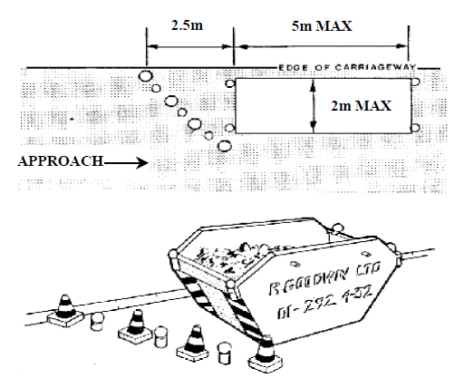

Section 86 of the Roads (Scotland) Act 1984 empowers the Roads Authority or a police officer to arrange for the removal or repositioning of a builder’s skip deposited on the road even though it was deposited in accordance with the road authority’s permission and after the removal the Roads Authority has the right to recover, from the owner, the cost of such removal or repositioning or for disposing of a skip which is not collected by its owner.
Failure to comply with a request to remove or reposition a skip under this section of the Act may result in the Roads Authority removing or repositioning the skip and recovering any expenses reasonably incurred in so doing

Notes:
- The arrangement of cones and lamps is set out in detail is shown above
- Dimensions are in metres.

