

Please find below a brief snapshot of the huge range of work being undertaken across the area by Roads and Infrastructure staff this week.
Roads and Infrastructure
Weekly member briefing
Edition 171: 18th October 2024

The updates are designed as a resource for you to be able to answer constituent queries.

You can view all previous weekly member briefings on the website

Oban, Lorn and the Isles | Helensburgh and Lomond | Mid-Argyll, Kintyre and the Islands | Bute and Cowal | All areas
Roads updates  The resurfacing scheme at Scammadale was successfully completed at the start of the week.  In addition the team have also completed a resurfacing project on the Musdale road which is benefitting from approx. £70,000 investment to improve the road surface.Iona Breakwater  The Marine Scotland License has been successfully secured, enabling the development of the Iona Breakwater.  The purpose of this project is to install a rock faced breakwater designed to absorb and deflect the wave and wind energy which historically has made ferry berthing difficult in heavy weather. This project will provide more resilience for the ferry service connecting Iona to Mull. Further works are planned at Fionnphort where an enhanced and sheltered pier redevelopment will be carried out in due course.  The contract for the breakwater construction is now in the final stages of the procurement process, with an award expected to be made soon to the preferred bidder.  Once awarded, the contractor will begin preparations for the project.  Pennyfuir Cemetery  The team have been carrying out some improvements to the surface of the footways within Pennyfuir cemetery.  These improvements will; provide safer and more accessible pathways for those visiting loved ones. | Roads updates  The Ardencaple Quadrant surfacing scheme has now completed.  Next week, the team will begin surfacing works on both Colquhoun Street and Columba Street.  Columba Street will receive an estimated £23,000 in capital funding, while Colquhoun Street will benefit from an investment of approximately £34,000.  Both schemes are inlay schemes which involves removing a layer of the existing road surface and then replacing it with a new material. This process helps to restore the road’s structural integrity, improve its surface quality, and extend its overall lifespan.  Where we can we will often overlay existing surfaces with any required preparity works. However, often in urban areas it is necessary to remove existing surfacing in order to accommodate kerb upstands, building thresholds etc.  Tigh Dearg Road  This project has been designed to increase storm water capacity by installing a new surface water pipeline designed to accommodate a 1-in-200-year rainfall event, including an allowance for climate change. As part of the project a new Scottish water foul sewer is being laid. Origionally both storm water and foul sewage was being carried in a Victorian-era combined sewer system.  Work is progressing well and currently only two properties remain to be connected to the new foul water line.  The Contractor has reached the midpoint of the roadway, where a new road base and surface course have been installed, enabling traffic flow to resume on this section. The upper section of the road has been closed to facilitate ongoing work.  Primary construction activities expected to be completed by the end of 2024 | Roads updates  The repairs to the damaged wall on Tomaig Road are now fully complete. In one section, the masonry has been carefully reset to ensure stability and restore the wall’s original appearance. For the remaining section, we have securely ‘dead-ended’ the wall, providing a tidy and durable finish. Last week, we mentioned that a small area required additional verge work, and we’re pleased to confirm that this has now been finished.  Claonaig  The team have been actively involved with laying the new road base at the Claonaig landslip site.  There has been a slight delay to the overall project due to difficult ground conditions made worse by the very wet conditions experienced this year. Work is now expected to complete in November rather than at the end of October.  Jura Ferry  The Jura car ferry was out of service over the weekend due to staff illness and limited staff availability. Instead, a passenger-only vessel was put into service.  All individuals and organisations subscribed to Jura ferry disruption alerts received SMS notifications about the disruption.  Fortunately, the service was able to resume back to normal on Monday morning. | Roads updates  In Cowal improvement, work continues with the edge strengthening scheme on the A8003 Tighnabruaich road.  Surfacing works on the A844 in Bute, between the roundabout and the Glenburn Hotel, are ongoing and progressing well. This project represents a £111,500 investment to enhance the road surface quality.  Surfacing works on Serpentine Road have now been completed successfully.  The surfacing project on Glenburn Road is also finished.  Surface dressing preparation work on Westland Road are underway with the existing surface planed in anticipation of new material being laid next week.  Balliemore Bridge  In preparation for the demolition of the original bridge, BT has completed the diversion of cables.  The bridge is scheduled for demolition in mid-November.  Our contractor has confirmed that the installation of the new bridge is planned for early 2025, therefore we expect the reopening to be by the end of the financial year. In the meantime traffic is being accommodated on the temporary bridge which is performing well. | Fleet vehicles  We have now received delivery of our new hybrid Nissan X-Trails.  These will be dedicated to assisting in the transportation of students to school as part of the home to school transport service.  This investment in environmentally friendly vehicles aims to reduce our carbon footprint while ensuring that students in rural communities have good access to school transportation.

New Hybrid Nissan X Trail
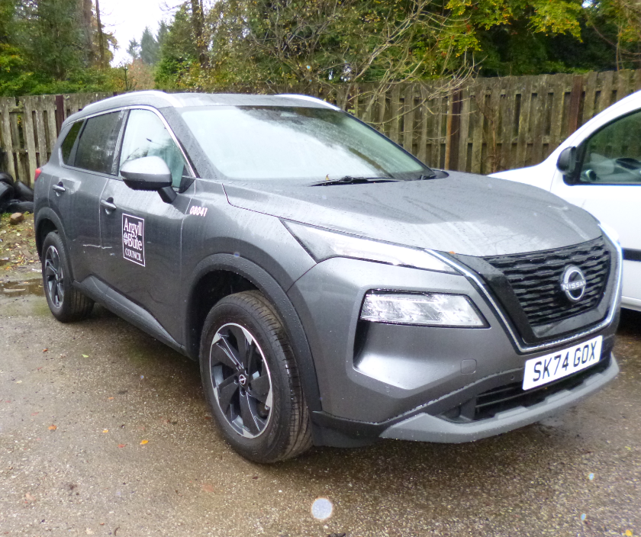
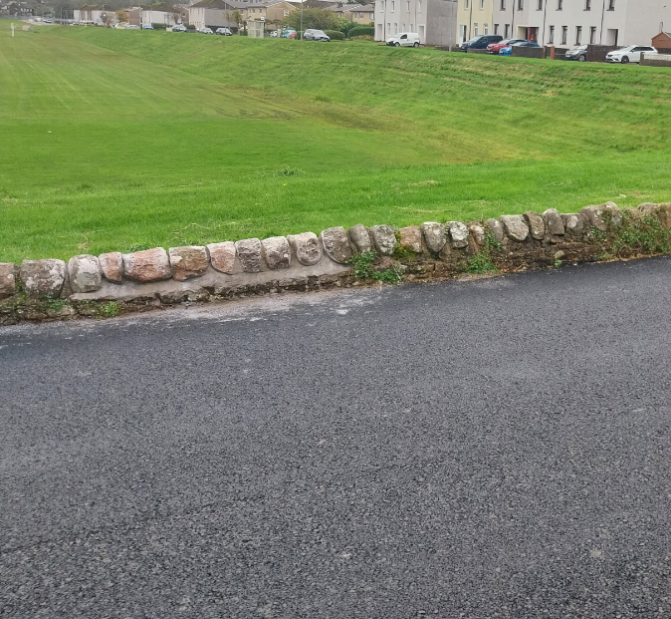

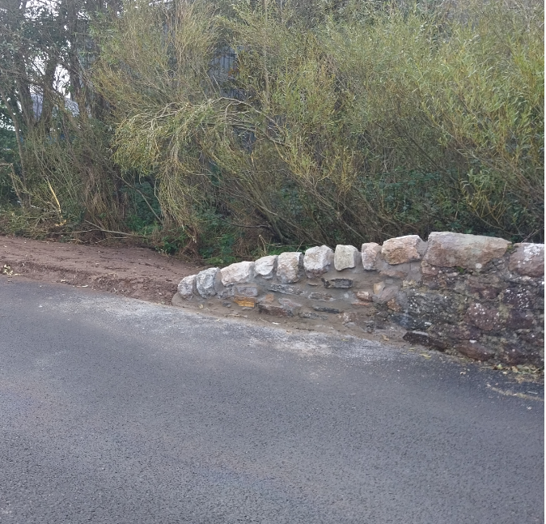

Repairs to the damaged wall on Tomaig Road

