

Please find below a brief snapshot of the huge range of work being undertaken across the area by Roads and Infrastructure staff this week.
Roads and Infrastructure
Weekly member briefing
Edition 165: 6th Sept 2024

The updates are designed as a resource for you to be able to answer constituent queries.

You can view all previous weekly member briefings on the website

Oban, Lorn and the Isles | Helensburgh and Lomond | Mid-Argyll, Kintyre and the Islands | Bute and Cowal
Roads updates  The Blaran scheme is ongoing – good progress is being made and it is on target to complete before the end of the month.  We’re undertaking some patching works to the adopted road on Kerrera, as well as progressing footway improvements outside the Rockfield Centre using extra materials from the Gibralter Street job.  The team on Mull are also making good progress on capital improvement works, having completed the scheme at Calgary Bay, and are now working their way towards Dervaig on what will be the fifth phase of overlay works to the B8073 this year following on from earlier schemes at Killiemore, Killichronan and Balligowan.  Mossfield  The amusements are in Oban this week and are using the blaes pitch at Mossfield.  Bus shelter works  The contractor has been working on bus shelter repairs in Oban and Dunbeg.  Repairs at Benderloch will go ahead this coming Tuesday. | Tigh Dearg Road  Good progress has been made this week – the contractor has laid 50 metres of the base surface material along Tigh Dearg Road as planned. In installing the new foul water drainage the team encountered additional rock which added a little time to the works. As a result we are now looking at switching the access arrangements from Argyll Road to Shore Road around 1st October.  Roads updates  The two schemes in Shandon as advised last week, have made good progress this week and are on target to complete by the end of next week – see photos below.  Safety barriers  The safety barrier contractor is continuing to progress with barrier repairs in and around Clynder.  Flooding A814, Blairvadach  As advised last week we are looking to progress a design to renew the culvert at the top of the hill near the old council office.  To determine the appropriate size and specifications for the new culvert, a site meeting has been scheduled with specialist engineers. This meeting will help us ensure that the new structure is suitably designed to handle the water volume and flow specific to this location.  Additionally, while the site is being excavated, we will take the opportunity to review the existing drainage system. Our aim is to identify any potential improvements that could be made to enhance drainage efficiency, reduce the risk of future flooding, and further safeguard the area from water-related damage.  We anticipate that these works will be completed ahead of the winter season, to minimise disruption and to ensure the area is well-prepared for any adverse weather conditions.  Hermitage Park  The team now have around 15 local community volunteers working in the park, with some doing the odd half day and others two full days a week. This community support has gone a long way to securing the Green Flag award we advised about last week. We have also recruited a modern apprentice for the parks team and they will start at the beginning of October.  Cardross Crematorium  The Crematorium will be closing after the last scheduled service this afternoon until Wednesday for the cremator to be serviced.  We’ve advised funeral directors of this in advance.  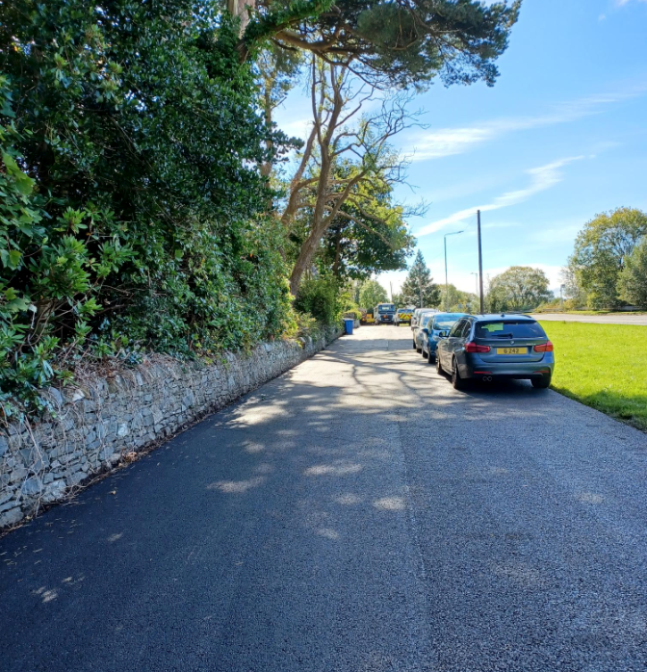  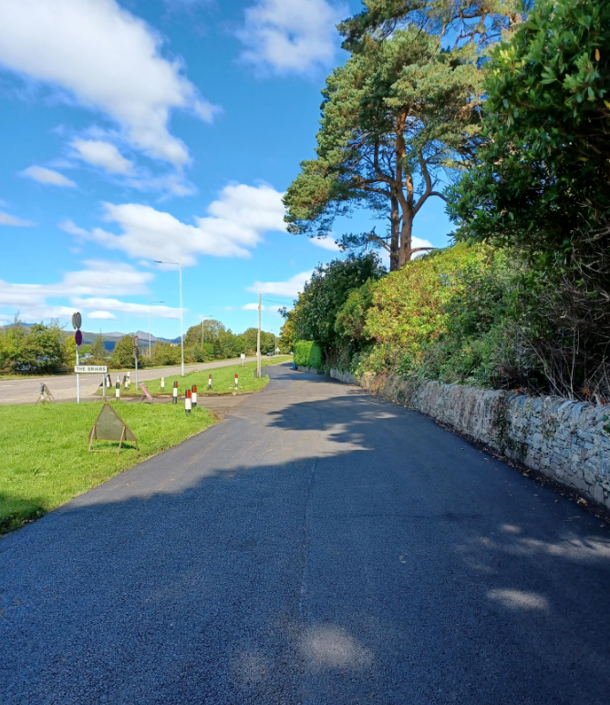 | Roads updates  The team in Mid Argyll have been patching on the A819 at Inveraray ahead of the Electric Cottage capital scheme restarting, and have been carrying out patching on the B8025 Bellanoch Brae.  The capital scheme at Shore Street in Campbeltown has been completed and the team have also been installing new signage along the B842.  The jetpatcher is working on Islay and capital works are progressing in and around Bowmore. The road surface was planed out earlier this week and surfacing starts today.  Bus shelter works  The contractor was in Campbeltown yesterday progressing bus shelter repairs.  They’ll be returning week commencing 23rd September to install the new shelters at Meadows Avenue and Ralston Road.  B8001 Claonaig  The works at Claonaig are continuing. This is a challenging scheme which is seeing large quantities of saturated soils making it difficult to provide a stable working area.  Upslope of the new road we are installing geogrid layers and mesh units to strengthen the embankment and protect the road.  The existing road has been excavated to the new road formation level and a temporary road is in place.  We are also reusing excavated soils in landscaping/improvements adjacent to the site, as well as grading the area around the scour protection site and installing upgraded drainage. We’ve been able to use less of this than originally planned due to its wetness, not helped by the very wet summer. We’ve had to bring in suitable extra material and are taking out the soil which can’t be reused. This means an increase in haulage on the road above previously expected levels. Overall though we are still managing to reuse some of the material which is environmentally friendly and cost effective.  Future site works will include:  - Construction of 120m of new road at a lowered level  - Upslope infill and grading  - Formation of verges and installation of fencing | Roads updates  In Cowal this week we’ve had five operatives away on their HGC certificate of professional competence training all week, which has meant the focus has been on revenue maintenance works only. Along the A815 the team have been grass cutting verges and sightlines with a tractor and flail, with traffic management in place. They’ve also tidied up the just completed capital site at the A886 Strachur Bay, as well as painting new SLOW markings on the A815 surface dressing site south of Loch Eck aswell as GIVE WAY markings on the A886 at Baycroft.  On Bute the jetpatcher has been working on the A844 and the B881, with hand patching continuing on the Serpentine Road and general revenue maintenance works in and around Rothesay town.  Bus shelter works  The contractor attended to repairs in Dunoon and Sandbank earlier this week but wasn’t able to make it to Strachur due to their vehicle breaking down and needing to be recovered. These works will be rescheduled for early next week.  They will be returning on 24th and 25th September to do the new installs in Toward and Innellan.  The Rothesay jobs will go ahead in early October.

B8001 Claonaig
Upslope excavation - terramesh

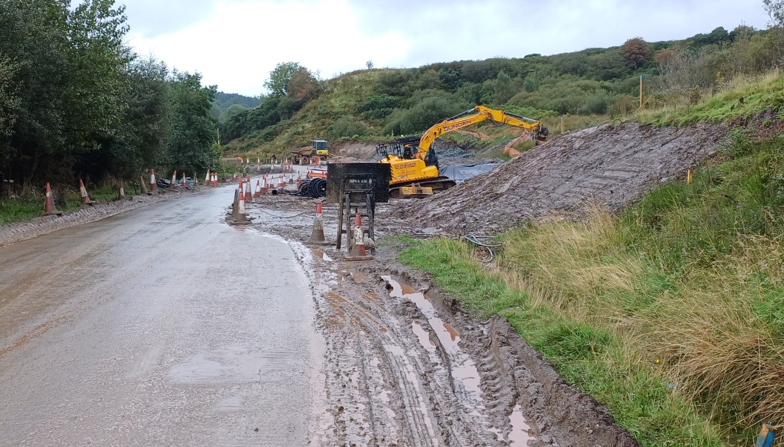

Scour Protection

