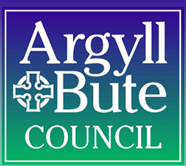
Form ERG1
EDUCATION SERVICE
Education Resource Group Application
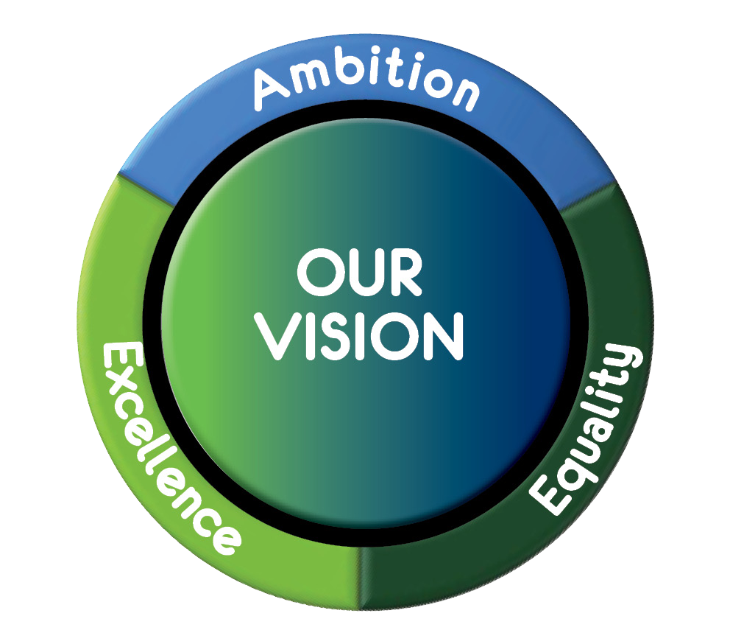

Application checklist

Applications will only be considered if the following has taken place and the appropriate documentation is included.

I attach the following documentation:

Child’s plan or if coming from another authority equivalent paperwork
Attainment levels must be specified in the “achieving” section of the SHANARRI assessment or “How I grow and develop” of the my world triangle in the Child’s Plan.
Chronology of support put in place
Parent / carer consent form
The application has been discussed with any of the following:

- Link Education Manager (For Partner ELC Providers, this would be Early Years Education Manager)
- Education Manager: Inclusion and Equalities
- The Educational Psychologist for the child

Where relevant, the Head Teacher/Depute Head Teacher of Parklands/Learning Centre attended the most recent Child Plan meeting and is in agreement with this recommendation (as per section 4.3 of policy).

Parent / Carer are aware of what provision is being requested through the ERG

Contact Details – Parent/Carer 1 | Contact Details – Parent/Carer 2
Name: | Name:
Address: | Address:
Tel: | Tel:
Email: | Email:

Argyll and Bute Council
Customer Services: Education

Education Resource Group
Request for discussion

Child’s Name
Child’s Date of Birth
Establishment currently attending
Early Years / School Stage
Date of submission

Provide Chronology of Support that has been put in place over time and the impact of this below:
Nature of Support | Impact of this

Summary of current challenges and concerns not included in the Child’s Plan:

What provision is required to meet the needs of the child and how will this improve outcomes:
Nature of support being requested | Anticipated outcome

Form completed by:

