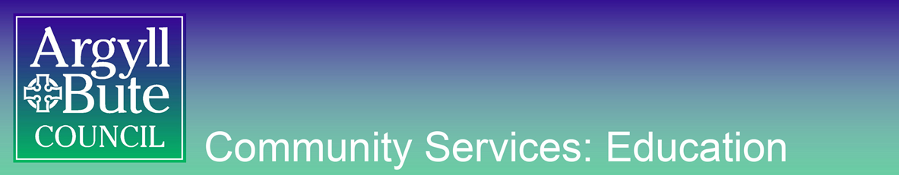

EDUCATION SERVICE
Education Resource Group

Consent Form

I consent to (name of school) sharing information about the wellbeing needs of my child
(child’s name and dob) with Argyll and Bute Council’s Education Resource Group in order to plan to meet the needs of my child.

I understand that consideration of my child’s needs at the Education Resource Group does not guarantee the allocation of specific resource or provision

Signed (parent name) …………………………………………………….

Print (parent name) …………………………………………………….

Date …………………………………………………….

(where appropriate)
I consent to (name of school) sharing information about my (child’s name and dob) wellbeing needs with Argyll and Bute’s Education Resource Group in order to plan to meet my needs.

I understand that consideration of my needs at the Education Support and Resource Group does not guarantee the allocation of specific resource or provision

Signed (pupil name) …………………………………………………….

Print (pupil name) …………………………………………………….

Date …………………………………………………….

