
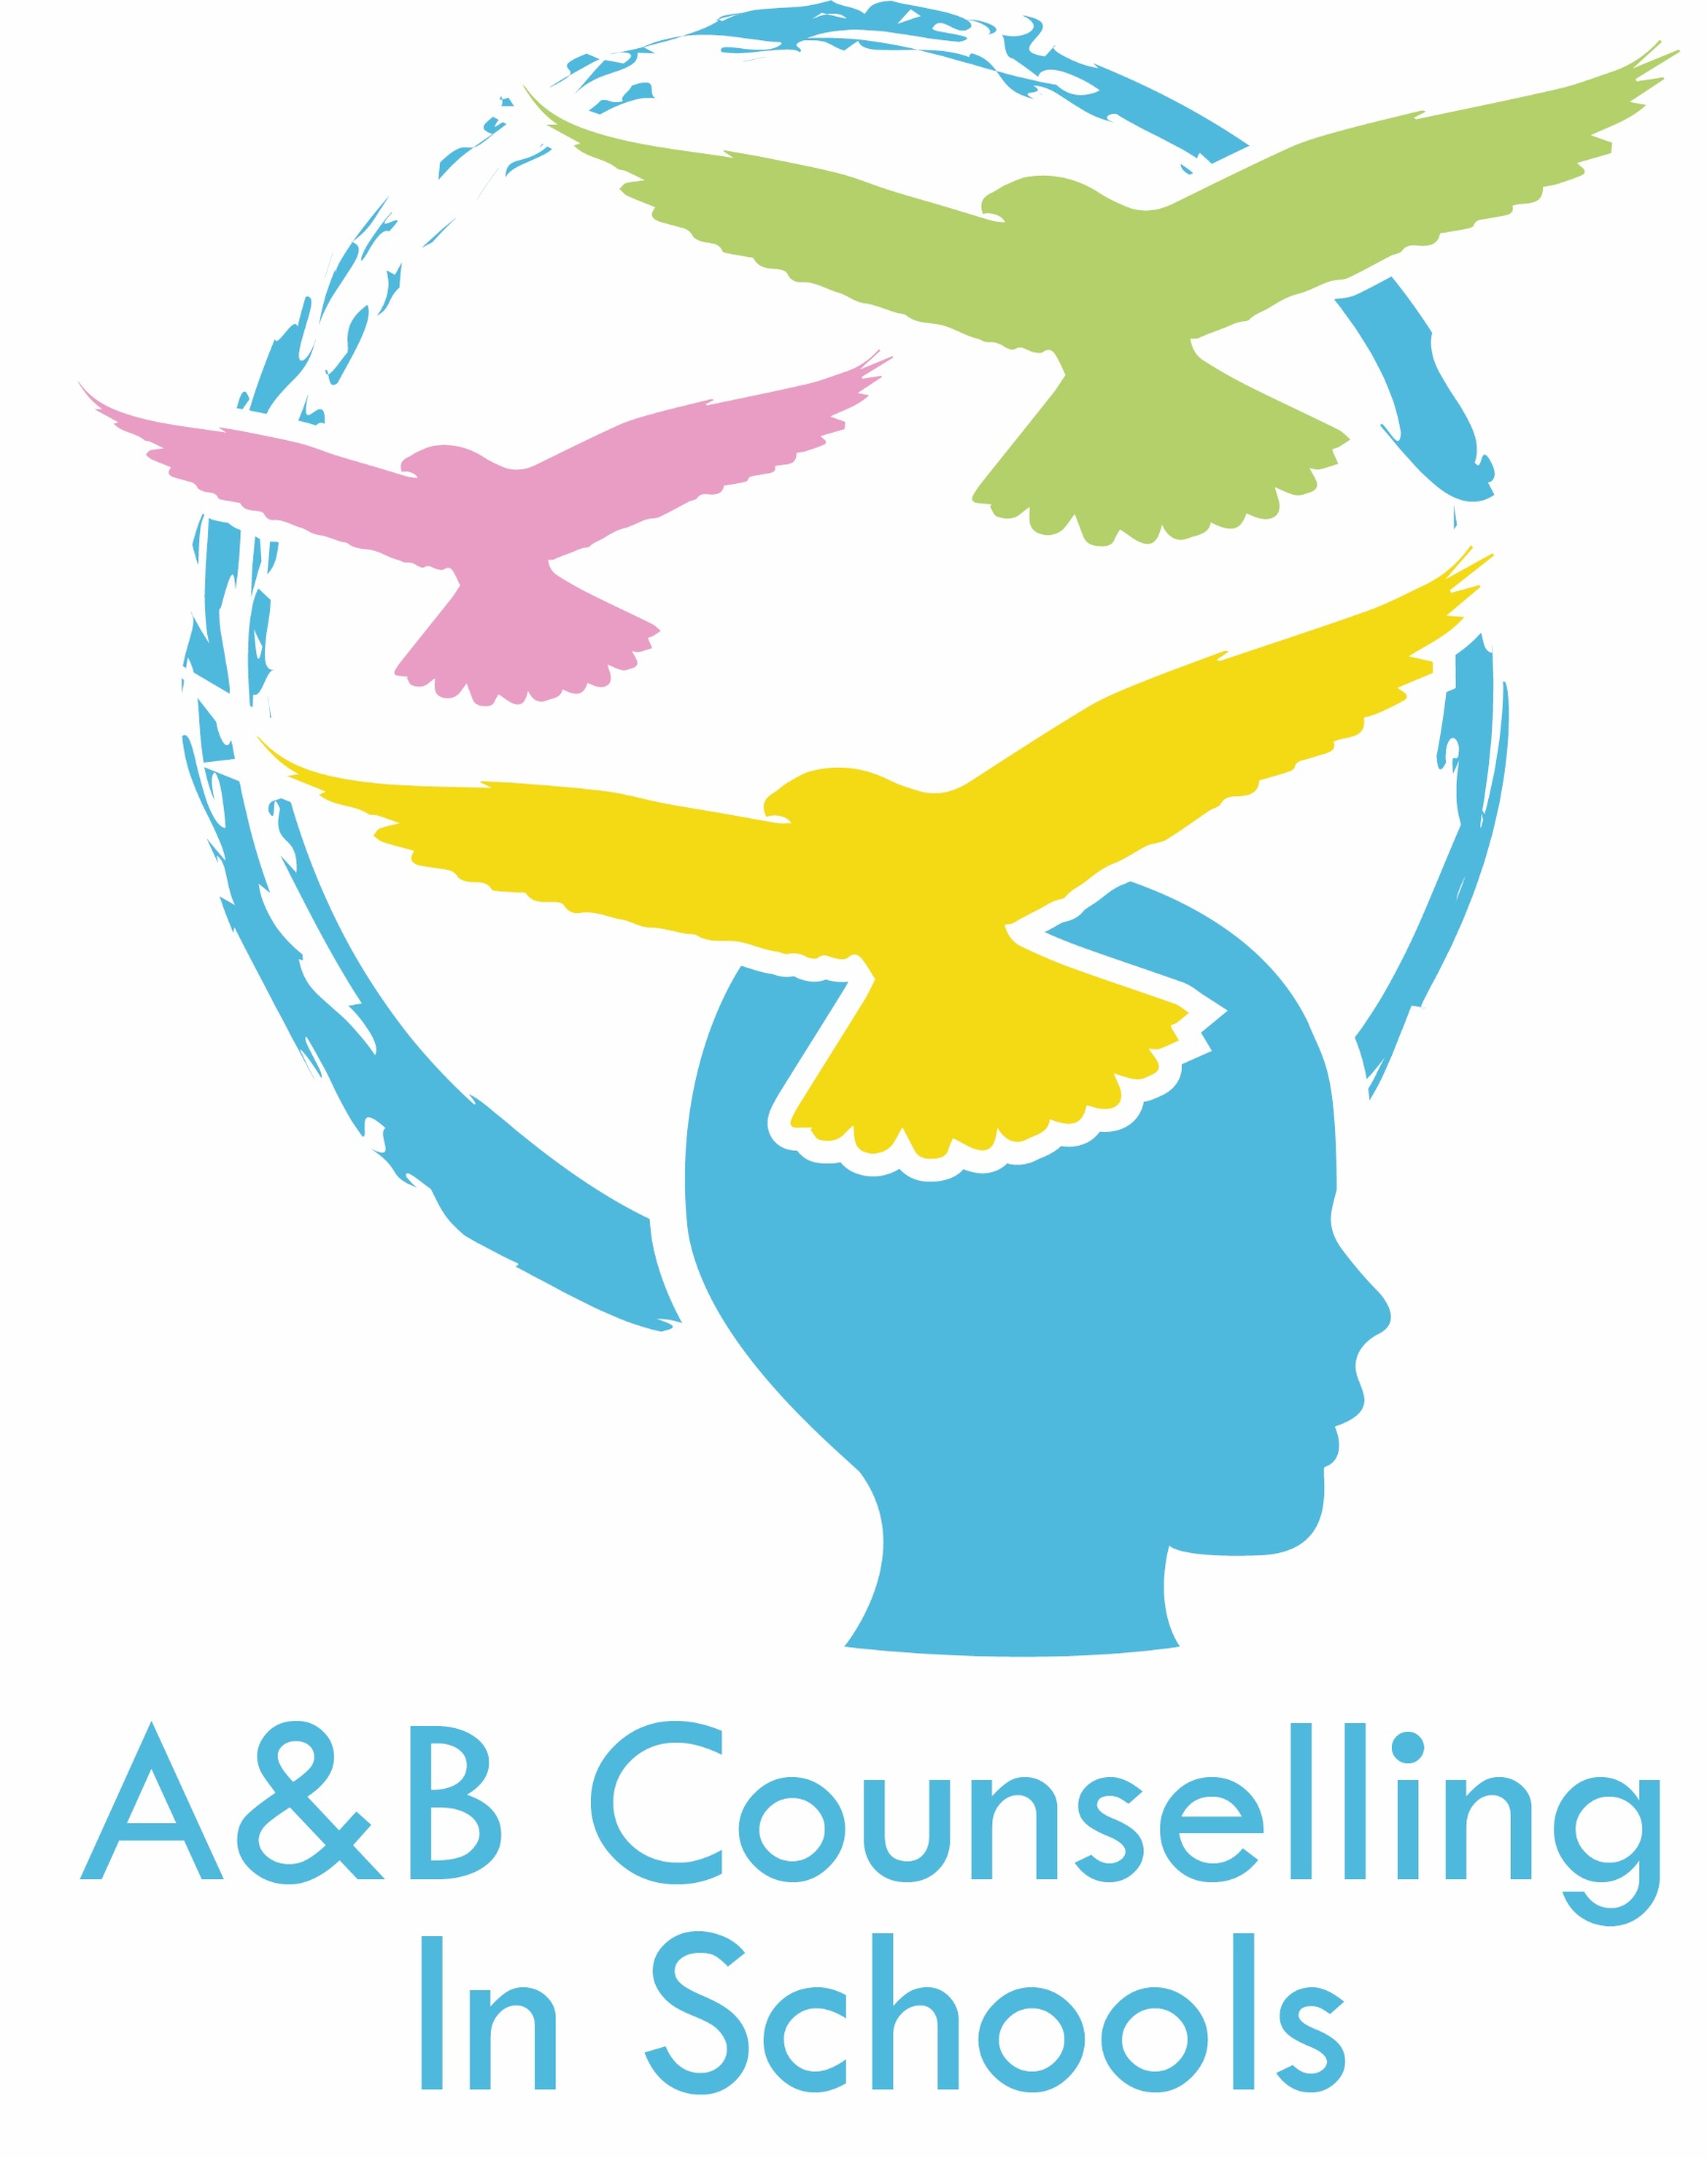

Argyll and Bute School counselling referral form

All referrals to school counselling should be made using this form and returned directly to
nhsh.counsellinginschools@nhs.scot
 |  | CHI Number:
Full name of young person: |  | Please delete below as appropriate
DOB: AGE: |  | Male ☐ |  | Female ☐
Has the young person consented to the referral? |  | YES ☐ |  | NO ☐
Is the named person aware of this referral? |  | YES ☐ |  | NO ☐
Is the young person looked after or care experienced? |  | YES ☐ |  | NO ☐
Is the young person considered to be a young carer? |  | YES ☐ |  | NO ☐
Does the young person receive Free School Meals? |  | YES ☐ |  | NO ☐
Named Person: |  | School:
Postcode (or SIMD): |  | School Year group:
Contact Tel: |  | First Language:
Parent / Carers name: |  | Contact Tel:
Detail any additional Support Needs (Autism Spectrum Condition / ADHD etc.)  (EXPAND AS REQUIRED) |  | Detail any other agencies involved in the young person’s life (CAMHS, Social Work, School Nurse including current referral etc.)  (EXPAND AS REQUIRED)
Referrers name: | Role: | Referrers email address:
Please detail reason for referral including the young person’s presentation and current concerns:
(EXPAND AS REQUIRED)
Impact on areas of child’s wellbeing (Please tick all that apply) |  |  | Safe ☐  Healthy ☐  Achieving ☐  Nurtured ☐ |  | Active ☐  Respected ☐  Responsible ☐  Included ☐
What current supports are in place within the school environment? (EXPAND AS REQUIRED)

Any other relevant information not detailed elsewhere (EXPAND AS REQUIRED)

In situations where school counselling is not an appropriate support young people will be referred to their named person following the GIRFEC practice model

