

Please find below a brief snapshot of the huge range of work being undertaken across the area by Roads and Infrastructure staff this week.
Roads and Infrastructure
Weekly member briefing
Edition 162: 16th August 2024

The updates are designed as a resource for you to be able to answer constituent queries.

You can view all previous weekly member briefings on the website

Oban, Lorn and the Isles | Helensburgh and Lomond | Mid-Argyll, Kintyre and the Islands | Bute and Cowal | All areas
Roads updates  The team are progressing pothole repairs in Dalmally and on Lismore this week, as well as working on the road widening scheme at Blaran on the A819  Mull capital works  We are engaging with CalMac about ferry availability for the start of our capital works on Mull which are due to start on Wednesday.  MacAuley Cup Final  We have been working this week to prepare Mossfield ahead of the shinty cup final tomorrow. All feedback is that the pitch is spick and span ahead of what will be a busy day. | Roads updates  Our road crews are still on the resurfacing works on the Haul Road and Whistlefield roundabouts, which are going well and are on track to finish next Friday.  B833 safety barriers  The barrier contractors are currently on site on the B833 to repair damaged vehicle safety barrier. These works are part of a package that covers several locations in the Lomond area.  Tigh Dearg Road  The works on the flood alleviation scheme are continuing. The contractor is making steady progress up Tigh Dearg Road installing the new foul water sewer and surface water pipe.  At present the works are on track to finish the lower section by Friday 13th September, before moving on to the upper section. | Roads updates  The inlay scheme at Crosshill is ongoing this week. The jetpatcher is out on the Kilberry Loop Road.  Capital surfacing works are planned to start on Islay on Monday.  We will be starting on the C12 Glen Road south of Barr Farm before moving on to the A846, then on to Bowmore the following week.  New benches Lochgilphead Front Green  Following feedback on the development at Lochgilphead Front Green we have bought some new benches which we’ve now placed between the playpark and square areas. This will provide additional seating for parents etc. who children are using the playpark beyond the stone plinth seat which was part of the original design.  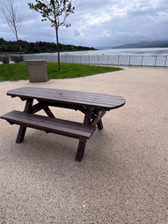  Sound of Kintyre lighting scheme  The replacement decorative columns at the Sound of Kintyre have now been installed. We now need to arrange to have the columns painted so that they match in with the original design colour. | Roads updates  In Cowal the team have been working on emptying gullies in Dunoon town and in and around the Stadium ahead of the Cowal Highland Gathering.  Along the A815 north of St Catherines we’ve been working on signs and pole replacements as well as scrub cutting. We’ve also been working on new verge markers along the resurfacing sites on the A886 as well as culvert repairs in Sandbank, Strachur, Glenbranter and along the B836, and re-setting some gullies in Dunoon.  On Bute we’ve been focussing on pothole repairs in Rothesay town and on drainage ditching works towards Rhubodach  Bute Highland Gathering  The majority of our resource on Bute this week has been deployed to prepare the stadium ahead of the Highland Gathering event. | New minibuses  We have included below some photos of the new 19 seater EVM Cityline buses recently brought into the transport fleet.  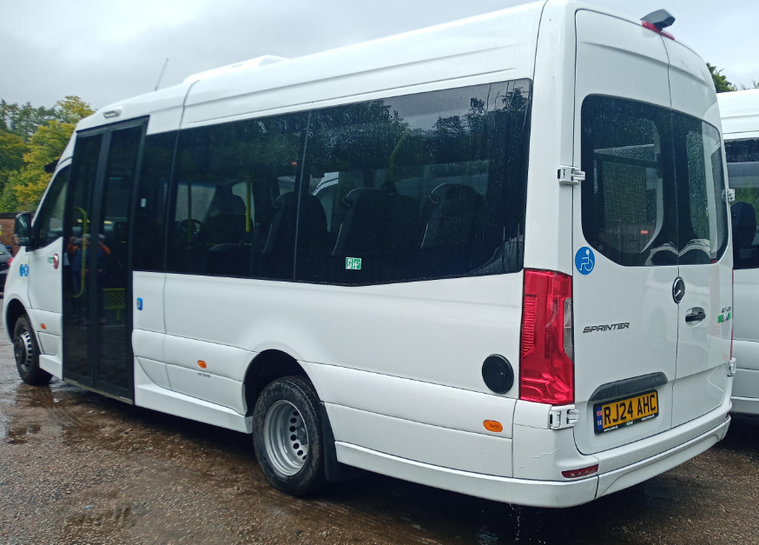  Heavy rainfall infrastructure checks  With heavy rainfall forecast earlier this week our teams were out proactively checking gullies and culverts in known ‘’hot spot’’ areas to ensure these were clear and able to take the flow of water as intended. Thankfully there don’t seem to have been any particular issues.  HAUC courses  We’ve had a lot of people away this week on HAUC (Highway Authorities and Utility Committee) courses, which is training for working on roads and undertaking works like excavations and reinstatements.  Back to school  Schools went back on Wednesday and overall the school transport arrangements worked very well. There were a few minor snags which are to be expected with new pupils/new pick up points etc. and the team worked through these quickly and efficiently.

