

Please find below a brief snapshot of the huge range of work being undertaken across the area by Roads and Infrastructure staff this week.
Roads and Infrastructure
Weekly member briefing
Edition 160: 2nd August 2024

The updates are designed as a resource for you to be able to answer constituent queries.

You can view all previous weekly member briefings on the website

Oban, Lorn and the Isles | Helensburgh and Lomond | Mid-Argyll, Kintyre and the Islands | Bute and Cowal | All areas
Roads updates  The team continue with edge strengthening work on the carriageway on the A816 at Blaran.  We have been able to carry out some slurry sealing at Nant Drive as part of capital footway work which improves the surface.  Capital Programme – Mull  The team will begin all capital work on Mull starting the week of August 19th.  They will work through the tasks over a six-week period, and we will provide an update on their starting point closer to the date.  We will also keep you informed with progress updates on each project throughout the duration.  Streetlighting  The Capital streetlighting project has been slightly delayed due to absence within the team.  We are hoping to be able to complete this next week and will provide a further update in next week’s briefing.  Cuan ferry  Cuan ferry, Belnahua, is now back in the water and over the next days the final aspects of the life extension works and MCA inspection will complete the extended docking period.  Following successful trials the vessel will be back on service at Cuan. | Roads updates  The team are continuing to concentrate on revenue works such as kerb repairs and scrub cutting.  Lining  The lining contractors have carried out the required machine lining on the B832, B872 and the A814.  They are looking to return next week to carry out any required hand lining work in the area (weather dependent).  B833 Crash barrier - Dalandhui  Unfortunately the scheduled work to replace the damaged crash barrier at Dalandhui on the B833 was delayed due to unforeseen circumstances.  They will now look to attend on 12th August and it’s expected work will approximately 4 days to complete.  Blackhill waste transfer site  Designs, business case and consents continue to be progressed as per the programme for works to be forecast to be completed by December 2025.  Hermitage Park café  Unfortunately the current leaseholder for the café has decided to cease operating.  We are working with colleagues to now look at future options. | Roads updates  The roadmaster has been attending to defects identified during inspection on Jura this week and will return to Maki next week.  Capital surfacing works are scheduled to commence in Kintyre at Meadows Avenue, Crosshill Avenue and Tomaig Road on the 5th August have been delayed one week and will now start on 12th August. This is due to unforeseen circumstances.  Bengullion road glass recycling  To address the issue of the glass recycle bins being blown over and to ensure the bins remain secure, we have taken proactive measures and created a fence at the bins. We believe this will effectively prevent any further disturbances.  Campbeltown TRO amendments  Following the recent June EDI Committee meeting, we have successfully secured funding for an additional warden in Maki.  This new position will play a crucial role in assisting with the enforcement of pavement parking legislation and the decriminalisation of parking offences.  We understand that parking issues have been a significant concern for the residents of Campbeltown, and we hope that this additional support will make a positive difference.  It is suggested that we delay any amendments to the current TRO as we believe the presence of the new warden will help ensure that parking regulations are more effectively enforced, which in turn should alleviate some of the current challenges.  Port Askaig  Port Askaig has reopened to the CalMac ferry service.  Planned port enabling works on the pier for the new Islay vessels have been completed as well as maintenance work on the linkspan. | Roads updates  The team have been continuing with routine gulley cleaning and grass cutting in both Bute and Cowal.  The jet patcher will be attending Bute next week to carry out any required repairs to defects that have been noted.  On Bute work continues with the capital footway work on the High Street.  We will be looking to commence preparation work for the capital surfacing works week commencing 5th August on the A886 Baycroft to A815 Junction, Strachur.  The in house lining trailer has been refreshing road markings at the taxi rank this week.  Inellan Bus shelter  A site meeting is arranged for Wed 7th August to discuss the new suggested location for the bus shelter in Innellan.  Following this meeting we will be able to finalise the list for the contractor and secure a date for work across Argyll and Bute to commence.  We are utilising an external contractor for the repair and installation of bus shelters and to ensure cost-effectiveness and best value for the council,  This approach allows us to optimise the contractor's travel time and expenses. | New buses  We have purchased two new EVM Citylines.  These are coachbuilt 18 seater buses (i.e. like a full-size service bus, but in miniature, with destination display, wheelchair space, low floor access ramp etc) based on a Mercedes Sprinter chassis.  The plan is to insert them into school and local bus contracts to realise a saving (as the operator does not have to procure of finance the bus).  We are also in the process of arranging a dozen new minibuses, some of which will be available for the start of the new school term in August and the remainder for the return from the October break.  Rotating out older vehicles increases the reliability of the service and reduces ongoing repair and maintenance costs across the fleet.  Paysmarti parking system  There was a short term issue on Friday with the Paysmarti parking platform, but this was quickly resolved.  This system allows customers to pay by phone or text for parking, which is in additional to the other payments options we offer, through traditional cash payments, and through card payments at some of our parking meters which have been upgraded fairly recently.

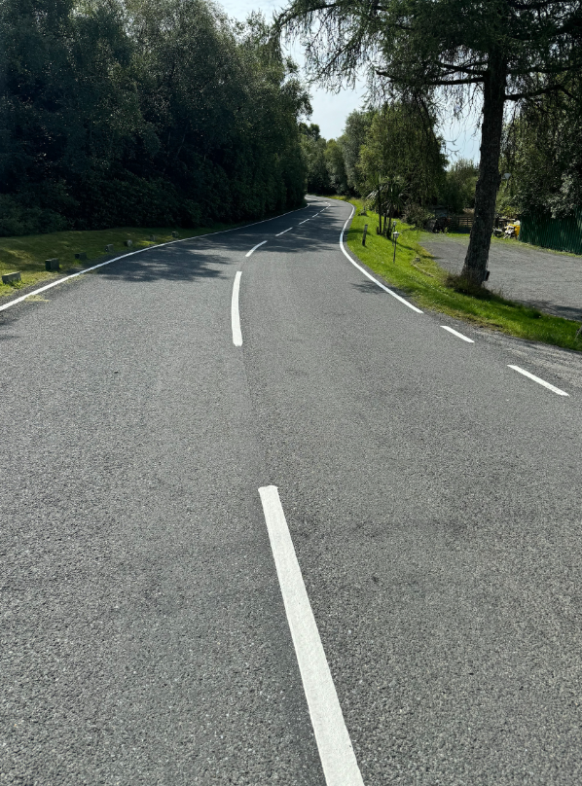
Recent lining work completed on the A814

