

Please find below a brief snapshot of the huge range of work being undertaken across the area by Roads and Infrastructure staff this week.
Roads and Infrastructure
Weekly member briefing
Edition 159: 25th July 2024

The updates are designed as a resource for you to be able to answer constituent queries.

You can view all previous weekly member briefings on the website

Oban, Lorn and the Isles | Helensburgh and Lomond | Mid-Argyll, Kintyre and the Islands | Bute and Cowal | All areas
Roads updates  The team continue with edge strengthening work on the carriageway on the A816 at Blaran.  This was an agreed capital scheme for 23/24 that has been rescheduled to 24/25.  We are hoping to carry out some slurry sealing at Nant Drive as part of capital footway work, however this is weather dependent.  Slurry seal is a thin layer of surfacing treatment used on footways to waterproof the surface, repair minor imperfections, and extend the life of the footway.  Streetlighting  The Capital streetlighting project is expected to be completed next week.  We have added an additional street, Feochan Gardens, to the programme, as it was originally intended to be included but was omitted due to an oversight. This addition involves the installation of three columns and the necessary wiring.  Currently, SSE is providing a supply to some of the new columns in Oban. We have requested SSE disconnect their supply to enable us to establish our own connections. This process will not impact the operation of any of the lights.  Following the completion of this capital scheme the contractor and our team will be commencing a capital scheme at the back brae on Mull.  This scheme is the replacement of 20 columns, 2 Highway Distribution Units (HDU) and necessary cabling. We will provide updates on this scheme through our weekly briefings | Roads updates  Surfacing works on the B872 at Whistlefield Road have now been completed.  The team are taking a two week break from capital work to concentrate on revenue works such as kerb repairs and scrub cutting.  Food waste vehicle  Our food waste vehicle has been repaired and was back in operation this morning.  B833 Crash barrier - Dalandhui  Our contractor is scheduled to attend on Tuesday 30th July to replace the damaged crash barrier at Dalandhui on the B833.  The work is expected to take approximately 4 days to complete.  Lining work  Following our capital work the lining contractor is now scheduled to attend next week to mark the new surfaces on the A814, B872 and B832 as well as some small revenue works that are required.  As always this is weather dependent and will be delayed if we experience poor weather. | Roads updates  Crews are carrying out repairs to defects that have been identified during inspection  We have also continued with rural grass cutting.  Capital surfacing works are scheduled to commence in Kintyre at Meadows Avenue, Crosshill Avenue and Tomaig Road the week commencing 5th August.  Bengullion road glass recycling  To address concerns about broken glass in the area, we have increased the collection frequency from monthly to every two weeks, with the next scheduled collection on Sunday, 28th July.  Since the last collection, our local amenity supervisor has been monitoring the site and reports no issues.  We hope that the increased collection frequency will help prevent any glass breakage as the bins will not be at full capacity, and our supervisor will continue to regularly monitor the area. | Roads updates  The team have been continuing with routine gulley cleaning and grass cutting.  They continue to work through small work instructions to repair defects identified through inspection.  We will be looking to recommence capital surfacing works week commencing 5th August on the A886 Baycroft to A815 Junction, Strachur.  On Bute work continues with the capital footway work on the High Street.  Our in house lining trailer has also attended the island this week carrying out small lining work requirements and we will be looking to re-attend next week to continue with these (weather permitting)  Bute Traffic Regulation Orders  We understand a business day has been scheduled with members on September 3rd to discuss Traffic Regulation Orders in Bute.  Our Assistant Network and Standards Officer will be attending this meeting and is currently preparing a list of issues to be discussed.  This list will be distributed prior to the meeting | HGV white lining vehicle  A preferred supplier has now been selected and we will be placing the order to purchase our HGV lining vehicle.  The lead time from ordering the vehicle and delivery is approximately 30 weeks so it is expected we will receive this sometime in January 25.  Following the delivery of the vehicle, we will need to recruit additional staff and train them on its use. However, we hope that as we approach the drier months next year, we will be able to fully utilise our own vehicle and be less reliant on external contractors.

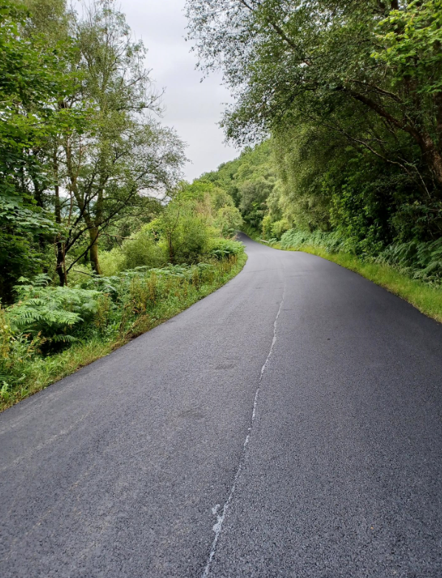

Surfacing work recently completed on the B872, Whistlefield Road, Helensburgh

