

Please find below a brief snapshot of the huge range of work being undertaken across the area by Roads and Infrastructure staff this week.
Roads and Infrastructure
Weekly member briefing
Edition 158: 19th July 2024

The updates are designed as a resource for you to be able to answer constituent queries.

You can view all previous weekly member briefings on the website

Oban, Lorn and the Isles | Helensburgh and Lomond | Mid-Argyll, Kintyre and the Islands | Bute and Cowal | All areas
Roads updates  Crews have been working on the A816 at Blaran carrying out edge strengthening work to the carriageway.  This was an agreed capital scheme for 23/24 that has been rescheduled to 24/25.  The team have also continued to work through any safety defects that have been identified through inspection and also continuing with rural grass cutting.  Clipper Race  Our teams have continued to provide a high level of support for the event. Feedback indicates that the event has been a huge success. Our support has included  - Navigational matters in Oban Bay and particularly around North Pier, passport control for international vessels  - Keeping the streets clean and tidy  - Providing minibus connections for some of the event delegates  - Arranging changes to car parking and managing parking  - Emptying bins including special arrangements for 'international waste' from the Clipper Boats  This is the first time the World Yacht Race has visited Scotland and provides a unique opportunity for the town.  More information about the event, including alternative parking arrangements and traffic management is available on our website here | Roads updates  Surfacing works on the B872 at Whistlefield Road have commenced and are expected to complete by Thursday 25th July.  A road closure is in place during working hours.  We are continuing with the rural grass cutting across the area.  Food waste vehicle  Our food waste vehicle is currently undergoing repairs in the garage.  We have made alternative arrangements to ensure the collection of food waste continues without any disruption to the service  Cardross Crematorium  We have been advised of required servicing at the crematorium which will take place on 21st – 23rd September.  We will remind you of this nearer the time. | Roads updates  Surfacing work on Davaar Avenue and Carlton Avenue in Campbeltown is scheduled to complete today.  These areas has benefitted from approximately £58,000 investment to improve the road surface.  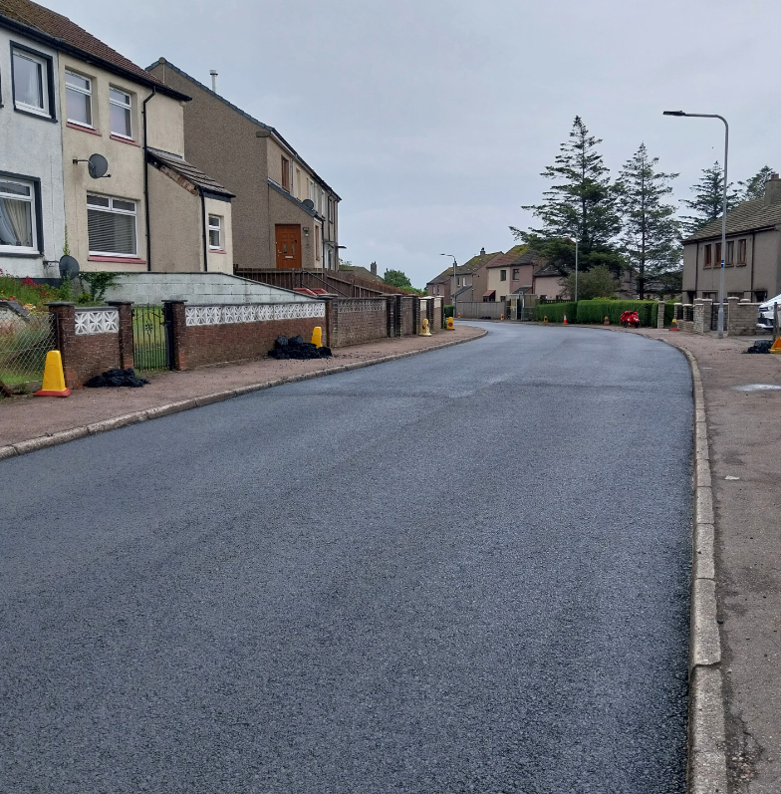  Kintyre bus contracts  The contracts to provide the Kintyre school and local bus services will be issued next week.  Port Askaig link span  During a recent inspection it was identified that the hydraulic cylinder that helps operate the link span at Port Askaig needed replaced.  The current closure of the Port has allowed the cylinder to be replaced preventing any further disruption  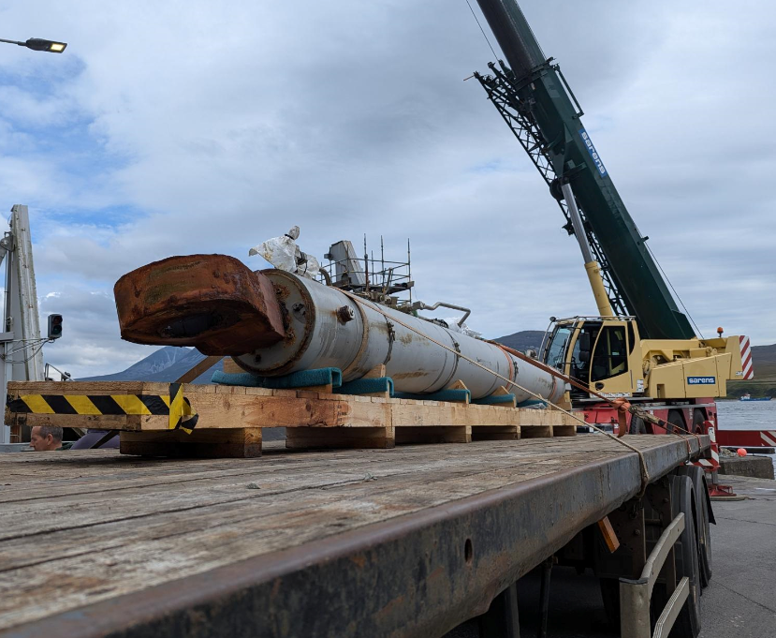 | Roads updates  We have been carrying out capital footway resurfacing High Street on Rothesay.  Our in house lining trailer has been refreshing double yellow lines for traffic orders, junction markings and disabled bays.  Capital resurfacing work on the C7 at Tanklanding Kames has now been completed.  Rural grass cutting has been ongoing this week along the A8003 Tighnabruaich and B839 Hells Glen.  The team have also been carrying out scrub cutting along the B866, Colintraive Coastal Route and the C9 Ardentinny, Stronchuillin Farm to Beacon.  Rothesay Esplanade  We have now received quotes to carry out the required repairs to the missing and displaced masonry along the retaining sea wall and the cracking and settlement of the footpath along the Esplanade.  We will be reviewing these and looking to progress repairs as soon as reasonably practical.  Cowal and Bute Highland Gatherings  Our teams are working to put things in place for these two important local events. | Waste ban compliance  The council has secured £1.5 million of Scottish Government funding to help it make the changes required to meet new waste regulations that come into force in December 2025.  Argyll and Bute is in a unique situation which makes it difficult to meet the requirements of the Biodegradable Municipal Waste (BMW) ban by the deadline  The new legislation bans almost all biodegradable material (food, card, paper, garden waste etc) from landfill.  The treatment processes used at the sites operated as part of a PPP (public-private partnership) contract the council has with its waste contractor will not be compliant with the BMW ban.  That contract runs until 2026, nearly a year after the ban comes into place and to end the contract would have financial implications.  The new funding will allow the council to switch from Mechanical Biological Treatment Plants (MBTs) to Waste Transfer Stations in Oban, Lochgilphead and Dunoon. General waste will then be taken from the Waste Transfer Stations to Energy from Waste plants, rather than being processed with residual waste for landfill, making it compliant with the new government legislation.  The council is progressing work as required on other sites in the area, managed outside the PPP contract, to ensure that they comply with the new legislation when it comes into force.



Photos of the Clipper Race event in Oban that finishes on Sunday 21st




