

Please find below a brief snapshot of the huge range of work being undertaken across the area by Roads and Infrastructure staff this week.
Roads and Infrastructure
Weekly member briefing
Edition 157: 12th July 2024

The updates are designed as a resource for you to be able to answer constituent queries.

You can view all previous weekly member briefings on the website

Oban, Lorn and the Isles | Helensburgh and Lomond | Mid-Argyll, Kintyre and the Islands | Bute and Cowal | All areas
Roads updates  This week the team have completed the capital surfacing work on McCaig Road in Oban.  Next week they will be focussing on carrying out repairs to any safety defects that have been identified through inspection and also continuing with rural grass cutting  Clipper Race  Arrangements are all in place for the Clipper race which starts today and will run until 21st July.  Our teams have been working with a number of different agencies and will be providing support for the event which include  - navigational matters in Oban Bay and particularly around North Pier, passport control for international vessels  - Keeping the streets clean and tidy  - Providing minibus connections for some of the event delegates  - Arranging changes to car parking and managing parking  - Emptying bins including special arrangements for 'international waste' from the Clipper Boats  This is the first time the World Yacht Race has visited Scotland and provides a unique opportunity for the town.  More information about the event, including alternative parking arrangements and traffic management is available on our website here  Iona public toilet  The public toilet at the slipway has had to temporarily be closed due to a blocked pipe.  We are awaiting the term contractor attending and expect this to be re-opened next week some time. | Roads updates  The capital inlay scheme on the U133 Forestry Houses, Succoth, Arrochar has now completed.  Next week surfacing works on the B872 at Whistlefield road will commence and are expected to take approximately 10 days to complete.  We will also have the jet patcher and road sweeper in the area next week to undertake the cyclic maintenance.  We are continuing with the rural grass cutting across the area.  Tigh Dearg Road  The contractor is continuing to progress further up Tigh Dearg Road whilst simultaneously installing the new foul sewer and carrying out some required works to tie in the 600mm surface water pipe to the newly constructed outfall.  A summarised programme of works received on Friday 2nd July indicates that Geo Rope will be finishing the lower section (between Shore Road and the driveway of HaarLiath and the gate to Ashwood) of the works on Friday 13th September and then will commence the upper section of the works (from driveway of HaarLiath and the gate to Ashwood to Argyll Road) from until 21st October. | Roads updates  Surfacing works on the U47 Crinan Loop have now been completed.  The capital inlay scheme to improve the surface on the B842 Campbeltown Esplanade has also completed this week.  Next week the team will be commencing work to resurface Davaar Avenue and Carlton Avenue in Campbeltown. This is expected to complete by Friday 19th.  Port Askaig  Officers have held meetings with Islay and Jura communities earlier this week and received positive responses regarding next steps for the enhancements to the marshalling area and quayside.  Gartbteck capping works  The capping works at Gartbreck completed successfully yesterday see images  Claonaig landslip  The work at Claonaig landslip is progressing well and is on schedule.  Below are images taken this week of the ongoing work. | Roads updates  Work has commenced on the C7 from B8000 to Tank Landing, Kames. This capital scheme will see approx. £147,000 investment to improve the road surface.  Rural grass cutting has been underway along part of the the A886 Strachur – Colintraive), B8000 and C9 Blairmore to Whistlefield.  Both Bute and Cowal teams have been working through safety defects that have been identified through inspection.  Rothesay Harbour  Rothesay Harbour  Stabilisation Works are well underway to repair damage caused by scouring from engine wash.  Work should take nine months to complete by carrying out work overnight to minimise disruption to ferry operations.  Day-to-day travel for Bute residents and visitors should mainly be unaffected. | Electric vehicle infrastructure fund (EVIF) allocation  This morning we received a letter from Transport Scotland indicating a provisional allocation of £1million from the EVIF.  We will be arranging to meet with colleagues from Transport Scotland shortly to work through the detail of this.  We are hopeful that we can push for more funding but with such a sizable provisional allocation this will allow us to develop and refine our plans to increase the electric vehicle charger network across Argyll and Bute.

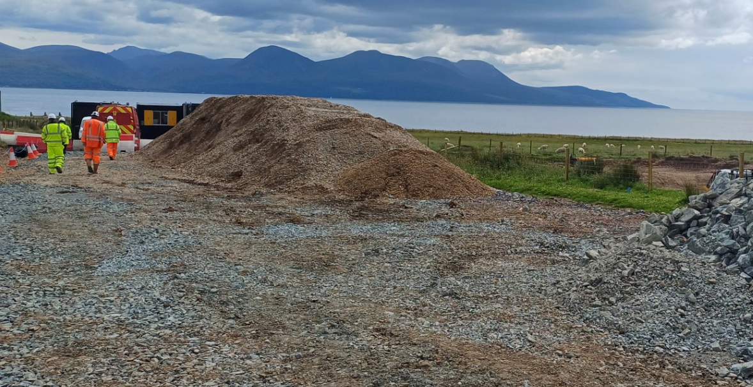
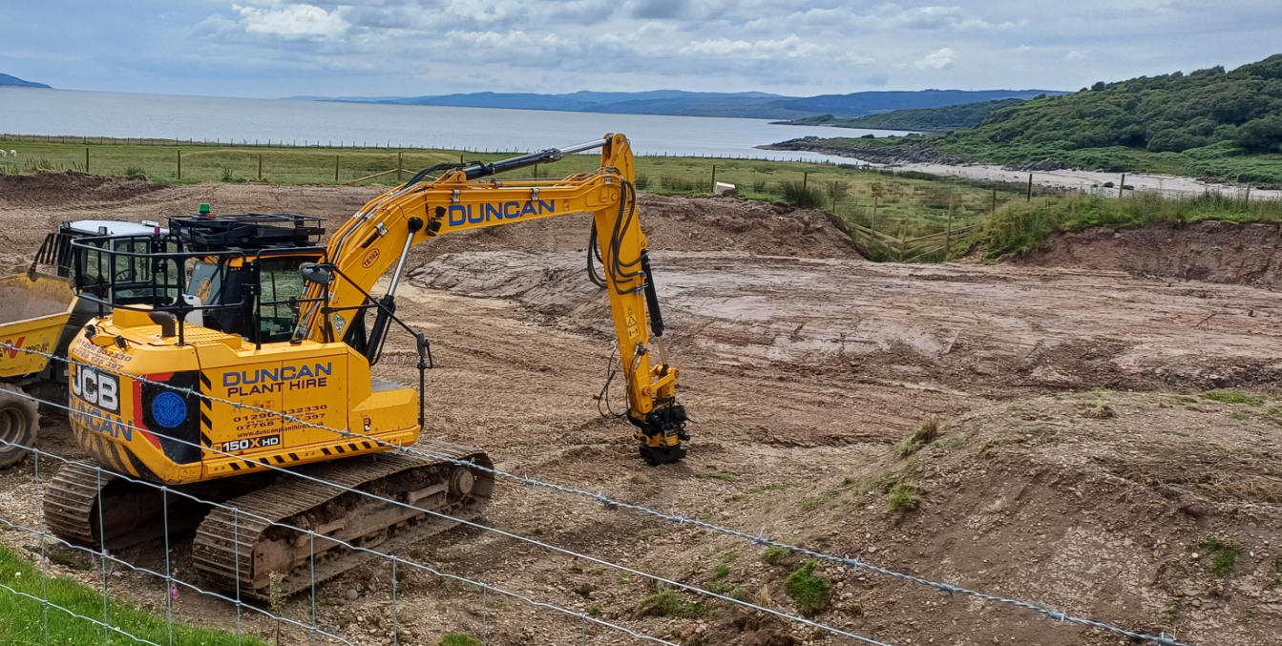
Ongoing work at Claonaig landslip

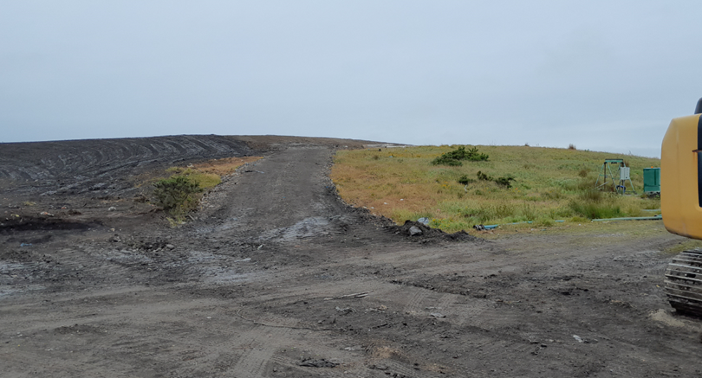
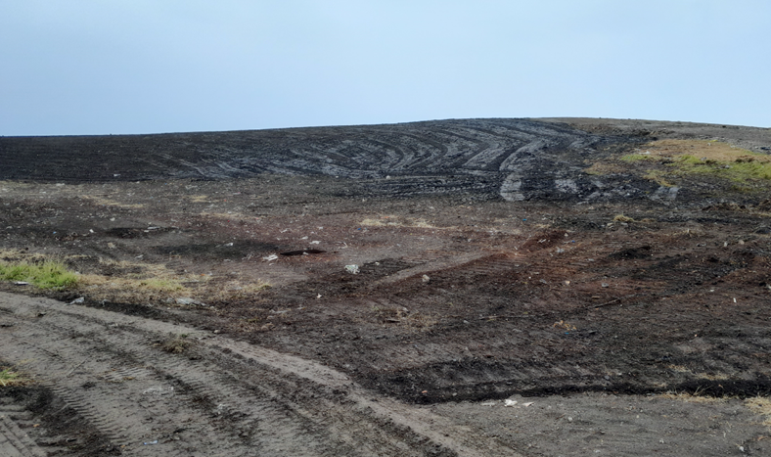
Completed profile for Gartbreck Capping

