

Please find below a brief snapshot of the huge range of work being undertaken across the area by Roads and Infrastructure staff this week.
Roads and Infrastructure
Weekly member briefing
Edition 156: 5th July 2024

The updates are designed as a resource for you to be able to answer constituent queries.

You can view all previous weekly member briefings on the website

Oban, Lorn and the Isles | Helensburgh and Lomond | Mid-Argyll, Kintyre and the Islands | Bute and Cowal | All areas
Roads updates  The C30 and U014 have now been resurfaced following the re-opening at Kilmaha and Scammadale.  A small section of footway on Coe Gardens, Oban has also been resurfaced this week.  General maintenance across the islands including cutting, back sightlines, pothole repairs and ditching.  Streetlighting  The capital scheme in Oban is progressing well. The team are currently working at Orchy Gardens.  Cuan Ferry  52 year old MV Belnahua is still undergoing maintenance and life extension works. The period has been extended, due to the quantity of steel being replaced to ensure the vessel is able to continue service. These upgrades will increase the lifespan of the vessel. | Roads updates  The team has now completed the capital surfacing program on the C69 Glen Douglas Hairpin bends, which benefited from a £34,320 investment in the road surface.  Next week the team will be commencing the capital inlay scheme on the U133 Forestry Houses, Succoth, Arrochar. This scheme is expected to take approximately 10 days to complete.  Cardross Crematorium  We have relatively few bookings at the crematorium over the next week or so (only 16 so far). During these quieter periods it allows the team there to catch up on housekeeping/maintenance tasks. | Roads updates  Surfacing works on the U47 Crinan Loop have continued this week, but have been slightly delayed due to the poor weather we have experienced. This capital scheme is now expected to complete next Mon / Tues.  Next week the team will also be commencing the capital inlay scheme which will see approximately £125,000 investment to improve the surface on the B842 Campbeltown Esplanade.  Lining contractors that were scheduled to attend Campbeltown this week have been rescheduled to attend next week due to the poor weather.  Campbeltown Old Quay Wall Replacement  Further ground investigation has been carried out, and site setup is underway. The main piling design is currently being progressed with works programmed to commence in September 2024.  Port Askaig  Enabling works are also well underway at Port Askaig to prepare for the new CalMac vessels, expected before the end of the year. | Roads updates  Capital surfacing works on the A886 at Dunans is now complete.  Surfacing work has also been ongoing at the B8000 Largiemore (C11 junction), this is expected to be complete today (Friday).  Next week preparation work will commence planing out the existing surface on the C7 from B8000 to Tank landing, Kames. This capital scheme will see approx. £147,000 investment to improve the road surface.  On Bute the team have been working through works instructions following safety inspections.  Footway repairs have been carried out on both the High Street and King Street. A gulley has also been repaired Serpentine Road.  Bus stop timetables  Timetable information across Cowal and Bute was updated this week to reflect the current bus service.  We were unable to update the following three stops:  • Toward, opp Machair Cottages – due to overgrown shrubbery – however this stop will be replaced this Summer with a fully enclosed bus shelter, and the timetable information will be displayed within the case built into the new shelter.  • Dunoon, Alexandra Parade opp Swimming Pool – due to the locks on the display case integrated into the shelter being frozen. Commutaports will attend this site in the Summer and drill out and replace these locks, to allow the timetable information to be updated.  • Kirn, Marine Parade before Kirn Gardens – due to the bus shelter having been temporarily removed to allow the building works currently ongoing at 75-77 Marine Parade, we were unable to update this panel. Shelter will be reinstated once works are complete and timetable information updated. | General election  Our teams supported the delivery of the election by collecting ballot boxes and taking them to the count centre. This worked well across the area. There was a slight problem in Oban due to the A85 being closed from 7pm till around 10.30pm which meant our drivers going north had to go the long way round, down to Inveraray then up to Dalmally to be at the collection points for the close of poll. Thankfully the road had reopened for the journey back which didn’t delay the deliveries to the count centre.

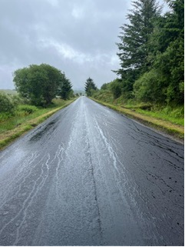
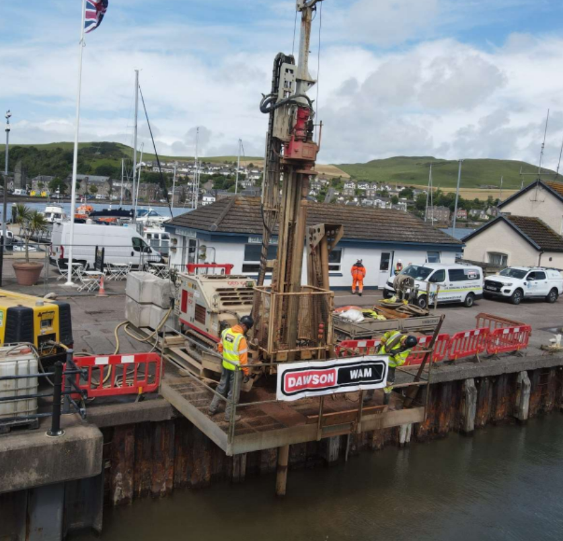
Recently completed surfacing scheme on the A886 Leanach, Cowal
Investigation work at Campbeltown Quay Wall

