

Please find below a brief snapshot of the huge range of work being undertaken across the area by Roads and Infrastructure staff this week.
Roads and Infrastructure
Weekly member briefing
Edition 155: 28th June 2024

The updates are designed as a resource for you to be able to answer constituent queries.

You can view all previous weekly member briefings on the website

Oban, Lorn and the Isles | Helensburgh and Lomond | Mid-Argyll, Kintyre and the Islands | Bute and Cowal | All areas
Roads updates  Both capital schemes on High Street and Dunuaran Road are scheduled to complete today.  Following the reopening of the C30 and U014, the team will be carrying out some required surfacing work on these roads, more specifically at Kilmaha and Scammadale.  Crews continue with routine grass cutting and pothole repairs.  Tobermory Wall and Rails Phase Two  Works are now fully complete, which includes flood alleviation measures with a new flood barrier and gate, increased wall height, resurfacing of parking area and flat valves.  A local community group has received a demonstration on how to install the barrier when a flood event is expected.  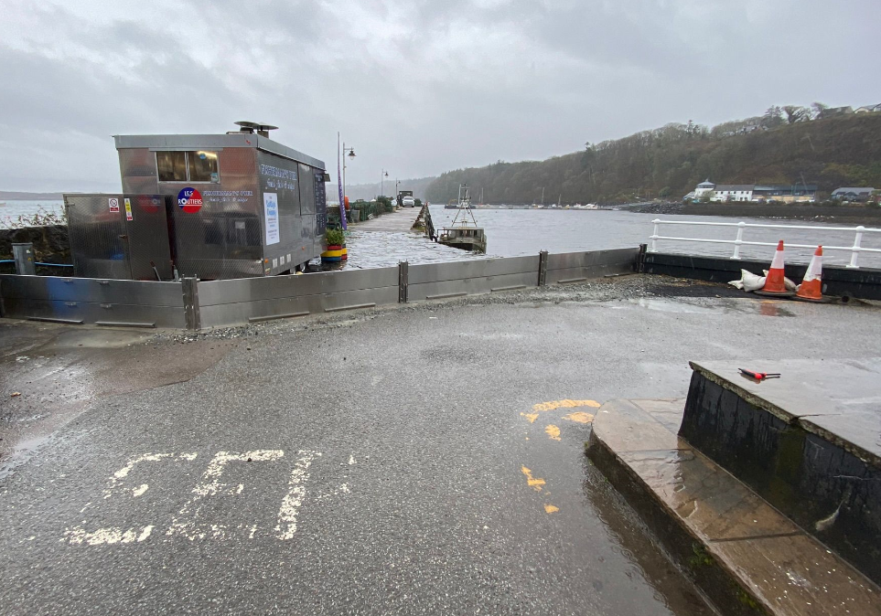  Iona Breakwater  All required consents except the marine licence have been granted.  The works have been tendered and a preferred bidder has been selected. The works contract will be awarded on receipt of the licence from the Scottish Government’s Marine Directorate.  Streetlighting  The capital scheme in and around Nant Drive is progressing well and on schedule to complete in the next two weeks.  A85 road closure yesterday  The road closure on the A85 yesterday affected school transport with those children living to the north (Connel, Barcaldine etc.) staying home. We also had a burial at Pennyfuir which unfortunately had to be rescheduled. | Roads updates  The capital surfacing scheme on the B832 completed this week meaning the road has now reopened.  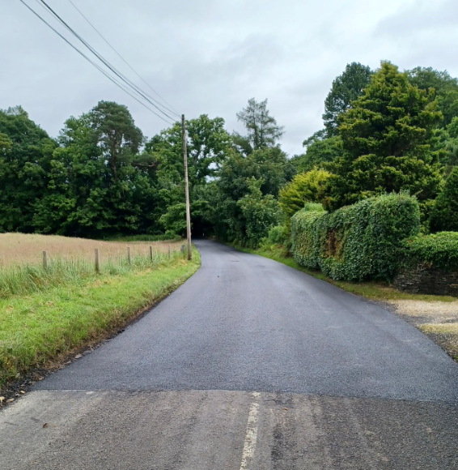  The team have planed out the surface on the C69 ahead of the capital resurfacing work scheduled to commence on Monday 1st July. Work is expected to complete around 5th July. A road closure will be required for the duration of these works.  The planned surface dressing works on the A814 have now been completed by our contractor and the road has re-opened.  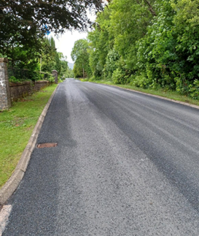  Planned road closure on A83 at Tarbet/Arrochar in November  We’ve been notified by Network Rail that they are planning works on the rail bridge which crosses the A83 between Arrochar and Tarbet.  The nature of the works mean that the road will need to close for 5 days.  Our understanding is that they are liaising with BEAR/Transport Scotland on this and their current plan is a closure from Thursday 7th November to Monday 11th November.  This will affect several of our services as well as the local road network.  We are currently working through this in terms of refuse collections, school transport and potential traffic increases on the A814 loch side road.  Enva recycling facility, Linwood  You may have seen in the news that there was a fire at the battery storage facility in Linwood adjacent to the facility where we take our recycling.  The facility remains closed.  We are working with our contractor, Enva, on this and have a temporary arrangement in place to use a different third party facility near Glasgow Airport.  Tigh Dearg Road Flood Alleviation Scheme  Works to remediate and complete the required works at Tigh Dearg Road are ongoing and closely following the published programme.  The outfall has now been completed and a connection has been made into the Scottish Water sewerage system.  Works are currently forecast to be completed at the end of October 2024. | Roads updates  The ongoing capital works at Barmalloch are scheduled to complete today.  Next week the crew will be carrying out surfacing works on the U47 Crinan Loop.  Streetlighting  Work to install columns in replacement of wall mounted lights on Bolgam Street is now complete. Originally three columns were to be installed however we have been able to install a fourth column near to the junction with Burnbank Place which will further improve the lighting/visibility.  As mentioned last week the footway has also been resurfaced.  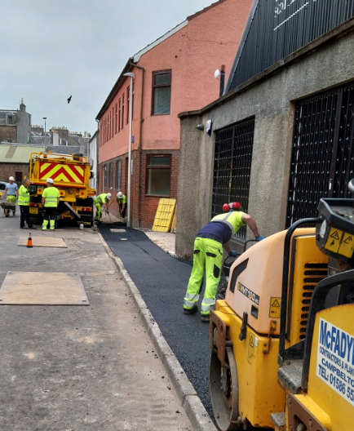  Gartbreck capping works  New capping works have started this week at Gartbreck.  We are required to progressively cap each phase of the landfill site as the waste is deposited in order to reduce leachate generation, and control landfill gas emissions.  The capping construction works include earthworks, re-profiling of waste mass, placement of a soil regulating layer and installation of restoration and capping layers.  The capping layer is to comprise a Geosynthetic Clay Liner (GCL), the GCL is made up from two layers of woven fabric with bentonite (a manmade clay), which is needle punched between the two layers of fabric. This material is manufactured and imported from Germany.  Locally produced sub soil materials, to a minimum depth of 300mm, are placed above the GCL cap.  A further layer of 200mm restoration soils (the sub soils are mixed with culms, barley, ash, and peat from local distilleries) this material is placed immediately above the capping layer, to aid growth as rough grazing, which is the intended after use of the site.  Surface water stone drains are also installed across the area to aid surface water run-off.  The works are being undertaken by a contractor along with a local sub-contractor, and some locally hired heavy plant, and are independently supervised by a construction quality assurance engineer as required by SEPA.  B8001 Claonaig  Works are progressing on site. At this stage these involve  setting out and initial excavations of the upper slope.  We have completed a significant amount of work to enable us to successfully obtain a SEPA licence exemption, which will allow the re-use of excavated soils to improve an area of land adjacent to the site works. If we had had to remove this material from site this would have been costly as well as having an impact on the road network and the environment through high volume of haulage works. Thanks to the good work of the project team this has been avoided. | Roads updates  Cyclic gully cleaning continues on Bute. We are currently working with a much reduced team on Bute which means work like cyclic gully cleaning is taking a little longer than we would like.  In Cowal machine surfacing on the A886 Leanach site is now complete.  Surfacing works have commenced on the A886 at Dunans and is expected to complete at the end of next week.  Rural grass cutting has taken place along the A815 North and the A886 North and Glendaruel.  Our in house lining trailer has been out in Innellan lining disabled bays and protection bars.  The roadmaster has been carrying out pothole repairs along the A885 Hunters Quay and the A815 Coylet.  Dunoon Rally  Our staff and the rally organisers have carried out a full survey of the route used for the rally and have identified some damage to walls and a telegraph pole (not affecting any lines). A contractor is being arranged to undertake the repairs at no cost to the Council. | Public convenience door access control project  The new system is continuing to perform reliably after some initial problems. At the moment all nine sites are operating as they should and are generating income.  We’ve asked the contractor for a programme for the remaining planned works plus proposals for Moir Street/Riverside and Rothesay Victoriana, with the latter proposal to be sensitive to the building’s listed status.  Bearing in mind the previous issues with the system it has been decided through last week’s Environment, Development and Infrastructure committee that the first set of installs should run for the season to allow a reasonable period to assess the overall reliability of the system. Therefore we have advised the contractor to structure their proposal accordingly.  The most up to date figures show that we have generated just over £13,000 so far from the new system.  School transport  With the school holidays upcoming we’ll be arranging to have any required works to our minibus fleet undertaken over the summer. While we won’t be transporting children to school there is still lots to do in terms of the fleet and the routes themselves, taking into account any changes in pupil rolls.
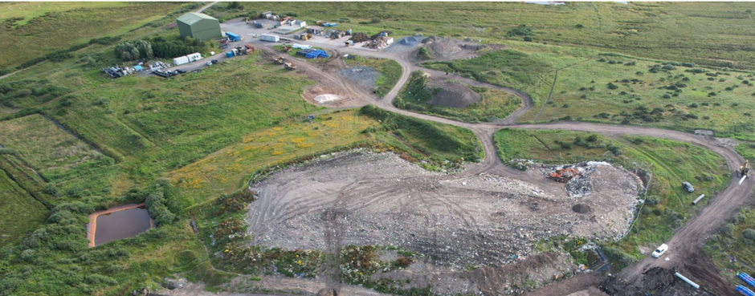

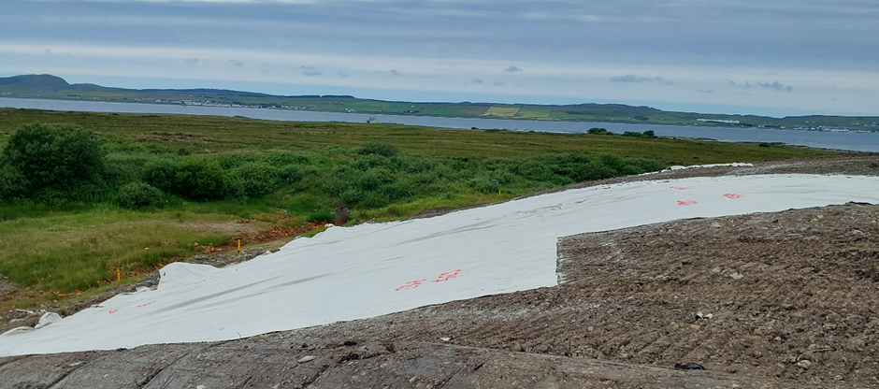

Gartbreck capping
