

Please find below a brief snapshot of the huge range of work being undertaken across the area by Roads and Infrastructure staff this week.
Roads and Infrastructure
Weekly member briefing
Edition 154: 21st June 2024

The updates are designed as a resource for you to be able to answer constituent queries.

You can view all previous weekly member briefings on the website

Oban, Lorn and the Isles | Helensburgh and Lomond | Mid-Argyll, Kintyre and the Islands | Bute and Cowal | All areas
Roads updates  The capital surfacing scheme on Pulpit Drive has now completed.  Next week the team will be commencing two different capital schemes on High Street and Dunuaran Road. Both schemes are expected to complete by the end of next week.  The improvement works to the Lochbuie passing places on Mull have also been completed with crews now turning their focus to grass cutting.  Marine  Cuan ferry, MV Belnahua is undergoing extensive overhaul that should see the working life of the vessel extended, better fuel and emission efficiency and preparation for regulatory safety improvements.  The vessel is expected to be back in service at the end of the month.  Streetlighting  The Oban capital works are progressing well and expected to complete in around 3 weeks.  The team are currently working on Creran Gardens before starting work on Orchy Gardens and Lonan Drive. | Roads updates  The capital surfacing scheme on the B832 is due to be completed by the middle of next week. The road closure remains in place until works are finished.  The team will then be moving on to carry out resurfacing work on the C69 from 26th June until 5th July. A road closure will be required for the duration of these works.  The planned surface dressing works on the A814 between Whistlefield roundabout and Glen Douglas junction have been postponed by the contractor and will now take place on Monday 24th June for 4 days, this will also require a road closure.  Helensburgh Mid Summer Festival  Additional bins will be in position in and around Colquhoun Square for the event on Saturday 22nd.  Bollards have been dropped to allow fairground rides early entry. | Roads updates  The capital surfacing scheme on the Main Street Campbeltown is on schedule to complete today.  The lining contractors are scheduled to attend on week commencing 1st July.  The ongoing capital works at Crinan going into Barmalloch are also expected to complete next week.  The jet patcher is currently on Islay carrying out essential pothole repairs.  Port Askaig  A separate briefing has been issued to local members advising of the progress with the Port Askaig development.  After consultation and work with consultants, a solution can be delivered at Port Askaig that will meet the concerns locals expressed in consultation feedback; be delivered well within budget and on time for the new vessel delivery; and remains within the parameters of the Marine Asset Management Plan.  Streetlighting  The installation of the new columns on Bolgam Street is now complete however when carrying out excavation work to track the cables the footway broke up quite significantly therefore this will need to be resurfaced. All works should be completed next week. | Roads updates  On Bute all rural grass cutting is now complete, the tractor and flail will now move into West Cowal.  Cyclic gulley cleaning has been ongoing throughout the area.  In Cowal pre surface dressing (scrub and ditching) works continue on the A886 at Dunans.  Machine surfacing on the Leanach site is ongoing.  Rural grass cutting has taken place along the B866 coastal route, C10 Glenstriven and A815 Dunoon North.  The jetptcher has been carrying out pothole repairs in Lochgoilhead.  Dunoon Rally  Support is in place for the Dunoon Rally including additional bins in and around the town and preparing Dunoon Stadium for use as part of the event. | EV Chargers  Following the increase of our EV charger tariff we carried out a 6 month comparison from 1st Jan – 1st June 2023 and the same period in 2024.  For this period in 2023 the total number of charging sessions was 10,468 with a consumption of 200,932.62 kWh.  For the same period in 2024 this has increased to the total number of charging sessions being 13,548 and the total consumption being 300,956.16 kWh.  This is the equivalent to saving 683 trees in the period of 2023 and saving 1021 trees in the same period for 2024.  The tariff for EV Chargers is now £0.45p kWh with a minimum charge of £2.00.  Pavement Parking  It was decided at the EDI committee meeting this week that Argyll and Bute Council will implement the pavement parking prohibitions however this is not likely to be until the end of the year. This will allow time to recruit additional staff and implement any IT adjustments that are required.  Election arrangements  The team have been liaising with the Governance Team regarding transport arrangements for the General Election - this includes delivery and collection of ballot boxes and polling booths across the area

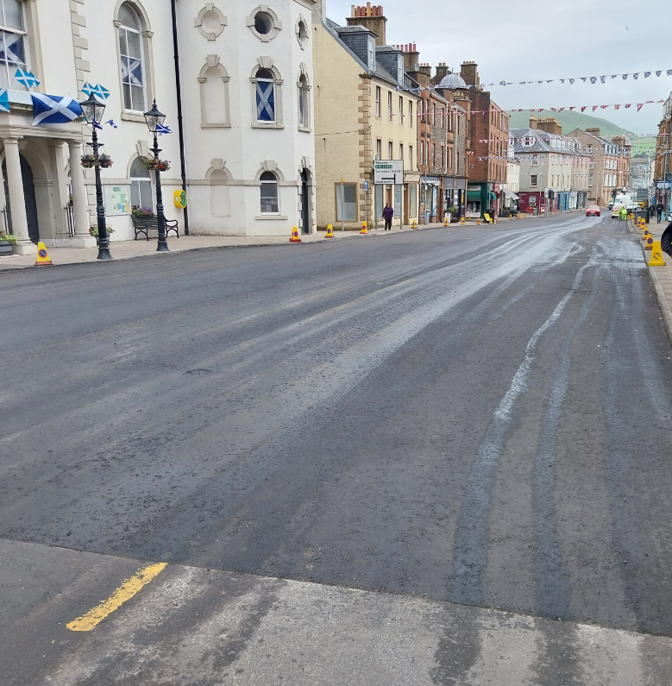
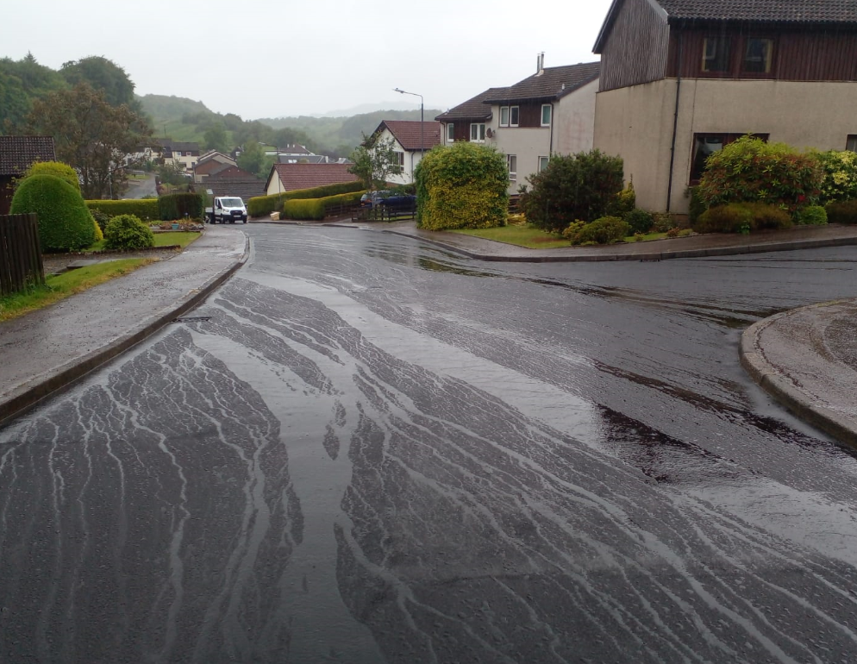
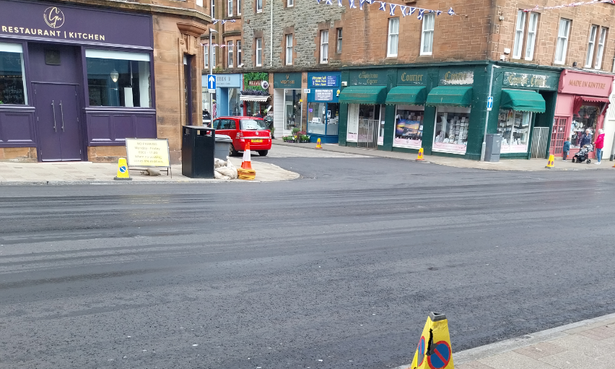
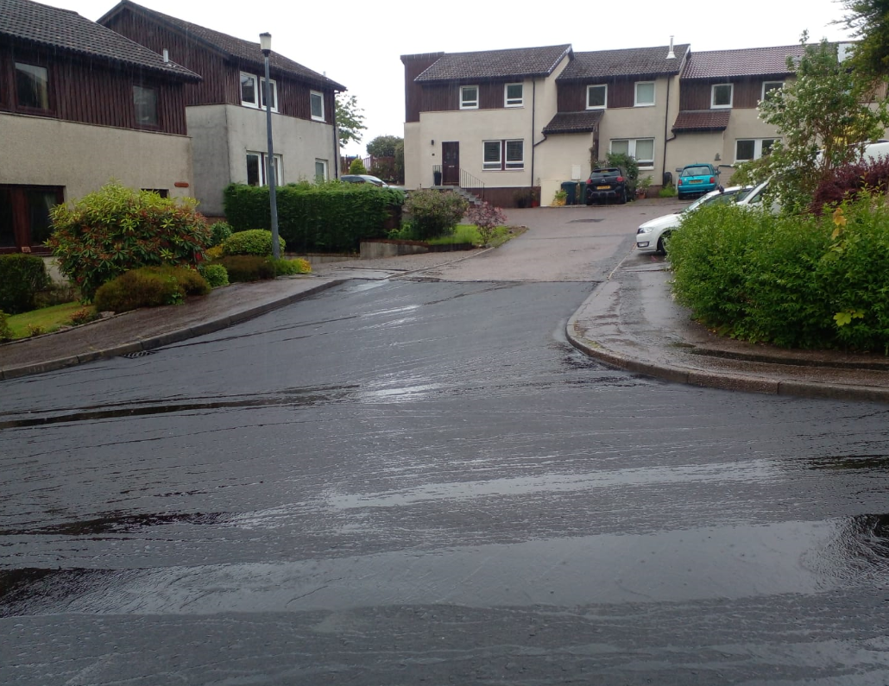
Recent resurfacing work on the Main Street, Campbeltown
Recent resurfacing on Pulpit Drive, Oban

