
Please find below a brief snapshot of the huge range of work being undertaken across the area by Roads and Infrastructure staff this week.
Roads and Infrastructure
Weekly member briefing
Edition 153: 14th June 2024
The updates are designed as a resource for you to be able to answer constituent queries.
You can view all previous weekly member briefings on the website
Oban, Lorn and the Isles | Helensburgh and Lomond | Mid-Argyll, Kintyre and the Islands | Bute and Cowal | All areas
Roads updates  This week our team have completed the overlay works on the B8085, Colonsay. (photo below). There is a significant challenge getting material to Colonsay and during these works we had the quarry unable to supply material on one day due to the Connel Bridge not being available (quarry located north of Connel) following a bridge strike by a large vehicle. We are normally challenged by weather and ferry availability, the bridge being closed being a first.  Next week crews will start Capital surfacing work on Pulpit Drive, Oban. t to improve the road surface.  Work is also ongoing on Mull to carry out improvements to passing places at Lochbuie.  Streetlighting capital scheme  This project continues to make good progress – we have completed column installations down to Ure Drive. The next phase will be Creran Gardens, then Orchy Gardens.  Mull bus services  The contracts to provide the Mull school and local bus services went out to tender this week.  Clipper Race  Our marine and roads teams are busy carrying out various tasks including issuing Notices to Mariners, progressing Traffic Orders and arranging for collection of ‘international’ waste to help to facilitate the Clipper Race which will be visiting Oban next month. | Roads updates  A resurfacing scheme along the B832 at Muirlands will commence next week.  The work will include a road closure between the hours of 9am and 4pm with a short diversion in place.  Roadside verge grass cutting has continued and the crew have been along the A814 this week.  The team have also been working on safety defects in and around Helensburgh town, as well as erecting new signs for the restricted parking zone (RPZ).  Tigh Dearg Road  Work on Shore Road will move to the opposite lane on Monday. This will mean Tigh Dearg Road itself will be closed for a period of time with emergency access maintained to properties affected. | Roads updates  Pre surface dressing work along the U18 Drimvore – Crinan Ferry has been completed this week.  Drainage works ahead of the surfacing scheme on Crinan loop is making good progress.  The resurfacing scheme on Campbeltowns Main Street is due to commence next week.  Any raised iron works will also be addressed as part of this project which is expected to complete with 1 week.  Bolgam street  The new columns replacing the faulty wall mounted lights will be installed next week.  Work is due to commence on Monday 17th. | Roads updates  Pre surface dressing work, including tree and shrub cutting, has been ongoing along the A886.  The team are now ready to commence the surfacing work next week.  The jet patcher has been at various locations in Dunoon and surrounding areas carrying out pothole repairs.  Culver repairs along the B8000 are now complete.  Abandoned vehicles  The warden has been working to clear abandoned vehicles and has removed 7 vehicles for Chapel Hill carpark and 5 from Hanover Street carpark.  The warden service will continue to monitor the areas and take appropriate action if necessary.  Strachur school warning signs  Repairs have been carried out to flashing warning signs / illuminated traffic signs etc.  The initial diagnostic work identified that there were problems with some of the underground electrical supplies to signs/lights on the A815 at Strachur. To expedite a quick repair the lights will are being swopped out with solar powered units.  This work is scheduled to be complete before children return back to school after the summer holidays. | Pavement parking  The footway parking is due to be discussed at next week’s ED&I Committee.  Rural Grass cutting  All areas are continuing with routine programmed grass cutting on schedule.  Bus timetables  Next week we are commencing the replacement of amended bus timetables across the network.  We will be starting on Bute next week.  NRSWA  Our roads inspectors from across Argyll and Bute met this week to undergo refresher training regarding the New Roads and Street Works Act (NRSWA). The NRSWA places a duty on the council to co-ordinate and record all works carried out across our roads by Utility companies and our own teams. The NRSWA also places a requirement for signing and guarding to be laid out to a set standard.  Our internal training coincides with the Roadworks Commissioner (an independent body responsible to Scottish Ministers) launching a team of compliance officers who will be travelling across Scotland checking that roads works are carried out with the correct noticing and traffic management. The compliance officers have liveried up vehicles which are very conspicuous – you might see them on your travels. NRSWA services are delivered through our operations team.  Non-compliant road works can attract a financial penalty.
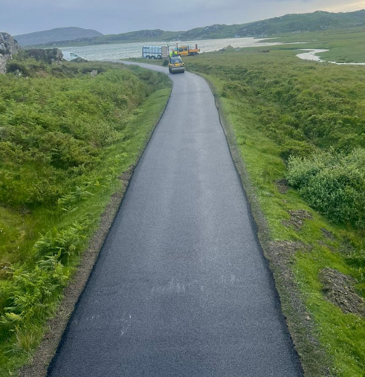

Recent surfacing work on Colonsay

