
Please find below a brief snapshot of the huge range of work being undertaken across the area by Roads and Infrastructure staff this week.
Roads and Infrastructure
Weekly member briefing
Edition 151: 31st May 2024
The updates are designed as a resource for you to be able to answer constituent queries.
You can view all previous weekly member briefings on the website
Oban, Lorn and the Isles | Helensburgh and Lomond | Mid-Argyll, Kintyre and the Islands | Bute and Cowal | All areas
Roads updates  The capital scheme on the U16 Laurel Road will complete by close of play today. Next week crews from Oban will be going to Colonsay for capital works there. Although Colonsay is in MAKI, it is far easier to deploy staff from OLI there for these works because of ferry availability.  Following on behind the streetlighting works at Nant Drive we are doing footway improvements there next week. We will be doing a slurry seal, which is a low cost preventative measure for footways which seals the surface from water ingress and provides a new texture.  On Mull the team are continuing with the passing place improvements as well as doing potholing works in and around Ulva Ferry  Streetlighting capital scheme  Things are continuing to progress with these column replacements – currently we are expecting the scheme to complete in the next 5 – 6 weeks  Oban Charity Day  Our teams are supporting the charity day in Oban tomorrow by providing cones, fencing, temporary bus stop signage etc. for crowd management/road safety. We’ll also ensure all the town bins are emptied tonight ahead of the event which is expected to be busy. We’ll have extra staff working over the weekend for litter picks, waste collection etc.  Craignure ground investigations  These works have successfully completed this week and the contractor is demobilising today. | Roads updates  The scheme to replace the culvert on the A814 near the former council office at Blairvadach will complete today – this will provide a significant improvement to the recent flooding/drainage issues.  The jetpatcher has been working in Lomond this week, in particular focussing on Fort Road in Kilcreggan.  The gully vehicle has been out on cyclic maintenance in the Rhu/Shandon area  Next week’s focus will be on the roadside verge grass cutting which will begin on the A818 from Arden roundabout working towards Helensburgh, before moving on to the A814 the following week  Cemetery drainage  The gully vehicle has also been clearing the drainage system in Faslane Cemetery and doing drainage investigations around Rosneath Cemetery.  Tigh Dearg Road  Works are ongoing on Shore Road and are expected to complete around the end of June. This includes construction of a new outfall and repairs to manholes on Shore Road and on Tigh Dearg Road itself.  Currently one lane of Shore Road is closed to facilitate the works. This closure will need to switch to the opposite lane to allow the works to complete which will mean no access to Tigh Dearg Road from Shore Road. Our contractor is working on an emergency access plan for residents which should be available shortly. | Roads updates  The scheme at Woodside in Carradale is now complete. This has provided an improvement in terms of access for residents with wider footways and dropped kerbs, as well as increasing the road width which makes it easier for large vehicles like bin lorries and delivery trucks to get round. The scheme took a little longer than expected due to the need for rock excavations.  The team in Kintyre have also this week completed the pre surface dressing patching on the Gobagrennan road, and the jetpatcher has been working in and around Kintyre.  In Mid Argyll we are progressing a capital scheme at Crinan, with the works this week focussing on drainage.  This phase of the works at Electric Cottage on the A819 has completed. We’re programmed to be back there for another phase starting in July.  Across all areas in MAKI we are undertaking roadside verge grass cutting.  School Street, Bowmore  Members may have seen correspondence about this – we progressed a footway scheme at this location to improve pedestrian and road safety. Previously the road was narrowed as a result of parked vehicles which made it difficult for lorries to safely navigate it and forced pedestrians to walk on what was effectively a single track road often against the flow of traffic. By providing a wide footway we’ve removed the parking option, provided an acceptable road width for large vehicles to pass single file on a give way basis and ensured that pedestrians, including those with mobility issues, can have a safe area to use. We’ve included before and after photos below.  Kilkerran Cemetery  Our local team were praised this week by some American visitors who were tracing family roots in Kintyre. They fed back on the good condition of Kilkerran in particular, comparing it to some American military cemeteries. Well done to all involved. | Roads updates  This week in Cowal we have been doing mechanical ditching on the A815 at Coylet, around the planned surface dressing site. We’ve had the jetpatcher out in the Hell’s Glen area as well as on the A815 at Dunoon road end and on the A886 at Glendaruel. With our own lining trailer we’ve been doing lining in Dunoon town – markings for new traffic orders, more vehicle access protection markings (H-bars) and disabled bays.  On Bute our focus has been on the cyclic gully programme in Rothesay and jetting the pipework at Port Bannatyne park.  Dunoon linkspan  On Tuesday evening a problem developed with the linkspan locking mechanism, which affects its operation. This meant the ferry service was disrupted.  As of 6pm last night the linkspan was operating as normal although repair works are ongoing to replace the locking mechanism. These ongoing works may cause some disruption but we’ll try to keep that to a minimum and of course continue to liaise with CalMac. | New vehicles  As part of our ongoing vehicle replacement programme we’ve recently taken delivery of two new gravemaster vehicles for gravedigging, as well as two new 7.5tonne roads vehicles – see photos below.  Commercial waste  This week we will be issuing reminder letters to over 500 commercial waste customers regarding their annual bills. This is a normal part of the administration of this service. The overall balance owed by these customers is around £750,000


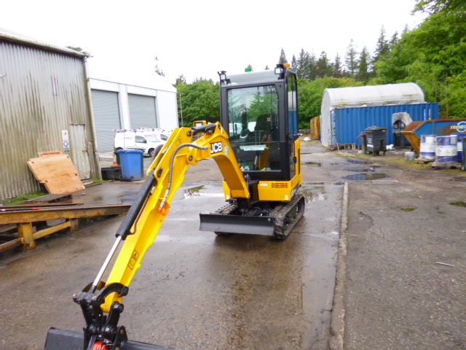
New gravemaster and flatback
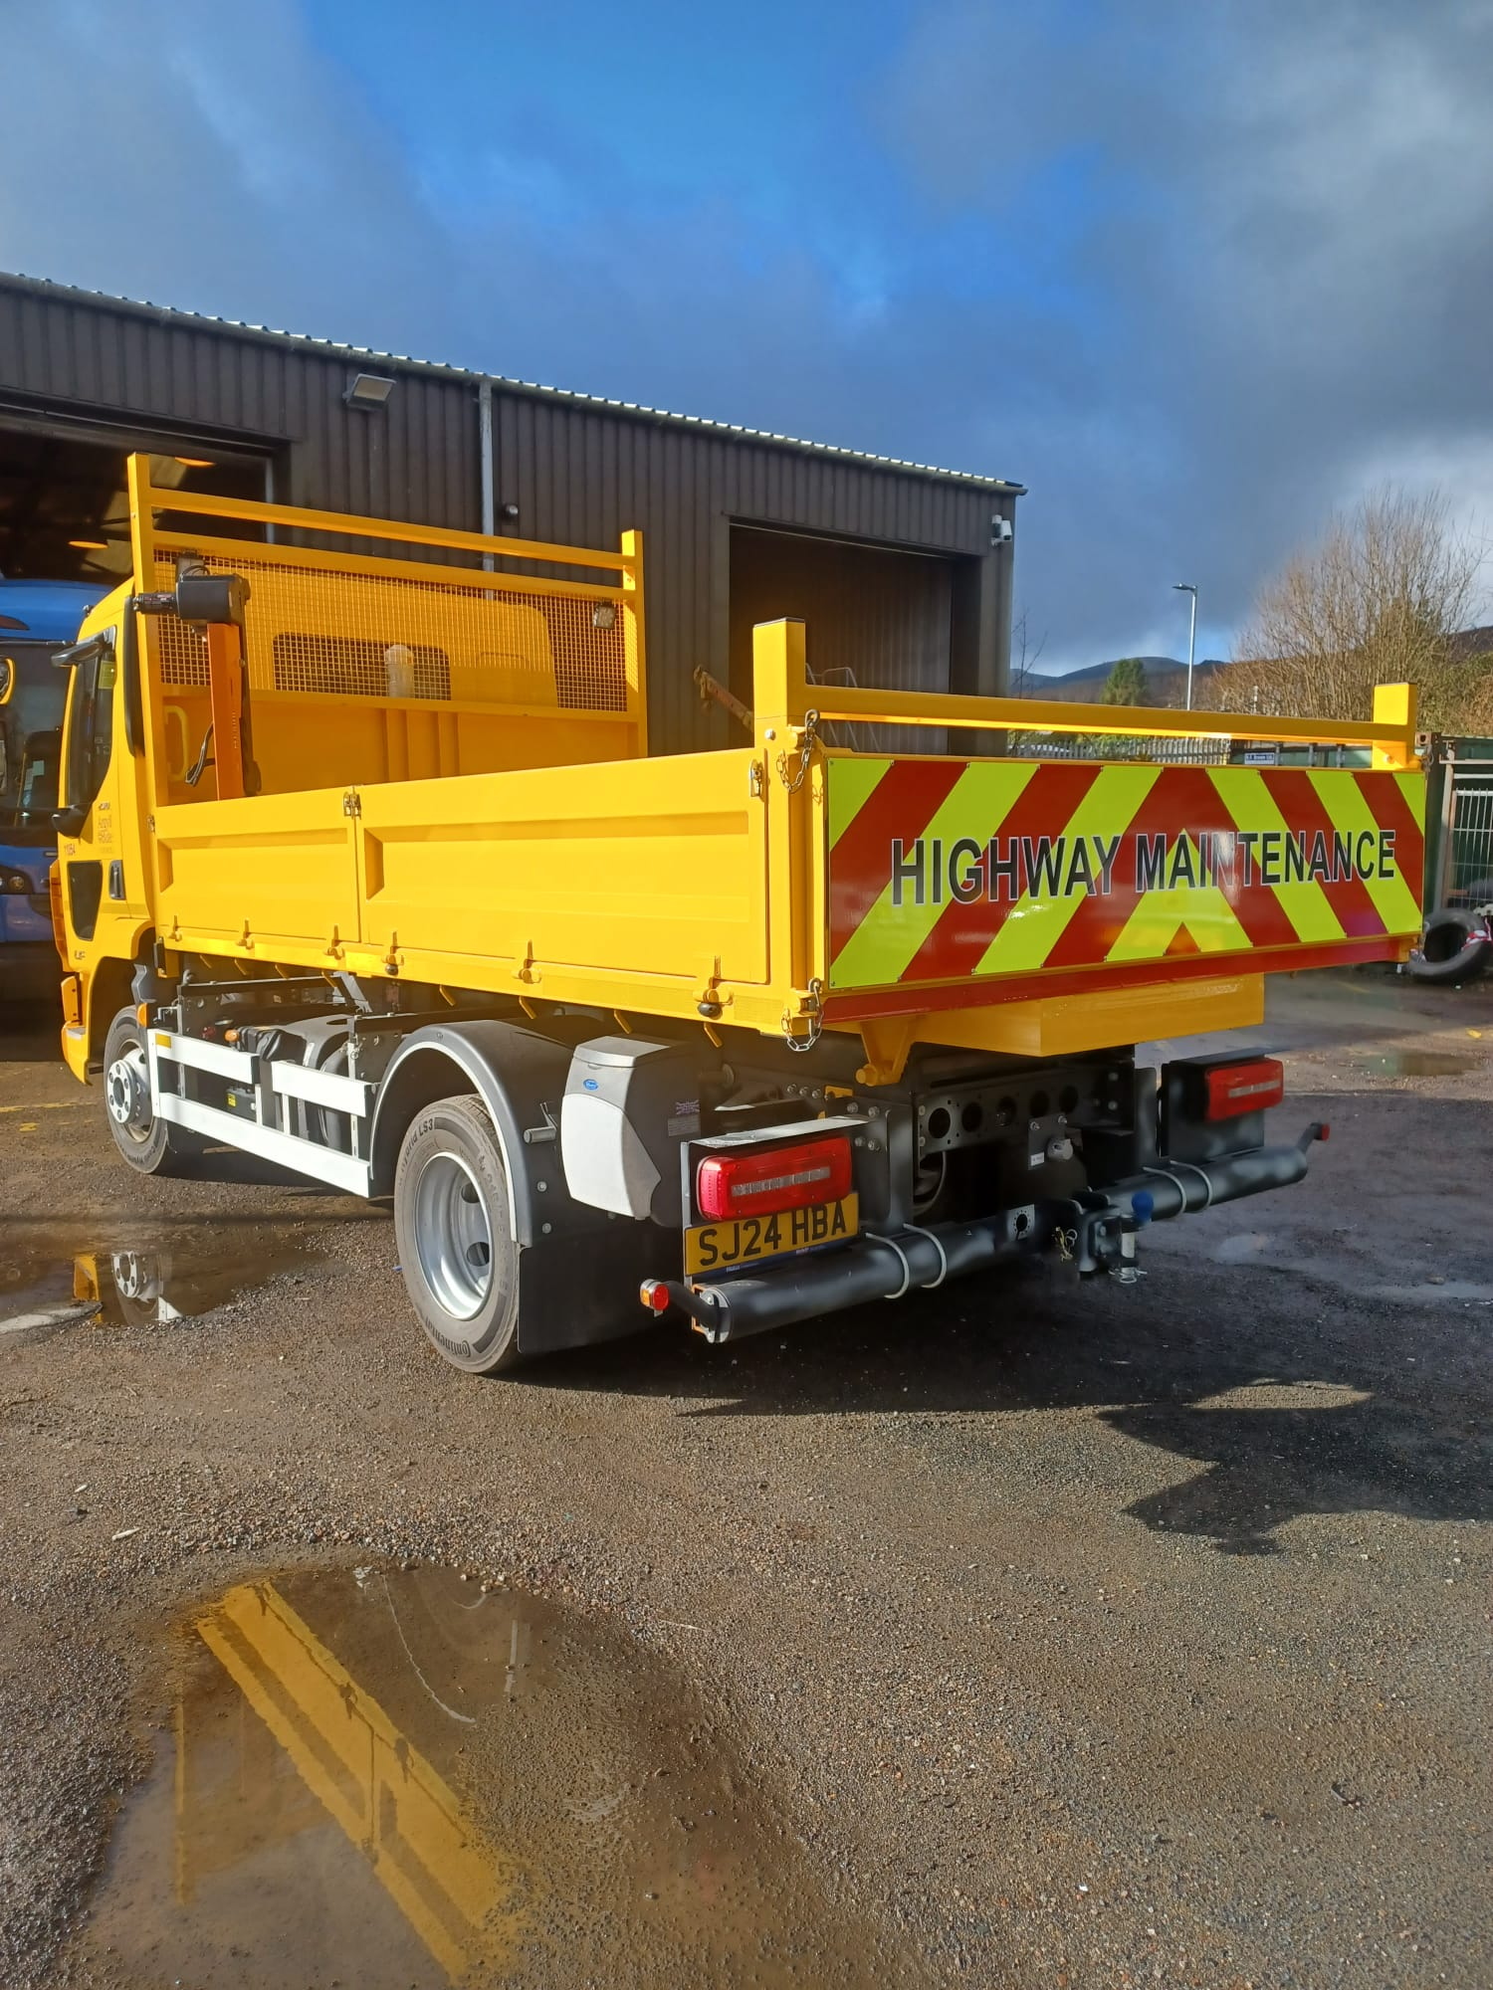

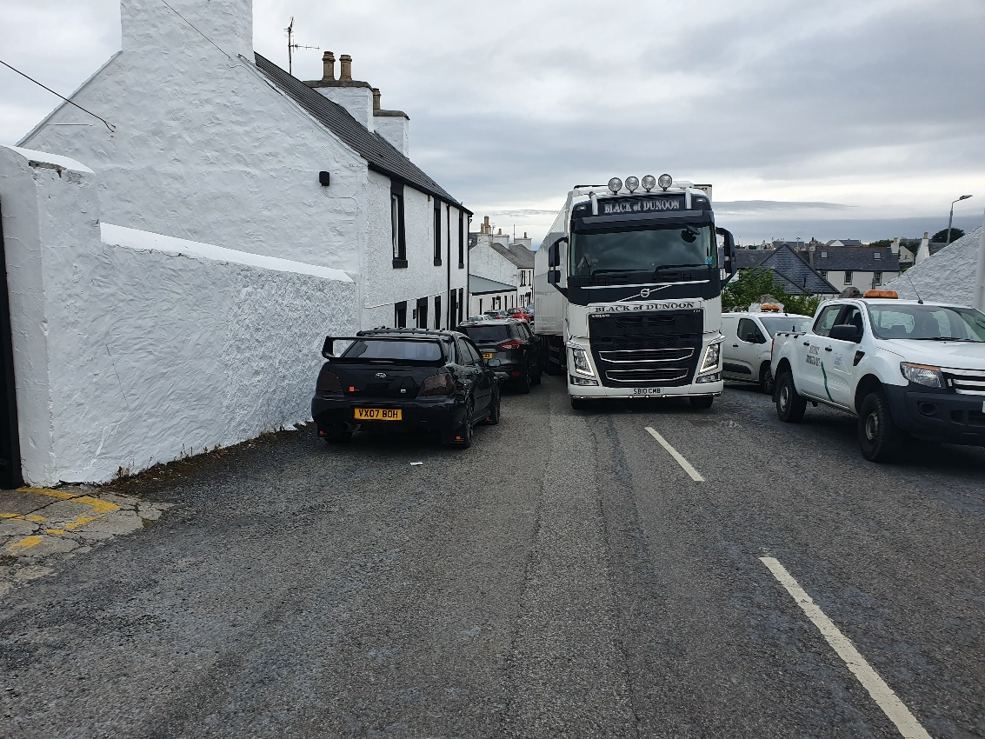
School Street, Bowmore – before and after

